

**2016 LEGISLATIVE SESSION IN HINDSIGHT**

u $460,000 for the Department of

Each January through May SPIN Education to provide training and follows the progress of the Hawaii

State Legislature to report important prepare for the implementation of the legislation and funding to benefit Restraints and Seclusion bill (page 3). children with disabilities. In doing so u $12,000,000 to help find housing

we hope to encourage families to get for homeless families.

involved in the process. Sometimes

a few heart felt testimonies make a **Unfunded Requests**

difference in whether a bill is passed A number of state or put to rest. departments and

Here’s a quick wrap-up on funding agencies are wondering

and laws passed. Of course, we how to pay for needed

have up until early June to see if the services for the coming year: Governor plans to veto bills passed.

u For the DOE, a $10 million

**Funded Requests** shortfall for services for students

There were some whose second language is English

groups and causes and a $3 million shortfall for skilled

that received nursing services.

big funding this u For the Developmental Disabilities

session included Division, $2.8 million in matching

the following: monies for the DD/ID Waiver.

u a whopping u In Department of Human Services

$100 million to the Department of budget for Medicaid, $6 million+ Education to cool or air condition up for early diagnosis and treatment of to 1000 classrooms across the state. autism in keiki through age 6.

u $16, 537,791 in additional Turn to page 2 for information on Weighted Student Formula monies to important bills.

help public schools address needed

supports.

u Almost $7 million in additional funding for public school transportation, including bus contracts for students with disabilities.

u $10 million in preschool subsidies through the Open Doors program to enable almost 2,000 at risk preschoolers to attend private preschools.

**WHAT’S INSIDE**

2016 Legislative Bills 2 Susie Chun Oakland 2

Restraints & Seclusion 3

The App Corner 4

Spotlight on Support 4

Newsletter Distribution 4

Parent Awards 5

Family Choice Awards 6

Professional Awards 7

Calendar of Events 8

**May 2016**

**Volume XXXII, No. 4**

**SPIN** is co-sponsored by the Disability & Communication Access Board and the Department of Education.

Services include a phone line for information referral and support, a quarterly newsletter, an annual conference and community workshops. SPIN is guided by an Advisory Committee made up of parents, teachers and people with disabilities.

**SPIN**

919 Ala Moana Blvd., # 101

Honolulu, Hawaii 96814

PHONE

**586-8126**

Neighbor Islands dial the ex- change below, then 6-8126

Kauai - **274-3141**

Hawai’i - **974-4000**

Maui - **984-2400**

Molokai - **1-800-468-4644**

Lanai - **1-800-468-4644**

FAX

586-8129

E-MAIL

[spin@doh.hawaii.gov](mailto:spin@doh.hawaii.gov)

WEB

[www.spinhawaii.org](http://www.spinhawaii.org/)

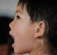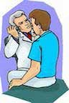

**New Legislation Passed**

**by the 2016 Legislature**

**Champion for Keiki**

**Bids Aloha to the Senate**

Senator Suzanne “Susie” Chun Oakland surprised family-serving agencies by announcing that she will not run for reelection in the Fall.

**TEMPORARY**

**EXEMPTION FROM ABA LICENSING**

**SB 1311** acknowledges the need to have “direct support workers”

who are providing autism treatment services to students with disabilities as part of an IEP to meet the licensing requirements established last year in Act 199. However, given that the current workforce

is inadequate to meet these needs, legislators gave the Department of Education until January 1, 2019 to ensure its teachers or paraprofessionals who directly implement autism intervention or

assessment plans under supervision have time to become credentialed as a Registered Behavioral Technician.

**DEFINITION OF**

**DEVELOP- MENTAL DISABILITIES**

This law (**Act 032**) extends eligibility for services from the Developmental Disabilities

Division (case management, waiver services, etc.) to children from birth to age nine who have a substantial developmental delay or specific congenital or acquired condition, and who are likely to meet the

strict criteria for developmental disabilities (for example, substantial delays in 3 or more life activities) later in life. The result is that infants and young children can receive early intervention and supports that may help lessen the extent of their disability.

Senator Chun Oakland has

been the Chair of the Senate Committee on Human Services, and also serves

on the Education and Ways and Means Committees.

She began her career in the House of Representatives in 1990 where she helped

found the Keiki Caucus along with Representative Dennis Arakaki. It has since grown to 27 House and Senate members who partner with dedicated community groups to sponsor legislation that affects the health, education and safety of Hawaii youth. Students are also a big part of the Keiki Caucus, and their ideas are showcased every year in October in a Children and Youth Summit.

If you, like SPIN, are going to miss Susie’s leadership, her dedication to the needs of children and families, her wisdom and her warm smile, drop her an email at senchunoakland@ capitol.hawaii.gov to say mahalo and aloha.

**LANGUAGE**

**MILESTONES FOR DEAF STUDENTS**

**PHYSICAL**

**EXAMS FOR SEVENTH GRADERS**

The purpose of **SB 2476** is to

address the very real problem that many deaf, hard of hearing, and deaf-blind children between the ages of 0-5 have received very little or no language instruction. This bill will enhance language development for these keiki and prepare them to be ready for kindergarten. The Executive Office of Early Learning, the Department of Health, and the Department of Education will form a working group with parents, teachers and individuals who are deaf, hard of hearing or deaf-blind to discuss issues and make recommendations to the Legislature.

Currently, physical exams are only

required when students start school, usually in kindergarten. Starting with the 2017-18 school year, **SB 2387** will require that students entering seventh grade at a public school also show proof of a recent physical examination. If students are not able to complete the exam before December 31st of their

7th grade year, the Department of Health will step in to provide information to their parents and guardians about healthy lifestyles

and how to obtain health insurance. The bill also aims to prevent or address childhood obesity by ensuring students see a health care provider.

2

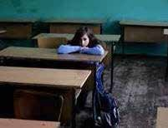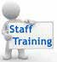

**Restraints and Seclusion Bill to Take Effect**

**August**

**1,**

**2016**

*“There is no evidence that*

*physically restraining or putting children in unsupervised seclusion in the K-12 school system provides any educational or therapeutic benefit to a child. In fact, use*

*of either seclusion or restraints in non-emergency situations poses significant physical and*

*psychological danger to students.”*

*--U.S. Senate Health, Education, Labor and Pensions Committee, 2014*

In 2014 advocacy organizations

representing Hawaii families of children with disabilities worked with legislators and the

Department of Education to pass **Act 206**, known commonly as the **Restraints and Seclusion**

**Bill**. It was patterned after federal legislation that was drafted to end the emotional and physical harm to students caused by restraining them (through medication, harnesses or by physically holding them) and by locking them in rooms or closets against their will. A large portion of the students harmed were students with disabilities who had behavioral outbursts or who failed to follow the teacher’s instructions.

In passing Act 206 the Legislature gave the Department of Education until August 1, 2016 to have the following in place:

A complete ban on the use of seclusion,

chemical restraints and mechanical restraints.

Limits of physical restraint to danger of harm to the student or others or to property.

Policies and procedures regarding the use of restraints in schools.

**Use and Scope of Restraints**

Act 206 reduces the circumstances where physical restraints can be applied to only those instances where a student’s behavior poses a present threat of property damage or physical injury to the student

or others. The restraint can only be used for as long as the danger exists. Restraints **cannot** be used for discipline or convenience.

**Focus on Prevention**

This law is not only about reducing the incidence of restraints. It’s also about preventing the need

for emergency interventions by teaching educators how to use positive behavior supports to promote a positive school culture and climate where all students feel safe.

At least annual review

of data on restraint.

Training and annual

recertification for teachers and staff who use restraints.

Verbal notification

to parents as soon as restraint occurs and in writing within 24 hours.

**For a copy of Act 206:**

<http://www.capitol.hawaii.gov/ses-> sion2014/bills/HB1796_CD1_.PDF

3

**Definitions in Act 206**

**Chemical restraint** means a drug or medication used on a student to control behavior or restrict freedom of movement; provided that the term does not include a drug or medication that is:

1. Prescribed by a licensed physician, or other qualified health professional acting under the scope of the professional’s authority under state law, for the standard treatment of a student’s medical or psychiatric condition; and
2. Administered as prescribed by a licensed physician or other qualified health professional acting under the scope of the professional’s authority under

state law.

**Mechanical restraint** means the use of devices as a means of restricting a student’s freedom of movement or the ability to communicate in the student’s primary language or mode of communication.

**Physical restraint** means a personal restriction, other than a chemical or mechanical restraint, that immobilizes

or reduces the ability of a student to move the student’s arms, legs, or head freely.

**Seclusion** means the confinement of a student alone in a room or structure from which the student is physically denied voluntary egress (the freedom to leave).



Spotlight

on Support

Social media apps have evolved and are not your

mother’s Facebook anymore. They are popping up with alarming speed, targeting our tweens and teens and encouraging them to post and share anonymously. That has many parents, teachers and safety officers worried. According to SafeSmartSocial.com, where you can watch videos to learn which apps can support or harm your child’s online profile, when students use apps in anonymous mode, they tend to behave badly and are more prone to bullying and predators. Apps that are considered not safe for students under 17 are: Afterschool, Ask.fm, Burnbook, Calculator Private

Photo, Kik Messenger, Ogle, OoVoo, Slingshot, Tumblr, Whisper, Wishbone, Yik Yak and YouNow. The National Crime Prevention Council recommends these three simple steps to increase internet safety:

**HelpYourKeiki.com** is a website designed to support

parents and caregivers with a child or young adult who may have emotional or behavioral difficulties. It is updated and maintained by the Evidence-Based Services Committee and has 4 major sections for

parents to navigate the site and easily find information.

**1.**

**Common Problems**: If you think you child may

suffer from attentional issues, depression, trauma, anxiety, eating disorders, autism or disruptive behaviors, you can click on a symptom to learn more about the behavior, common signs and symptoms and find ways for parents, keiki and professionals to help your keiki.

**What Works**: Not all treatments for emotional and behavioral problems are proven to work, so Help Your Keiki has compiled research supported or “evidence-based” practices. Here you will find “Keiki Skills” that your child can develop and use to help themselves, “Parent Tools” are activities that you can use at home and “Treatments that Work” showcase the best, proven, evidence-based treatments that you can discuss with your child’s mental health professional.

**Find Help**: guides you on who to call for help depending on your child’s insurance.

**Resources**: covers topics from educational needs to where to find family support to what to expect and questions to ask during therapy.

**2.**

1.

Don’t give optional information when creating a

profile, just your name and email.

Choose “friends only” as your privacy setting. Accept only people you know as friends.

2.

3.

Social apps can be used to develop a positive profile

that colleges and potential employers can learn about your child. Here are a few tips to keep your teen on the right path:

**3.**

•

Be “friends” with your child on their social media

apps and have access to their passwords. Keep the lines of communication open.

Talk to them about their future and give them a chance to prove they can be responsible.

**4.**

•

•

Funding Cuts Will Affect SPIN Newsletter

Though SPIN has been around for over 30 years, most people don’t realize that we are funded by the Department of Education on a year-to-year contract. The contracted funds support two full time staff, support to SEAC, trainings such as the SPIN Conference, the SPIN line and the

SPIN News. The newsletter is printed 4 times a year and distributed to families, principals, teachers and other service providers around the state. Funding for our upcoming contract, beginning July 1st, will be significantly reduced and one of the ways to make our budget work will be to stop printing the quarterly newsletter. We will still be able to offer it electronically, so if you have received this edition as

a “hard copy” via “snail mail”, or if you received this newsletter from one of our

community partners, please call us at 808-586-8126 or send us an email to [spin@doh.hawaii.gov](mailto:spin@doh.hawaii.gov) so we can add you to the email distribution list for the newsletter.

4

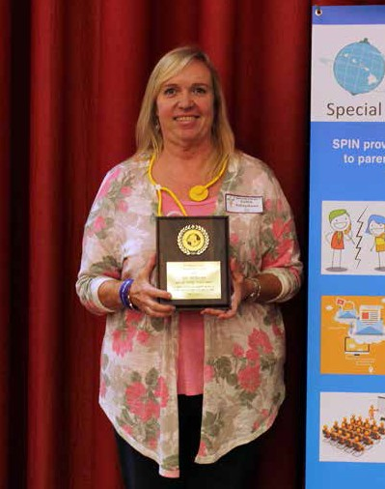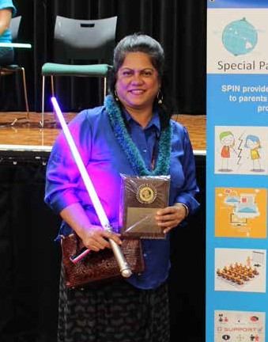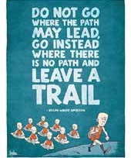

5

**2016 Parent of the Year Awards**

**Debbie Kobyakawa Rosie Rowe**

Debbie has been a life-long advocate for her son, Over the last 10 years, Rosie has empowered

Ian, who is 26 and living a successful life in the thousands of families while working at the Learning community. She has worked as a special education Disability Association of Hawaii. She works

teacher, and is currently employed as a parent tirelessly to equip parents with the tools, training and consultant and personal assistant to a young lady information they need to be the best advocates for who is attending community college. She serves on their children, while advocating for legislation and the Special Education Advisory Council and is active policies to benefit children and families. Rosie wears in Special Olympics and the Windward Children’s many hats - she’s a leader, a teacher, a champion, a Community Council. Despite her busy schedule, parent and a role model. Most importantly, she never Debbie is working to establish a network of parent gives up, and works to improve special education

support through mentoring and technical assistance. systems, for her own family and our island community.

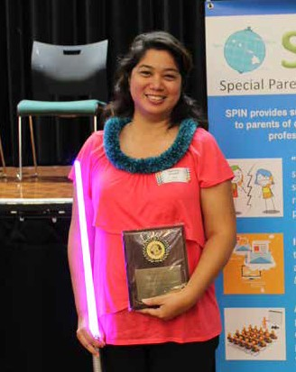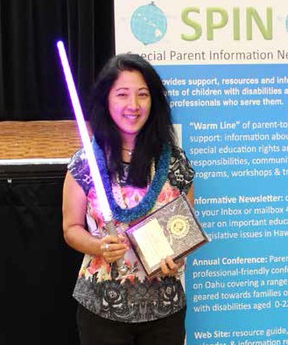

6

**2016 Family Choice Awards**

**Tammy Evrard**

Tammy is the Program Specialist for the State Council on Developmental Disabilities. She is a great role model for self-advocates in empowering and supporting them to be the best they can be with three easy steps: Think - Plan - Do. Through her genuine care and mentoring, the Hawaii Self-Advocacy Advisory Council has flourished and grown and members serve on several task forces, committees and work groups around the state. Tammy also works

with the Best Buddies program, promoting friendships between students with and without disabilities.

**Susan Okamura**

Susan is a mom to two special children and a gifted Speech Language Pathologist with over 20 years

of experience. She has worked with little keiki in early intervention, Central district school kids and as a professor and clinical supervisor at UH Speech Pathology Program and now has her own practice providing speech services and academic tutoring.

Susan’s dedication to serving children and families led her to start a parent support group called Side By Side and she is also a coach for Team Inspire with Hawaii’s Special Olympics.

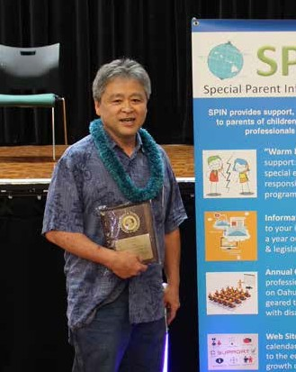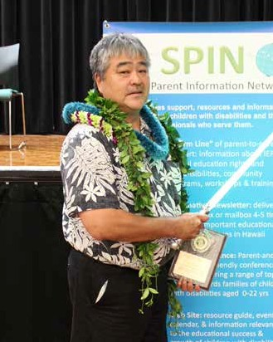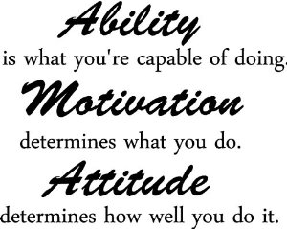

7

**2016 Professionals of the Year**

**Representative Roy Takumi**

Representative Takumi has been a Hawaii legislator for over 20 years and has served as the Chair of the House Education Committee since 2002. He is a believer

in and strong advocate for universal preschools and giving schools the autonomy, flexibility and resources to serve thier students. He co-sponsored the Restraints and Seclusion bill and was key in this year’s legislative session, in carving out funding to train teachers in the use of positive behavioral supports so that restraints are less likely to be used. Special education advocates and families appreciate that Representative Takumi

has come to understand the needs of special education students and is always ready to act on thier behalf.

**Bill Arakaki**

Kauai Complex Area Superintendent Arakaki has served public education students for 36 years. He developed a heart for kids he called the “underdogs” while teaching in an alternative learning center and is a champion for special education students and issues. CAS Arakaki has been an active member of the Kauai Children’s Community Council for over 10 years and worked with the DD Council and other community groups to create the Mauka to Makai Bully-Free Kauai initiative which includes all school, County Parks and Recreation programs on Kauai.



**Summer Events**

**Easter Seals Hawaii Girls Group 2016** offers classes for girls ages 12-20 years old. 6/4 will be a community work day at Kanewai Lo’i and 6/11 will be a cooking class at Down to Earth. email: [youthenrollment@eastersealshawaii.org.](mailto:youthenrollment@eastersealshawaii.org)

**& Workshops**

**6/4**

**6/11**

**6/18**

**7/16**

**Buildng the “Lego’s” of Autism** sponsored

by the **Autism Society of Hawaii** is a FREE event at the Liliha Library meeting room.

2:00 - 3:00 pm. RSVP [austimhi@gmail.com](mailto:austimhi@gmail.com)

**6/24**

**7/29**

**Easter Seals Boys Night 2016** is for boys

ages 12-20. 6/24 will meet at Ward Theaters for “Finding Dory” and 7/29 will meet at Dave and Busters. 6:30 - 8:30 pm. email: [youthenrollment@eastersealshawaii.org.](mailto:youthenrollment@eastersealshawaii.org)

**6/6**

**Hawaii Assn. for Infant Mental Health** workshop

“Using Play to Promote Healthy Relationships, Language and Development in the First Year.” 1505 Dillingham Blvd. Suite 214 Visit www.spin hawaii.org/events and click on the link to register.

**Youth Mental Health First Aide** is offering a **FREE** workshop at the Ma’ili Community Learning Center. Visit [www.spinhawaii.org/events](http://www.spinhawaii.org/events) and click on the link to register.

**6/24**

**Marathon IDEA Workshop** sponsored by

the **Learning Disability Association of Hawaii** will offer insights into special education law, understanding evaluations and how to develop your child’s IEP. FREE. To register, call 536-9684.

**6/7**

**6/9**

**6/11**

**7/2**

**Access Surf** will be hosting a **Day at the**

**Beach at White Plains** from 9:00 am - 1:00 pm. Free surfing event, for all ages

and abilities. Sign up @ [www.accessurf.org.](http://www.accessurf.org/)

***Special Parent Information Network***

*919 Ala Moana Blvd., Room 101*

*Honolulu, Hawaii 96814*

***Providing a world of support to parents of children with special needs***