sdfdsfs

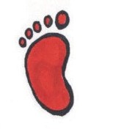

Planning and Preparing for

ransitions

By recruiting friends, family, teachers and other supportive folks to join the transition process you can make the load lighter and the journey easier.

Transition is movement from one

state or place to another. Examples Here are some steps to plan for changes of school transition are when your coming up in your child’s future:

child enters preschool from Early

Intervention, moves from one grade Write down what your next to another, one school to another transition will be.

or changes from one educational

placement to another. Job changes, Think about what a successful housing moves and changes in transition looks like. For

family dynamics also represent example, if your child transition into a new chapter of life. is graduating from high

school, would successful

Transitions of all kinds have transition include a job?

several things in common: More education? Continuing friendships?

A period of uncertainty

and questioning. Growth Identify any worries you have often occurs at this time. about the transition. This step

will help you develop your

A change in our support plan of action. system. Family, friends

and co-workers are often Make a plan. Figure out who

affected. can help with each step and allow them to help you.

An overall increase of

stress, affecting work, Keep a positive attitude and

home and friendships. remember that transitions are part of life and they will pass.

Transitions require some advanced planning in order to make the move less hectic, more effective and successful.

**WHAT’S INSIDE**

E.I. to Preschool 2

Elementary to Middle 2

Middle to High school 3

High school to adult 3

Calendar of events 4

T

**2016-17 School Year**

**Special Edition**

**SPIN** is co-sponsored by the Disability & Communication Access Board and the Department of Education.

Services include a phone line for information referral and support, a quarterly newsletter, an annual conference and community workshops. SPIN is guided by an Advisory Committee made up of parents, professionals and people with disabilities.

**SPIN**

919 Ala Moana Blvd., # 101

Honolulu, Hawaii 96814

PHONE

**586-8126**

Neighbor Islands dial the ex- change below, then 6-8126

Kauai - **274-3141**

Hawai’i - **974-4000**

Maui - **984-2400**

Molokai - **1-800-468-4644**

Lanai - **1-800-468-4644**

FAX

586-8129

E-MAIL

[spin@doh.hawaii.gov](mailto:spin@doh.hawaii.gov)

WEB

[www.spinhawaii.org](http://www.spinhawaii.org/)

Find us on FACEBOOK

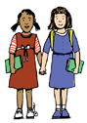

Early Intervention to Preschool

**If you opt for DOE Preschool:**

If your child has been receiving

Early Intervention services, they may qualify for special education preschool. There is a process to follow that begins with the Individual Family

Support Plan that you create with your Care Coordinator.

•

You will need to provide recent evaluations or

request a comprehensive set of evaluations from the DOE.

After the testing and evaluations are complete, the school will schedule an Eligibility Meeting to review the evaluations and see if your child meets the criteria for special education.

Have an Individual Education Program (IEP) meeting to create a plan for educating your child and providing related services as needed.

•

•

**Transition Conference Meeting:**

•

•

•

6 months before your child turns 3 years old

Establish relationships with providers

A time for family to gather information about community programs and supports

**Preparing you child for Preschool:**

Talk to your child about the next setting.

**Transition Options:**

Spend a little time at the site with your child.

•

Department of Education (DOE) Special Education

Preschool

Private preschool or child care center Playgroup or community program Traveling Preschool or Headstart Home

Consider starting part-time and gradually

increasing the hours they attend.

•

•

•

•

Establish a routine for saying goodbye to your

child so they feel safe know you will return.

Elementary to Middle

**Preparing for the move to the middle:**

The transition to middle school is often as challenging

for parents as it is for students. We are saying goodbye

to childhood and hello to adolescence. By taking time to do some thoughtful planning and have important conversations, parents can set the tone for success in the pre-teen years.

Visit the new school, map out the schedule and

do some “dry runs” of getting from class to class.

Designate a “base camp” or friendly face to go

to if they get lost or mixed around .

**What students are worried about:**

Find a buddy (or two or three) to go with your

child from class to class.

•

A larger school with more students they don’t

know.

Different teachers for each subject.

More homework and higher expectations. Balancing the desire for more independence while still needing help with organization and assignments.

•

•

•

To help get organized, color code the schedule,

folders and school map.

Buy a lock a few weeks before school and

practice using it.

**What parents are worried about:**

Talk with your child about new peer groups

and how to hang back a bit to see who is friendly and who is not. Reinforce that it’s okay to take time to make positive, supportive friends.

•

•

•

•

Bullying (both in person and cyber).

Their child not being able to handle the extra work. Not being able to make supportive friends.

Teachers and staff who don’t “know” their child.

2

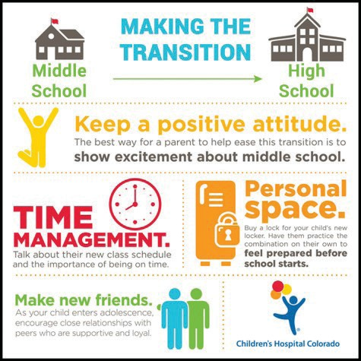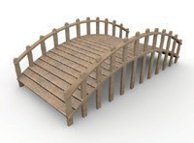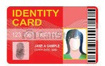

Middle to High School

While in middle school, your

child has been working on many of the skills they will need to function in high school. Your child has met new people,

changed classes every period, navigated the halls, worked with different teachers and used a locker. In high school, they may encounter new situations like:

**Planning for Transition to High School:**

•

Request a high school representative be invited to

your child’s final middle school IEP meeting. Attend an orientation tour of the new school.

Do several walk throughs with your child, take pictures of school landmarks and paste in planner. Give your child positive messages like “I know your going

to be able to handle this.” Consider your child’s interests, strengths and future plans in select-

ing classes, joining clubs and trying new activities.

•

•

•

•

•

•

•

•

Choosing mulitiple elective classes

Meeting graduation (or IEP) requirements Developing self-advocacy skills

Dating

Becoming a legal adult

Planning for continued education, employment and life after high school.

•

In general, a good time to begin transition planning

is six months prior to your child’s last IEP meeting in middle school. You may want to start earlier if your child has more complex needs.

High School to Adult

**Planning for the future is more than whether they will find a job, go to college or stay home:** Hilopaa has developed a transition booklet and check- list that can help families plan for transition. You can find [it at www.hilopaa.org/documents.](http://www.hilopaa.org/documents) Planning for transition into adult life includes:

**Self Advocacy:** Identifying what they need and how to make a plan and ask for help in getting it.

**Personal documentation:** State ID, collecting health records, Power of Attorney.

**Legal representation:** Guardianship, Power of Attorney or self determination.

**Medical coverage:** family plan to personal health plan or a Medicaid plan.

**Primary care:** moving from a pediatric to an adult care and/or specialty provider.

**Career pathways:** higher education, vocational training, supported employment. **Financial Support:** government benefits, ABLE Act, trust funds, work salary.

**Citizenship:** transportation, voter registration, living arrangements, alternatives to guardianship, social networks and leisure activities.

3

As our children grow

into adults, there are many things to

consider and prepare for so they are ready to tackle the next stage of their lives: life after high school.

**At your IEP meetings:**

The IEP is a pathway to your child’s goals and dreams and an opportunity to receive the help they need to reach those goals.

•

Encourage your child to create a vision of their

future, share it with the IEP team and work out a plan on how to get there.

At age 14, focus on what classes are needed to match future goals.

At age 16, the plan should include appropriate, measurable goals and what services are needed to be successful. Those services can include job training & independent living skills training.

Identify and invite community supports and work opportunities to the IEP meetings:

~ Vocational Rehabilitation

~ Developmental Disability Division (DDD)

~ College Student Disability Office

~ independent living skills organizations

•

•

•

Graphic credit: Children’s Hospital Colorado

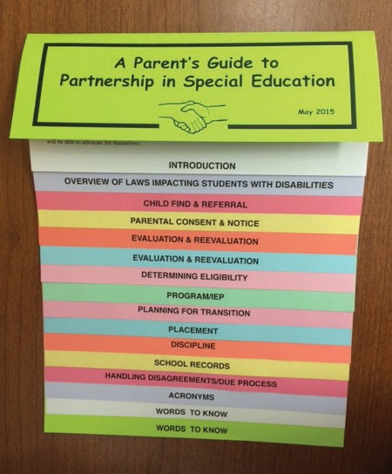

**MARK YOUR**

**CALENDARS...**

**7/26**

**TACA Coffee Talk & Play**

9:00 am Moanalua Gardens

RSVP required: tacanow.org/hawaii

**9th Annual Traveling Mini-Conference 2016**

Presented by the Learning Disabilities Association of Hawaii

**7/27**

**My Choice My Way Informational meeting**

9:00 - 11:00 am for parents & consumers at various state video conference centers

[Info/RSVP: mychoicemyway@dhs.hawaii.gov](mailto:mychoicemyway@dhs.hawaii.gov)

**8/6**

**8/11**

**9/1**

**9/10**

**10/1**

Lanai

Molokai Maui Kauai Oahu

Easter Seals Hawaii Youth Services presents:

For locations and details, contact LDAH at

536-9684 or toll-free (800)533-9684.

**7/29**

**8/26**

**8/6**

**Teen Boys Night Out @ Dave & Busters**

**Teen Boys Night Out @ SikDoRak Teen Girls Group @ Re-Use Hawaii** Email: enroll@easterseals.com/hawaii

**10/2**

**Hawaii Children and Youth Day**

at the State Capitol building 10:00 am - 3:00 pm

visit [www.hawaiicyd.org](http://www.hawaiicyd.org/) for more information

**8/6**

**Access Surf - Special Day at the Beach**

9:00 am - 1:00 pm Kualoa Beach Park

Free canoe rides, paddle boarding, swimming. sign up at accessurf.org.

**10/22**

**Footsteps to Transition Fair**

Hosted by DOE Honolulu Districts Kaimuki High School, 8:00 am - noon for students ages 13-22, talk story with agencies, a student panel, speaker & prizes Call SPIN to register 586-8126

[or online: www.tinyurl.com/2016FTTRegister](http://www.tinyurl.com/2016FTTRegister)

**8/12**

**Special Education Advisory Council Meeting**

9:00 - 12:00 pm 919 Ala Moana Blvd. 5th floor for info, call 586-8126 or [spin@doh.hawaii.gov](mailto:spin@doh.hawaii.gov)

**8/21**

**Autism Society “Building Lego’s of Autism”**

2:00 - 3:00 pm Liliha Library meeting room 1515 Liliha St. RSVP: [autismhi@gmail.com](mailto:autismhi@gmail.com)

For more transition info:

[www.PACER.org/transition](http://www.PACER.org/transition) [www.hilopaa.org/documents](http://www.hilopaa.org/documents) <http://www.parentcenterhub.org/topics/transitiontoadult/>

4

To get your FREE copy of our new

**Parent Guide**

give a call 586-8126 or email us at [spin@doh.hawaii.gov](mailto:spin@doh.hawaii.gov) or visit our website.

**Like us on**