

**‘EVERY STUDENT SUCCEEDS’ BECOMES LAW**

In a rare moment of agreement with free or reduced lunch, students between Republicans and who are English Language Learners

Democrats, the Every Child Succeeds (ELL) and special education students. Act (ESSA), the new elementary and Now that ESSA has become law, secondary education law, was signed Strive HI and other state waivers

by President Obama on December 10, will be phased out by the end of this 2015. Congress had been trying to school year. ESSA will give states a improve upon the unpopular parts of good deal of flexibility in designing the No Child Left Behind (NCLB) Act their own goals to meet accountability of 2002 for more than requirements. On page

a dozen years. In the 2 we will look at some

meantime, the Obama of the pieces of the

administration began new law to see what

granting “waivers” lies ahead.

in 2012 to states who Special education

offered reasonable advocates hold a

alternatives to NCLB’s measure of hope about

accountability system. the future, despite the

Rather than looking at loss of some federal

student achievement protections. The

scores alone, states hope stems from the were encouraged to use other factors law’s mandate to shine a light on

to judge whether their schools were individual groups of students and hold meeting the needs of students. schools accountable for speeding up

Hawaii received its waiver, their progress. As you’ll see on the which the Department of Education following pages, that progress for called the **Strive HI Accountability** special education students is urgently **System**, in 2013. It measures school needed.

performance in three main areas:

**√** student achievement

**√** student growth, and

**√** readiness factors (such as absentee rates, scores on national tests, graduation rates and college enrollment).

Strive HI has also rated schools on their Achievement Gap -- the difference in math and reading achievement scores for regular

students and ‘high needs’ students, and whether that gap is getting larger or smaller. The high needs student group has been made up of students

**December 2015**

**Volume XXXII, No. 2**

**SPIN** is co-sponsored by the Disability & Communication Access Board and the Department of Education.

Services include a phone line for information referral and support, a quarterly newsletter, an annual conference and community workshops. SPIN is guided by an Advisory Committee made up of parents, teachers and people with disabilities.

**SPIN**

919 Ala Moana Blvd., # 101

Honolulu, Hawaii 96814

PHONE

**586-8126**

Neighbor Islands dial the ex- change below, then 6-8126

Kauai - **274-3141**

Hawai’i - **974-4000**

Maui - **984-2400**

Molokai - **1-800-468-4644**

Lanai - **1-800-468-4644**

FAX

586-8129

E-MAIL

[spin@doh.hawaii.gov](mailto:spin@doh.hawaii.gov)

WEB

[www.spinhawaii.org](http://www.spinhawaii.org/)

Like us on Facebook

**WHAT’S INSIDE**

What’s in ESSA? 2

SpEd SBAC Scores 3

My Choice My Way Forum 3 Meet SPIN Advisors 4-5

APP Corner 6

Spotlight on Hilopa’a 6

Ask SPIN 6

SPIN Conference Schedule and Registration Form 7

Calendar of Events 8



**What’s New about the Every Student Succeeds Act?**

√

Schools that are in the bottom 5% of

achievement performance,

Schools with a graduation rate of 67% or less, Schools where subgroups of students are consistently struggling.

While there are a lot of elements about ESSA that look

similar to our Strive HI accountability system, there are differences, too. Here are a few:

**TESTING**

Students will still be assessed in the same grades (3rd through 8th and 10th grade). The big change is that states are encouraged to reduce the amount of classroom time spent on testing. Another option offered

is to break up tests and administer parts throughout the school year. That allows teachers and parents to get feedback throughout the school year rather than at the end of the year when the results are less

useful for instruction. States can also choose to use a nationally recognized test like the SAT for high school accountability.

√

√

In these schools, support staff would work with

teachers and other school staff to develop evidence-based plans for improvement.

**NO HIGH NEEDS GROUPING**

States are no longer allowed to create super high-needs groups for accountability purposes.

Each state must report data for specific groups of children,

including students with disabilities, English Language Learners, low-income students and students in various ethnic groups. Up to 10% of students with disabilities-

-typically those with more significant disabilities-- will be allowed to take an alternative assessment, if appropriate.

**COMMON CORE STATE STANDARDS**

States are going to be required to have “challenging” academic standards

for students that make them career and college ready. These could be the Common Core State Standards or

Hawaii may choose to develop another set of standards.

**TEACHERS**

ESSA does away with the definition and requirement for “Highly Qualified Teachers.” It also allows states to choose whether to remove the requirement that teacher

evaluations be tied to student test scores.

**ANNUAL GOALS**

On page one, we talked about the main goals of our current StriveHI system--student achievement, student growth and readiness for

college and career. Under the new law, Hawaii could choose to keep these goals or add new ones. Two “musts” are graduation rates and English-language proficiency. Schools must also be pushed to close the gaps in academic achievement and graduation rates for individual groups of students, like special education students.

**SUPPORT FOR PRESCHOOL**

The new law expands access to preschool by including $250 million in annual funding for early-childhood education. These preschool grants target low income students.

_ _ _ _ _ _ _ _ _ _ _ _ _ _ _ _ _ _ _ _ _ _ _ _ _ _ _ _ _

For more information on the **Every Student Succeeds Act (ESSA)**, check out these links:

**Senate Summary:** <http://www.help.senate.gov/imo/media/The_Every_> Child_Achieves_Act_of_2015--summary.pdf

**Bill Text:**

[https://www.congress.gov/bill/114th-congress/senate-](http://www.congress.gov/bill/114th-congress/senate-) bill/1177/text

**LOW-PERFORMING SCHOOLS**

States will identify low-performing schools for special attention. These include:

2

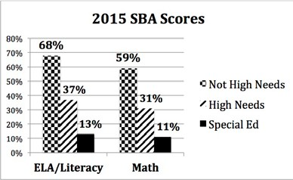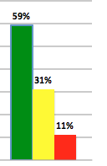

**SBA Scores Disappointing for Special Education Students**

**Smarter Balanced Assessment (SBA)**

Last spring, the majority of students in 3rd through 8th

grade and students in 10th grade took the new Smarter Balanced Assessment-- a statewide test created for the Common Core State Standards. Scores for all student groups were lower than 2014, when Hawaii used a version of the Hawaii State Assessment. That’s

because the SBA had more complex problems and required students to work out answers rather than check off a multiple choice box.

In the graph of SBA scores, we show just how poorly special education students performed against students without needs and the High Needs Group as a whole. We need to point out that

the result -- only about one special education student in ten being proficient in math and literacy

-- is a combined score, and some Hawaii schools (mostly elementary schools) had much higher results. Still the bad news is that students with disabilities are falling further behind in achievement.

**Achievement Gaps**

One of the main concerns that special education advocates in Hawaii have had about Hawaii’s High Needs Group (SPED + ELL

+ Disadvangated students) is that their combined achievement scores in math and reading are higher than special education (SPED) and may mask poor SPED performance.

In the example at the right, the achievement gap between the High Needs Group and students without high needs in math is 28%, but the gap between special education and regular students is 48%. The gap is even higher in ELA/Literacy.

**SBA Math Achievement Gap**

**Reg needs: Hi needs Gap = 28%**

**Reg needs: SpEd**

**Gap = 48%**

*Data taken from a DOE Presentation*

*to the Board of Education’s Student Achievement Committee, Dec. 1, 2015*

**My Choice, My Way** is the

name of the plan that the Med- Quest Division and its partners have put in place to ensure choice and community access. It is targeted to benefit individuals who receive day program and residential living services in the

community that are funded through Medicaid’s Home and Community Based Waivers.

Of our SPIN readers, the forum on Janaury 14th would be helpful to parents of children and young adults with developmental disabilities who may be attending day programs or living in a group

home--now or in the near future.

Medicaid has set a target of 2019 or sooner to guarantee that all individuals receiving their long-

term services and supports have full access to benefits of community living in the most integrated setting appropriate. These benefits include chances to look for work, connect with community activities and control personal finances.

The public forum is offered twice a year to provide a progress report.

*Videoconferencing will be available at select Neighbor Island sites. Check out *News & Events* on [www.Med-quest.us.](http://www.Med-quest.us/)

**PUBLIC FORUM ON MY CHOICE, MY WAY PLAN**

**WHEN: January 14, 2016**

**9:30 - 11:30 a.m.**

**WHERE: Queen’s Conference**

**Center Auditorium 1301 Punchbowl St.\***

3

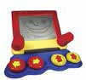

4

**Meet our SPIN Advisors**

Our SPIN Advisory Committee is made up of a group of individuals representing organizations that provide services, supports and advocacy to our disability community. They are responsible for planning the SPIN Conference and advising us on other SPIN activities. Recently, we asked them a few questions, so you might get to know them better. For links to their organizations, visit our webpage at [www.spinhawaii.org/resourceguide.](http://www.spinhawaii.org/resourceguide)

Q: children’s book? *Early Intervention*

What is your favorite **Sheri Umakoshi**

*Services (DOH*

*A:* Caps for Sale

**Esther Puna-Fonoti Waynette Cabral**

*Hawaii Families Developmental Disabilities as Allies Council*

*A:* Caterpillar *A:* I Love You Forever The Very Hungry

Q: What is your favorite **Lila Ota**

adaptive toy? *Children with Special*

*Health Needs Program*

*A:* A Cardboard Box

**Jensen Tabil Pratima Musburger**

*Assistive Technology Project Laulima*

*Resource Center*

The iPad. It can act

*A:* as a switch and so *A:* Lego & Lego Duplo

much more!

Holiday Cheer Santa: Knock, knock.

One night a Viking named Rudolph the Red was Elf: Who’s there?

looking out the window when he said, “It’s going to Santa: Olive. rain.” His wife asked, “How do you know?” Elf: Olive, who?

“Because Rudolph the Red knows rain, dear.” Santa: Olive the other reindeer.

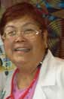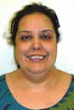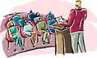

5

Q: What is your favorite thing **Merlene Jose**

about the SPIN Conference? *Shriners Hospital for*

*Children*

So many options

*A:* in one place at one

time.

**Lynn Murakami- Dr. Jeffrey Okamoto Akatsuka** *Developmental Disabilities*

*Community member Division*

The exhibits! Learning something

*A:* I learn so much each *A:* new about a topic I

time I go! thought I knew about.

Q: What is your favorite **Steven Vannatta**

IEP tip? *Children’s*

*Community Council Office*

Prepare and organize

*A:* before the meeting.

**JoAnn Yuen Anthony Akamine**

*UH Center on Community Member*

*Disability Studies*

Dare to dream, dare

Focus on what’s to believe, speak the

*A:* right, not on who’s *A:* truth with love and

right. an open mind.

Q: What is your favorite **Breanna Fetters** online resource? *Learning Disabilities Association of Hawaii*

*A:* The Pacer Center

**Andi Kubota Leolinda Parlin**

*Shriners Hospital for Hilopa’a Family to Family Children Health & Information Center*

*A:* Center for *A:* Healthy Children The National

Independent Living



Spotlight

on Support

The Hilopa‘a Family to Family Health Information

Center provides information and referral, technical assistance and training. The Center is staffed by “veteran” parents of children with special health care needs. They provide free, confidential assistance to families raising children and youth with special health needs, self advocates and the professionals who serve them. Hilopa’a is also the Ombudsman (a public advocate) for the Hawaii State Medicaid system. If you have questions, concerns or need help figuring things

out, contact them for advice, information and navigation. Have you heard of the “Rainbow Book”? It is a medical home resource directory for children and youth with special needs and represents the core of services found in Hawaii. Check out their website for a virtual copy of the book. Hilopa’a also provides webinars, trainings, a developmental screening checklist for families, autism resources and Hawaii’s best high school to adult transition planning book. Hilopa’a is SPIN’s go-to resource for families with special health care needs.

V[isit them online at www.hilopaa.org,](http://www.hilopaa.org/) call 791-3467 or e-mail them at [info@hilopaa.org.](mailto:info@hilopaa.org)

There IS an App for That!

Google defines an app as “a self-contained program or piece of software designed to fulfill a particular purpose.” For students with disabilities, their teachers, therapists and families, apps have become a part of their daily routine, maximizing educational potential and promoting independence like never before. You can find apps designed for specific disabilities like autism, hearing loss, low vision and dyslexia or apps to fill a specific need like visual schedules and timers, gaining new math skills or communication support like speech to text. Today’s students are growing up digital - they live and breath technology. Apps give them the opportunity to

support and strengthen their needs, add modifications to their learning environment and lets them access the world around them. It can level the playing field for many of our students. Be sure to check out “The App Corner” on the SPIN website, for new weekly app links for both Apple and Android systems [www.spinhawaii.org/the-app-corner/.](http://www.spinhawaii.org/the-app-corner/)

Got Questions? Ask SPIN

We get many calls and e-mails at SPIN from parents and professionals seeking answers, advice, resources and information. We do our best to provide answers, and if we don’t know, we do some research or refer to places and people who might have those answers. Here is a question that came in from our Special Parent Information Network this past month:

Q: We have had many meetings with the school. Things are getting very tense, and I still don’t feel like my child is receiving

the supports and services they need from the school. What do I do?

A: There are many layers of answers to this question. First we would suggest trying to work it out at the school level. We

recommend [www.wrightslaw.org](http://www.wrightslaw.org/) to learn more about IDEA, what appropriate services are and how to advocate for them. Remember to use kind language, even if you’re feeling far from kind. Inflammatory words and blaming others only puts everyone in a defensive mood. Then we ask the parent if they have worked their way up the local DOE chain? Have they spoken with the principal, the DES and then the CAS to help find solutions and solve the issue. If communication is still breaking down, it might be time to call the Mediation Center of the Pacific (521-6767). Both the parents and the school must agree to mediation, but it can be a valuable tool to be heard by a neutral party. If things are still challenging, then we recommend calling either the Learning Disabilities Association of Hawaii (536-9684) or the Hawaii Disability Rights Center (949-2922) for advice, advocacy and next steps.

6

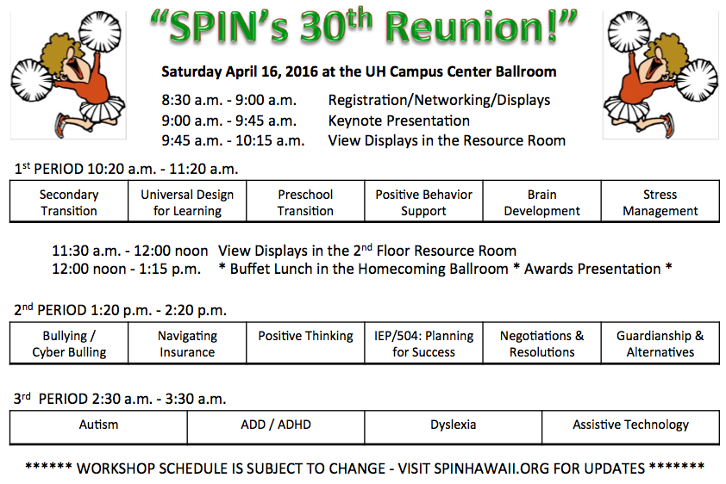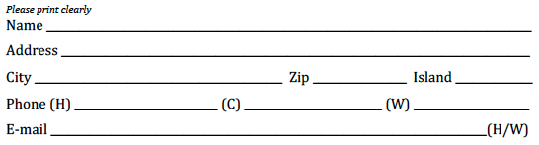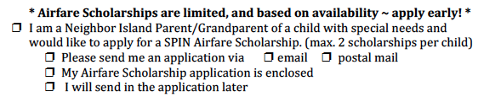

**Registration Form**

7



***Special Parent Information Network***

*919 Ala Moana Blvd., Room 101*

*Honolulu, Hawaii 96814*

***Providing a world of support to parents of children with special needs***

**Return Service Requested**

**Winter Calendar**

**of Events**

**1/2**

**2/6**

**Access Surf Day at the Beach**

White Plains, Ewa Beach from 9:00 am - 1:00 pm. FREE surfing event, for all ages and abilities. Sign up @ online accessurf.org

**1/8**

**2/12**

**SEAC** - **Special Education Advisory**

**Committee Meeting** 9:00 am - 12:00 pm Oahu; 919 Ala Moana Blvd. 5th floor, 586-8126.

**1/30**

**2/27**

**Hawaii Theater for Youth**

ASL & sensory-friendly performances Mud Pies & Magic @ 2:00 pm for ages 5+ The Tiny Tree @ 11:30 am for ages 3+ htyweb.org or 839-9885.

**Theresa Willkomm Make & Take Workshops**

Kamuela, Hawaii 9:00 am - 3:30 pm Honolulu, Oahu 9:00 am - 3:30 pm

$75 includes breakfast and materials.

$50 Parent rate. Velina Sugiyama 956-5688.

**SAVE THE DATE!**

**30th Annual SPIN Conference**

8:30 am - 4:00 pm at UH Campus Center Registration forms and airfare scholarships available [www.spinhawaii.org](http://www.spinhawaii.org/) or call us at 586-8126.

**4/16**

**1/12**

**1/14**

**4/25**

**4/26**

**32nd Annual Pac Rim Conference**

Hawaii Convention Center. For info, contact [www.pacrim.hawaii.edu](http://www.pacrim.hawaii.edu/)

Happy Holidays and a very Happy New Year

from the SPIN Advisory Panel

Presorted Standard

U.S. Postage PAID

Permit No. 1280 Honolulu, Hawaii