

**DON’T MISS SPIN’S 30TH CONFERENCE!**

In her book *Families*, author Jane you’ll make new friends.

Howard said, “Call it a clan, call it

a network, call it a family. Whatever **Awards**

you call it, whoever you are, you Lunchtime will be our opportunity to need one.” That sums up SPIN’s give out awards to deserving parents motivation to put on our conference and professionals. Please consider each Spring. We want families of nominating your heroes (see page 5).

children and young adults to know that **Family Stories**

they are not alone, and that despite the Our morning presentation will struggles around raising a child with reconnect you to some of our best

a disability, there’s a lot to celebrate, SPIN stories over the last 3 decades. too!

This year there’s **Ono Food**

even more to celebrate The Campus Center

on **Saturday, April** is known for its tasty

**16th** at the University of lunches.

Hawaii Manoa Campus **Favors**

Center--it’s “**SPIN’s** There will be

**30th Reunion!”** And lots of prizes,

like the cartoon says, including goodies

it won’t be the same for every guest.

without you, so we hope

you’ll consider attending. So don’t be shy. Check out our SPIN believes strongly in building conference program on page 7 and

partnerships between school and make plans to join us. We still have home, so you’ll find elements of both a few airfare scholarships for our class reunions and family reunions at Neighbor Island ohana.

the conference. . .

**+**

**Catching up on the News**

We have 16 different workshop topics to keep you up-to date on the latest evidence-based information. There will also be over 50 agency displays on the 2nd Floor to help you find the right support.

**Finding Old (and New) Classmates** If this is not your first conference, we bet you’ll run into familiar folks to network with, and if this is your first,

**February 2016**

**Volume XXXII, No. 3**

**SPIN** is co-sponsored by the Disability & Communication Access Board and the Department of Education.

Services include a phone line for information referral and support, a quarterly newsletter, an annual conference and community workshops. SPIN is guided by an Advisory Committee made up of parents, teachers and people with disabilities.

**SPIN**

919 Ala Moana Blvd., # 101

Honolulu, Hawaii 96814

PHONE

**586-8126**

Neighbor Islands dial the ex- change below, then 6-8126

Kauai - **274-3141**

Hawai’i - **974-4000**

Maui - **984-2400**

Molokai - **1-800-468-4644**

Lanai - **1-800-468-4644**

FAX

586-8129

E-MAIL

[spin@doh.hawaii.gov](mailto:spin@doh.hawaii.gov)

WEB

[www.spinhawaii.org](http://www.spinhawaii.org/)

Like us on Facebook

**WHAT’S INSIDE**

ABLE Act Update 2

Tax Deductions 2

Ask SPIN 3

Pacific Rim Conference 4

Contests for Kids 4

SPIN Award Nominations 5

Family-School Partnership 5 Spotlight on ATRC 6

APP Corner 6

SPIN Conference Schedule and Registration Form 7

Calendar of Events 8

It won’t be the same without U.



**ABLE Act Update**

It’s now been 14 months since the passage of the **Achieving a Better Life Experience (ABLE) Act**, and families of children and adults with disabilities are still waiting for an opportunity

to set up a tax-free savings account much like existing 529 college savings programs. These ABLE accounts will allow folks to save up to

$14,000 a year without affecting public benefits. Up to now, parents have had to take care that their child has no more than $2,000 at any time or risk losing needed SSI and Medicaid coverage. Once ABLE Accounts are

up and running, families and individuals can have up to $100,000 in total savings to help pay for certain education and health related expenses.

Hawaii and 33 other states have passed laws to set up ABLE programs for their residents, but as of today, no accounts have been opened. Folks who will administer these programs are waiting for final regulations from the Internal Revenue Service.

A new development in December may speed up the availability of ABLE accounts. Congress included a provision in its tax bill (the

Consolidated Appropriations Act) that allows folks to establish an ABLE account in any state. This will permit families to shop around for the best options once state programs are up and running. Some bigger states, like Virginia, Florida and Ohio, appear ready to open their programs in the next month or so. If you would like to be notified of new developments, call or email SPIN. For more information on the ABLE Act, go to: https:// parentingspecialneeds.org/article/new-savings-accounts-may-fund-care/.

**LAST MINUTE**

**TAX DEDUCTIONS**

Families of children with disabilities often have greater expenses than other families. Luckily some of these expenses are tax deductible. If you are still working on your taxes, think about whether you

have some of the expenses below.

4 Therapy received as a medical treatment, for example, speech therapy or physical therapy

4 Special diets such as gluten- free or ketogenic diets. You

can deduct the amount over and above what a regular diet would cost.

4 Gas mileage for medical visits--currently 23¢ a

mile

**COMPARISON OF ABLE ACCT. & SPECIAL NEEDS TRUST**

4 Equipment, devices and supplies to treat a medical condition

4 Tutoring by a trained tutor. Your child’s doctor will need to certify that these services are necessary.

The Internal Revenue Service

(IRS) has a fact sheet about available credits, benefits and deductions for families of children with disabilities at [https://www.irs.gov/pub/irs-pdf/](http://www.irs.gov/pub/irs-pdf/) p3966.pdf.

2

**ABLE Account**

**Special Needs Trust**

Eligibility

Same as SSI; disability must have occured before age 26

Under age 65

Expense

$ - administrative fees

$$ - attorney’s fees

Spending Restrictions

For qualified disability expenses ONLY (education, transportation, assistive technology, health care, personal support, etc)

Same as ABLE plus travel, entertainment, other items to supplement the individual’s quality of life

Funding Limits

$14,000 per year; up to

$100,000 in assets without affecting SSI

No limits

Medicaid Payback

If funds remain in account after the beneficiary dies,

it may be required to repay Medicaid

No payback required if trust was set up by family

Control Over Spending

By individual with a disability or his/her representative

By a Trustee

# of Accounts Allowed

One per individual

No limits

Tax on Earnings

No

Yes



Got Questions? Ask SPIN

In our December SPIN News **Ask SPIN** column we offered some suggestions to a parent who was frustrated over a lack of productive communication with her child’s school, resulting in a lack of appropriate support for her child. Here’s what we recommended:

1) Working up the “Chain of Command”-- starting with the classroom teacher and then with the principal, if there is still an issue, before contacting the District Education Specialist or the Complex Area Superintendent;

2)

3)

4)

5)

Educating yourself about your rights, as well as strategies to use in the IEP process;

Keeping “cool” in meetings with school staff (curb your emotions, be polite, avoid blaming others); Considering mediation through the Mediation Center of Hawaii; and

Calling the Learning Disabilities Association and/or the Hawaii Disability Rights Center for advice and

advocacy.

SPIN’s intent was to focus on early intervention--fixing the disagreement before it resulted in a written complaint or due process hearing request. Our column resulted in three helpful comments from other agencies and individuals providing support and information to families, so we wanted to share their insights below:

**DOE Complaints**

**Management Program**

(808) 586-5374

**Art Cernosia, esq.**

**Vermont Attorney and Education Consultant** [acernosia@gmail.com](mailto:acernosia@gmail.com)

**The Learning**

**Disabilities Association of Hawaii**

(808) 536-9684

*“The list below is the actual order*

*of interventions we support as the Parent Training and Information Center (PTI), based on level and intensity of intervention:*

The Complaints Management

Program (CMP) receives and investigates written complaints from families and other individuals who believe that a violation of a student’s rights under IDEA has occurred around identification, evaluation, placement or the provision of a free appropriate public education (FAPE). The CMP Educational Specialist

also wants families to know that her office is available to answer questions, help them understand their rights and receive a second opinion, if needed. Families can also make a phone complaint--

a less formal option than a written complaint--and a quick and effective way to resolve a disagreement. The CMP acts as a bridge to improve communication between parents and school. She helps clarify legal requirements,

and when a school has not followed regulations, she helps monitor progress toward a solution.

At his annual workshop at the

Learning Disabilities Association Mr. Cernosia added to parents’ understanding of IDEA with a legal update that he also uses to train audiences, including hearing officers. Despite the fact that this

update contains a lot of information about due process, he says *“My goal is to never get there [to due process]. Using the law, not as a threat, but as a tool to advocate*

*for your child. At times we need to be reminded of what the law says to empower parents to ask*

*questions, to be respectful.”* Later, in discussing the options parents have for resolving conflicts, Mr.

Cernosia observed *“mediation is not used in Hawaii to the extent it should be... It is less adversarial and it preserves the relationship. If you reach an impasse, I would highly recommend that you ask the school for mediation.”* For a copy of Mr. Cernosia’s remarks, go to: [http://goo.gl/gvtIRa.](http://goo.gl/gvtIRa)

*1.*

*Work it out with the school,*

*no other support, etc.*

*2.*

*Work with the principal,*

*DES, CAS.*

*3.*

*In conjunction with number*

*2, call LDAH for assessment*

*of need, training, technical assistance (including referral to law websites and other resources), and if it’s a really difficult case, advocacy.*

*4.*

*It is rare LDAH cannot settle*

*conflicts, but if we can’t, then we*

*refer to the Mediation Center. We stay with the family while they enter into mediation.*

*5.*

*Where mediation and*

*advocacy does not seem to work,*

*then we support the family in creating a state complaint or filing for due process.”*

3

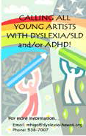

Pacific Rim International Conference on Disability and Diversity April 25-26, 2016

The theme of the 32nd annual Pac The topic of “Innovation” will tackle

Rim Conference will be “From the the conference theme and explore the

Margins to the Center.” They will journey from exclusion to inclusion. be showcasing 2 days of workshops

and keynote speakers that will Look for cinematic entertainment and

explore answers to the question of enlightenment at the Mini Film

“how do we innovate to bring Festival. Each year Pac Rim offers a

more people from the margins of variety of national and international

society into the center where they films embracing disability and

can live to their full potential?” diversity. Check out the website for a complete listing of film of[ferings this year: www.](http://www/)

With international, national and local speakers taking pacrim.hawiai.edu/events/film-festival. on the theme and leading discussions, this year is

gearing up to be great. There are three main topic Pacific Rim has a very limited number of

areas that will spawn a wide variety of workshops. scholarships available for parents and caregivers who Under the topic of “Foundation” you will find have a child with a disability. They will be offered on sessions on inclusion, advocacy, quality of life, a first come, first served basis only and will include education and childhood development. The admission to keynotes, workshops, the film “Exploration” topic will focus on health, diversity, festival for both days, and lunch on Monday. If you resiliency, disability laws and rights. are interested, call SPIN at 586-8126. The deadline

to apply is March 14th. Hurry and call us today!

Calling Young Artists Contests & Enrichment

The Hawaii Branch of the The Hawaii Department of International Dyslexia Education’s website has a Association is looking for local hidden gem of information artists in grades 3-12 to submit an for parents and students art piece or bookmark by March called “Contests and

15, 2016. Email Margaret Hida, Enrichment.” It is a current [mhiga@dyslexia-hawaii.org](mailto:mhiga@dyslexia-hawaii.org) or listing of contests and

call 538-7007 for the bookmark programs and their deadlines

template and artwork release that are available to students in varying form. grade levels. From Doodle for Google, to

scholarships and grants, to writing, art and video contests, there is something that is sure to tickle the competition bug in many kids. You can find the listing by going to the DOE website at [www.](http://www/) hawaiipublicschools.org, click on the Parents & Students tab, then the Contests and Enrichment block. Use the drop-down menu to choose the dates (use “within a year” to see the complete listing) and press “Go”. The full web link is [www.](http://www/) hawaiipublicschools.org/parentsandstudents/ contests/pages/home.

4



**2016 SPIN Awards Needs Your Nominations!**

Every year, SPIN publicly celebrates key parents and professionals whose efforts make a positive difference in the lives of our keiki with disabilities and their families. The SPIN Advisory Committee is looking for candidates for our 2016 SPIN Awards and we need your help in nominating someone who models the qualities and actions that families appreciate and rely on. There are three award categories:

* The **Parent of the Year Award** is given to a parent of a child or young adult with a disability whose actions and advocacy have benefited other families.
* The **Professional of the Year Award** is given to a professional who has had a significant impact in improving services for children and or youth with a disability and their families.
* The **Family Choice Award** is given to a professional who has been particularly helpful to families as they sort out services for their child with a disability. This individual may not have an impact on the larger system, but is recognized in his or her community as an extraordinary professional.

We encourage you to share your aloha and nominate one or more very special people for any or all of the awards. You can go to our website at [www.](http://www/) spinhawaii.org, click on the conference tab and download a nomination form. Or call us at 586-8126 and we’ll mail you a form. Deadline to apply is March 15th.

Family-School Partnerships are Now School Policy

The Board of Education’s passage of its policy on **Standard 3**: Supporting student

**Family and Community Engagement/Partnership** success—Families and school staff

(Policy 101.14) last June was a shared victory. The continuously partner to support

Special Education Advisory Council, the Coalition on students’ learning and healthy

Children with Special Needs, the Hui for Excellence development both at home and at in Education, and a number of other organizations school, and have regular opportunities to strengthen had spent several years encouraging policymakers their knowledge and skills to do so effectively.

to revise an existing policy on family engagement **Standard 4**: Speaking up for every

to include the National PTA’s Standards for Family- child—Families are empowered to

School Partnerships. be advocates for their own and other The National PTA had developed these standards children, to ensure that students are

in 2007 to shift the focus from what schools should treated fairly and have access to do to involve parents to what parents, schools, and learning opportunities that will support their success. communities can do together to support student **Standard 5**: Sharing power—

success. These standards are based on evidence-based Families and school staff are equal

practices and have been adopted by numerous states partners in decisions that affect

and cities. children and families and together

**Standard 1**: Welcoming all families inform, influence, and create policies, into the school community— practices, and programs.

Families are active participants **Standard 6**: Engaging/partnering

in the life of the school and feel with community—Families and

welcomed, valued, and connected school staff engage/partner with

to each other, to school staff, and to what students are community members to connect

learning and doing in class. students, families, and staff to **Standard 2**: Communicating expanded learning opportunities, effectively—Families and school community services, and civic participation.

staff engage in regular two-way, For a copy of the Board Policy on **Family and** meaningful communication about **Community Engagement/Partnership** go to [www.](http://www/) student learning. hawaiiboe.net/Docs/101/101.14%20(2015-06-16).pdf

5

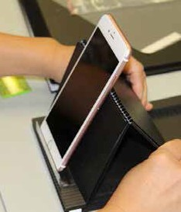

Spotlight

on Support

The Assistive Technology Resource Centers of Hawaii is

a nonprofit organization that links people of all ages and needs with technology. ATRC is an education center and does not sell assistive technology (AT) products, though they do recommend vendors if you request it. A sampling of the many services they offer statewide are:

While searching for a new app to showcase in the

App Corner, on the SPIN website, we came across a little gem that can be used by parents and teachers alike and kids across the board seem to love it! It’s called Go Noodle and it’s a free website with a lot of interactive games and videos that can help kids focus, provide a transition between subjects or just

help them get the sillies out. With over 100 activities to choose from, ranging from calm, moderate to vigorous activity, Go Noodle can help kids manage their energy in a fun and easy way. Teachers can use it to start the day with a morning stretch, have some mindful meditation before a test and have a dance party at the end of the day. Parents can use it at home to do a bit of yoga before homework begins, sing a song between math and English worksheets and do some kinesthetic learning to clear the brain after a long day at school. And for indoor recess and rainy days at home, there are 10-15 minute videos designed to get kids moving and grooving and laughing. Sign up for free at [www.gonoodle.com.](http://www.gonoodle.com/)

•

Device Demonstrations: make an appointment to

check out different types of AT that may help you. Device Lending Program: borrow AT to “try before you buy” or while your AT is being repaired.

Computer Redistribution Program: you can apply for a refurbished computer, monitor, printer or keyboard, if you do not have access to one.

AT Exchange Program: trade or donate AT to help others. Donated items must be in good condition. Training and Technical Assistance: fee-based classes for computer literacy, using social media and more. Public Awareness Programs: ATRC can come to your event/school/program to showcase AT.

•

•

•

•

•

For more information, visit them on the web at [www.](http://www/)

atrc.org, like their Facebook page or call 808-532-7110.

**Make-n-Take Workshops Inspire Creativity**

Therese Willkomm, an assistive

technology guru, came back to Hawaii for two make-n-take workshops on both Hawaii island and Oahu in January. Participants made and took home 10 different projects, including a SPIN favorite, the Eileen - a simple, portable, adjustable iPad holder, smart phone holder and document holder. Like most of Therese’s devices, it’s made with easy to find objects like old campaign signs, corner guards from the hardware store, sticky tape and velcro.

If you missed the workshops, or

want ideas to create your own assistive technology solutions, check out the University of New Hampshire’s YouTube page, [www.](http://www/) youtube.com/user/ATinNH. You will find step by step videos on low tech solutions to fit nearly every need. SPIN would like to send a special shout-out to the Hawaii and Pacific Deaf Blind Project, Easter Seals Hawaii and Assistive Technology Resource Centers of Hawaii for sponsoring these workshops. Mahalo!

6

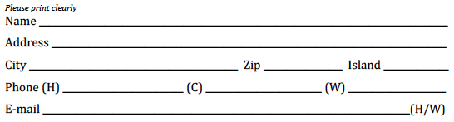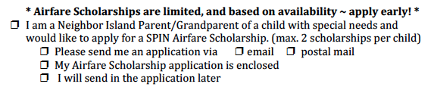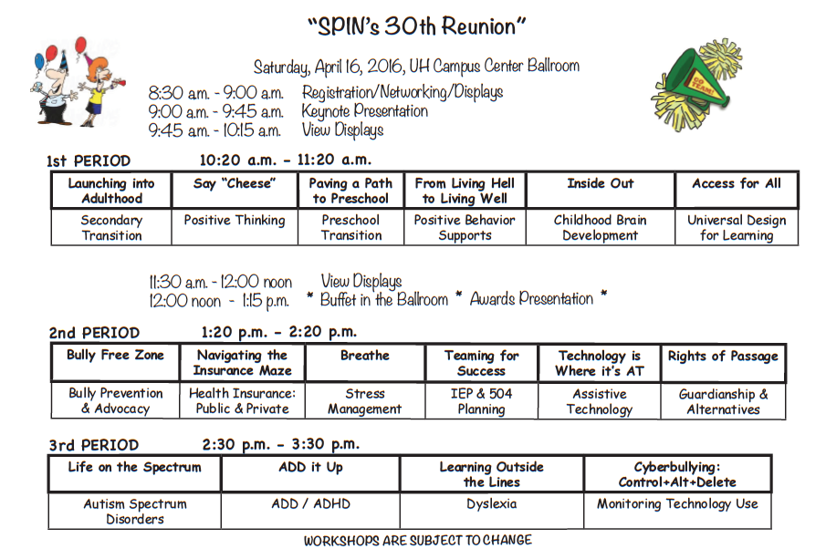

**Registration Form**

Child’s age: Disability:

7



***Special Parent Information Network***

*919 Ala Moana Blvd., Room 101*

*Honolulu, Hawaii 96814*

***Providing a world of support to parents of children with special needs***

**Return Service Requested**

**Spring Calendar**

**3/25**

**Access Surf Day at the Beach**

White Plains, Ewa Beach from 9:00 am - 1:00 pm. FREE surfing event, for all ages and abilities. Sign up online @ accessurf.org

**of Events**

**Easter Seals Backyard Movie and Sleepover** 7:00 - 9:00 pm $15 includes snack & breakfast. 710 Green St. Honolulu. RSVP 529-1726 or [eaiwohi@eastersealshawaii.org](mailto:eaiwohi@eastersealshawaii.org)

**3/5**

**4/2**

**5/7**

**3/26**

**TACA: IEP Workshop**

10:00 am-12:00 pm Aliamanu Community Center, 101 Kauhini Rd., Honolulu RSVP [www.tacanow.org/local-chapters/west/hawaii](http://www.tacanow.org/local-chapters/west/hawaii)

**My Journey Autism Awareness Event Hilo** 4:00 - 6:00 pm UH Hilo Campus Center Plaza Sharing stories of autism. Pre-registration required: 238-6280 or [anaya@hawaii.edu](mailto:anaya@hawaii.edu)

**SAVE THE DATE!**

**30th Annual SPIN Conference**

8:30 am - 4:00 pm at UH Campus Center Registration forms and airfare scholarships available [www.spinhawaii.org,](http://www.spinhawaii.org/) call us at 586-8126 or email [spin@doh.hawaii.gov](mailto:spin@doh.hawaii.gov)

**32nd Annual Pac Rim Conference**

Hawaii Convention Center. For info, contact [www.pacrim.hawaii.edu](http://www.pacrim.hawaii.edu/)

**3/12**

**4/8**

**SEAC** - **Special Education Advisory**

**Committee Meeting** 9:00 am - 12:00 pm Oahu; 919 Ala Moana Blvd. 5th floor, 586-8126. [www.seac-hawaii.org](http://www.seac-hawaii.org/)

**Easter Seals Bunny Breakfast & Egg Hunt**

9:00-11:30 am, Central Union Church 1660 S. Beretania St. Honolulu

$12 general, $8 kids 3-12, free kids 02 RSVP: 529-1727 or easterseals.com/hawaii

**Hands & Voices Hawaii Ice Cream Social** 10:00 am - 12:00 noon Comprehensive Services Center. 1953 S. Beretania St.

For families with deaf/hard of hearing and deaf/blind children, and community

members. RSVP on H &V Hawaii facebook.

**4/9**

**3/12**

**4/16**

**3/12**

**4/25**

**4/26**

Presorted Standard

U.S. Postage PAID

Permit No. 1280 Honolulu, Hawaii