

**Reclaiming Your Super Powers**

The beginning of a new school your body caused by the extra amounts year is stressful for most families. of energy you expend in parenting a

There are clothes and supplies to child with a disability. This physical buy, new teachers to meet, new bus stress may cause you to have an schedules to juggle. These pressures unhealthy diet, lack of time to exercise get piled onto the everyday stress that and too little sleep.

parents of children with disabilities SO. . . now that we have identified experience. all of the pressures on parents of kids A number of studies have with disabilities, what can we do to shown that parents of children with make our lives less stressful and more

disabilities are more enjoyable?

likely to experience c Start by checking out

major disruptions your potential sources of

in their family life-- support on page 5.

hospitalizations, marital c Plan to join us on April distress, extra expenses

that strain the budget-- 22, 2017 as we celebrate

and a greater number of another SPIN Conference, daily problems or worries, compared entitled most appropriately,

to parents of typically developing **“Superheroes of SPIN.”**

children. These daily stresses c Look through the stress include things like challenging bed- management ideas found at https:// time routines, homework hassles, [www.verywell.com/parent-disability-](http://www.verywell.com/parent-disability-) medication management, and frequent stress- tips-2162645.

doctor or therapy appointments. c Find something funny to watch The stresses above are considered on TV or in the movie theater.

***external stressors***--they result from c Try to learn and practice yoga or the situation and often involve our mindfulness.

relationships with others. Two

other types of stress affect parents of c Stop and smell the plumeria!

children with disabilities or medical conditions--***internal*** and ***physiological stress***.

***Internal stress*** comes from a parent’s own personal expectations and attitudes. For example, when your child doesn’t make an expected milestone on time (like learning to walk or learning to read) you may feel guilt, frustration, sadness or worry about the future.

***Physiological stress*** is the stress on

**WHAT’S INSIDE**

SEAC and LBC 2-3

Voting Supports 2016 4

Finding Family Support 5

Footsteps to Transition 6

Fall Fun Things 7

Project Laulima 7

Ask SPIN 7

Calendar of Events 8

**September 2016**

**Volume XXXIII, No. 1**

**SPIN** is co-sponsored by the Disability & Communication Access Board and the Department of Education.

Services include a phone line for information referral and support, a quarterly newsletter, an annual conference and community workshops. SPIN is guided by an Advisory Committee made up of parents, teachers and people with disabilities.

**SPIN**

919 Ala Moana Blvd., # 101

Honolulu, Hawaii 96814

PHONE

**586-8126**

Neighbor Islands dial the ex- change below, then 6-8126

Kauai - **274-3141**

Hawai’i - **974-4000**

Maui - **984-2400**

Molokai - **1-800-468-4644**

Lanai - **1-800-468-4644**

FAX

586-8129

E-MAIL

[spin@doh.hawaii.gov](mailto:spin@doh.hawaii.gov)

WEB

[www.spinhawaii.org](http://www.spinhawaii.org/)

Like us on Facebook

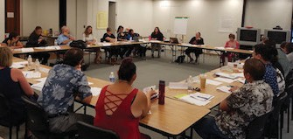

T

**Leading by Convening**

This school year, the leadership in the Department of Education has agreed to partner with SEAC in using the **Leading by Convening** process to help solve complex issues related to special education. Leading by Convening (LBC), also referred to as “the Partnership

Way,” is a tool, developed by **IDEA Partnership,** that can be used to positively change practice around the delivery of special education services.

LBC has three main habits that must be developed for successful interactions:

u **Coalescing around issues**: having groups of people come together around shared concerns or problems of practice that they want to fix;

u **Ensuring relevant participation**: participants show a willingness to do the work necessary by responding to the

invitation and doing the preparation necessary to move forward; and

u **Doing the work together**: valuing diversity, modeling respect, practicing shared leadership and encouraging personal investment in the work.

You can find more about LBC on this website: http://www.nasdse. org/publications-t577/leading-by- convening.aspx.

he **Special Education**

commenting on rules and

policies regarding the education of students with disabilities,

**Advisory Council,** or

**SEAC** (pronounced *see-ack*),

is Hawaii’s state advisory panel under Part B of the Individuals with Disabilities Education Act. Congress intentionally created the requirement for these panels to be made up of a majority of parents of children with disabilities and persons with disabilities to ensure that their voices be heard by the Superintendent and others in the Department of Education when

addressing policies or programs for students with disabilities.

SEAC’s 27 members also include teachers, administrators,

reviewing and commenting

on special education due process hearing decisions,

participating in the Annual

Performance Report process, and

reviewing and supporting the

DOE’s budget and legislation related to students with disabilities.

department reps and community

folks. All have been appointed by the Superintendent and serve

without pay. SEAC’s most common responsibilities include:

SEAC also prepares an annual

report each June that includes specific recommendations to the Superintendent. It can be found, along with meeting agendas and minutes, and past testimonies on SEAC’s website:

[www.seac-hawaii.org.](http://www.seac-hawaii.org/)

advising on the unmet needs

of children with disabilities,

2

**The Special Education Advisory Council (SEAC) . . .**

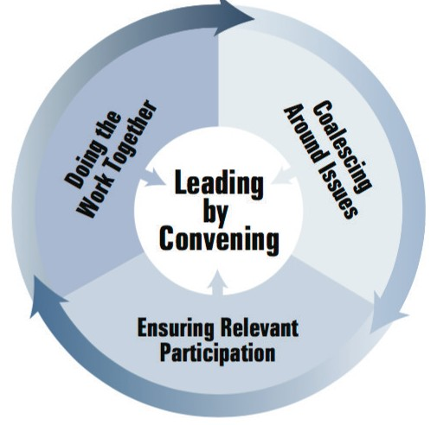

**Options for Engaging**

**Engaging Everybody**

u

1. Attend a SEAC meeting as a guest (see our website below for meeting dates).

Families

Advisors

u

2. Click on the **Leading by Convening** menu tab on SEAC’s website. We’ll be posting information and surveys as we discuss key information. [www.seac-hawaii.org.](http://www.seac-hawaii.org/)

Experts

u

3. Email us with your input or for more information : [seac.hawaii@gmail.com.](mailto:seac.hawaii@gmail.com)

Educators

u

4. Call and talk to SEAC staff @ 808-586-8126.

3

**4. STUDENT ASSESSMENTS**

* time spent on assessments
* authentic assessments
* testing accommodations
* alternatives to Smarter Balanced
* opt out of testing

**3. PROFESSIONAL DEVELOPMENT**

* induction and mentoring
* when/ how to provide training
* training for principals
* role of DESs in training

**2. INCLUSIVE EDUCATION/LRE**

* defining inclusion
* co-teaching
* serving more students in gen ed
* related services in inclusive settings
* lack of preschool inclusive options

**1. STAFFING SHORTAGES**

* staffing allocation methodologies
* recruitment of special ed staff
* retention issues
* use of contracted personnel

**FOUR BIG ISSUES HAVE BEEN IDENTIFIED FOR PROBLEM-SOLVING IN SY 16-17**

It’s a two-way communication loop: SEAC needs to hear your experiences with these issues AND your feedback on possible solutions

& recommendations suggested through discussions at SEAC meetings.

**. . . invites you to join Leading By Convening**

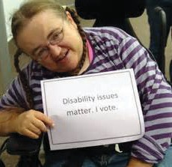

*Nobody will ever deprive the American people*

*of the right to vote except the American people themselves, and the only way they can do this is by not voting.*

*-- Franklin D. Roosevelt*

all-day

Voter registration deadline

**10**

Ocycle, a number of folks have gotten discouraged with the voting

ver the last decade, and especially during this long presidential election

all-day

Early walk-in locations open

process. That’s why we’re taking a minute in the SPIN Newsletter to give

you a little pep talk. We want to remind you that most of the legislative protections our children with disabilities enjoy--the Individuals with Disabilities Education Act and the Americans with Disabilities Act to name just two--came about from families of folks with disabilities advocating at a grass roots level, and then turning out at the voting booth. Families voting for their local legislators and council members help determine whether

or not there is enough funding for education, health care, a social service safety net and accessible transportation.

With all of these reasons to vote, there’s one that tops them all: you are setting a good example to your children that you take seriously your

**25**

4:30 pm

Deadline to request mail-in ballot

all-day

Early walk-in voting ends

**1**

**5**

duty as a citizen of this great country and beautiful state.

TALK STORY WITH YOUR ISLAND LEGISLATORS

The **Hawaii State Council on Developmental Disabilities** has a long tradition of helping to facilitate legislative forums on Neighbor Islands. The purpose of the forums is to educate state and county officials on disability issues and to hear from candidates for state and county offices about their positions on issues important to individuals with disabilities and their families. Some of the most popular themes of past forums have been employment, housing and anti-bullying efforts. Of course, adequate funding for education is another important issue.

The DD Council is planning four forums in the month of October:

**ELECTION DAY**

**Go vote!**

Oct. 5

Oct. 6

Oct. 12

Oct. 18

Molokai Talk Story

Hilo Legislative Forum Maui Legislative Forum Kauai Legislative Forum

(West Hawaii held their forum on September 9th). For more information

about times and locations, call or email Daintry Bartoldus-- 808-586-8100 or [daintry.bartoldus@doh.hawaii.gov.](mailto:daintry.bartoldus@doh.hawaii.gov)

ACCESSIBILITY AT HAWAII POLLING STATIONS

Here are some of the accessibility features for voting:

Every election is

determined by the folks that show up!

√

√

Curbside voting

Direct Recording Electronic Voting Machines

Language access

√

Sign language interpreters (request 5 days in advance)

Magnifiers and signature guides

√

√

For more info, call the **Office of Elections** @ (808) 453-VOTE (8683)

or Neighbor Island Toll-Free: 1 (800) 442-VOTE (8683).

4

**NOV**

**8**

**NOV**

**NOV**

**OCT**

**OCT**

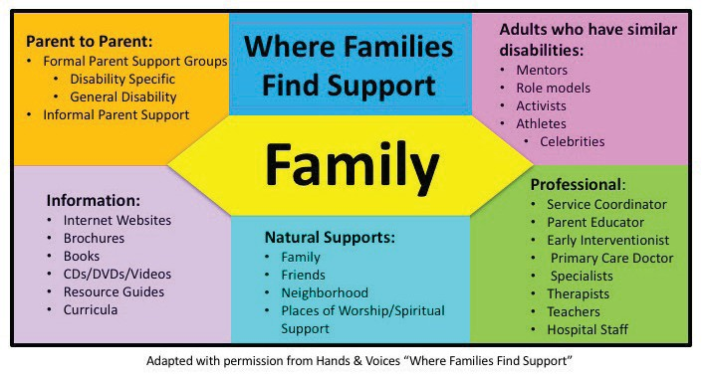

5

Often, when we hear the term “Parent Support” we think **Parent to Parent:**

of a formal meeting, held monthly, at a non-profit • Formal support groups are very helpful to connect meeting room. But support comes in many forms and families whose children have the same or simi- how families access it and use it is as individual and lar diagnosis or needs. Discussions about doctors, diverse as our children. therapies, school services, insurance, going to the

store and finding peace at home can happen in group Time and again, parents need the most support right after meetings, outings, picnics and other events.

they discover their child is more “special” than they • Informal support is usually outside of those formal expected. Other high-need support events are before a meeting groups: school hallways, doctors offices, change in care (medications, surgical procedures, parent partners, and yes, SPIN. :)

therapy) or before IEP meetings. There are so many **Information:**

questions, worries, fears and unknowns, and parents are • Be careful what you look for. Google can be both starving for answers and hope. Many times those answers a blessing and a curse. Trust in known sites and be come from Google and are not always the most helpful wary of anyone who offers a cure or quick fix.

or insightful. The Internet cannot tell you it’s going to be **Natural Supports:**

alright or that you are doing a great job. • Surround yourself with friends and family who can

support you when you need it. Don’t be afraid to At SPIN, we are parents talking to parents. We can help reach out and ask for help, whether it’s an hour of

you find a name and number, an organization, or agency kid-free grocery shopping or a play date with cousins to call for more help. We talk story to parents who may at the park.

feel they have no one to turn to. **Professional/Community:**

Sometimes it’s a quick call and a •This is where most of us get our

shared phone number, or request first taste of supports and advice.

to be added to the newsletter or Professionals are connected to

e-blast list. Other times it’s 45 other support networks in your

minutes of listening and reassur- local and global community.

ance. Explaining next steps and **Adults with Disabilities:**

empowering families to believe •Adult mentors can provide hope

in themselves and their role as for a brighter future and give kids

their child’s best advocate. Here and their parents insights, tips and

are other ways that families real-life advice on going to school,

may find the supports they need finding a job they love and living a

around them: full, happy life with a disability.

My friends & family are my

*Support System*

**They tell me what I NEED to hear, not what I want to hear.** They are there for me in the bad times and good. **Without them I have no idea**

**where I would be.** And I know that their love for me is what’s keeping my head above the water.

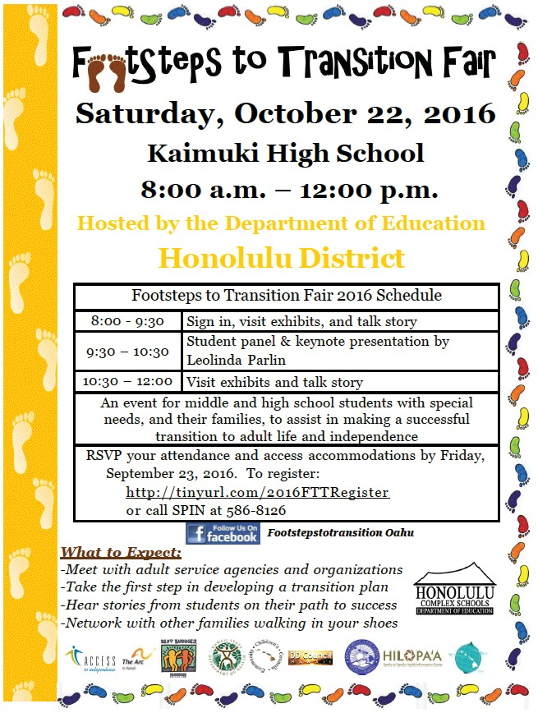

6

Transition to Success

Please join us at the

“Footsteps to Transition Fair,” hosted by the Department of Education, Honolulu District! This FREE event is geared towards middle and high school students with

special needs, their families, case managers, therapists, teachers, and anyone else

in their circle of support. It’s not too early to start planning and preparing for life after high school. As you transition to post-

graduation and adulthood, it can be a challenge to make the many decisions about life after high school. Will you go to college, get a job, and/or move into your own place? Who do you turn to if you need help with your finances, or need to see a doctor, or want to make new friends? Will your parents continue to make decisions for you, or will you be responsible for your own choices? How do parents access services for their adult child? All of these

questions can be answered at the upcoming “Footsteps to Transition Fair” hosted by the Department of Educa- tion in partnership with various community agencies. Knowledgeable guest speaker, Leolinda Parlin of Hilopa‘a Family to Family Health Information Center, will explain the transition process in easy to understand steps. A student panel will share their own experiences of the transition process. A variety of State and private agencies will come together under one roof to provide information about their services for students with special needs after high school. This is a great opportunity to meet and network with other students and families to build and add to your support system. There will be door prizes and free light refreshments to enjoy.

We look forward to seeing you there! Call SPIN at 586-8126 to register, or go online at the website listed above.



7

Spotlight

on Support

Project Laulima is a grant funded program

that is focused on meeting the needs of children

and youth with a mental health diagnosis and cognitive

10 Things to Fall For abilities within a range of 55-85 IQ range. They have 3 Fall is in the air. With changing weather patterns, primary roles to serve our community:

holidays approaching and hurricane season in full 1. Project Laulima has contracted with Hawaii swing, there are lots of fun things to do to make the Behavioral Health to provide statewide

most of the season. Comprehensive Behavioral Intervention (CBI) for

1. Go pumpkin picking at Aloun Farms or Waimanalo eligible youth who live at home and in the Country Farms. community. To find out more call the Family
2. Make a homemade Halloween costume. Guidance Centers Central Administrative Office at
3. Go on a nature hike and do bark and leaf rubbing 808-733-9333.

with crayons and paper. 2. Solution Hui is a pilot program in East Hawaii that is

1. Check out a local Farmers Market for new foods to designed to help families address system barriers and try. Let kids create a new recipe to make with you. enhance service coordination across multiple agencies.
2. Pitch a tent in the backyard and have a family For more information, call Project Laulima at 808- camp out. 733-9354.
3. Check out a local calendar for a festival, event or 3. Laulima means “many hands”, and they continue to carnival in your area. connect multiple systems and agencies together by
4. Take a flashlight stroll through your neighborhood. training providers,
5. Go fly a kite! Try to make one of your own. families and community
6. Have an “Emergency Kit Scavenger Hunt”for groups on how to best

needed supplies and practice evacuation drills. serve kids and youth in

1. Attend a sporting event, concert or play and let our communities who your child choose which one to go to. have a dual diagnosis.

Ask SPIN

Q: What happens when my child turns 18? Will I still be able to have a say in the IEP process and make decisions for him?

A: When a your child turns 18, they reach their “age of majority” and become an “adult student.” If the student has a disability, this means the educational rights to make decisions transfers from the parents to the adult student. There is an automatic presumption that the student has “decisional capacity” and can make these education decisions for themselves, until they exit special education. If they are not able to make decisions for themselves, or if the adult student chooses to have someone else make decisions on their behalf, there are three options available to an adult student:

* 1. The student can appoint an agent, often the parent, through a limited Power of Attorney for Special Education (POA SPED) to make educational decisions on behalf of the adult student.
  2. Appointment of an “Educational Representative” (ER) for an adult who lacks the capacity to make educational decisions for themselves. You must get written documentation by a qualified professional (student’s physician, psychologist, psychiatrist or DDD) to confirm the lack of decisional capacity. The ER is usually a parent, sibling or other close relative.
  3. Appointment of a guardian, established through the court systems, for an adult student who lacks decisional capacity to make educational decisions for themselves. This option can cost a few thousand dollars and can be a parent, spouse or an individual appointed by the court.



**Fall Calendar of Events**

**& Workshops**

**9/24**

**LDAH FREE Traveling Mini Conference**

Kauai: King Kaumualii Elementary school 9:00 am - 2:00 pm RSVP 800-533-9684

**LDAH FREE Traveling Mini Conference** Oahu: Iron’s Table & Tavern at Navy Marine Golf Course

9:00 am - 2:00 pm RSVP 800-533-9684

**10/7**

**11/4**

**SEAC** - Special Education Advisory

Committee Meeting 9:00 am - 12:00 pm Oahu: 919 Ala Moana Blvd.

Public welcome to attend. RSVP 586-8126

**10/1**

**10/**

**10-14**

**Easter Seals Fall Day Camp**

For school aged children. Fee for services. 8:00 am- 5:30 pm, call 536-3765 for info.

**9/18**

**10/23**

**11/20**

**Building the Lego’s of Autism**

2:00 - 3:00 pm. Liliha Library meeting room. Kids work on communication and social skills as they play and build with Legos. Free event, but space is limited to 7 families. RSVP to [autismhi@gmail.com](mailto:autismhi@gmail.com)

**10/14**

**10/15**

**HAEYC (Hawaii Association for the**

**Education of Young Children) Conference**

10/14 Leadership Symposium 10/15 Early Childhood Conference

Hawaii Convention Center. Call 942-4708 or email: [info@hawaiiaeyc.org](mailto:info@hawaiiaeyc.org)

**Easter Seals Teen Programs**

[youthenrollment@eastersealshawaii.org](mailto:youthenrollment@eastersealshawaii.org)

**Girls Group ages 12-20** Animal Hero Learning Service **Boys Night Out ages 12-20** Laser Tag at Rascals

**Halloween Dance Party ages 12-20**

at Green Street location

**10/21**

**24th Annual White Cane Walk** FREE

10:00 am-12:00 Hawaii State Capital. The walk starts at the State Capital Rotunda, goes through downtown and ends at Iolani Palace. For more info, call 586-5271

**9/17**

**9/30**

**10/28**

**10/22**

**Footsteps to Transition Fair** FREE

8:00 am - 12:00 pm Kaimuki High School RSVP 586-8126 for students age 14-21 & family

**10/1**

**11/5**

**Access Surf Day at the Beach**

White Plains, Ewa Beach from 9:00 am - 1:00 pm. FREE surfing event, for all ages and abilities. Sign up online at accessurf.org

**11/12**

**Breakthrough Epilepsy Conference** FREE

for individuals, caregivers and professionals. 9:00 am - 3:00 pm. For more info, visit [www.epilepsyhawaii.org/conference](http://www.epilepsyhawaii.org/conference)

***Special Parent Information Network***

*919 Ala Moana Blvd., Room 101*

*Honolulu, Hawaii 96814*

31st Annual

SPIN Conference

***Providing a world of support to parents of***

***children with special needs***