

**Victories Large and Small at the Capitol**

At the end of the 2015 legislative One other important legislative session, advocates of children event worth noting was an

and young adults with disabilities took informational briefing on the

a few minutes to enjoy their hard won Department of Education’s progress victories. This was especially true toward special education reforms. for parents of children with autism Senator Michelle Kidani, Chair of who had brought their pleas for the Senate Education Committee, insurance coverage for their children’s and Representative Roy Takumi, complicated medical and behavioral Chair of the House Education needs to multiple hearings over the Committee, heard presentations

last three or four years. Getting from Deputy Superintendent

to the finish line felt more like a Ronn Nozoe and Special

marathon than a footrace. Education Advisory Council The autism bill that (SEAC) Chair Ivalee

emerged from the Conference Sinclair.

Committee at the end of the The focus was on session reflected compromises recommendations made by with the insurance industry. Still, WestEd, national consultants on supporters were grateful to have education, for improving special coverage in the near future despite age education services in Hawaii. restrictions and spending caps. SEAC made the point that the

Two other groups of advocates-- performance gap between special those representing keiki managing education and general education diabetes and life-threatening allergies students is actually growing. (like an allergy to peanuts) and those They asked that the community seeking added coverage for keiki with be included in and kept informed facial and oral birth defects--also high- of reform efforts. Learn more by fived each other after a long race. You going to SEAC’s website: http:// can read summaries of these bills and seac-hawaii.org/west-ed-report/. others on page two and three.

Of course, all bills passed in the last days of the Legislature must also survive the threat of a veto by Governor Ige. He has 45 days from the end of the session to either sign a bill into law, allow it to become law without his signature, or veto (reject) it. Should he veto a bill, the Legislature has the option of getting back together to try to override the veto.

**WHAT’S INSIDE**

2015 Legislative Bills 2 Budgets & Failed Bills 3 *Parent Guide* 3

Legislative Information 3

Communication Tips 4

Parent Awards 5

Family Choice Awards 6

Professional Awards 7

Calendar of Events 8

**May/June 2015**

**Volume XXXI, No. 4**

**SPIN** is co-sponsored by the Disability & Communication Access Board and the Department of Education.

Services include a phone line for information referral and support, a quarterly newsletter, an annual conference and community workshops. SPIN is guided by an Advisory Committee made up of parents, teachers and people with disabilities.

**SPIN**

919 Ala Moana Blvd., # 101

Honolulu, Hawaii 96814

PHONE

**586-8126**

Neighbor Islands dial the ex- change below, then 6-8126

Kauai - **274-3141**

Hawai’i - **974-4000**

Maui - **984-2400**

Molokai - **1-800-468-4644**

Lanai - **1-800-468-4644**

FAX

586-8129

E-MAIL

[spin@doh.hawaii.gov](mailto:spin@doh.hawaii.gov)

WEB

[www.spinhawaii.org](http://www.spinhawaii.org/)



**2015 ‘Marathon’ Bills Cross over the Finish Line**

The following legislation reflects dedicated advocacy by parents and others and

hours and hours of testimony over several years to achieve the desired goals:

**OROFACIAL**

**HEALTH INSURANCE COVERAGE**

**AUTISM**

**HEALTH INSURANCE COVERAGE**

**EPI-PENS &**

**DIABETES CARE IN SCHOOLS**

Children born with cleft and palate

and other conditions involving the mouth and teeth often require

orthodontic treatment--like braces-- to ensure the best outcome from

re-constructive surgery. **House Bill 174** requires insurance carriers to provide up to $5,500 per treatment phase for medically necessary orthodontic services for children born with facial defects that affect eating, chewing, speech and breathing. Coverage takes effect on July 1, 2015.

Students with life-threatening

allergies and students with diabetes may need an epinephrine injection (epi-pen) or insulin to prevent medical complications while at school. **House Bill 10** allows school volunteers to administer the epi-pen when students are unable to do so themselves. It also allows school personnel to assist with the testing and management of diabetes and students to self-test and self- manage their diabetic symptoms, when possible. Parents must provide the necessary supplies.

The final version of **Senate Bill**

**791** requires all insurance carriers to cover diagnostic and treatment services for children with autism up to age fourteen. Coverage for applied behavioral analysis (ABA) services are capped at $25,000

per year and requires that they be delivered by a licensed provider. Since Hawaii does not currently have an licensing program, a companion bill--**Senate Bill 40**--is establishing a Behavior Analyst Program to license ABA providers in the state.

**More 2015 Bills Impacting Students**

**with Disabilities**

**PUBLIC**

**PRE-KINDER- GARTEN PROGRAM**

**MOVIE**

**CAPTIONS IN HAWAII THEATERS**

**HAWAII ABLE**

**SAVINGS PROGRAM**

The Achieving a Better Life

Experience (ABLE) Act, signed into law in December 2014, allows children and adults with disabilities to have tax-free savings of up to

$14,000 a year without losing Medicaid or SSI income. **House Bill 119** creates the Hawaii ABLE Savings Program to encourage Hawaii residents with disabilities and families of children with disabilities to set up tax-free savings accounts to assist in their support.

2

Creating an Executive Office

on Early Learning Public Prekindergarten (via **House Bill 820**) will help to promote high quality instruction for preschoolers served in public preschool classrooms and charter schools.

The focus is on serving four-year olds who do not have access to quality preschool programs in their community. Children with disabilities are to be included alongside their non disabled peers in these programs.

For movie lovers who are Deaf,

hard of hearing or visually disabled, **House Bill 1272** (already signed into law as **Act 39**) is a

big step towards accessibility. It requires movie theater chains who operate in two or more locations to offer at least two open captioned showings of each movie per week (when the movie is produced with that capability). Movie goers can also request audio description of available movies.

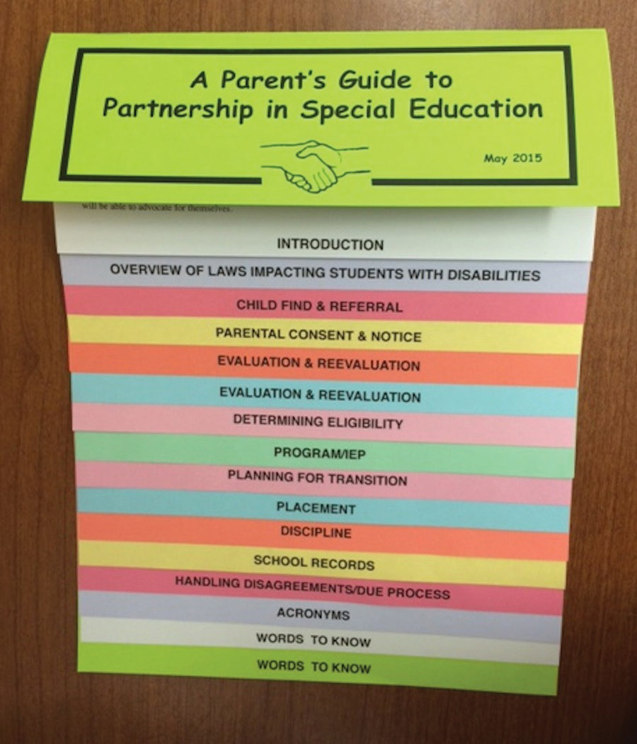

**2015 Budget Highlights and Potential Bills for 2016**

**BILLS THAT**

**FELL SHORT OF PASSING**

**DEPARTMENT**

**OF HEALTH BUDGET**

**DEPARTMENT**

**OF EDUCATION BUDGET**

This year the Department of

Education sought and won more money for bus transportation, teacher recruitment and retention, school food services and skilled nursing services. However, the funds awarded by the Legislature were less than requested. One solution offered was to seek more Medicaid reimbursement dollars for skilled nursing and transportation. Legislators also turned down the Department’s request for $12 million to expand the availability of technology, including iPads and laptops for individual students.

Legislators honored requests from

the Department of Health for $3 million for the Genetics Services Project and $254,000 to expand metabolic screening of newborns. However, only about $800,000 was funded of the Developmental Disabilities Division’s request for roughly $2.3 million to expand its home and community based

waiver services to COFA (Compact of Free Association) residents.

These include individuals from the Marshall Islands, Palau and Micronesia. Services to COFA children with developmental disabilities should not be affected.

A number of bills affecting student

with disabilities came close to the finish line but failed to pass.

These included bills to address bullying and cyberbullying in and out of school and a bill to extend Medicaid coverage to individuals with disabilities who are working. Called ‘Medicaid Buy-In’ the program is currently available

in most states and encourages people with disabilities to seek employment without worrying about losing medical coverage. Most of the dedicated supporters of these failed bills will try again next year.

**Links to Additional**

**Legislative Information**

**Updates on Governor Ige’s actions on 2015 bills** <http://governor.hawaii.gov/bills/>

**Parent Guide Now Available**

Mhave been waiting patiently

any of SPIN’s faithful readers

for the updating of the popular ***A***

***Parent’s Guide to Partnership in Special Education***. Written by SPIN with support from the Special Education Advisory Council and the Department of Education, the *Guide* provides easy to follow information about the steps in the special education process as well as special terms and acronyms parents hear in IEP meetings.

The *Guide* is meant to support and not replace the Procedural Safeguards Notice given to parents each year. It is written in parent- friendly language with a ‘flip’ format that allows readers to jump to the section they would like to read. SPIN is also working on a digital version that will contain

**A full listing of bills that were**

**passed by the 2015 Legislature** <http://www.capitol.hawaii.gov/ad-> vreports/main.aspx (Click on Bills that Passed under Legislature)

**A full listing of resolutions that**

**were passed in 2015** <http://www.capitol.hawaii.gov/> advreports/main.aspx (Click on Resolutions Adopted under Legislature)

links to useful documents and

websites. This electronic version should be up on SPIN’s website by June (www.spinhawaii.org). In the meantime, feel free to request your copy of the print version of the *Guide* by calling (808) 586-8126 or emailing [spin@doh.hawaii.gov.](mailto:spin@doh.hawaii.gov)

**A Citizen’s Guide to Participation**

**in the Legislative Process** <http://www.capitol.hawaii.gov/> citizensguide.aspx

3

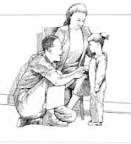

4

**June is National Effective For children who are non-verbal,** they may

**Communication Month** mix different forms of communication to express

themselves. Encourage effective communication by

mixing it up and modeling language in various ways. The Public Broadcasting System **Motoric**: Direct physical manipulation of a shares ways to have meaningful person or object (for example, taking one’s conversations with our kids. hand and pushing towards a desired item).

1. **Ask specific questions.** A well- **Gestural:** Pointing, showing, gaze shifting meaning but general question can (for example, a child looks or points to a

get one-word answers. Instead, desired object then shifts his gaze to another try asking a specific question that person, requesting that object).

will let your child know you are paying attention and **Vocalization:** Use of sounds, including crying, encourage him to respond with a specific answer. to communicate (for example, a child says

1. **Physical actions** like making eye contact, bending “ah-ah-ah” to draw your attention). down to your child’s level and tilting your head shows **Sign language**: Communication with a them you are really listening. conventional signed language system.
2. **Accept your child’s feelings**. In response to your **Using objects:** The child hands an object to keiki’s statement, you might say “I’m glad to know you to communicate (for example, the child that” or “I understand.” Sometimes this hands a cup to his parent to indicate “drink”).

acknowledgment is all your child needs **Using photos**: Use of two-dimentional

to hear. photographs to communicate (for example,

1. **Pause to consider your child’s** pointing to, or handing photos of various

**question.** Even if the answer will still be objects, actions or events to express desires).

“No”, pausing and saying “Let me think **Pictoral**: Use of two-dimentional drawings

about what your saying and get back that represent objects, actions or events (for to you” helps your child feel you are considering their example, handing a line drawing of a “swing” question and lessens the chance for a power struggle. to his parent to indicate he wants to swing).

1. **Avoid attacking your child’s character**. If your **Written**: Use of printed words or phrases to child acts out, instead of saying “bad girl, how dare you communicate (for example, the child writes speak to me that way!” you could say “That kind of “too loud” to indicate the noise level around language is not OK.” In this way you are separating the her is bothering her).

behavior from the child. --*Written by Susan Stokes under a contract with CESA 7*

*--For more on this article, visit* [*www.pbs.org/parents/*](http://www.pbs.org/parents/) *and funded by a discretionary grant from the Wisconsin talkingwithkids/strategies.html. Department of Public Instruction* [*http://www.specialed.us/autism/nonverbal/non11.htm*](http://www.specialed.us/autism/nonverbal/non11.htm)

**Effective Communication in Your IEP Meeting**

Tips for Parents & Professionals

1. Communicate with your child before the meeting. Ask how school is going, and if they would like to change anything. Find out what they like and dislike and what they want or need.
2. Write down any questions or concerns before the meeting, so you don’t forget. You can submit these questions as a written proposed agenda to the school before the meeting. Bring extra copies.
3. Be an active listener. Make sure you make eye contact with people as they are speaking. Give each speaker your full attention and allow them to finish their thoughts before speaking up. Don’t fidget.
4. Parents are a full and equal member of the IEP team. If someone says “The team feels..” you should also agree with the statement. If you do not agree, you could say “I am an equal member of this team, and I do not feel that way”. Do not allow yourself to get into a “us versus them” situation. Be kind.

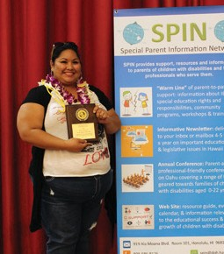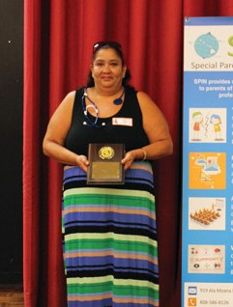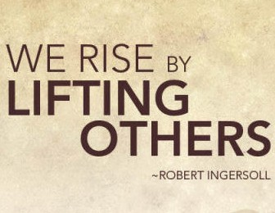

5

**2015 Parent of the Year Awards**

**Kau`i Rezentes Lisa Jaso**

Kau`i is a Kamehameha graduate who works at Lisa is a single mother to four children and thirteen Hilopa`a Family to Family Health Information Center. grandchildren. She is a resident of Ka`ahumanu She is the mom to Ava, who, at 11 years old is the homes where she is the President of the Residents’ most medically fragile child in Hawaii. Kau`i serves Association. Lisa gives back to her community by on Hawaii’s SEAC and the Western Regional Genetic volunteering for Summer Fun, after-school tutoring Alliance Advisory Council and is Vice President of and organizing dances. She has been active in both Family Voices. She embodies *aloha,* advocating for the East and West Honolulu CCCs for the past nine and mentoring families, sharing the message that years and has taken on the role of caregiver to her tomorrow is another day, and it will be a good day as four-year old granddaughter who has special health

long as you stay true to yourself and love your child. care needs. Lisa is a gem in our community that shines

in every heart she touches.

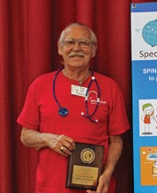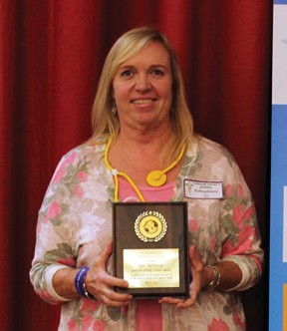

6

**2015 Family Choice Awards**

**Tom Smith**

Tom works for Bayada Behavioral Health but he also works for his community. He is the Professional Co-Chair at the Windward CCC for the past 6

years, serves on the Special Education Advisory Council and co-chairs the Coalition for Children with Special Needs. He has worked alongside families and community advocates on various policies including Chapter 60, the State Performance Review and Response to Intervention policies. Tom is truly a collaborative community partner working for us all.

**Matt MacDonagh**

Known by his students and families as Mr. Mac, Matt is a teacher at Castle High School. He has a special kind of tough love in his teaching that has lasting impacts on his students. He works tirelessly after hours as a Special Olympics coach and transporter, picking up and dropping off athletes who need a

ride. Mr. Mac works hard to create sustainable job opportunities for his students while at school and after graduation. He was nominated by parents for his dedication, caring influence and his ability to help students achieve independence.

Debbie Kobayakawa accepted the award for Matt MacDonagh, as he was not able to attend.

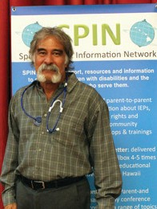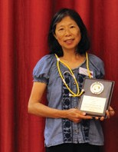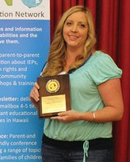

7

**2015 Professionals of the Year**

**Art Souza**

Art is a Complex Area Superintendent from the island of Hawaii and is the perfect partner for any family member. He has his roots in community development education and is a leader in Hawaii’s Community of Practice cohort. He is an avid national speaker and is known for his incredible vision and ability to bring various stakeholders together. Art is a mentor, a shepherd and the embodiment of family-professional partnerships.

**Dr. Bobbie-Jo Moniz-Tadeo**

Bobbie-Jo is the Program Director for Imua Family Services on Maui. When both of her children were born with their own unique medical conditions, it fueled Bobbie-Jo’s determination to help others. She is a graduate of the MCH LEND program, an alumni instructor at Argosy University and the Professional Co-Chair on Hawaii’s Early Intervention Coordinating Council, working to improve the lives of Hawaii’s

**Dr. Patricia Heu** children & families.

Dr. Heu is the Branch Chief of the Children with Special Health Needs Branch. She is a graduate

of the Hawaii Pediatric Residency Program & the School of Public Health. She has moved forward initiatives for the Newborn Hearing & Metabolic Screening programs and, for the past 3 years, provided extra special support to the Early Intervention Program. Dr. Heu is the author of the Rainbow Book, and her passion for family-centered care is evident in everything she does.

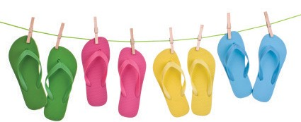

**Summer Events & Workshops**

**6/6**

**6/8**

**THERAsurf** is a free surfing program for

children with special needs. They will be at **Poipu Park on Kauai June 6** and **Launiupoko Park in Lahaina on June 8** from 10:00 am - 4:00 pm both days. Visit Therasurf.org for more information.

**KELII** presents their 2nd annual **Car Show and Family Event** at Kapolei High School.

11:00 a.m. - 6:00 p.m.

Car, truck & bike show, food & vendors. Register at [www.keliifoundation.webs.com](http://www.keliifoundation.webs.com/)

**7/11**

**Access Surf** will be hosting a **Day at the**

**Beach at White Plains** from 9:00 am - 1:00 pm. Free surfing event, for all ages and abilities. Sign up @ [www.accessurf.org](http://www.accessurf.org/)

**8/13**

**LDAH at Lanai Community Center**

2:30 - 5:00 pm. Free traveling Mini Conference. Call 800-533-9685

**6/6**

**8/21-22 Family Learning Vacation** sponsored by

the **Hawaii School for the Deaf and Blind**. Includes workshops for parents and kids,

in a 2-day program designed to strengthen family relationships and communication. Call Roz Kia at 808-733-4999 or email [Billy_Kekua@notes.k12.hi.us](mailto:Billy_Kekua@notes.k12.hi.us) for info on cost and registration.

**6/15-19 LDAH** presents **5 Clinics in 5 Days!**

June 15: Present Levels of Achievement June 16: Transition Plan

June 17: IEP Goals & Objectives

June 18: Modifications & Accommodations June 19: Least Restrictive Environment

**All sessions are free** and are from 10:00 am to 11:30 am at 245 N. Kukui St, in Honolulu.

Call 536-9684 to register. **Child care available!**

**8/27**

**LDAH at Molokai Community Center**

3:00 - 7:00 pm. Free traveling Mini Conference. Call 800-533-9684