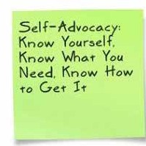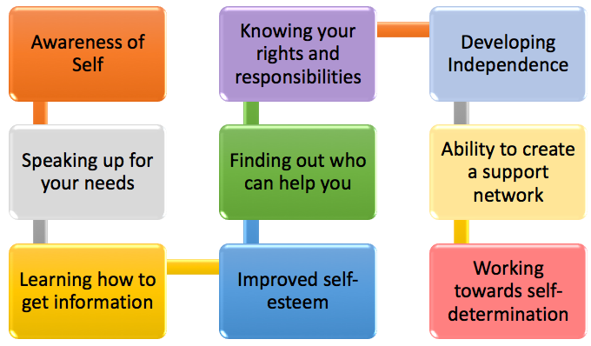

Raising Your Child to be a Self-Advocate
2016-17 School Year
Special Edition
SPIN is co-sponsored by the Disability & Communication Access Board and the Department of Education.
Services include a phone line for information referral and support, a quarterly newsletter, an annual conference and community workshops. SPIN is guided by an Advisory Committee made up of parents, professionals and people with disabilities.
SPIN
1010 Richards St. Room 118
Honolulu, Hawaii 96813
PHONE
586-8126
Neighbor Islands dial the ex- change below, then 6-8126
Kauai - 274-3141
Hawai’i - 974-4000
Maui - 984-2400
Molokai - 1-800-468-4644
Lanai - 1-800-468-4644

FAX
586-8129

E-MAIL
spin@doh.hawaii.gov

WEB
www.spinhawaii.org

Find us on FACEBOOK

In the early years, we spend a lot of time explaining to school staff how our child learns, what strategies work best for them and how we can help them be active participants in school. At the doctors office, we explain symptoms, how they responded to a new medication and report on anything new. With family and friends, we explain the diagnosis and how to have positive interactions with our child. But eventually, for
many children, we have to start letting go and start letting our children have a voice of their own. To tell us what works for them, and what doesn’t and to have the knowledge and courage to ask for the help they need, the way they need it. This is the journey of self-advocacy.

In this special issue, we’ll share with you some tips, strategies and the ideas behind self-advocacy and self-determination. You can start your child on this road at a very young age or add it to the IEP as part of the transition plan. We

WHAT’S INSIDE
Building Self-Advocacy 2 Including Kids in the IEP 2 Self-Determination 3
Calendar of Events 4

always say that parents are a child’s best advocate, but teaching children to represent themselves, and make choices that positively impact their lives is one of the best things we can do for our kids.
sdfdsfs

Building Self-Advocacy in Your Keiki

Skills need to be worked on over time. Be patient and encouraging, allowing your child to find their voice and be comfortable in asking for help when and where they need it.
- Talk to your child about their strengths and weaknesses.
- Help them understand that asking for help is ok.
- Encourage your child to use the class- room accommodations that are written in the IEP.
- Consider putting advocacy goals in the IEP and building on them each year
- Teach your child about their legal rights and how to talk about them in a positive, helpful way.
- If a challenge arises, allow them the chance to problem solve before you step in to fix it.
- Let you child weigh in on what works best for them in different situations and let them share those thoughts with teachers and staff. Drawings, printed templates or a short video can all be used.

Including Your Child in the IEP

Even if your child is not able to attend the physical IEP meeting, or if they are unable to voice their thoughts and feelings about their educational environment, there are other ways to include them in the IEP process.

Consider making or downloading the 3x3 sheet from Understood.org. It includes
spaces to draw or write what you child feels are their strengths, challenges and strategies that may help them.

Make a short video to play at the IEP meeting showcasing your child and what they like or do not like and ways they like to learn.
If they are non-verbal,
this could include showing ways your child indicates if they like to do not like something offered to them and ways to encourage them making a choice.
Ask your child to tell the team what their disability means to them. What are the challenges they face? When do they feel the most comfortable in their learning? Sharing their feelings and being able to explain their diagnosis can help them be more comfort- able in their own skin.

As your child gets older, you can include them more in the IEP process. If a question comes up, ask them what they think, or to come up with a suggestion. Eventually, they may develop leadership in the IEP meeting, becoming more responsible in guiding what and how they learn.

For teens who are working towards transitioning to adult life after high school, have them share their goals of a job, secondary schooling and an independent
life. Allow them to lead these discussion so they take ownership of their educational pathways.

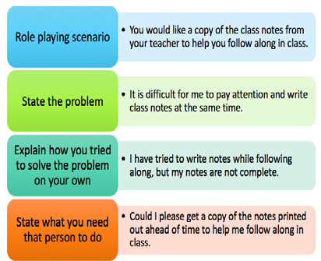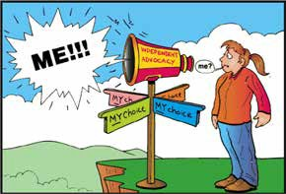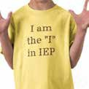
2

Self-Determination
Self determination is believing you can control your own destiny. It means learning to effectively solve problems, making your own choices, taking responsibility for your life and accepting the consequences of those choices. Below are some tips from the NCSET.org for families and professionals
to help students and young adults reach their own level of self-determination.

Promote Choice Making
- Identify strengths, interests and learning styles
- Provide choices about clothing, social activities, family events and ways of learning new things
- Allow for mistakes and natural consequences
- Involve children and youth in educational, medical and family decisions

Encourage Exploration of Possibilities
- Talk about future jobs & hobbies
- Identify young adult mentors with similar disabilities
- Use personal, tactile, visual and auditory methods to explore the world

Promote Reasonable Risk Taking
- Make choice maps listing risks, benefits and consequences of choice
- Build a safety net of family members, friends, school and mentors
- Develop skills in evaluating consequences

Encourage Problem Solving
- Accept problems as part of a healthy development
- Hold family meetings to identify problems at home or in the community

For more ways to build your self- advocacy skills, consider contacting or joining one of these local groups:

SAAC - Self-Advocacy Advisory Council 586-8100 or hawaiisaac@yahoo.com

Best Buddies Hawaii 545-3025 or
hawaii@bestbuddies.org

Promote Self Advocacy
- Encourage communication and self-representation
- Practice ways to talk about their disability and accommodation needs
- Praise efforts to self- advocate and problem solve

Facilitate Development of Self-Esteem
- Provide experiences for children and youth to use their talents
- Provide opportunities for individuality and independence
- Model self-esteem and self-confidence

Develop Goal Setting and Planning
- Define what a goal is and show the steps needed to reach a goal
- Make a road map to mark short-term identifiers as they work towards their goal
- Be flexible in supporting your child in reaching their goals. Be there when they need extra support, and be able to step back when they want to try to go it alone

Help Youth Understand their Disabilities
- Talk about your child’s disability
- Talk about your child’s abilities
- Develop a “one pager”, directed by your child, that addresses their needs, strengths, interests and what kinds of support they would like to have.

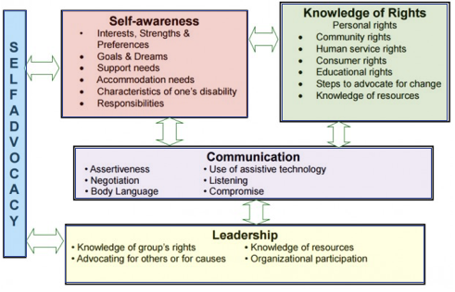Internet Resources: www.understood.org www.pacer.org www.ncset.org

graphic credit: Independent Living Research Utilzation 3

MARK YOUR CALENDARS...

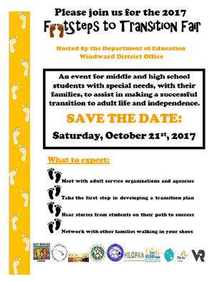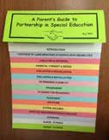

7/29 Autism Society Sib Shop Mixer
6:00 - 7:00 pm, Zippy’s Pearlridge
For siblings 12 and up, kids are responsible for their own meal. RSVP: eventbrite.com/e/ sibshop-mixer-tickets-33654078254

7/30 Hilo: Sensory Friendly Film Despicable Me 3
10:00 - 11:30 am, Adults $10, Children with autsim free, siblings $5.
Prince Kuhio 9 Regal Theaters, Hilo
Visit SPINHawaii.org/events for ticket link

8/5 Welcome Back to School Train Ride
Sponsored by Hawaii Autism Society
12:00 - 2:00 pm, $6 per person, under 2 free Hawaiian Railway Society
91-1001 Renton Road, Ewas Beach
Visit SPINHawaii.org/events for ticket link

8/16 Honolulu District Families Embracing Autism Support Group
Sponsored by the Learning Disability Association of Hawaii
6:00 - 7:00 pm, free parking 245 N. Kukui Street, Honolulu RSVP for childcare: 536-9684

9/19 Autism Workshop FREE
10:00 - 11:00 am Sexual Abuse Prevention Kainalu Elementary school in Kailua RSVP: prevent_abuse.eventbrite.com
To get your FREE copy of our new
Parent Guide
give a call 586-8126 or email us at spin@doh.hawaii.gov or visit our website.

Like us on

4

9/19 Autism Workshop FREE
12:00 - 1:00 pm De-escalation Techniques Maemae Elementary School, Honolulu RSVP: deescalatetech.eventbrite.com

10th Annual Traveling Mini-Conference 2017 Presented by the Learning Disabilities Association of Hawaii. Call for info 536-9684 8/10 Lanai - 2:30 -5:30 pm
Lanai High & Elementary School
8/17 Molokai 3:00 - 7:00 pm
Molokai Community Health Center
8/26 Oahu 9:00 am - 1:00 pm 9/9 Hilo 9:00 am - 2:30 pm 9/14 Maui 5:00 - 9:00 pm 9/23 Kauai 9:00 am - 2:00 pm 10/7 Oahu 9:00 am - 1:00 pm

10/21 Footsteps to Transition Fair Hosted by DOE Windward District Windward Community College 8:30 am - noon FREE
for students ages 13-22, talk story with agencies, a student panel, speaker & prizes Call SPIN to register 586-8126

