SPECIAL EDUCATION TASK FORCE FIRST YEAR RECOMMENDATIONS
Superintendent Kishimoto and her Special Education Task Force recently presented recommendations to the Board of Education for improving access to quality education for students with disabilities. Here are their 1st year priorities:

In order to pave the way for more students with IEPs to learn alongside their peers, schools need common definitions, multi-level and individualized supports, well planned transitions and community/parent partnerships.
May/June 2018
Volume XXXIV, No. 4
SPIN is co-sponsored by the Disability & Communication Access Board and the Department of Education.
Services include a phone line for information referral and support, a quarterly newsletter, an annual conference and community workshops. SPIN is guided by an Advisory Committee made up of parents, teachers and people with disabilities.

PHONE
586-8126
Neighbor Islands dial the ex- change below, then 6-8126
Kauai - 274-3141
Hawai’i - 974-4000
Maui - 984-2400
Molokai - 1-800-468-4644
Lanai - 1-800-468-4644

FAX
586-8129

E-MAIL
spin@doh.hawaii.gov

WEB
www.spinhawaii.org

1010 Richards Street
Room 118
Honolulu, HI 96813
Redesign staffing allocation based on student needs
Adequate time for care coordination and preparation
Professional development for all stakeholders
Identify a shared vision of inclusive education

Educators and parents need to understand the skills and knowledge needed to supprt students in inclusive placements. Some areas to include are Response to Intervention, IEP process, supports for transition and specially designed instruction.

Additional supports are needed to allow special education and general education teachers time to plan together and monitor student outcomes. Supports may include additional substitute days, an additional release period and recall pay for after school hours.

Redesigning how money is given out to schools for staffing needs will include a weighted allocation system, a Risk Pool for special staffing needs and short-term funding to schools, such as grants, to expand best inclusive practices.
NEXT STEPS
WHAT’S INSIDE
Jobs Now Partnership 2 Life Course 101 Class 2
Executive Functioning 3
Summer Reading 4
The App Corner 4
Screen Time Limits 4
SPIN Awards 5-7
Calendar of Events 8
With the Board’s approval to go forward with the Task Force’s short and long term recommendations, the Superintendent
is putting together an Implementation Team. Although the team members haven’t been identified, SPIN is hoping that they will include a broad mix of stakeholders, including parents.

Stay tuned to the SPIN News for progress updates, and visit our website to view the Task Force Report: http://spinhawaii.org/ wp-content/uploads/2015/01/Task-Force- Report.pdf.

eeward Oahu families may want to take advantage of an exciting new pilot project
L
to help high school students with intellectual and developmental disabilities get a good job after high school or college. The Jobs Now Partnership embraces the entire ohana with both a student-centered project and a parent project. Here are some of the benefits for parents:
Workshops
Topics include important things to know like how to get the right things included in the IEP, how to manage money, and government benefits that may be available to your child.
Goal Setting
The project will teach your family how to chart your son or daughter’s
life course to a successful job and adult living based on his or her goals and preferences.
Family Support
Project staff will be available to enrolled families through a variety of ways--face- to-face meetings, phone calls and emails. They can help to reinforce new skills learned in the workshops.
Gift Certificates
In appreciation of the time and energy families devote to the project, they will
be eligible to receive up to $200 in gift certificates for grocery stores.
Information and Registration
In order to be eligible for project activities, students must be receiving services from the Division on Vocational Rehabilitation (DVR) or the Developmental Disabilities Division. Check out a YouTube video for more information: https://youtu.be/6-pptGR4RV8.
Then contact Chin Lee (chinlee@hawaii.edu, 808-956- 9142) or Chuan Chinn (chuanc@hawaii.edu or 808- 956-5379) at the Center on Disability Studies.

LIFECOURSE 101 CLASSES ON OAHU
A

number of Hawaii agencies
serving individuals with disabilities and their families-- Hilopa‘a, the Developmental Disabilities Division, the Center on Disability Studies and the State Council on Developmental Disabilities to name some--have formed the Supporting Families Hawaii State Team. They are dedicated to helping promote best
practices that have been developed by the Community of Practice for Supporting Families of Individuals with Intellectual & Developmental Disabilites. A key set of tools for enhancing quality of life is called Charting
the LifeCourse. These tools look at
2
goals within six major domains:
- daily life and employment,
- community living,
- social and spirituality,
- healthy living
- safety and security, and
- citizenship & advocacy.
You can view this toolkit by going to: http://www.lifecoursetools.com/ planning/.

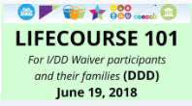
Families on Oahu are being
invited to a free and very helpful
workshop later this month One date is reserved for I/DD Waiver participants and the other is open to ALL interested families.

Workshops are being held at the Oahu Veterans Center, 1298 Kukila Street in Foster Village. Register by June 15th by going to www. lifecoursehi.eventbrite.com. Call for more information--453-6028.

To Improve Executive Functioning in Children
6 Ways
The term executive functioning refers to a set of mental skills that help you get things done. Many children with disabilities--including autism, learning disabilities, Attention Deficit Hyperactivity Disorder and intellectual disabilities--may have difficulty performing brain tasks like paying attention, managing time, remembering details, multi-tasking and problem-solving. Here are six strategies that can help to improve these skills:
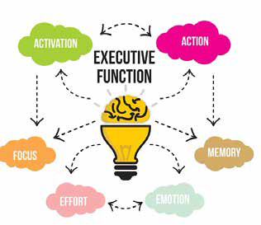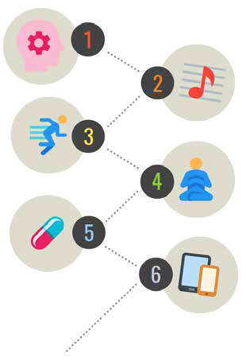

- NEUROFEEDBACK
Also called EEG biofeedback, this evidence- based therapy for children with attentional disorders helps improve concentration through interactive brain training exercises that teach the child how to alter brain waves.

- MUSICAL TRAINING
Practicing a musical instrument engages all four hemispheres of the brain, optimizing brain power and improving focus while reducing stress.

- PHYSICAL ACTIVITY
Regular physical activity and fine-tuned motor skills benefit brain function as early as infancy, continuing through every age. Hormones released during exercise produce feelings of well-being and help to stimulate neuron development.

- MINDFULNESS & REFLECTION
Mindfulness training (like belly breathing and body scans) helps children calm down, regulate stress and sustain attention. Students seem to like Apps like Headspace, Calm and Smiling Mind.

- MEDICATION
Stimulant medications (like Ritalin) and non-stimulants (like Strattera) have been used to treat ADHD, which has executive functioning issues.

- TECHNOLOGICAL AIDS
These aids come in a variety of forms including electronic organizers, pagers, cell phones, web-based schedulers and voice recorders. Smartphones and tablets, considered desirable by all students, can offer Apps that target specific cognitive deficits.

This infographic was developed from a presentation by Dr. Jeff Okamoto at the 2018 SPIN Conference.

3

Summer Reading Rolls Into Your Local Library

Looking for a way to connect with your keiki, while allowing them to expand their imaginations and learn new things? Take a short walk, bike or drive to your local library and sign up for the summer reading program. With 51 branches statewide to choose from, there is bound to be a library near you. Register online to start recording your reading minutes towards fun incentive prizes and a chance to win 4 tickets on Alaska Airlines!
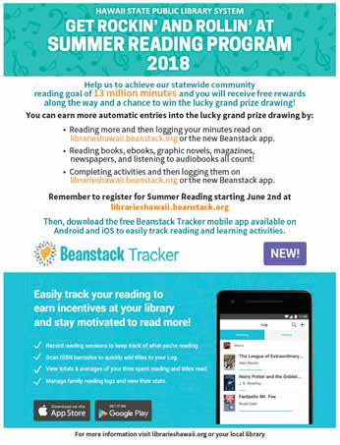

Set up a charging station outside of the kid’s
bedroom to allow them to get a good night’s sleep free from late night interruptions.
Use apps that take you outside to enjoy
stargazing, geocashing and exercise.

Set screen time for after all chores are done and consider tickets to trade in for game time.
Start at “No Device at Dinner” rule and stick
with it and include adults in the rule.
Summer Screen Time Limits
As school ends and summer time leaves kids with excess time on their hands, it’s easy to let them slide into more screen time. But the American Academy of Pediatrics warns that too much screen time (TV, tablets, smart phones and computers) can lead to social and developmental delays, vision problems and obesity due to lack of sleep and exercise. Here are some tips for summertime screen limits for your family:
Create a Family Media Plan to designate when screen time can be used and where. Visit www.healthychildren.org for an online template to print out for your family.

4

2018 Parent of the Year Awards

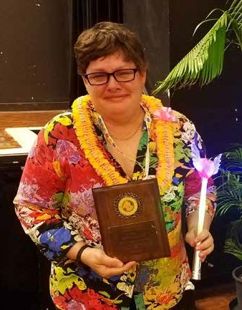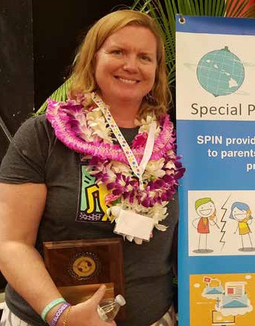Michelle Manfredi
Michelle is the Navy wife and mother to three lovely children, including one daughter with autism. Before retiring in Hawaii, they moved from one duty station to the next. Michelle had to navigate new schools, new houses, new therapists and doctors as well as try to create a new support system for her and her family.
When her daughter Rene graduated, she continued to need supports so Michelle continued to do what she’s always done, lead from behind, guiding Rene and creating avenues for her to realize success and belonging. In doing so, Michelle has found her own advocacy voice while sitting on the No Wrong Door
Committee, helping the DDD make written materials for families, providing parent-to-parent mentoring and training transition teachers.

Sarah Man
Sarah and her Hawaii-born husband Gabe were living in New York City when they decided to pack up and bring their three children home to Hawaii. It started Sarah on a path that would prove beneficial in her journey of raising a daughter with autism, as well
as for many families in Hawaii who have received strength and support from this dynamic mom. Sarah began volunteering and helped establish Best Buddies in Hawaii, a favorite organization since she was one of the first Buddies in the nation, back in her college days. She participated in the MCH LEND program as a family trainee and volunteered with the Center on Disability Studies’ Being Safe, Feeling Safe project.
Now Sarah is the Statewide Director of Best Buddies Hawaii, helping kids around the state to be included with friendship and respect.

5

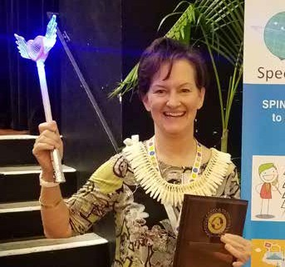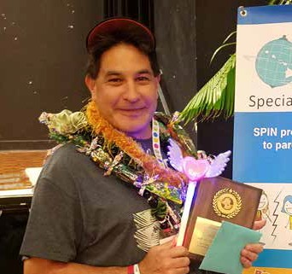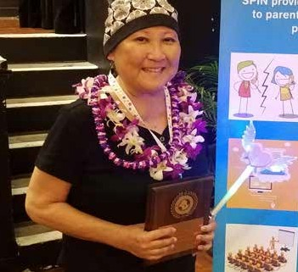

2018 Family Choice Awards

Dr. Lisa DeLong
Dr. DeLong is the principal of Kailua Intermediate school and has created a community of inclusion at her school that is supported by staff, students and families alike. She started her career in education as a special education teacher and worked her way up to VP and principal of Kahuku High and Intermediate and as the Complex Area Superintendent for Nanakuli-Waianae. Lisa is also the co-chair for the Special Education Task Force. Dr. DeLong partners with parents and students to create positive outcomes for all students and we are so happy to shine a bright spotlight on her.

Jan Miyashiro
Jan has served our most complex and fragile keiki for the past 20 years, working as an occupational therapist with the Kapiolani Early Intervention Program. She has dedicated countless hours to helping families understand their child’s individual needs, celebrate developmental accomplishments and show her love and appreciation of each child’s unique personality and gifts. Now it’s our turn to celebrate you, Jan!

Willie Cadena
Willie was born in Okinawa and has been living in Hawaii over 30 years. When he started working at the Community Children’s Council Office in 2006, Willie immediately connected with families, sharing his motto: “It’s all about the keiki.” He’s relatable, with a silly side that makes him easy to work with,
but he is always serious about looking out for families and helping them find the services they need in our communities. Thank you, Willie, for all you do for us!

6

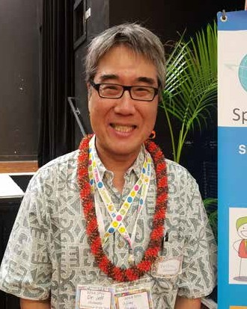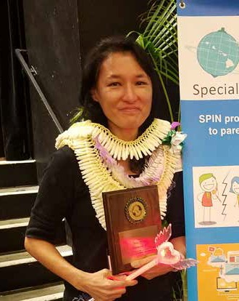

2018 Professionals of the Year

Dr. Jeff Okamoto
Dr. Okamoto has spent most of his professional life dedicated to helping children and families access quality health care and supports. Currently you can find him in his specialty clinic at Kapiolani Medical Center working as a skilled neurodevelopmental and behavioral pediatrician. Jeff is knowledgeable and non-confrontational, spending time listening to families and kids, so he can find answers that will lead to appropriate treatments and interventions. He has served on the DD Council, the SPIN Advisory Committee and was the Medical Director of the
Developmental Disabilities Division for over 10 years. He is also an Assistant Professor of Pediatrics at the John A. Burns School of Medicine. We are grateful
for the work Dr. Okamoto continues to provide to our keiki in Hawaii and look forward to many more years of working with him.

Miki Wong
Miki is a gifted dietitian and nutritionist who has been with Shriner’s Hospital for Children in Honolulu since 2005. In April, she transitioned to a new neurodevelopmental program known as Milestones, to work with keiki in Hawaii and the Pacific. Miki is an expert in the Ketogenic Diet Program and works with children with seizure disorders and autism. This program can be challenging to start and maintain,
and Miki helps families to be successful by providing counseling, conducting a nutritional intake history, and educating families on how to calculate calories, select and prepare food. She started a Ketogenic Facebook page with recipes and has nurtured parent-to-parent communities to grow and thrive. SPIN is proud to honor Miki in her work supporting families.

7

Events & Workshops

6/4 Self-Defense Project Coach Certification FREE 6/5 After successful completion of this course,
6/6 participants will be able to teach 1Touch Self- Defense classes. Neighbor island scholarships available. Info at www.SPINhawaii.org/events.
6/9 Family Conference & Resource Fair FREE 9:00 am - 2:00 pm Sponsored by Hawaii Families as Allies, dedicated to empowering families who’s
children and youth are in different systems of care. Kroc Center 91-3257 Kualakai Pkwy. Ewa Beach for more info: www.hifamilies.org or 682-1511.

6/8 Supporting Communication in Children with Autism FREE 5:30 - 7:00 pm Learn how to implement low and high tech supports and strategies for successful communication. For more info, visit www.autismsocietyofhawaii.org
6/10 TACA Family Day FREE
10:00 am - 1:00 pm Enjoy water play, bubbles, textures and more. Bring a potluck dish and gently used clothing for our annual clothes swap.
Aliamanu Community Center 101 Kauhini Rd, Honolulu. RSVP at www.tacanow.org/hawaii.
6/13 Epilepsy Talk Story FREE 5:30 - 6:30 pm The talk this month will center around
chiropractic care. 200 N. Vineyard Blvd. Honolulu RSVP: efh@epilepsyhawaii.org or 538-3058

6/15 Jobs NOW Partnership Information Session
5:30 - 7:30 pm, University of Phoenix,
6/16 | 949 Kamokila Blvd. in Kapolei, RSVP by 6/14:  chinlee@hawaii.edu or 808-956-9142  Sensory Friendly Film - Oahu
6/17 | “Incredibles 2” 11:30 am- 1:30 pm.  Olino Consolidated Theaters, 91 Kapolei Parkway, Kapolei Sensory Friendly Film - Hilo
. | “Incredibles 2” 9:30 am- 12:00 pm.  Prince Kuhio 9 Theater in Hilo. Sensory films have the lights a little brighter and the sound a little lower. Keiki with ASD are free, siblings $5, parents $13 on Oahu and $10 in Hilo  RSVP at www.autismsocietyofhawaii.org
8

6/19 Lifecourse 101 (see page 3)
1/DD Waiver families and participants 10:00 am - 1:00 pm or 4:00 - 7:00 pm
6/20 Lifecourse 101 (see page 3)
Open to all individuals and families 10:30 am - 1:00 pm or 5:00 - 7:30 pm
Oahu Veterans Center, 1298 Kukila St. www.lifecoursehi.eventbrite.com to register

6/20 Honolulu District Families Embracing Autism Support Group FREE
6:00 - 700 pm. Will be showing the movie “Including Samuel.” Free parking,
245 N. Kukui Street, Honolulu. RSVP for childcare 536-9684.

6/23 I.D.E.A. Marathon Training FREE sponsored by LDAH. Workshop will review special education law, understanding the evaluation process and developing an IEP. Held at Inspire Church, 94 Lumiana St., Waipahu. Bring your own lunch. Sorry, no childcare available. RSVP: 536-9684.

6/28 & Ho‘omana, Parents Supporting Parents 7/26 FREE Windward Oahu Autism Support
Group. 6:30 - 8:00 pm. Meet at Pali View Church, 45-510 Halekou Rd., Kaneohe.
6/29 Ho‘omana’s free Family Movie Night with crafts and dinner. Location is the Key Project in Kaneohe. For more info, email hoomanagroup@gmail.com or call 426-6879
7/7 AccesSurf Day at the Beach FREE 9:00 am - 1:00 pm Provides adaptive surfing, shoreline flotation and swimming for any person with a disability. White Plains, Ewa
Beach. Sign up @ www.accessurf.org

7/8 Microsoft Autism YouthSpark Camp FREE 7/15 8:00 - 9:00 am. Kids ages 11+ will build a 7/22 robotic finger and code a talking robot with 7/29 Ohbot. Classes at the Ala Moana Microsoft
store. For more info, visit www.autismsocietyofhawaii.org

