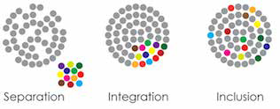

2018-19 School Year
Special Edition
Inclusive Education: Moving Hawaii Forward

SPIN is co-sponsored by the Disability & Communication Access Board and the Department of Education.
Services include a phone line for information referral and support, a quarterly newsletter, an annual conference and community workshops. SPIN is guided by an Advisory Committee made up of parents, professionals and people with disabilities.

SPIN
1010 Richards St. Room 118
Honolulu, Hawaii 96813
PHONE

586-8126
Neighbor Islands dial the ex- change below, then 6-8126
Kauai - 274-3141
Hawai’i - 974-4000
Maui - 984-2400
Molokai - 1-800-468-4644
Lanai - 1-800-468-4644

FAX
586-8129

E-MAIL
spin@doh.hawaii.gov

WEB
www.spinhawaii.org

Find us on FACEBOOK
sdfdsfs
he concepts of inclusion have been around for more than 30
years and there have been numerous efforts to include Hawaii’s students with disabilities in the general education classroom for most or all of the school day. When inclusion efforts fail, it may be due to:
T
√ a lack of buy-in and commitment from educational leadership;

√ inadequate teacher preparation and classroom supports;
√ little or no time for planning; &
√ parent misgivings.
Hawaii’s Superintendent, Dr.
Christina Kishimoto, defines inclusion as ‘all students have the opportunity to be educated in the general education classroom to the greatest extent - expectations are high and instruction is standards based. Inclusive education provides general education curriculum and personalized supports as needed’ and ‘… occurs when a student with a disability successfully engages in the same learning environment with the same learning opportunities as his/her classmates.’
Inclusive schools have a collaborative and respectful school culture where students with disabilities are presumed to be competent, develop positive social relationships with peers and are fully participating members of the school community. Inclusion brings the support services to the student (instead of the moving the
student to the services) and requires

only that the student will benefit from being in the class, rather than having to “keep up” with the other students.
This special edition will tackle some of the myths of inclusion, take a look at the benefits and show ways we can advocate for inclusive practices in our classrooms and schools.

WHAT’S INSIDE
Busting Inclusion Myths 2 Benefits of Inclusion 3
Advocate for Inclusion 3
Calendar of Events 4

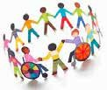Busting Myths
About Inclusive Education
1

MYTH: Students who can't keep up academically should not be included.
FACT: Students with IEPs do not need to be able to meet the exact same grade level standards in order to be successfully educated in the general education classroom, but they do need to be held to the same high expectations.

2 MYTH: Extra support to some students isn't fair to the others in the class. FACT: Equality means providing the same experience to every student. On the other hand, equity--which is the stated goal of our public schools--requires
providing individualized supports based on the unique needs of the student.

3 MYTH: Inclusion hurts the achievement of typical students.
FACT: As a rule, students without disabilities learn as much or more in inclusive classrooms. They may benefit from differentiated instruction, a diverse learning environment and an improved understanding for student differences.

MYTH:Students with significant disabilities won't get the support they need.
4
FACT: Inclusion means providing supports so that each and every student feels a sense of belonging, meets high expectations, develops meaningful social relationships, and leaves school ready for post-secondary education and a career.

5 MYTH: Inclusion always costs a lot more money.
FACT: A number of research studies have shown that while start-up costs may initially increase the cost of inclusive services, the costs over time decrease, and are likely to be less than more restrictive placements. Inclusion requires schools to examine how to best use all available resources, including peers.

6 MYTH: Parents don't support inclusive education.
FACT: Parents have been the strongest advocates for inclusion. Some parents may not have been educated about the benefits of inclusive education and become strong supporters once their children experience quality inclusion.
2
This infographic was adapted from a 2017 presentation by SEAC at the HawaiiKidsCAN Equity Conference.

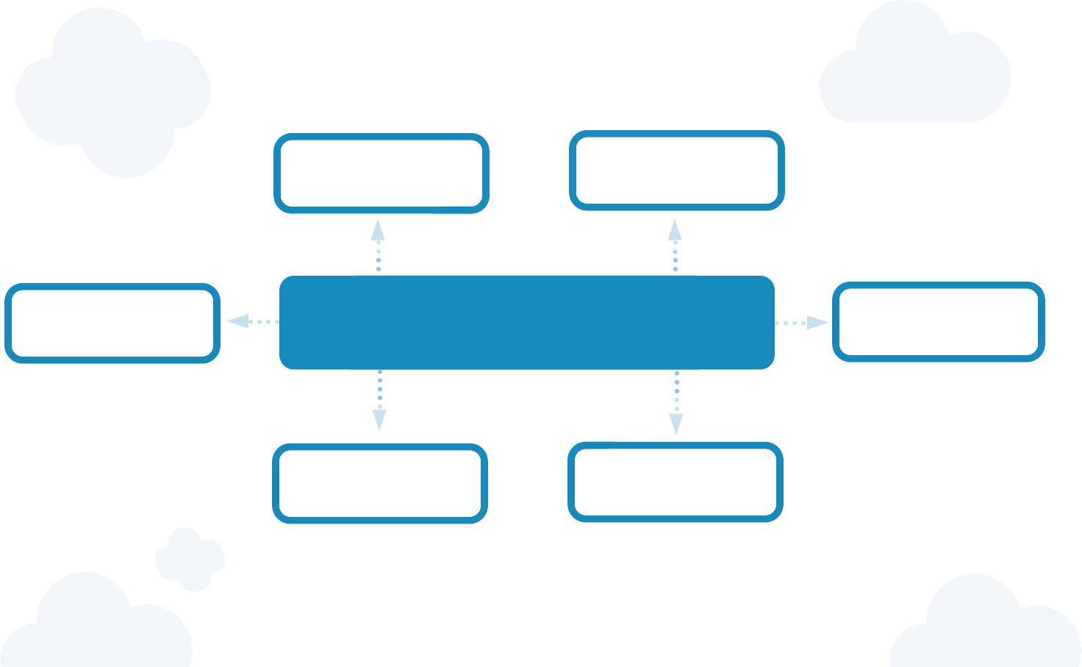Differentiated Instruction Peer to Peer Interactions A Culture of Belonging

All students learn differently.
Teachers use a variety of tools like Universal Design for Learning, manipulatives, smart boards and technology to provide all students with a means to engage and absorb the curriculum in a
variety of ways.
When students learn together, they learn to live together. Inclusive classrooms build and maintain friendships, grow empathy and reduce stigma for students with a disability. Peer tutoring has been shown to provide academic & social benefit to the tutor as well as the student who is tutored.

Benefits of Inclusion
Inclusion fosters a culture of respect and belonging for all students and provides the opportunities for acceptance of individual differences. Parents become more involved and invested in the school when their children are learning in the same classrooms.

Higher Expectations Effective Use of Resources Improved Behavior

Having access to the general education curriculum will increase a student's exposure to more challenging content as they work toward grade level standards.
Inclusive practices can raise the bar on what we expect from students with disabilities and give them the confidence they need to succeed.
In traditional classrooms, many students are 'pulled out' for services like speech, reading and specialized instruction. By bringing the specialists into the classroom, more than one student can benefit from the instructional strategies used by specialists visiting the classroom.
Ideally, inclusive classrooms use Positive Behavior Supports to set behavioral expectations for all students and to provide early intervention when problems arise. Students with disabilities also benefit from having positive role models for behavior.

Inclusion does not have to be an “all or nothing” approach to a student’s school day. If you’re hesitant about your child being in an inclusive classroom, look at the child’s interests to place them in 1 or 2 classes with their gen-ed peers.
- SPED Task Force Report
- Strategic Plan Inclusion Indicator
- SEAC’s Inclusion Vision

Follow Inclusion Initiatives
- Workshops on inclusion
- Meet other parents
- Network with teachers
- Find inclusion resources

Attend the SPIN Conference
Talk to your child about being in an inclusive classroom. They may be nervous at first, especially if they have always been separated from their peers. Let them know they will be okay, and the supports they need will be there for them.

Look Up Existing Inclusion Policy

  - Board of Education Inclusion Policy
  - Early Childhood

Advocate for Inclusion

Ask for Inclusion in the IEP
  - Come prepared
  - Know your rights
  - Ask if IEP goals can be

Inclusion Policy Statement

Take a Class from LDAH

    - IDEA/IEP workshop
    - Small group help on IEP
    - Parent training and information

Online Learning

- The Inclusive Class
- Understood
- PBS Parents
- Parent Center Hub
met in the gen-ed class with supports
- Partner with teacher(s) and other team members

3

MARK YOUR CALENDARS...

8/4 | Oahu: Sensor-Friendly Film  “Teen Titans Go! To the Movies”  9:00 - 11:00 am, $13 parents, $5 siblings, free for children with autism. Sponsored by the Autism Society of Hawaii. Olino Consolidated Theater, Kapolei. For more info visit https://autismsocietyofhawaii.org/. | 8/10  8/15 | SEAC - Special Education Advisory  Committee Meeting 9:00 am - 12:00 pm Puuhale Elementary School, 345 Puuhale Rd.,  Honolulu. For more info, call 586-8126 or visit www.seac-hawaii.org.  Honolulu District Families Embracing
8/4 | AccesSurf Day at the Beach |  | Autism Support Group “All About Section  504” Sponsored by Leadership in Disabilities
8/4 | 8:00 am - 5:00 pm, FREE  A day of fun at Kualoa Regional Park. Visit www.accessurf.org to sign up.  Back to School Train Ride |  | and Achievement Hawaii.  6:00 - 7:00 pm, free parking & childcare. 245 N. Kukui Street, Honolulu. RSVP for childcare by calling 536-9684.
 | Sponsored by Autism Society of Hawaii 12:00 - 1:30 pm, $10 adults, $9 children, under 2 free if sitting on your lap.  Hawaiian Railway Society  91-1001 Renton Road, Ewa Beach  Visit https://autismsocietyofhawaii.org/  for tickets | 9/22 | Honolulu Theater for Youth  Sensory friendly/ASL performance of “Filipino Folktales & Fables” for ages 6+ Tenney Theater, 229 Queen Emma Square, Honolulu. Visit http://www.htyweb.org/ for tickets. 11:00 am, $20 adult, $10 youth 3-18
8/8 | Epilepsy Foundation Talk Story  “Hawaii Research in Epilepsy Treatment” 5:30 - 7:30 pm, FREE, The event can also be viewed on Facebook Live. 200 N. Vineyard  Blvd, 5th Floor Conference Room. For info, call  528-3058 or email efh@epilepsyhawaii.org.

8/9 Lanai Health & Wellness Event Sponsored by Leadership in Disabilities and Achievement (LDAH) FREE
2:30 - 5:30 pm, Lanai High & Elementary School. Developmental & hearing screening, resource fair, and more. For info, call 696-5361.

Like us
October 20, 2018
8:30 am - 12:00 noon Radford High School
Take the next steps in developing a transition plan for your teen. Hear stories from students on their path to success, network with other families walking in your shoes and talk story with community resources and organizations.
To register, call 586-8126 or
visit www.footstepstotransition.weebly. com to sign up online.

4

