Strategic Plan Update Charts Progress for Special Education Students
Like us on Facebook
SPIN
1010 Richards Street, Rm 118
Honolulu, Hawaii 96813

PHONE
586-8126
Neighbor Islands dial the ex- change below, then 6-8126
Kauai - 274-3141
Hawai’i - 974-4000
Maui - 984-2400
Molokai - 1-800-468-4644
Lanai - 1-800-468-4644

FAX
586-8129

E-MAIL
spin@doh.hawaii.gov

WEB
www.spinhawaii.org
December 2018
Volume XXXV, No. 2
SPIN is co-sponsored by the Disability & Communication Access Board and the Department of Education.
Services include a phone line for information referral and support, a quarterly newsletter, an annual conference and community workshops. SPIN is guided by an Advisory Committee made up of parents, teachers and people with disabilities.

“Without goals, and plans to reach them, you are like a ship that has set sail with no destination.”--F. Dodson
he Department of Education’s
T
Strategic Plan 2017-2020 commits to three main goals--Student Success, Staff Success, and Successful Systems of Support--aimed at closing the achievement gap and ensuring equity and excellence for all students.
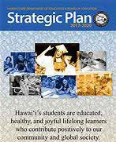
Thanks to the Strategic Plan Dynamic Report, parents, teachers and the other interested
folks can track progress on 14 key success indicators tied to these goals. Each indicator has a target that should be met by 2020.
Data is now available for three school years--2015-16,
2016-17 and 2017-18. Most of the indicators allow data to be reported a number of ways:
- by ethnicity,
- by complex area, and
- by subgroup, including students with disabilities, English learners, and economically disadvantaged students.
When the Dynamic Report was updated earlier this month by adding results from the 2017-18 school year, SPIN took a look specifically at data for students with disabilities on eight of the student success indicators. We tracked results for each of the three school years to identify trends. Here are some of our discoveries:
The percentage of 3rd graders reading at, near or above grade level rose 8 points over the previous year.
41% of students were spending all or most of their day learning in a regular classroom--up from 37% the two previous years.
More students with IEPs graduated with a diploma in four years (65%).
There is a steadily increasing number of special education students who graduate having completed a Career
and Technical Education Program of Study (28%).
While we celebrate these gains, we also must note that students with disabilities made almost no progress in the other four indicators (see our infographic on page 2).
If you would like to see how students are progressing in your child’s complex area, go to www. hawaiipublicschools.org and type in
“Strategic Plan Dynamic Report.” Let us know, if you need help navigating.
WHAT’S INSIDE
Strategic Plan Data 2
Financial Literacy 3
Relationship Study 3
Pac Rim Conference 3
Money $mart Tips 4
Homework Success Tips 5
HI Dyslexia Association 6
APP Corner 6
Inspiration 6
SPIN Conf. Registration 7
Calendar of Events 8

Strategic Plan Achievements for Hawaii Students with IEPs
2017-18 SY
E

3RD GRADE LITERAC
GRADUATION RAT

% of SPED 3rd Graders "At, Near or Above" on SBA* of ELA**
Y
50
28
33
20
25
0
SY 15-16 SY 16-17 SY 17-18

100
75
50
25
0

Students Graduating with Diploma in 4 years
Class of 2015 Class of 2016 Class of 2017

* Smarter Balanced Assessment
** English Language Arts

INCLUSION RAT
E

% of SPED Students in Reg Ed Class 80% or More of the School Day

SY 15-16
37
37
41
51
SY 16-17
SY 17-18
2020 Target
0 20 40 60
w/o disabilities w/disabilities

CAREER & TECHNICAL E
D
�CTE�
% of 12 Graders Who Complete a CTE Program of Study
60
40
20
0
SY 15-16 SY 16-17 SY 17-18

w/o disabilities with disabilities

Strategic Plan Indicators with Little or No Growth
24%

Of SPED students taking the SBA are proficient in Reading
16%
16%
Of SPED students taking the SBA are proficient in Science
Of SPED students miss 15 or more days of school per year

Of SPED students taking the SBA are proficient in Math
12%

33 pts. ELA
29 pts. Math

The achievement gaps between high needs and non-high needs students is not shrinking.

29%

Of SPED students enroll in trade school or college by the Fall following graduation

2

FINANCIAL
+ = LITERACY
TRAINING

The National Disability Institute (NDI) and the University of Hawaii’s Center on Disability Studies (CDS) recently teamed up with Hawaii agencies that assist young people with disabilities with job training and placement. Their mission: to ensure that those young people not only develop job skills but also develop financial know- how. Financial education and coaching is a key strategy to ensure financial security--
having a stable income or other resources to support a standard of living now and in the future.
Learning about money management -- budgets, taxes, investments, borrowing, savings, and estate planning -- typcially isn’t a large part of public education, so it is up to parents to begin to teach those skills to our children at home and in the community
as early as pre-school. NDI and CDS have generously shared a number of resources for parents that SPIN wants to share with you through this newsletter and our annual conferences. Our first installment in our Financial Literacy Series can be found on page 4. Money $mart was developed by the Federal Deposit Insurance Corporation (FDIC) for teaching children about money management. If you’re eager to speed up your learning curve, call SPIN for a list of on-line resources. Also plan to attend our workshop on Financial Literacy at the April 13th SPIN Conference!

1 in 3 people with disabilities live in poverty and face barriers to
employment, education and financial security.

UCCESSABILITY is the theme of this year’s 34th Annual Pacific Rim International
S
Conference on Disability and Diversity, coming up soon on March 4 & 5, 2019. If you’ve never attended a Pac Rim conference, be prepared to be amazed!
Hundreds of folks from around the world convene at the Hawaii Convention Center to share the best ideas on how to celebrate and enrich the lives of people with disabilities.
Themes for this year’s presentations include:
- Health and Wellbeing
- Accessibility
- Early Learning & Education and
- Secondary Education and Employment.
Parents of children with disabilities are being offered a special rate of $100 a day--HALF the regular registration. Find out more by visiting www.pacrim. hawaii.edu, emailing prreg@hawaii.edu or calling (808) 956-8816.

Romantic Relationships Study
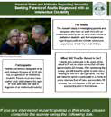Researchers from Michigan State University are reaching out to parents of young adults with
an intellectual disability aged 18-30. To participate in the study, parents must also have a child without a disability in the same age range. Their study is aimed at learning more about a parent’s role and attitudes about sexuality and intimate relationship experiences of both of their adult children.
Parents who participate in a one-hour phone or on- line interview will receive a $30 gift card. Don’t have that much time? Consider filling at an online survey that takes about 20 minutes, and you will be able to enter a drawing for one of four (4) $50 gift cards. The link to the study is https://msu.co1.qualtrics.com/jfe/ form/SV_0feRfgQ7K01owst. You are also wecome to contact the researchers, Rebecca Kammes (rkammes@ msu.edu) and Sarah Douglas (sdouglas@msu.edu).
The study will be winding up soon, so please act now to add your experiences to this body of research.

3

9th to 12th
Grade
6th to 8th
Grade
3rd to 5th
Grade
Pre-K to 2nd Grade
Financial Literacy for Families of Kids with Disabilities:
Part 1
Money $mart

Fun activities for parents to help kids get smart about money
For Parent Guides and lots more information go to: www.fdic.gov/moneysmart
Help your child learn the value of various coins and bills.
Let your child sell lemonade, old toys, etc. for an afternoon to learn about selling a product and earning money.
Play the Need or Want Game. Call out an item and have your child determine if it's a need (must have to survive) or a want.
Begin exploring interests and careers. Ask others what they like the most about their job. Help your child create and track a Goals Chart with short- and long-term goals.
Teach your child about charitable giving by donating clothes or toys or volunteering as a family (Meals on Wheels, Food Bank, etc.)

Play Guess the Cost of items around the house or seen on T.V. to teach the value of things.
If your child earns money through a job or allowance, teach them to create "savings" and "spending" envelopes.
Offer to loan your child money for a purchase "with interest" to learn the pros and cons of using credit.
Engage your teen in the process of filing taxes. Compare credit cards for percentage rates, fees, penalties and terms.
If your teen is already using social media, discuss the harm of oversharing personal information and the risk of identity theft.
Set a family goal, like a new TV or vacation, and create a family plan to save enough money to reach that goal.

4

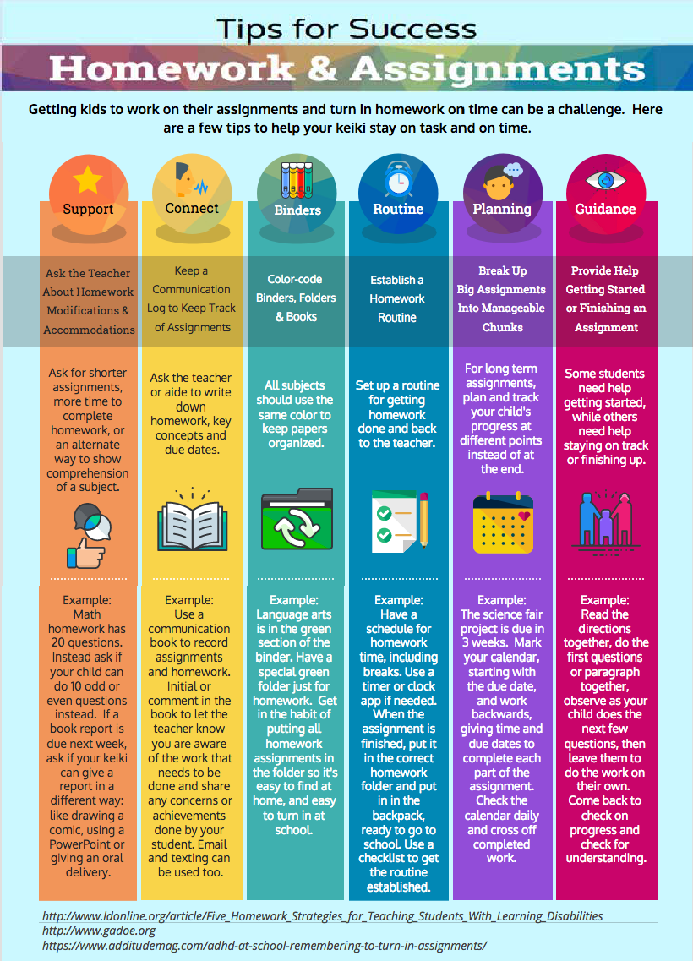

5

Happify is an app that uses science-based activities to reduce stress, overcome negative thoughts and improve your emotional well-being. It is available on both Apple and Android systems, and is free to download. If you like the
app, they offer a monthly subscription for access into more activities, but the free version works great and gives good insight to your happiness levels.
This app can help you:
- break old patterns & form new habits,
- try simple & effective solutions for emotional health and well-being,
- use it anywhere, anytime you need a boost, and
- measure your happiness and keep tabs on it.

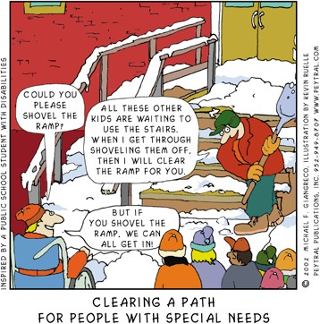
Visit their website www.happify.com for inspiring videos and articles on the Science of Happiness.

6
Spotlight on Support
Hawaii International Dyslexia Association
Dyslexia is more than a reading disability. If your child struggles with memory storage, sequencing and retrieval of information, they may be
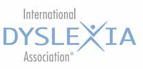
experiencing dyslexia. The mission of the International Dyslexia Association - Hawaii Branch, is to increase awareness of dyslexia in
our community; provide support for individuals with dyslexia, their families and educators; promote teacher training; and, improve literacy for struggling readers. Visit their website at www.hi.dyslexiaida.org for:
- upcoming trainings and workshops,
- information and resources,
- understanding dyslexia, and
- upcoming local events.
You will also be able to speak to them at the SPIN Conference or give them a call at 808-538-7007 or email them--info.hi@dyslexiaida.org.
Cartoon used with permission by the author.

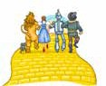Workshop Session 1

32nd Annual SPIN Conference
April 13, 2019 • 8:30 am - 3:30 pm
UH Manoa Campus Center Ballroom

Ease on Down  the Road | We’re Not in  Kansas Anymore | Wonderful World  of Reading | Who You Meet  Along the Way | If I Were King  of the Forrest | The Great Oz  Has Spoken
Transition to Adulthood | IEP 101:  Basic Training | Early Literacy | Town Hall | Civic Advocacy | Family Media Plan
Workshop Session 2

Taming the  Flying Monkeys | You’ve Had the  Power All Along | Nothing is  Impossible | Munchkin  Land | The Emerald  City | Happy Little  Bluebirds
Positive Behavior Support | IEP 201:  Advanced | Assistive Tech: Reading/Writing | Early Intervention | Financial Literacy | Parent Self-Care
Workshop Session 3

A Horse of a  Different Color | Over the  Rainbow | Keep Calm and  Click Your Heels | The Road  to Oz
Autism Supports | Seizure Disorders | ADD/ ADHD | Self- Determination

REGISTRATON FORM

Name:

Address: City Zip

Phone: H / C / W (circle one) Email:

Child’s Disability: Child’s Age:

Program or School:

Please register me for the SPIN Conference. Specify sponsor, if appropriate:

q Parent/Family Member - $25 q Two Family Members - $45 q College Student - $25 q Professional - $50

Amount enclosed (payable to SPIN): $ Check/Purchase Order #:

q Airfare Scholarship Request (for Neighbor Island parents and grandparents of kids with disabilities 0-21)
q Please send me an application by: q email q street address (check one)
q Accommodation Request due to a disability (check one below)
q Materials in an alternate format (Braille, audiotape, etc.) q Sign language Interpreter
q Other: Accommodations must be supbmitted by March 15, 2019 to ensure availability.

q Sign me up for SPIN’s E-Newsletter q Sign me up for SPIN’s E-Blasts of workshops and events

Send completed form with payment as soon as possible to SPIN via mail, fax or email:
1010 Richards Street, Room 118, Honolulu, HI 96818 • (808) 586-8129 (fax) • spin@doh.hawaii.gov

Winter Calendar of Events

1/5 Access Surf Day at the Beach FREE 2/2 White Plains, Ewa Beach from 9:00 am -
1:00 pm. Surfing event, for all ages and abilities. Sign up at www.accessurf.org/ participant-forms/

1/8 Mac Plus Recreation 2019 Spring Program From January to April, for ages 15+. Choose from Foodie Adventures, UH Spring Sports or Duckie Race & Festival. $10. Sign up beginning Jan. 8.
RSVP macplus@ucpahi.org or 532-6748.

1/11 SEAC - Special Education Advisory
2/8 Committee Meeting 9:00 am - 12:00 pm Oahu; Puuhale Elementary school library. For more information call 586-8126.

1/19 Family Sign Language Class FREE Comprehensive Services Center, 1953 S. Beretania Street, Suite 5A. Play games, eat snacks, learn to sign. Email for info: Roz@csc-hawaii.org. Sign up online at www.buff.ly/2TQsEVt.com.

1/22 Side by Side Parent Support Meeting FREE
Inspire Church, Waikele 4:30 - 6:30 pm Topic: Concussion Management Workshop
Speaker: HI Concussion Management Program RSVP: sidebyside@inspirechurch.tv

1/26 Marathon IDEA Workshop FREE
Inspire Church in Waikele, 8:30 am - 2:30 pm Learn about IDEA law, understanding the evaluation process and how to develop your child’s IEP. RSVP: breidy@ldahawaii.org

1/26 TACA Back to School IEP Tips FREE
9:00 - 10:30 am. Easter Seals Hawaii,
92-461 Makakilo Dr., Kapolei. Join us for Lynn Arnold’s “Back to School IEP Tips” recorded webinar followed by a moderated discussion.
RSVP required, visit: www.tacanow.org/local- chapters/west/hawaii.org to sign up.

Honolulu Theater For Youth
Sensory Friendly and ASL performances
1/26 Elephant & Piggies “We Are in a Play” written for keiki 3 and up.
2/23 “Home of the Brave” written by Leslie Wilcox, good for keiki 7 and up.
Tickets are $10-20. Visit, www.htyweb.org

2/22 Amazing Comic Con Aloha
2/23 Hawaii Convention Center. For discounted
2/24 tickets for the whole family, email Kris at neverquitdreaming@gmail.com or call 722-6843

SAVE THE DATE!
3/4-5 Pacific Rim International Conference
on Disability and Diversity “Successability”
For more info, visit www.pacrim.hawaii.edu
or call 808-956-8816 / email: prreg@hawaii.edu

SAVE THE DATE!
4/13 33rd Annual SPIN Conference “SPIN on Down the Road”
8:30 am - 3:30 pm at UH Campus Center Registration forms and airfare scholarships available. Go to www.spinhawaii.org or call us @ 586-8126.

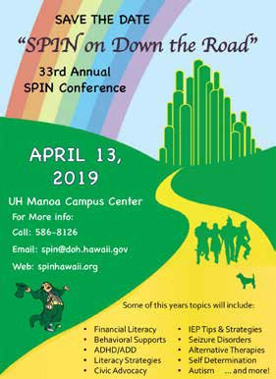
Special Parent Information Network
1010 Richards Street, Room 118
Honolulu, Hawaii 96813
Providing a world of support to parents of children with special needs

