Feburary 2019

Volume XXXV, No. 1
Oh the Places You’ll Go!

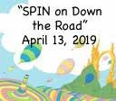
SPIN is co-sponsored by the Disability & Communication Access Board and the Department of Education.
Services include a phone line for information referral and support, a quarterly newsletter, an annual conference and community workshops. SPIN is guided by an Advisory Committee made up of parents, teachers and people with disabilities.

SPIN
1010 Richards Street #118
Honolulu, Hawaii 96813

PHONE

586-8126
Neighbor Islands dial the ex- change below, then 6-8126
Kauai - 274-3141
Hawai’i - 974-4000
Maui - 984-2400
Molokai - 1-800-468-4644
Lanai - 1-800-468-4644

FAX
586-8129

E-MAIL
spin@doh.hawaii.gov

WEB
www.spinhawaii.org

Like us on Facebook
n March, many schools celebrate Dr. Suess as part of Read Across
America Day! Today we’re borrowing from this great childen’s book author to talk up the upcoming SPIN Conference. We think if
I
Dr. Suess was writing about our conference, he might say something like the following:

Oh the places you’ll go, if you join us at SPIN,
Are to tables of experts, What? 8, 9 or 10?
No more like six times that, all ready to please;
So that you and your family can feel more at ease.
Then off to the Ballroom where SPIN dancers gyrate
And “Dorothy’s” singing is really first-rate.
We’ll pick all your brains for needs large and small,
So we’ll be real committed to solving them all.
Now the workshops are starting, there’s plenty to see,
Whether your kid is teen-aged or really quite wee.
They’re all full of knowledge and tips to take back,
To help make a difference and keep you on track.
Did we tell you there’s lunch along with great prizes?
And SPIN award winners in all shapes and sizes?
They’re people we thank for the work that they do
In making our journey just a little more true.
But by far the best place you’ll encounter at SPIN
Is the place of belonging with other like kin.
With moms and with dads whose keikis have needs
And extraordinary
gifts to share. Yes, yes indeed!
So flip to page seven,
the conference description, And commit to come join us.
No need for conniption!
If it’s support that you need, just give SPIN a jingle,
And we’ll find a nice Santa or maybe Kris Kringle
( AKA agencies willing to pay to help you come join us).
IT’S THE SPIN WAY!
WHAT’S INSIDE
Reading Apps for SLD 2 Reading Building Blocks 2 OSEP Monitoring Visit 3 Child Allowances 4
Internet Safety Tips 5
SPIN Awards Quest 5
Spotlight on Ho’omana 6
App Corner/Mazu 6
Day at the Capitol 6
SPIN Conference Flyer 7 Calendar of Events 8

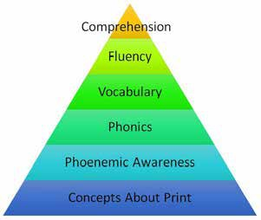
Related to Reading

Five Finger Rule
Here’s a tip for how to select books at your child’s reading level:

Building Blocks to Reading Success
In learning to read, children typcially have to master the basic skills at the bottom of the pyramid in order to develop higher level reading skills. Research in the area of children with learning disabilities has shown that deficiencies in processing letter-sounds are at the heart of many reading problems.
√ Have your child pick out a book he or she thinks looks enjoyable.

√ Ask him or her to read the 2nd page of the book.

√ Hold up one finger for each word that your child is not sure of or doesn’t know.

If there are five or more words that your child didn’t know, choose an easier book.

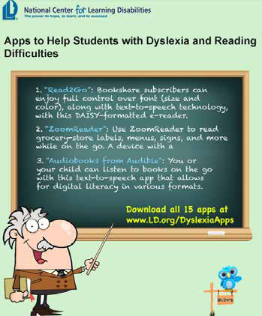
If you child did not miss any words, the book may be too easy. Pick one a little more challenging.

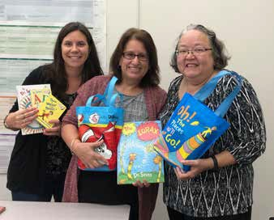
Lindsay Heller and Susan Wood, SEAC parent reps from the Big Island and Martha Guinan, SEAC Chair, with Dr. Suess books collected for a future donation to special education students.
To learn more about the Special Education Advisory Council, SEAC, check out their website: http://www.seac-hawaii.org

U.S. DOE Office of Special Education Programs (OSEP)

Monitoring and Support System for Hawaii

Due Feb. 1st each year

Due April 1st each year

Hawaii's SPP/APR Hawaii's SSIP

This required state performance plan (SPP) and annual performance report (APR) measures our progress towards meeting special education targets on 16 indicators (like graduation rate, LRE, student achievement, drop-out rate, parent participation, disproportionality, etc.)

The State Systemic Improvement Plan makes up Indicator 17 on the APR. It is a six-year plan targeting an area of student functioning critical to long term success. Hawaii selected reading achievement of 3rd and 4th graders as its main measurement of how the system is improving to provide better outcomes for these students.

Technical Assistance

Differentiated Monitoring & Support
OSEP's DMS system of determining what kind of technical assistance a state may require looks at four main components:
√ compliance with IDEA regulations
√ student performance outcomes
√ the SSIP, and
√ fiscal (how money is spent).
Determination arrives in June

Annual Determination Letter
OSEP reviews the APR and the SSIP sent earlier that year and makes a determination of the extent the state meets the requirements of IDEA. It then places Hawaii in one of 4 categories:
Meets requirements Needs assistance Needs intervention
Needs substantial intervention
Note: Hawaii has been in the Needs Assistance category for the last five years.

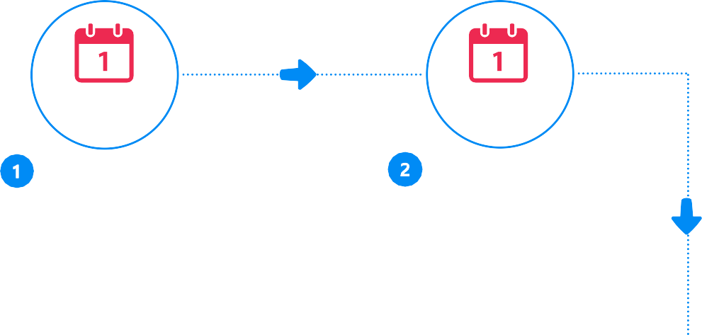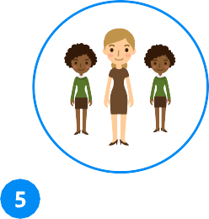

Site Visit

An OSEP DMS team visited Hawaii January 7-11, 2019 to conduct intensive monitoring and support to both early intervention & special education.

Team members included:
Jennifer Barrett-Zitkus, Part B & C State Contact, Angela Tanner Dean, Team Leader, and Christine Pilgrim, Team Member
Their main areas of technical assistance were related to the following:

- improving math and reading performance outcomes for students, and
- offering tools and suggestions to make the SSIP more effective.

Financial Literacy for Families of Kids with Disabilities: Part 2

Paying Your Child an Allowance

An allowance can be a good way for your child to learn about money. There are at least 5 money management skills you can teach with an allowance: 1) setting goals, 2) doing basic math to count money, 3) saving for a future purchase, 4) accounting (keeping track of spending), and 5) budgeting (deciding how much to spend, how much to save and how much to give to others). Here are some things to consider in setting an allowance:
When is my child ready?
5?
8? 10?
7? 9?
What are the Benefits?
Accounting
Goal setting
Budgeting
Math
Savings

Although many parents begin paying allowances when their child is in 1st or 2nd grade, there's actually no perfect age to start. See if your child is open to learning about or handling money. If you start an allowance that is tied to chores or grades, but your child is unmotivated by the money, you may want to wait until he or she is older.

Some experts suggest that you should match your child's age with dollars--for instance, $8 weekly for an 8-year old,
$10 for a 10-year old. Of course, the amount will depend on your overall family budget. If you want your child to learn to save some of their allowance and also give some to charitable causes, then you may need to provide enough money to make those options possible.
How much allowance should I give?
Spending
Saving
Donating
Should I have my child
earn the money?
Here the experts are split. Some say having chores helps kids learn the connection between money and work.
Consider tying the allowance to extra tasks--above normal family expectations of helping with dinner, making beds, etc. Others say the real purpose of the allowance is to provide the opportunity for money management lessons, not to withhold money when kids don't finish all their chores.
What are some other important things to consider?
Be clear about the terms of the allowance. Help your child create a personal budget. Pay the allowance consistently and on time.
Set a good example with your own money management.

YouTube Challenges and Internet Safety
Momo is a sinister‘challenge’that has been around for some time. It has recently resurfaced and once again has come to the attention of schools and children across the country. Dubbed the ‘suicide killer game’, Momo has been heavily linked with apps such as Facebook,WhatsApp, YouTube, and most recently (and most worryingly)...YouTube Kids.The scary doll-like figure reportedly sends graphic violent images, and asks users to partake in dangerous challenges like waking up at random hours and has even been associated with self-harm. It has been reported that the‘Momo’figure was originally created as a sculpture and featured in an art gallery in Tokyo and unrelated to the‘Momo’challenge we are hearing about in the media.
What parents need to know about
CHILDREN’SVIDEOS BEING‘HIJACKED’
MOMO
There have been recent reports that some seemingly innocent videos on YouTube and YouTube Kids (such as ‘surprise eggs’, unboxing videos and Minecraft videos) have been edited by unknown sources to include violence provoking and/or other inappropriate content. Even though YouTube monitor and remove videos that include inappropriate content, clips can be uploaded and viewed thousands of times before they get reported and removed. As a parent, it’s difficult to spot these videos as the harmful content doesn’t appear until partway through the video.
DISTRESSING FOR CHILDREN
Popular YouTubers and other accounts have been uploading reaction videos, showing their experience of the MOMO challenge. Some of the videos include a disclosure message warning that the content may be “inappropriate or offensive to some audiences” and that“viewer discretion is advised” but these videos are still easily accessed by clicking ‘I understand and wish to proceed’. The image of the ‘Momo’ character can be deeply distressing to children and young people and it’s important to note that it may slip through parental settings and filters.
SUGGESTEDVIDEOS ONYOUTUBE
Video apps such as YouTube include an ‘up next’ feature which automatically starts playing another video based on the video just watched. Due to YouTube’s algorithm, users are shown ‘suggested videos’ that they may be interested in. The thumbnails used on suggested videos are purposefully created in a way to encourage viewers to click them. During our research, we found that when watching one Momo related video, we were shown countless other Momo themed videos and other scary content which would be age-inappropriate for children under 18.

TELLTHEMIT’SNOTREAL
Just like any urban legend or horror story, the concept can be quite frightening and distressing for young people. Whilst this may seem obvious, it’s important for you to reiterate to your child that Momo is not a real person and cannot directly harm them! Also, tell your child to not go openly searching for this content online as it may only cause more distress.
BEPRESENT
It’s important for you, as a parent or carer, to be present while your children are online. This will give you a greater understanding of what they are doing on their devices, as well as providing you with the opportunity to discuss, support and stop certain activities that your child may be involved in. As the nature of each task become progressively worse it’s also important to recognise any changes in your child’s behaviour.

TALKREGULARLYWITH YOURCHILD
As well as monitoring your child’s activity, it’s important for you discuss it with them too. Not only will this give you an understanding of their online actions, but those honest and frequent conversations will encourage your child to feel confident to discuss issues and concerns they may have related to the online world.
Top Tips for Parents
DEVICESETTINGS&
Ensure that you set up parental controls for your devices at home. This will help to restrict the types of content that your child can view, as well as help you to monitor their activity. In addition to this, it’s vital that you are aware of your device and account settings to ensure your child’s utmost safety. For example, on YouTube you can turn off ‘suggested auto-play’ on videos to stop your child from viewing content that they have not directly selected.
PARENTALCONTROLS
REPORT&BLOCK
You can’t always rely on parental controls to block distressing or harmful material. People find ways around a platform’s algorithm in order to share and promote this type of material. Due to this, we advise that you flag and report any material you deem to be inappropriate or harmful as soon as you come across it. You should also block the account/content to prevent your child from
viewing it. Also encourage your child to
rec be
ord/screenshot any content they feel could
malicious to provide evidence in order to escalate
PEERPRESSURE the issue to the appropriate channels.
Trends and viral challenges can be tempting for children to take part in; no matter how dangerous or scary they seem. Make sure you talk to your child about how they shouldn’t succomb to peer pressure and do anything they are not comfortable with, online or offline. If they are unsure, encourage them to talk to you or another trusted adult.
REALORHOAX?
As a parent it is natural to feel worried about certain things you see online that may be harmful to your child. However, not everthing you see online is true. Check the validity of the source and be mindful of what you share as it may only cause more worry.
FURTHERSUPPORT
Speak to the safeguarding lead within your child’s school should you have any concerns regarding your child’s online activity or malicious content that could affect them.

If your child sees something distressing, it is important that they know where to go to seek help and who their trusted adults are. They could also contact Childline where a trained counsellor will listen to anything that’s worrying them.

The Childline phone number is 0800 1111.
Kids love YouTube. They watch other people play video games, they watch movies and music and they like to watch challenges. Many of them are funny or even helpful, like the “Try Not to Laugh” and “ALS Ice Bucket Challenge”, but there are some that can be downright dangerous, like the “Tide Pod” Challenge. National Online Safety has posted a guide for a sinister challenge called “Momo”. It has been around for awhile, but has resurfaced and is linked to Facebook, Whatsapp and YouTube. It is very concerning because it not only shows graphic and violent images to your keiki, “Momo” encourages youths to self harm. The best thing you can do to protect your keiki from online harm is to talk to your kids about what they see and interact with online. Common Sense Media posted 12 challenges your kids probably already know about.
Visit their website to find out more about internet safety. Here are a few fun ones you could do with your keiki:
- Whisper Challenge: one peson wears headphones with loud music and the other person says a phrase outloud. The person listening to the music tries to repeat the phrase.
- Mannequin Challenge: a group of people get together and pose, freezing in place, while someone with a camera walks around recording the scene

with music playing in the background.
- Eat It or Wear It Challenge: A player chooses food from numbered bags. If they choose to eat it, they can dump the rest on another players head; if they choose to wear it, well, plan this one around laundry day.
To learn more about internet safety, visit the following websites:
- https://www.commonsensemedia.org/blog/12-youtube-challenges- your-kid-already-knows-about?utm_source=Facebook&utm_medi- um=social
- https://nationalonlinesafety.com/resources/platform-guides/momo-on- line-safety-guide-for-parents/
- https://smartsocial.com/

2019 SPIN Awards Need Your Nominations!
very year, SPIN publicly celebrates wonderful parents and professionals whose efforts make a positive difference in the lives of our keiki with disabilities and their families. The SPIN Advisory Committee is
E
looking for candidates for our 2019 SPIN Awards and we need your help in nominating someone who models the qualities and actions that families appreciate and rely on. There are three award categories:
  - The Parent of the Year Award is given to a parent or parents of a child or young adult with a disability whose actions and advocacy have benefited other families.
  - The Professional of the Year Award is given to a professional who has had a significant impact in improving services for children and/or youth with a disability and their families.
  - The Family Choice Award is given to a professional who has been particularly helpful to families as they sort out services for their child with a disability. This individual may not have an impact on the larger system, but is recognized in his or her community as an extraordinary professional.
We encourage you to share your aloha and nominate one or more very special people for any or all of the awards. You can go to our website at www.spinhawaii.org, click on the conference tab and download an award nomination form. Or call us at 586-8126 and we’ll
accept your nomination over the phone or mail you a form. Deadline to apply is March 12th.

Spotlight
on Support

If your kids are begging you to join social media, but you’re worried about what they will see, do and post, we have discovered an app that will make both kids and parents happy. Mazu is
a social media platform for kids that promotes mindful interactions based on core values, fun activities and exclusive experiences. Created by a parent, Mazu allows kids and teens to join communities and share ideas that you and your
kids care about. There are moderated group chats and no ads to pop up and click on. They have their own messenger service to keep families connected and share their day with one another. We like that all posted content and comments are moderated and filtered for appropriate content.
Mazu is free to download on Apple and Android devices.
If you live on the Windward side of Oahu and have a child with autism, check out Ho‘omana, a support group by parents, for parents. They are sponsored by the Windward District Autism Program and have two locations for meetings, one at the Key Project in
Kahalu’u and one at the Pali View Church in Kaneohe, both meetings are from 6:00 - 7:30 pm.
They offer:
- Unbiased support to families
- Free child/teen/adult care (please RSVP to guarantee childcare by qualified individuals)
- Guidance to navigate systems
- Guest speakers
- Light snacks
To find out more about them and RSVP for their next meeting you can contact them via:
- Website: https://sites.google.com/view/ windwardautismprogram/parentfamily-support/ hoomana
- Email: hoomanagroup@gmail.com
- Call: 808-426-6879

A Day at the Capitol

Thursday March 7, 2019, State Capitol Auditorium, Chamber Level 9:00 - 3:00 pm

March is Developmental Disabilities Month and one of the many activities happening in March is A Day at the Capitol. It is an annual event that celebrates and encourages individuals with intellectual and developmental disabilities and their family members to take the opportunity to discuss disability-related issues and concerns with legislators and network with other concerned citizens.
Activites for the Day:
  - Continental breakfast
  - Welcome & orientation
  - Meet with Legislators
  - House & Senate floor sessions
  - Lunch
  - Legislative hearings
  - Meet with Legislators
  - Tour of State Capital

For more information call the State Council on Developmental
Disabilities office at 808-586-8100.

“SPIN on Down the Road”

Saturday April 13, 2019 • UH Manoa Campus Center Ballroom

8:30 a.m. - 9:00 a.m. Registration • Networking • Display Tables 9:00 a.m. - 9:45 a.m. Keynote Presentation in Ballroom
9:45 a.m. -10:15 a.m. View Displays in Boardwalk of Resources Room, 2nd floor • Networking Act 1 10:20 a.m. - 11:20 a.m.
“Ease on Down the Road” | “We’re Not in Kansas Anymore” | “Wonderful World of Reading” | “If I Were King of the Forest” | “The Great Oz Has Spoken” | “Happy Little Bluebirds”
Transition to Adulthood | IEP 101:  Basic Training | Early Literacy | Civic Advocacy | Family Media Plan | Parent Self Care

A
11:30 a.m. - 1:00 p.m. View Displays in the Yellow Brick Road of Resources 12:00 p.m. - 1:15 p.m. Buffet Lunch in Ballroom • Awards Presentation
ct 2 1:20 p.m. - 2:20 p.m.
“Who You Meet Along the Way” | “You’ve Had the Power All Along” | “Taming the Flying Monkeys” | “Nothing is Impossible” | “The Emerald City” | “Munchkin Land”
Planning for Supports | IEP 201:  Advanced Training | Positive Behavior Supports | Coping Strategies for Families | Financial Literacy | Early Intervention Transition to DOE

Act 3 2:30 p.m. - 3:30 p.m.
“A Horse of a Differnet Color” | “Keep Calm & Click Your Heels” | “Over the Rainbow” | “The Road to Oz”
Strategies to Support Students with Autism | ADD / ADHD | Seizure Disorders | Self-Determination
Workshops are subject to change

REGISTRATION FORM
Name Address City Zip Phone: H / C / W (circle one) Email: Child’s Disability: Child’s Age: Program or School:
q $25 per parent q $45 for two family members q $25 per college student q $50 per professional
Amount Enclosed $ (payable to SPIN) Check or P.O. Number

q Airfare Scholarship Request (for Neighbor Island parents and grandparents of kids with disabilities 0-21) Note: due to a large demand, we are now waitlisting requests for scholarships.
q Please send me an application by q email q postal mail
q My Airfare Scholarship application is enclosed. q I will send in the application later.

q Accommodation Request due to a disability (check one)
q Sign Language interpreter q Materials in an alternate format: Accommodations must be submitted by March 15, 2019 to ensure availability
Send completed form(s) with payment as soon as possible to: SPIN via mail, fax or email:
1010 Richards Street, Room 118, Honolulu, Hawaii 96813 • Fax: (808) 586-8129 • Email: spin@doh.hawaii.gov Questions? Call us (808) 586-8126 • Website: www.spinhawaii.org

3/2 Access Surf Day at the Beach
Calendar of Events

3/16 Self Defense Seminar

4/6 9:00 am - 1:00 pm, FREE surfing event for all
5/4 ages and abilities. White Plains, Ewa Beach Sign up online at www.accessurf.org

Pacific Rim International Conference
3/4 “Sucessability” 7:00 am - 5:00 pm both days
3/5 Multiple workshops over two days, held at the Hawaii Convention Center in Honolulu.
A special rate of $100 per day is being offered to parents, students and self-advocates. Use the code: SFAjy100. For more info or to sign up online: www.pacrim.hawaii.edu/ or call
808-956-4437, email: prreg@hawaii.edu

3/5 Talk About IEP’s Workshop
9:30 - 11:00 am FREE
A moderated discussion on the process of getting out of district placements, independent evals and common missteps to avoid. Meet at Ebar at Nordstrom at Ala Moana. RSVP by visiting their website: www.tacanow.org/hawaii

3/7 Day at the Capitol with Hawaii State Council on Developmental Disabilities 8:00 am - 12:00 pm FREE
Meet with legislators and celebrate diversity. RSVP 586-8100.

3/8 SEAC - Special Education Advisory 4/5 Committee Meeting 9:00 am - 12:00 pm
5/17 Open to the public. Meetings held at Puuhale Elementary School, library. 345 Puuhale Rd. For more info, call 586-8126 or visit their website at www.seac-hawaii.org

3/8 Radical Self Care Workship
8:00 am - 12:00 pm, $20 + $6 parking Sponsored by Hawaii chapter of NAMI. To register, call 808-594-1297 or online www.namihawaiistate2019.eventbrite.com

3/9 Hawaii Families as Allies Family Conference 9:00 am - 2:00 pm FREE at the Kroc Center in Ewa Beach. To register, call 808-682-1511 or email: events@hfaa.net
900 - 11:00 am FREE
Central Oahu Jiu-Jitsu, 401 North Cane St. #A3 Waihiawa. $10 per student/parent. To RSVP, call Kris Dung at 808-722-6843.

3/16 ASL Nook Author Book Signing
9:00 am - 12:00 pm FREE at Hawaii School for the Deaf and the Blind. Lunch, book signing and book fair. To register or for more info, email: deedee_mikasa@hsdb.k12.hi.us

3/20 EFMP Come Fly with Me
9:30 - 11:00 am FREE
All branches are welcome to attend this event that is aimed at helping kids who do not like to fly or do not like crowds, feel more comfortable with the process. Hickam Air Force Base.
RSVP online: https://hawaii.armymwr.com or call 808-655-4227.

3/20 | Honolulu District Families Embracing
4/17 | Autism 6:00 - 7:00 pm FREE
5/15 | 245 N. Kukui Street, Honolulu  Different topics each month. 3rd Wednesday every month, Free parking and childcare with RSVP 536-9684.
3/29 | EFMP “SPEDucation Blitz”  10:00 am - 12:00 pm FREE  Presentation by the Hawaii Disability Rights Center on “Transition Plans” to learn how to be advocates and learn more about to plan for transition from high school to adult life.  RSVP online: https://hawaii.armymwr.com or  call 808-655-4227.

SAVE THE DATE!
4/13 33rd Annual SPIN Conference “SPIN on Down the Road”
8:30 am - 3:30 pm at UH Campus Center Registration forms and airfare scholarships available www.spinhawaii.org, call us at 586-8126 or email spin@doh.hawaii.gov.

For more events and happenings around the state, be sure to visit our website events calendar at www.spinhawaii.org/events and like us on Facebook!
SPIN - Special Parent Information Network

8

