Reflecting on the Legislative Session
May 2019
Volume XXXV, No. 4
SPIN is co-sponsored by the Disability & Communication Access Board and the Department of Education.
Services include a phone line for information referral and support, a quarterly newsletter, an annual conference and community workshops. SPIN is guided by an Advisory Committee made up of parents, teachers and people with disabilities.

PHONE
586-8126
Neighbor Islands dial the ex- change below, then 6-8126
Kauai - 274-3141
Hawai’i - 974-4000
Maui - 984-2400
Molokai - 1-800-468-4644
Lanai - 1-800-468-4644

FAX
586-8129

E-MAIL
spin@doh.hawaii.gov

WEB
www.spinhawaii.org

1010 Richards Street
Room 118
Honolulu, HI 96813

very year about this time, we take a minute to reflect on the small
E
and large legislative victories resulting from the four-month long legislative session. On page two we have listed ten bills and/or resolutions that made it through to the last committee hearings and final vote. They all
have a potential impact on the lives of children and youth with disabilities and their families.
While the Hawaii State Legislature has adjourned until
January of 2020, these bills and the other 288 bills that passed have several more hurdles posed
by the Governor’s Office:
- avoiding the Governor’s veto, and
- budget restrictions, if monies are involved and state revenues drop.
As you can see from the graphic below, only a small fraction of the bills introduced at the beginning of the session make it all the way to the end, so it is also important to pay attention to what bills died in committee. Here is a partial list of issues we hope may

PROCESS OF ELIMINATION FOR BILLS AND RESOS
WHAT’S INSIDE
New Bills and Resos 2
Never Quit Dreaming 3
Executive Functioning 3
Summer Reading 3
The App Corner 3
Summer Jobs for Kids 4
P SPIN Awards P 5-7
Calendar of Events 8
be brought back to life next year:
4 including people with disabilities in minimum wage requirements;
4 allowing special education teachers with appropriate training to design and carry out behavior plans for their students;
4 providing teacher housing subsidies and other incentives; and 4 banning the susupension of pre- schoolers in public pre-K programs.
Also on our wish list are some
improvements to the legislative
process that would result in greater transparency
and public participation. At the end of this year's session, a number of bills seemingly headed for passage were lost in conference committees. The public deserves a clear explanation of what or who killed the bills. Secondly, the Senate should change its practice of only allowing oral testimony in the first committee a bill is discussed.
Parents and others are discouraged when their voices are not heard.

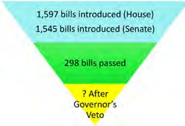

TOP
from 2019 Legislature with an impact on students with disabilities
10
BILLS & RESOLUTIONS

HB 1009 – Requiring movie theaters to provide at least two showings per week per movie offered with open captioning. (Benefits student who are deaf, hard of hearing, learning disabled and English learners).
1
SB 330 – Requiring the Department of Human Services to carry out an earned income program that disregards the work income of a person with disabilities that totals 138% of the poverty level when making a determination of their eligibility for Medicaid.
Kal's Law
2
SB 383 - Requiring the Department of Education to start a mandatory youth suicide awareness and prevention training program for all public schools, including charter schools.
3
SB 388 - Forming a task force to create a system for assessing children and youth who are having behavior problems, academic challenges, and/or chronic absenteeism and who are in need of supports and interventions.
4
SB 1236 - (for parents whose children have been issued handicapped parking placards) Limiting the exemption from paying parking meter fees to drivers who are unable to reach or operate a parking meter or unattended pay station due to a physical disability.
5
6

SB 549 - Requiring restaurants that serve a child's meal to include a healthy beverage (water, 1% milk, or 100% fruit or vegetable juice).

HB 664 - Banning the use of conversion therapy on a student under the age of eighteen as a treatment to change the individual's sexual orientation or gender identity.
7
HB 1273 - Creating an Intellectual/Developmental Disability (I/DD) Administrative Claiming Special Fund to hold federal matching funds from the DD Waiver and requiring the Departments of Health and Human Services to inform stakeholders of I/DD Waiver services.
8

SR 153 - Requiring DOE to conduct a study to address whether it has adequate vocational education programs.
9

HR 33 - Encouraging DOE and interested stakeholders to meet as a working group to promote sexual violence prevention programs in public schools.
10

2

Spotlight on
Support

Never Quit Dreaming is a not-for-profit organization on Oahu that creates recreational activities and unique ex- periences for children who have a disability. Since their inception in 2016, Kris Dung, the founder of NQD, has provided opportunities for kids to attend fun events at discounted prices, like the Amazing Aloha Comic Con, and Kauai Kon. He also works with local businesses and professionals to develop workshops and clinics for young athletes who are interested in golf, martial arts and soccer. Kris also coaches and manages an AYSO soccer team and a baseball team called the Firebirds
for children with disabilities. He goes the extra mile to make the experience fun, inclusive and meaningful. He partnered with the Mililani High School’s baseball team to provide mentoring and practice games, and it has been a win-win for both teams. Whether you are
looking for fun recreational opportunities, a community event or want to see what Never Quit Dreaming has to offer, visit their website at www.nqdhawaii.org, contact Kris by email neverquitdreaming@gmail.com or call them at 808-722-6843. Don’t forget to visit their Facebook page too. Happy Dreams!

After reading an article in the Washington Post about app tracking, data sharing and privacy settings, we thought we share a few ways to protect yourself and your keiki from third party “data brokers”. The apps on your phone will share your information - location,
phone number, email, and internet searches, just to name a few - to third party companies, so that they can provide targeted advertising to you. Have you ever noticed that after you’ve searched for bike helmets on Amazon or Google, you start to see ads for bike helmets all over the place? You can thank app and data tracking for that. For iPhone users, there is a free app called Disconnect that will protect your phone from hidden apps and tracking. You can also go directly into your iPhone to Settings > Privacy > Advertising > Toggle on “Limit Ad Tracking”. For Android users, you can opt out of targeted ads by going to Settings > Google > Ads > Toggle on “Opt out of ads personalization”. For more information and other ways to “opt out” of data tracking, visit https://www.us- atoday.com/story/tech/columnist/komando/2019/02/14/ your-smartphone-tracking-you-how-stop-sharing-data- ads/2839642002/

INFORMAL JOBS

Bake Sales

In our February SPIN News, we talked about paying your child an allowance as a great way to help learn about money. Summertime offers yet another opportunity--the summer job--for lessons related to setting goals, earning, budgeting and saving. Below are some simple job ideas that may appeal to you and your keiki:
Financial Literacy* for Families of Kids with Disabilities: Part 3
Summer Jobs for Kids
Cookie, cake and cupcake sales and/or preparing desserts for special occasions .

Recycling

Offer to pick up cans, bottles and scrap metal from neighbors and friends.

Pet Services

Pet walking, pet-sitting, and pet grooming are all sought after services for pampered pets.

Raking, mowing the grass, and doing other light yard work is a healthy activity that grows repeat customers.

Yard Care

Gardening

Bounty from the garden-- fruits, vegetables, spices, flowers, and house plants--can be sold to neighbors & friends.

Yard Sales or Swap Meet

Selling items that your child no longer uses--like books and toys--can earn some extra $$.

FORMAL JOBS

Food Services
1
25% of young people work as a host, cashier or server in a restaurant.

Retailing

17% of young people work in retail jobs as sales clerks, stockers and cashiers.

Childcare

11% of young people hold jobs as a babysitter, nanny or tutor.

* Financial Literacy involves teaching our children how money is made, spent and saved, and how to make good money decisions that lead to their financial stability and security as adults.

2019 Parent of the Year Awards
Jon Stremel
This Navy dad is a single parent raising his son Calvin while he bravely balances his Navy obligations and on-line courses at Harvard. After his son was diagnosed with autism, Jon worked out a schedule to attend Calvin’s early intervention sessions with his skills trainer and found time to volunteer, sharing information and encouragement with other families through Autism Speaks and the Exceptional Family Member Program. Now a proud parent of a preschooler at Maili Elementary, both Jon and Calvin are easing on down the road to a brighter future for themselves and their community. Please welcome this Oz-some dad to the SPIN Community as a Parent of the Year.
Shana Cruz
Like the beloved Scarecrow in Wizard of Oz, Shana embodies friendship, problem-solving and leadership. The parents who nominated her filled the pages with how she helped them to feel not alone anymore and how she took their hands and guided them through complex systems with strength and courage. She has mastered the art of juggling a full time job at Habitat for Humanity, being an active member of her Kauai Community Children’s Council, a regular participant at Easter Seals parent support group and a strong advocate for her 3 young children, 2 of whom have been diagnosed with Autism. And if that wasn’t enough, Shana created a parent support group called “Be the Voice!”, hosting a coffee hour every Saturday in different locations, to accommodate Kauai families. We are delighted to recognize her commitment as a parent leader and lifetime friend.
Anita Yokota
Like Dorothy, who was lost but determined to find her way, Anita has built supports that were missing in her daughter’s life. Those who know her say that she is a gracious, and appreciative parent, always striving to build bridges within her school community. She keeps a positive, mindful attitude, even when it feels like a tornado is brewing. She partnered with LDAH to create a series of training opportunities at Kailua High school, on topics that are important to teens, like dating and transitioning from high school to adult life. Anita linked arms with a dedicated educator to support an after school social skills group for students. She is solution-oriented and thinks out of the box to create a world where her daughter Indigo is respected and appreciated. We predict you will love her as much as we do!
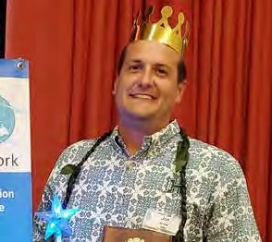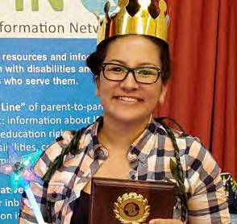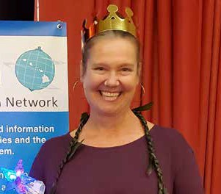

2018 Family Choice Awards
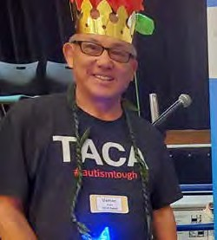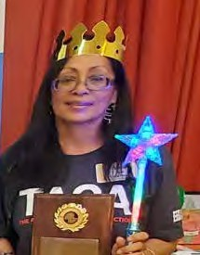
Vernon & Vera Asato
This Family Choice duo has a bond stronger than Dorothy & Scarecrow and has traveled the road to Oz and back again in their journey to support their son. Instead of hiding behind the curtain, these parents have pulled the curtain aside and have become mentor wizards to families who are on their own journey down the yellow brick road. These two characters volunteer their time with TACA, The Autism Community in Action, to be a voice
of experience and wisdom to parents who have younger children. Moms often lead the charge in connecting to others, attending meetings and staying on top of school and medical information, but this dad is very supportive and is a wonderful role model for other fathers. Vera & Vernon attend every TACA event, volunteer at every SPIN Conference to sit at the TACA table, and often bring their adult son, Tyler, to events as well, in order to give back to the community that supported them. Please join us in thanking them for their time, their experience and their dedication to helping families navigate their own journeys to Oz.
Kristopher Dung
This is a guy with a really big heart. He saw a need in Munchkin Land for more recreational activities for kids with disabilities, and instead of waiting around for someone else to start a program, got busy with creating his own. This sports wizard coaches the VIP Soccer program through AYSO and on the baseball diamond with the first community based PONY baseball team, the “Firebirds”. He partners with Mililani High’s baseball student athletes, providing opportunities for inclusion, friendships and mentoring. Coach Kris creates unique experiences through his non-profit “Never Quit Dreaming”, offering discounts to events like Aloha Comic Con and Kauai Kon and has partnered with professionals to provide weekend golf clinics and martial arts self-defense classes in Jiu Jitsu. In his “spare” hours, Kris also volunteers his time to provide childcare
to the monthly parent support group Side by Side. Whether you are dreaming of a sports experience, wishing for more community
inclusion or thinking of ways to connect with others click your heels 3 times and say “There’s no place like Never Quit Dreaming” We are so happy to bestow this Family Choice Award to Kris Dung.
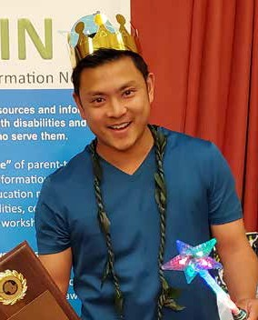

2018 Professionals of the Year
JoAnn Quon
JoAnn has shared her magic—helping little keiki to speak and communicate—in public schools, in HeadStart classrooms and now inside the welcoming doors of the Parent and Child Development Center for Early Intervention in Waianae. JoAnn is a wizard at dispensing wisdom and mentoring families, including families with the Exceptional Family Member Programs and families of keiki who have graduated from early intervention. For some, a new diagnosis can feel like a tornado is bearing down on them. Joanne helps shelter them from the storm of emotions and information overload. She gives them a safe haven to pick themselves up and continue down the yellow brick road. More importantly, she imparts hope that each family and child will find their way to success. We are delighted to welcome the Wizard of Waianae as a SPIN Professional of the Year.
Galen Chock
This next Professional of the Year not only has an amazing brain but an amazing heart too. When Galen was the president of the American Academy of Pediatrics Hawaiʻi Chapter, he received national recognition for estab- lishing The Pediatric Council for health plans and public health directors to hui around pediatric health issues. Through his efforts families have saved thousands of dollars in out of pocket expenses by insuring adequate access to services. He also helped create a membership role for a family advocate, the first of its kind in Hawaii. As the Co-author of the Hawaiʻi Pediatric Obesity Tool Kit, he has brought the necessary tools to have conversations with youth and families around obesity. Galen is committed to building resiliency in
not only youth, but in his community. He as been an scout leader facilitating youth to become eagle scouts, a reader for his church, and has ukulele days at his office where we had his staff can reduce their stress levels by playing music, using his gifts and talents to make Hawaii a better place for all.
Gabriele Finn
Gabriele is like Glinda the Good Witch, spreading joy and happiness everywhere she goes. She began her career in the DOE as a Social Studies teacher. But when her son was diagnosed with ADHD and reading challenges, she got trained in Orton Gilliingham to help him. Like Glinda, she traveled around the land of the DOE, and was part of the first cohort of Student Services Coordinators at Kaiser High School. She traveled by bubble to Olomana and then became a Resource Teacher in the Windward District. Today, you can find Gabriele working with the munchkins at Keolu Elementary school as their SSC. She has been a strong advocate for inclusive education and Assistive Technology, and works to bring both
high and low tech to the classroom for her students. With over 25 years of service with the DOE, Gabriele has the brains, heart and courage to help our children find their home in the classroom and we are so happy to
honor her today as one of SPIN’s Professional of the Year.
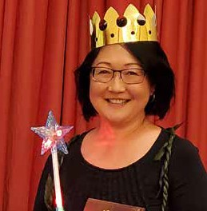
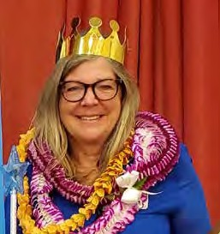

Events & Workshops

6/1 AccesSurf Day at the Beach FREE
7/6 9:00 am - 1:00 pm Provides adaptive surfing, shoreline flotation and swimming for any person with a disability. White Plains, Ewa
Beach. Sign up @ www.accessurf.org

6/6 Read to Me Conference
6/7 7:30 am - 4:00 pm $195 for 2 days, includes breakfast and lunch. Open to educators, parents and anyone who is interested in sharing the love and joy of reading aloud. Koolau Ballrooms, Kaneohe. More more info, visit their website at www.readtomeintl.org/conference2019

6/7 TACA Coffee Talk & Learn FREE
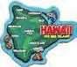
10:00 am - 12:00 pm Waikoloa Community Church, 68-3621 Paniolo Ave., Waikoloa 5:00 - 7:00 pm PATCH Hilo Office,
26 Waianuenue Ave. Hilo
The theme of this Big Island event will be “Occupational Therapy Across the Spectrum”. RSVP at www.tacanow.org/local-chapters/west hawaii/

6/7 Sibling Workshop “What About Me?” FREE 5:30 - 6:30 pm EFMP Army workshops for siblings aged 6-16 whose sibling is an exceptional family member. Army Community Services Bldg 690, to RSVP or for more info, call 655-4227.

Sensory Friendly Films - Oahu
6/9 “Secret Life of Pets 2” 9:00 am- 12:00 pm.
6/29 “Toy Story 4” 9:30 am - 12:00 pm Sponsored by the Autism Society of Hawaii. Sensory friendly films have the lights up a little and the sound down a little with lots of aloha from your neighbors in the theater. $13 for adults & siblings, FREE for children with autism. Consolidated Ward Theater 1044 Auahi St, Honolulu. for more info,
visit www.autismsocietyofhawaii.org

6/11 Kauai AccesSurf Day at the Beach FREE 10:30 am - 2:00 pm at Lydgate Park in Lihue. Surfing, and other adaptive water sports like snorkeling, swimming and kayaking.
Sign up at www.accessurf.org
6/12 Epilepsy Talk Story FREE 5:30 - 7:30 pm The talk this month will center around
“Art Therapy”. 200 N. Vineyard Blvd., Honolulu. RSVP: efh@epilepsyhawaii.org or 538-3058

6/19 Honolulu District Families Embracing Autism Support Group FREE
6:00 - 7:00 pm. The theme is about
“Safety Strategies” with guest speakers from Kapiolani Medical Center. Free parking, 245 N. Kukui Street, Honolulu.
RSVP for childcare 536-9684.

6/22 Kualoa Ranch Bus Tour and Petting Zoo 3:30 - 5:00 pm with dinner to follow. $25 per person. Sponsored by Never Quit Dreaming. For more info or to RSVP, call 722-6843 or email neverquitdreaming@gmail.com
6/22 Maui Ability Awareness Fair FREE 10:00 am - 3:00 pm, Queen Kaahumanu
Center in Kahului. Contact Nani Watanabe for more info 243-4328.

Side by Side Parent Support Group FREE
6/25 “Special Needs Trusts”
7/23 “Executive Function Disorders”
6:30 - 8:30 pm, Inspire Church, Waikele Shopping Center. Limited childcare available. RSVP by email: sidebyside@inspirechurch.tv

6/27 Ho‘omana, Parents Supporting Parents 7/25 FREE Windward Oahu Autism Support
Group. 6:00 - 7:30 pm. Come to talk story, share tips and learn about resources.
Pali View Baptist Church, 45-510 Halekou Rd., Kaneohe. For more info, email hoomanagroup@gmail.com or call 426-6879

8
Want to keep up to date on happenings, workshops and events around the state? Here are three ways to get connected:
- Sign up for E-blasts spin@doh.hawaii.gov
- Visit our website at spinhawaii.org
- Like our Facebook page for SPIN - Special Parent Information Network!

