The Newsletter for Parents of Children with Disabilities

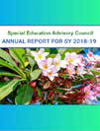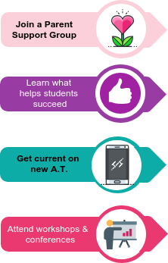

September 2019
Volume XXXVI, No. 1
SPIN is co-sponsored by the Disability & Communication Access Board and the Department of Education.
Services include a phone line for information referral and support, a quarterly newsletter, an annual conference and community workshops. SPIN is guided by an Advisory Committee made up of parents, teachers and people with disabilities.

SPIN
1010 Richards Street #118
Honolulu, Hawaii 96813

PHONE

586-8126
Neighbor Islands dial the ex- change below, then 6-8126
Kauai - 274-3141
Hawai’i - 974-4000
Maui - 984-2400
Molokai - 1-800-468-4644
Lanai - 1-800-468-4644

FAX
586-8129

E-MAIL
spin@doh.hawaii.gov

WEB
www.spinhawaii.org

Like us on Facebook

Nurturing Your Inner Advocate
With our first edition of the school year SPIN would like to offer some suggestions to best support your journey this year:
Learning from other parents is both informational and inspirational. Check out page 8 or our SPIN website for groups near you.

Every year research shines light on what works best for students with disabilities.
Page 2 and 3 talk about how important regular school attendance is for our keiki’s future success.

Even though your 4th grader may know way more about phone apps than you do, check out the phone tools on page 4 to keep your toe in the game.

Next month on Oahu there’s a great transition fair for middle and high- school families. It’s also not too early to plan for the 2020 SPIN Conference!

WHAT’S INSIDE
Absenteeismm- Facts 2
Absenteeism - Strategies 3
Tools for Your Phone 4
Footsteps to Transition Fair 5
Develop Growth Mindset 6
9 Ways to Growth Mindset 7
Calendar of Events 8

Get your copy of the SEAC Annual Report for SY 18-19 by going to:
www.seac-hawaii.org/reports.

Chronic Absenteeism and Students with Disabilities

Chronic absenteeism measures the % of students who are absent for 15 or more days during the school year due to excused and unexcused absences and suspensions.
One in four of Hawaii's students with disabilities are chronically absent every year. This rate is 1.7 times higher than students without disabilities.

Missing 15 or more days of instruction puts students at risk for:

Higher drop-out and lower graduation rates
Missed opportunities for rewarding activities at school
Lower future earnings

Students with disabilities have extra risk factors for chronic absenteeism, including the following:

HEALTH
More students with IEPs are likely to have a chronic health condition.
3x

Taking medication may cause fatigue or side effects.

Emotional disabilities like anxiety and depression may cause students to miss school.

PROGRAM
Inadequate or inappropriate special education and related services can put students at risk of missing school.

PLACEMENT
Students who spend the majority of their school day with mostly other special education students miss more school than those in inclusive classes.

BULLYING
2-3x more
students with IEPs are likely to be bullied than students without IEPs.

SUSPENSIONS
More students with IEPs are suspended than students without disabilities.
3x

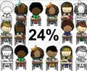
For more information and links to information used in this infographic, go to SPIN's website: www.spinhawaii.org/newsletter.

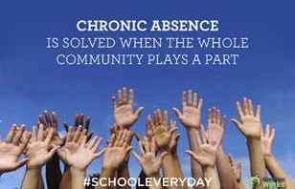Chronic Absenteeism and Students with Disabilities
students with IEPs aremore likely to have a chronic health condition

Helping students with disabilities reach the goal of "School Every Day" will take families, students, educators and community members working together.

Here are some recommendations for families and schools to take into consideration:

Family suggestions
School suggestions

Talk to a teacher or counselor if your child seems anxious about going to school, or if he or she has a sudden change in behavior.

Schedule doctor and other appointments after school.

Have regular routines for bedtime and morning preparation for school.

Make getting to school on time every day a priority.

Stay on top of your child's social contacts and school work.

Report any bullying of your child at school or on school property to the principal.

Don't let your child skip school to sleep in, finish an assignment or go on holiday.

Let the school know about any chronic health conditions and ask for any needed supports at school.
Provide access to school health services, including school-based therapists, for students with chronic health conditions

Act quickly to address absences directly related to a student's disability. Consider the need for an IEP meeting.

Provide mentoring programs for students who start to head off track.

Make communication with parents a priority.

Reduce the use of suspensions for school discipline offenses.

Consider implementing an evidence based drop out prevention program.

Provide access to inclusive classrooms and appropriate supports.
Involve students in developing strategies for reducing absences and improving school climate.

For more information and links to information used in this infographic, go to SPIN's website: www.spinhawaii.org/newsletter.

In this edition of The App Corner, we are highlighting the basic accessibility tools available on most phones. You can access them by clicking on settings, then accessibility. Let us know on Facebook which one is your favorite go-to access tool. For more info, check out these websites:
www.understood.org/en/school-learning/assistive-technology/assistive-technologies-basics/assistive-tech-
nology-thats-built-into-mobile-devices and www.commonsensemedia.org/special-needs/what-accessi- bility-settings-on-my-devices-can-help-my-child-with-special-needs

Popular Accessibility Tools for Your Phone

Vision Hearing Reading

iOS/Apple

VoiceOver: narrate commands, providing auditory feedback for the actions he or she is performing on the device.
Invert Colors: improves screen clarity with higher contrast.
Zoom: magnifies anything on the screen

Android

Talk Back: narrate commands, providing auditory feedback for the actions he or she is performing on the device.
Magnification Gestures: magnifies anything on the screen.
Both iOS & Android
Braille Devices Bluetooth to devices.
Camera: can be used to magnify small text by opening the camera and zooming in.

Voice Assistants
Between Siri, Bixby, Samsung Voice, Alexa and Google Assistant, using your voice to send an email or text, get directions or check your calendar is an easy way to access your digital world.

Infographic created by SPIN

For additional links to learn more about phone accessibility, visit our website: www.spinhawaii.org
iOS/Apple

Captions and Subtitles can be turned on to caption any media that has been captioned.

Android
Live Captions: caption all media played on your device.
Both iOS & Android
Bluetooth: connects to hearing aids directly.
Video Calls: so users can see each other during calls.

Writing
iOS/Apple
Shake to Undo: is an easy way to undo mistakes made when typing.

Android
Switch Access: You can use one or more switches or a keyboard to control your phone rather than using the touch screen.
Both iOS & Android
Dictation: translates speech to text and has word. prediction already turned on. Predictive Text: anticipates what word might come next and lessens the amount of typing needed.
iOS/ Apple

Speak Selection: text to speech lets you change the rate of speech and highlights words.
Speak Screen: reads the whole screen.

Android

Talk Back: a screen reading feature to read aloud text from websites, email and more.
Both iOS & Android
Font Size, Magnification and High Contrast are available across platforms and allow for customizable experiences for all users.

Other
Both iOS & Android
Guided Access & Restricted User Profile: temporarily limit access on the device to only one app at a time.
Assistive Touch & Assistant Menu: lets your child customize hand gestures (such as gestures for zooming in and out).
Bluetooth to other devices like screen readers, braille writers and speakers Calendar app: for reminders on assignments, appointments and other things to keep organized.

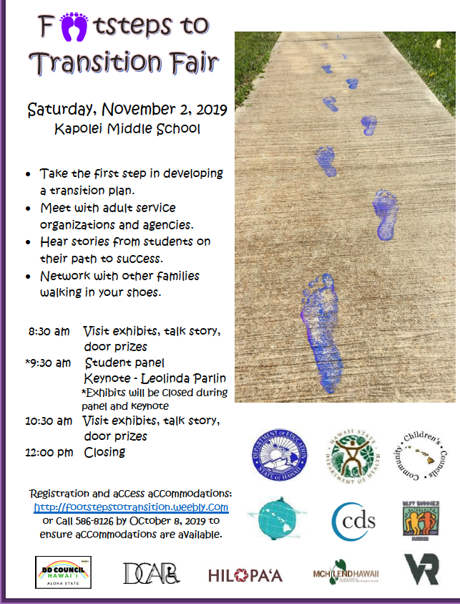Transition to Success
Please join us at the “Footsteps to Transition Fair,” hosted by the Department of Education, Leeward District! This FREE event is geared towards middle and high school students with disabilities, their families, case managers, therapists, teachers, and anyone else in their circle of support. It’s not too early to start planning and preparing for life after high school. As you transition to post- graduation and adulthood, it can be a challenge to make the many decisions
about life after high school. Will you go to college, get a job, and/or move into your own place? Who do you turn to if you need help with your finances, or need to see a doctor, or want to make new friends? Will your parents continue to make decisions for you, or will you be responsible for your own choices? How
do parents access services for their adult child? All of
these questions can be answered at the upcoming “Footsteps to Transition Fair” hosted by the Department of Education in partnership with various community agencies. Knowledgeable guest speaker, Leolinda Parlin of Hilopa‘a Family to Family Health Information Center, will explain the transition process in easy to understand steps. A student panel will share their own experiences of the transition process. A variety of State and private agencies will come together under one roof to provide information about their services for students with special needs after high school. This is a great opportunity to meet and network with other students and families to build and add to your support system. There will be door prizes and free light refreshments to enjoy. We look forward to seeing you there! Call SPIN at 586-8126 to register, or go online www.footstepstotransition.weebly.com and click on the RSVP tab. Walk-ins are welcome, if you forget to register in advance of this free Oahu-wide event.

Developing Your Child’s Growth Mindset

Most of our readers may have heard the words “fixed mindset and growth mindset”, but hearing about these concepts and using them in our daily lives are two very different things. A Fixed Mindset reinforces the idea that our intelligence, talents and skills are born to us, that we are this way from birth and we’ll always be that way. A Growth Mindset sets the stage for growth and improvement
by suggesting that anyone can develop their intelligence, talents and skills by practicing and working through challenges and mistakes in order to learn.

Dr. Carol Dweck, a pioneering psychologist in the field
of mindset, has many books, videos and presentations listing numerous studies about how children learn, and grow over time, depending on how we reinforce their achievements and failures. In one study, a group of children received the same non-verbal IQ test. One half of the group were praised for their ability “That is a really good score, you must be smart at this”. The other half were praised for their effort “That is a really good score, you must have worked really hard.” The students who were praised for their ability showed a nearly instant fixed mindset; they did not want to try a harder test, when given the harder test, they did poorly and lied about it, and they looked for other kids who did worse than they did to point out how they are still smarter than those other kids. Dr. Dweck said of these kids “If success had meant they were intelligent, then less-than-success meant they were deficient.” Think on that for a moment. On the other hand, for the students who were praised for their
effort, most of them wanted a challenging new test that they could learn from, had significant improvements on those harder tests and seemed to have more fun learning as things got harder.
They had discovered that mistakes and failure allowed them to learn something new, that they had the ability to learn new things, even if it was hard.
Promoting growth mindset is about more than praising for effort. According to Understood.org, they suggest that you praise the way your child approached the challenge, not how hard they tried or how well they did. This is called ‘Process Praise” and puts emphasis on the steps your child took (asking for help after getting stuck, trying a
new strategy or organizing technique) to get to the end result. If your child is struggling and you tell them to just try harder or give more effort, without offering new ideas or strategies to get to a better answer, they won’t feel good about the effort they are giving and may want to give up.

So how does all of this relate to our children who have learning differences? Students with disabilities often have lower expectations placed on them due to the nature of their diagnosed or perceived disability. Many are not challenged with new material and often become prompt- dependent and have a hard time relying on themselves. They hear things like “this is how
you were born” and “you’ll always be like this”. To counter these stereotypes of ability, try some tips from the infographic on the next page.

Parents who have children with disabilities are great at celebrating small achievements as a part of larger successes. They have all the hallmarks of a Growth Mindset: they embrace challenges, persist in the face of setbacks, see effort as the path to mastery, learn from criticism and find lessons and inspirations in the success of others. Now it’s time to pass on those skills to our keiki so they can reap the benefit of a growth mindset and show us all what they can do.

For additional resources and the science behind growth mindset, check out these websites:
- www.mindsetworks.com/parents/growth- mindset-parenting

- www.brainpickings.org/2014/01/29/carol- dweck-mindset/

- www.understood.org/en/friends-feelings/ empowering-your-child/building-on-strengths/ growth-mindset

- www.create-abilities.com/blogs/create-abilities- blog/growth-mindset-strategies-to-teach-your- students

- www.transformingeducation.org/growth- mindset-toolkit-parents/

9 WAYS
TO TEACH YOUR KIDS ABOUT GROWTH MINDSET

  - Explain Growth Mindset
Talk to your kids about growth and fixed mindsets. Let them know their brains are like muscles: the more they use them, the stronger they get. Anyone can learn and get better with practice and perseverance.

Discover the Power of "YET"
By adding the word "YET" at the end of a sentance, you are opening the door to learning and growth by affirming that even though it hasn't happened yet, it will in the future if you keep working towards it.

Set Mini-Goals
Setting small, achievable goals that can be mastered, will lead to more confidence in the process it takes to reach larger goals. Make sure they are Smart Measurable Achievable Realistic and Timely (SMART) for best results.

Praise the Process
Praise the learning process, not just the effort they made. Let them know that it is the process of trying a new strategy, of not giving up, or asking for help, all lead up to the success of learning something new.

Normalize Mistakes 6. Grow Your Expectations

When we normalize mistakes and failures as pathways to improvement, we teach our kids that it's O.K. to fail, because it helps them discover new knowledge. Offer words of advise on how to correct the problem and let them move forward.
When we promote higher expectations in our keiki, they will rise up to meet them. When we believe in our child's ability to improve and grow, they start to believe in themselves. Always make sure they have the supports needed to reach those higher goals.

Share Your Own Struggles
Talk openly to your children about your own struggles, mistakes and failures, and how you overcame them. Let them know they are not alone in thier struggles and you will be there to support thier learning every step of the way.
- Ask for Help
Teach your kids that when they get stuck, asking for help is a valuable tool and in not something to be embarrassed or ashamed of, but a valuable step towards learning and understanding.

Give it Time
Explain that some things take time and effort to master, and that is O.K. If something is hard, don't give up on it, try a new way, or strategy and keep practicing until the pathways in the brain strengthen and the skill is mastered.

For more information on this topic, go to our SPIN website: www.spinhawaii.org.

Fall Calendar of Events

 | LDAH Traveling Mini Conference - FREE | 10/11 | SEAC - Special Education Advisory
10/5 | Oahu 8:30 am - 2:00 pm | 11/8 | Committee Meeting 9:00 am - 12:00 pm
 | Workshops and resources for families.  RSVP 536-9684 or breidy@ldahawaii.org | 12/13 | Puuhale Ele School, 345 Puuhale Rd.Honolulu  Public welcome to attend. RSVP 586-8126
10/5 | Access Surf Day at the Beach - FREE | 10/16 | Honolulu District Families Embracing
11/2 | White Plains, Ewa Beach from 9:00 am -  1:00 pm. Fun surfing event, for all ages  and abilities. For a complete calendar and to sign up online at www.accessurf.org | 11/20 | Autism Support Group - FREE  6:00 -7:00 pm. Sponsored by LDAH  245 N. Kukui St., Honolulu 96817 Child care provided, RSVP 536-9684
10/6 | Children & Youth Day - FREE  10:00 am - 3:00 pm, State Capital Grounds  A fun-filled day of activities, music, food and entertainment. Free parking at City and State parking lots, Centeral Pacific Bank and Central | 10/22 | Side by Side Parent Support - FREE “Math Challenges” w/ Eryle Okamura Waikele Shopping Center, RSVP to Susan  Okamura. Email: sidebyside@inspirechurch.tv

Middle School. For more information and the full schedule, visit www.hawaiicyd.org

10/9 Epilepsy Foundation Talk Story - FREE 5:30 - 7:30 pm 200 N. Vineyard, 5th Floor Conference Room. RSVP 528-3058 or email efh@epilepsyhawaii.org

10/10 Children & Youth Summit - FREE
8:30 am - 3:00 pm State Capital Auditorium Youth participation to identify key issues in Hawaii

10/12 GEM Center Awareness Day $10-30 each 9:00 am - 12:00 pm, Bay View Mini-Putt and Zipline. A Deaf, Hard of Hearing and Deaf Blind Awareness event. All are welcome. For more information, call 938-9625 or visit www.gemcenter.org
Providing a world of support to parents of children with special needs
Special Parent Information Network
1010 Richards Street, Room 118
Honolulu, Hawaii 96813

Ho‘omana Parent Support Meetings - FREE
6:00 - 7:30 pm. For families on the windward side of Oahu. Childcare available on request.
10/23 Key Project: “Getting to Know You”
10/24 Pali View: “What is Dyslexia”
RSVP: hoomanagroup@gmail.com or call 426-6879.

SAVE THE DATE:
11/2 Footsteps to Transition Fair - FREE
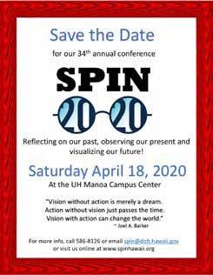
8:30 am - 12:00 pm, Kapolei Middle School Resources, student panel & Keynote speaker for families of middle & high school students. RSVP at www.footstepstotransition.weebly.com or call 586-8126

