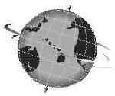

New Complaint Procedures for Bullying, Harassment and Discrimination
December 2019
Volume XXXVI, No. 2
SPIN is co-sponsored by the Disability & Communication Access Board and the Department of Education.
Services include a phone line for information referral and support, a quarterly newsletter, an annual conference and community workshops. SPIN is guided by an Advisory Committee made up of parents, teachers and people with disabilities.

SPIN
1010 Richards Street, Rm 118
Honolulu, Hawaii 96813

PHONE
586-8126
Neighbor Islands dial the ex-
change below, then 6-8126
Kauai - 274-3141
Hawai’i - 974-4000
Maui - 984-2400
Molokai - 1-800-468-4644
Lanai - 1-800-468-4644

FAX
586-8129

E-MAIL
spin@doh.hawaii.gov

WEB
www.spinhawaii.org

Like us on Facebook

n 2013 and 2014 the
I
U.S. Department of Educations’s Office for Civil Rights (OCR) visited Hawaii to
conduct a review of policies related to harassment and bullying in public schools based on race, sex and disability. OCR then collected student surveys from a sample of schools over the next two years and found the following:

of all students reported being bullied or harassed
32%
of those bullied believed it was due to their sex, race, color, national origin or disability
62%
of those bullied did not report it because they believed 1) the school would not do anything about it, 2) it would make the bullying/harassment worse, or 3) it would do both.
21%

As a result of these findings of bullying and harassment against a significant number of students who are protected from discrimination by federal law, the Department
of Education and OCR signed a Settlement Agreement. It takes timely actions to prevent and resolve instances of bulllying, harassment and
discrimination. These actions include:

- Posting Non-Discrimination Notices where parents,
students and staff can see them; and
Adding grievance procedures and new definitions to Chapter 19, and Chapter 41 (now called Chapter 89).
3)
The changes to Chapter 19 and the new language of Chapter 89 will
take effect in January, 2020. We have summarized the changes to Chapter 19 on page 2. Chapter 89 spells out
procedures for investigating complaints of adults at school bullying, harassing or discriminating against students. The new rule can be found on the Board of Education’s website: boe.hawaii.gov.
Bullying, harassment and discrimination may also be addressed under IDEA (Chapter 60) or Section 504 (Chapter 61), if it affects a student’s free appropriate public education (FAPE). OCR developed a Parent Fact Sheet, “What Are Public Schools Required to Do When Students with Disabilities Are Bullied,” which can be found on page 3.

  - Hiring 15 Equity Specialists to investigate complaints
WHAT’S INSIDE
Updates to Chapter 19 2 OCR Parent Fact Sheet 3 Tips for Happy Holidays 4 The Legislative Process 5 The APP Corner 6
Spotlight on Support 6
Pac Rim Conference 6
SPIN Conf. Registration 7
Calendar of Events 8
and advise schools;

Updates to Chapter 19:

Hawaii's Rules re: School Discipline

SPIN has summarized some of the important changes to Chapter 19. These are part of the HIDOE's efforts to prevent acts of student-to-student bullying, harassment, and discrimination and to create a clear set of procedures for investigating these actions when they occur. The new rules are set to go into effect in January 2020, and will offer greater protections for students with disabilities who are often the victims of bullying and harassment at school.

New Definitions

Many of the new terms that appear in the revised Chapter 19 are related to the December 2017 settlement agreement reached between the Hawaii Department of Education and the Office for Civil Rights to prevent and resolve complaints of bullying and harassment of public schools students, including the protected class. Chapter 19 defines protected class/basis to include "race, color, religion, sex, sexual orientation, gender identity, gender expression, age, national origin, ancestry, disability, physical appearance and characteristics, and socio-economic status."

Revised Definitions

sexual exploitation

discrimination

Bullying: any written, verbal, graphic, or physical act that hurts, harms, humiliates of intimidates a student, including those with protected class statuses, that is sufficiently severe, persistent, or pervasive that it creates an intimidating, threatening, or abusive educational environment.
Cyberbullying: electronically transmitted acts, including but not limited to those transmitted through the Internet, cell phone, or other wireless hand-held device initiated by one student toward another student or employee of the department that hurts, harms, humiliates or intimidates the student or employee, and is sufficiently severe, persistent, or pervasive, that it creates an intimidating, threatening or abusive educational environment.
Harassment: any threatening, insulting or aggressive conduct, which can be written, verbal, or physical, and is directed against a student, including those with protected class status. Harassing conduct must have the effect of: (1) Placing a student in reasonable fear of harm to his or her person or property; (2) Interfering with a student's educational performance, opportunities, or benefits; or (3) Disrupting the orderly operation of a school.

Reclassified Offenses

New Class A Offenses New Class B Offenses

In Chapter 19, the most serious offenses are labeled 'Class A' and may result in stronger disciplinary actions, including suspensions. Bullying and cyberbullying had been considered 'Class B' offenses, but the new revisions raise them to the most serious offense level in high school grades. Harassment is also considered a Class A offense in grades 9-12.

Bullying (grades 9-12)
Cyberbullying (grades 9-12)
Harassment (grades 9-12) Sexual assault
Sexual exploitation Sexual harassment Stalking

Bullying (grades K-8) Cyberbullying (grades K-8) Discrimination Harassment (grades K-8) Retaliation
Sexual harassment (grades K-4)

5
The principal or his/her designated investigator will complete the investigation within five school days.

New Complaint Procedures
A new sub-chapter has been added to Chapter 19 that outlines the complaint procedure for discrimination, harassment (including sexual harassment), bullying and/or retaliiation. Complaints may be filed by students, parents, staff and anyone on behalf of a student. This sub-chapter also assigns responsibility to the school principal or designee to investigate these complaints and provide remedies as appropriate at the conclusion of the complaint investigation. Immediate interventions may be offered prior to an investigation or while the investigation is ongoing.

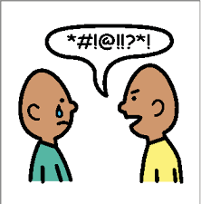

This infographic is based on the revisions to Chapter 19 that were adopted by the Board of Education on August 15, 2019. These rules can be found at: http://boe.hawaii.gov/Documents/Public%20Hearing%20Docs/Ch%2019%20Amendment%20Ramseyer.pdf.

2

UNITED STATES DEPARTMENT OF EDUCATION
Office for Civil Rights

Parent Fact Sheet

What are Public Schools Required to Do When Students with Disabilities Are Bullied?

What does a school have to do when a child with a disability is being bullied?

School staff, parents, and other caring adults have a role to play in preventing and responding to all forms of bullying. If a student with a disability is being bullied, federal law requires schools to take immediate and appropriate action to investigate the issue, and as necessary, take steps to stop the bullying and prevent it from recurring.

- Regardless of whether the student is being bullied based on his or her disability, schools must remedy the effects of bullying on the services that the student with a disability receives (special education or other disability-related services) to ensure the student continues to receive a free and appropriate public education (FAPE). Any remedy should not burden the student who has been bullied.

Does it matter if a child has an Individualized Education Program (IEP) or 504 plan?

No. Some students with disabilities receive FAPE through an IEP developed under the Individuals with Disabilities Education Act (IDEA) and others receive a plan developed under Section 504. If changes in a student’s behavior or academic performance indicate that a student may not be receiving FAPE, the IEP or Section 504 team should meet to determine whether the student’s educational needs have changed and the school must provide any needed additional services promptly to ensure the student’s ongoing receipt of FAPE.

Where can I go for help?
- Go to www.stopbullying.gov, a federal website that provides helpful information and resources on bullying prevention and remedies.

- Ask to meet with the IEP or 504 team, the principal, or the district’s Section 504 or Title II Coordinator if you believe your child is being bullied. Consider using your school’s disability grievance procedures to have the school adress your concerns.

- The U.S. Department of Education’s Office for Civil Rights (OCR) has issued a Dear Colleague Letter explaining what public schools must do under federal law to respond when students with disabilities are bullied. OCR investigates complaints of disability discrimination at schools. To learn more about federal civil laws or how to file a complaint, contact OCR at 800-421-3481 (TDD: 800-877-8339), or ocr@ed.gov. OCR’s website
is www.ed.gov/ocr. To fill out a complaint form online, go to http://www.ed.gov/ocr/ complaintintro.html.

3

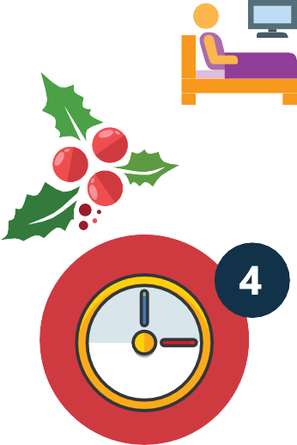

Tips to Happier Holidays This Season
5

Do not over schedule. Prioritize 1 or 2 really important events to your family and stick with it. It's OK to say no to extra parties, events and visits. When you do go out, consider taking 2 cars in case you need to leave with one child while the rest of the family can stay and enjoy the festivities.

Bring your own food and supplies. If your child has an interesting diet or is picky about new foods, bring foods they like to eat or graze on. Bring along their favorite toy, electronics, blanket or anything that helps them stay calm and focused.

Do your best to keep routines in place. Winter breaks can be a time of uncertainty. Keep bed times, morning routines and screen time the same as school days. It will provide an anchor of stability in an otherwise chaotic holiday season.

Allow for extra time. Whether it's building in an extra 30 minutes to get ready to go out or extra down time in the day for quiet play or reading, trade the holiday rush for some peace and joy. Don't forget to add some extra "me" time for adults to unwind and be pampered too.

Create moments of peace and joy and spend some quality time together. Establish holiday rituals that you want to do instead of have to do, something that everyone looks forward to. Go for a winter scavenger walk, make special treats or gifts, help someone who may have less than you or snuggle up together with your favorite holiday movie.

4

How to Get Involved in the Hawaii State Legislative Process

1: Communicate with your Legislators
If you have an idea or if there is an issue that is important to you, let your Senator and Representative know about it by sending them an email, a letter or call their office. When sending a letter or email, remember to keep it brief and get to the point, be kind, tell the truth and don't exaggerate. Explain your idea or position and why it matters to you. Be sure to share your contact information. Not sure who your representative is? Search for them on the capitol website.

2: Share an idea for a new law
Legislators introduce new bills during the first week of the new session, which begins in mid-January. Find a legislator who represents you or who has supported similar bills in the past and share your idea with them. Include what you think the law should do and use bullet points to highlight main objectives. Let them know if you have research, sources or examples to back up your idea.

3: Ask for a public hearing
Once a bill is introduced, it goes into committee. It must be "heard" in a public hearing to be voted on and to move forward. You have to follow your bill carefully and be quick to ask the chair of the committee, by phone or letter, for a hearing. If a bill does not get a hearing, it will miss its deadlines and "die in committee." If your bill does not make it out of committee, try following similar bills; otherwise you must wait till next year to reintroduce your bill. Visit the capitol website to view the committee chair assignments.

4: Testify & repeat as necessary
If a bill gets scheduled for a hearing, you may get the opportunity to testify for or against the bill in writing and/or in person. If the bill moves from one committee to the next, be ready to send in your testimony again. Try to find others to help you testify and gather legislative support for your bill. Having a bill become law is not an easy process and can take a few years. Be patient, be persistent and be passionate.

5: Want to learn more?
The Public Access Room (PAR) can assist you in learning more about the process, timelines and contact information for your legislators. They can also help you navigate the legislature's website to keep track of bills, sign up for hearing notices and more.
Contact them by phone at 808-587-0478 or by email: par@capitol.hawaii.gov. For a list of your representatives and to follow this year's bills, visit www.capitol.hawaii.gov.

SOURCE: Public Access Room. www.lrbhawaii.org/par/

5

Life 360 offers a safe, easy way to keep track of your family members as they move from place to place. Simply download the app, add folks to your circle and see where they are on a private map.
Included in the free app:
- Chat directly with those in your circle
- Real-time location of Circle Members
- See the battery level of everyone’s phone
- Receive alerts when Circle Members arrive or leave destinations you choose like home, school or work.
Life 360 uses GPS to provide the location for everyone in your private circle who has download- ed and registered for the app. The basic plan is free and you can upgrade to more options like roadside assistance and crash detection. It works with both Android and Apple phones. So the next time you wonder if your kids are still at soccer practice, or the kids ask, “where’s mom?”, now you can check the app and know exactly where they are.
Spotlight on Support
UH Center on Disability Studies:
Hawaii Family Engagement Center
The Center on Disability Studies at UH Manoa has secured a grant to explore and grow family engagement practices in Hawaii. They will be focusing on families, educators and community groups and will share strategies on six high-impact areas to increase family engagement between the school and family.
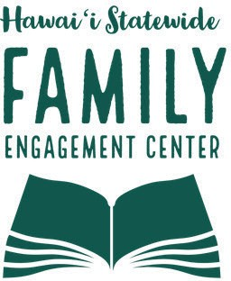
- Building personal relationships with respect and mutual understanding;
- Sharing data with parents about academic, communication and social skills;
- Modeling effective teaching practices so families can use them at home;
- Incorporating home cultures into classroom lessons;
- Listening to families about their child’s interests and challenges; and
- Aligning family engagement activities with school improvement goals.
To learn more, visit: https://cds.coe.hawaii.edu/hfec/

onnect is the theme of this year’s 35th Annual
C
Pacific Rim International Conference on Disability and Diversity, coming up soon on March 2 & 3, 2020. If you’ve never attended a Pac Rim conference, be prepared to be amazed! Hundreds of folks from around the world convene at the Hawaii Convention Center to share the best ideas on how to
celebrate and enrich the lives of people with disabilities.
Themes for this year’s presentations include:
  - Health and Wellbeing
  - Employment
  - Inclusion
  - Early Learning & Education, and
  - Secondary Education.
Parents of children with disabilities are being offered a special rate of $125 a day--HALF the regular registration. Find out more by visiting www.pacrim.
coe.hawaii.edu, emailing prinfo@hawaii.edu or calling (808) 956-8816 for a special online code.

6

Workshop Session 1

34th Annual SPIN Conference
April 18, 2020 • 8:30 am - 3:30 pm

UH Manoa Campus Center Ballroom

Reflecting on our past, observing our present and visualizing our future! Join us for a day of fun, networking and learning!

“Raise Your Sights” | “Can’t Take My Eyes Off of You” | “Set Your Sights on Serenity” | “Hocus Focus” | “Now You See Me” | “Looking Ahead”
Positive Behavior Supports | Relationships and Dating | Reducing your Stress | Assistive Tech: Vision Supports | Inclusive Classrooms | Financial Planning
Workshop Session 2

“Focus on the Future” | “A B See” | “Let’s Have a Look-see” | “Through a Sibling’s Eyes” | “Shared Vision” | “Look Both Ways”
Transition to Adult Life | E.I.S. to Preschool | Alternatives to Health Care | Sibling Panel | Parent Engagement | Kids Safety: Online and Off
Workshop Session 3

“See Through My Eyes” | “Vision Quest” | “Finding Your Child’s Happy” | “Looking Good”
Autism Supports | Vision Supports | Emotional Well-Being | Healthy Kids: Diet & Exercise

REGISTRATON FORM

Name:

Address: City Zip

Phone: H / C / W (circle one) Email:

Child’s Disability: Child’s Age:

Program or School:

Please register me for the SPIN Conference. Specify sponsor, if appropriate:

❑ Parent/Family Member - $25 ❑ Two Family Members - $45 ❑ College Student - $25 ❑ Professional - $50

Amount enclosed (payable to SPIN): $ Check/Purchase Order #:

❑ Airfare Scholarship Request (for Neighbor Island parents and grandparents of kids with disabilities 0-21)
❑ Please send me an application by: ❑ email ❑ street address (check one)

❑ I have a disability and I need an accommodation to participate in the conference. Please specify below:
❑ Materials in an alternate format (Braille, audiotape, etc.) ❑ Sign language Interpreter
❑ Other: Accommodations must be supbmitted by March 15, 2019 to ensure availability.

❑ Sign me up for SPIN’s E-Newsletter ❑ Sign me up for SPIN’s E-Blasts of workshops and events

Send completed form with payment as soon as possible to SPIN via mail, fax or email:
1010 Richards Street, Room 118, Honolulu, HI 96818 • (808) 586-8129 (fax) • spin@doh.hawaii.gov

Winter Calendar of Events

1/4 Access Surf Day at the Beach FREE 2/2 White Plains, Ewa Beach from 9:00 am -
1:00 pm. Surfing event, for all ages and abilities. Sign up at www.accessurf.org/ participant-forms/

1/10 SEAC - Special Education Advisory
2/14 Council Meeting 9:00 am - 12:00 pm Oahu; Pu‘uhale Elementary School library. For more information call 586-8126.

LDAH Parent Training & Workshops FREE 1/15 Honolulu Families Embracing Autism 6-7:00 pm 1/25 Marathon IDEA Workshop FREE

Side by Side Parent Support
Inspire Church in Waikele, 8:00 am - 2:00 pm Learn about IDEA law, understanding the evaluation process and how to develop your child’s IEP. RSVP: breidy@ldahawaii.org
or call 536-9684.
2/5 Organizing Your Child’s Records 6-7:30 pm
2/10-14 Blitz Week 12 - 1:00 pm daily
2/19 Study Hall for Parents 6-7:00 pm
2/19 Honolulu Families Embracing Autism 6-7:00 pm All classes at LDAH office in Honolulu, unless noted. To RSVP, call Bev at 536-9684.

Special Parent Information Network
1010 Richards Street, Room 118
Honolulu, Hawaii 96813

1/9 TACA Coffee Talk FREE
Down to Earth, Pearlridge, 6:30 - 8:00 pm For parents and caregivers to get together and share ideas, resources and fellowship.
RSVP required: www.tacanow.org/local-chapters/ west/hawaii/

Honolulu Theater For Youth
Sensory Friendly and ASL performances
2/1 “Rainbow” @ 11:00 am, for all ages
2/29 “The Carp Who Would Not Quit” @ 11:30 am written for young children.
Tickets are $10-20. Visit, www.htyweb.org

SAVE THE DATE!
3/2-3 Pacific Rim International Conference on Disability and Diversity “Connect”
For more info, visit www.pacrim.coe.hawaii.edu or call 808-956-8816 / email: prreg@hawaii.edu

SAVE THE DATE!
4/18 34th Annual SPIN Conference “SPIN 20/20”
8:30 am - 3:30 pm at UH Campus Center Registration forms and airfare scholarships available. Go to www.spinhawaii.org or call us @ 586-8126.

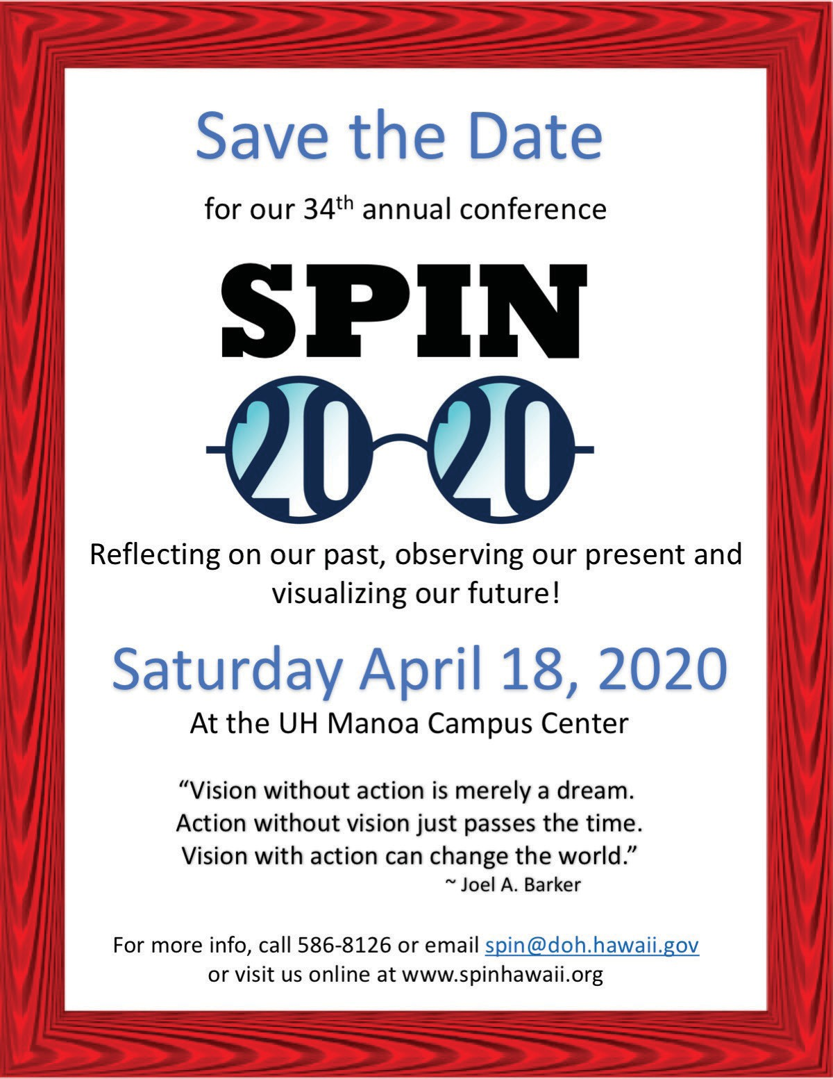
Providing a world of support to parents of children with special needs

