Visioning Your Future
Feburary 2020
Volume XXXVI, No. 3
SPIN is co-sponsored by the Disability & Communication Access Board and the Department of Education.
Services include a phone line for information referral and support, a quarterly newsletter, an annual conference and community workshops. SPIN is guided by an Advisory Committee made up of parents, teachers and people with disabilities.

SPIN
1010 Richards Street #118
Honolulu, Hawaii 96813

PHONE
586-8126
Neighbor Islands dial the ex- change below, then 6-8126
Kauai - 274-3141
Hawai’i - 974-4000
Maui - 984-2400
Molokai - 1-800-468-4644
Lanai - 1-800-468-4644

FAX
586-8129

E-MAIL
spin@doh.hawaii.gov

WEB
www.spinhawaii.org

Like us on Facebook

ith all of the scary news on the
W
T.V. and the uncertainties facing our families, wouldn’t you like to feel better about what’s coming ahead? Then come to the 34th Annual SPIN Conference on April 18th!
We’re calling it SPIN 20/20 to remind us that we all need vision in our lives. The word vision comes from the Latin word visionem which means “wisdom.” To have vision is to have the ability to think about and plan for the future
with imagination and wisdom.
Where do you find that knowledge? At the SPIN Conference,
of course! Imagine this...
16 different workshops on a wide range of timely topics--each one lead by experts in that area.

Inspiring stories and great advice from our keynote speakers--parents like you and a talented musician.

Information tables filling the whole 2nd floor of the Campus Center cafeteria and featuring over 50 agencies serving children and families.

An opening number by the SPIN Advisors that will make you think you’ve just tuned in to “So You Think You Can Dance!”
An Award Ceremony at lunch that celebrates the visionaries in our midst.

Feasting your eyes on an ono-licious luncheon Bar-B-Que. YUM!

. Now that you can see the conference in your mind’s eye, you’ll want to register using the form on page 7 or by calling SPIN at (808) 586-8126.
Conference forms are also available on our website at www. spinhawaii.org.
The Conference will be held in our
favorite spot--the University of Hawaii at Manoa Campus Center on Saturday, April 18th from 8:30 am - 3:30 pm.
SPIN still has some airfare scholarships available for neighbor island parents, and we will have a shuttle from the Honolulu Airport on Saturday to bring folks to and from the conference. Please call ASAP as those scholarships won’t last!

WHAT’S INSIDE
Strategic Plan Trends 2
Strategic Plan Results 3
Medicaid Claiming 4
COVID-19 Information 4
SPIN Awards 5
Spotlight on Services 6
Day at the Capitol 6
SPIN Conference Sign-up 7
Calendar of Events 8

REVIEW OF STRATEGIC PLAN DATA TRENDS

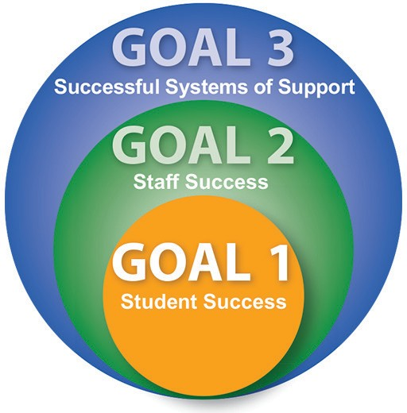
The Department of Education & Board of Education Strategic Plan is a blueprint for schools and complex areas to ensure excellence and equity for each student by closing the achievement gap (the difference in achievement between high needs students, including special
education students, and students without high needs). The Plan measures progress toward 3 main goals--Student Success, Staff Success
and Successful Systems of Support--and 14 Student
Success Indicators that are seen to have the greatest impact on student success.
The Special Education Advisory Council (SEAC) recently reviewed four years of data from the Strategic Plan to help inform its members about significant trends affecting students with IEPs. SEAC’s infographic on page 3 focuses on the following six Student Success Indicators:

ACADEMIC ACHIEVEMENT
1
The % of students meeting achievement targets on statewide assessments in Language Arts (ELA), Math and Science
The Every Student Succeeds Act (ESSA) requires Hawaii to measure progress on these core subjects and monitor whether subgroups are falling behind. Over the four year period from 2015-19, special education (SPED) students underperformed students without disabilities by 30-40 percentage points. The trend line for all 3 subjects was fairly flat with no progress.

3RD GRADE LITERACY
2
The % of 3rd graders demonstrating reading of “At or Near” or “Above” grade-level on the Smarter Balanced Assessment
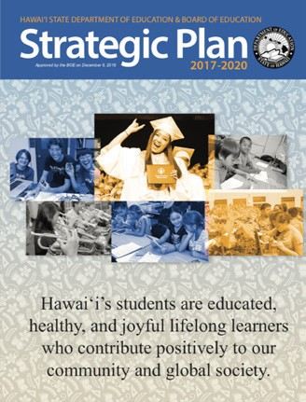Reading at grade level by 3rd Grade is an important benchmark of success, because literacy is a foundation for future learning. Hawaii has focused on 3rd and 4th grade literacy as part of State Systemic Improvement Plan (SSIP) for students with Learning Disabilities, Speech or Language Disabilities and Other Health Disabilities. These efforts have paid off with improving performance, although the reading gap with their nondisabled peers has remained about the same.
Readers can access the Strategic Plan Dynamic Report by going to this page. Select a success indicator, then use the scroll bars to compare subgroups, years and complex area data.

CHRONIC ABSENTEEISM
The % of students who are absent 15 or more days in a school year
3
It is well documented that missing too many days of school is likely to negatively affect achievement. The number of students with IEPs who are considered chronically absent has been consistently higher than students without IEPs by about 10 percentage points.

ACHIEVEMENT GAP
4
The difference in meeting achievement standard between high-needs and non high-needs students
The High-Needs student group is made up of students with disabilities (who make up about 1/5 of this group), English Learners and students who are eligible for Free and Reduced Price Lunch. Over the last four school years, the gap has not gotten narrower.

INCLUSION RATE
5
The % of students receiving special education services who are in general education classes 80% or more of the school day.
Learning opportunities in the general education classroom with supports have been shown to lead to better outcomes for students with disabilities. The good news here is that more students over time are belonging to the general education class. The bad news is that Hawaii is still well below the Mainland average.

HIGH SCHOOL GRADUATION
6
The on-time rate for graduating with a high school diploma in four years.
A high school diploma can be the gateway to postsecondary education, better employment and a successful college career. While 4-yr. graduation rates for students with disabilities have risen to 64% over the last four years, they are 20+ percentage points behind their nondisabled peers.

STRATEGIC PLAN RESULTS 2015-19

1 Students with Disabilities
75 Students without Disabilities
55 54 58 58
ELA

20
13 11

14 12 16

16 12

13 11 14
50 45 46

25
MATH
45 49
46 49
46 47

0
2015-16 2016-17 2017-18 2018-19

0
15
16
2015-16
SCIENCE

2016-17

2017-18

2018-19

2

100

% At, Near or Above 3rd Grade Reading Level

73 69

3RD GRADE LITERACY

3 % Absent 15+ Days/Year
40

24 25 24 23

77 79
28 20 33 34
0
2015-16 2016-17 2017-18 2018-19
20 14 14 14 14

0
ABSENTEEISM
2015-16 2016-17 2017-18 2018-19

SPED Non-SPED

4
High needs includes SPED, English Learners and Economically
Disadvantaged Students

Achievement Gap
SPED Non-SPED

2015-16 2016-17 2017-18 2018-19 2020 Target

5 6
INCLUSION RATE

% SPED Students in RegEd 80+% of School Day
50
37 37 41 44

0

2020
Target 51%

100

0
3RD GRADE LITERACY
ABSENTEEISM
GRADUATION RATE

Graduation Rate Comparison

61 59
87

64
85

65
86
84

2015 2016 2017 2018

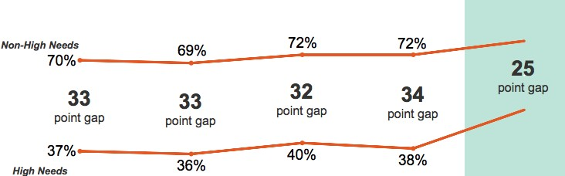2015-16 2016-17 2017-18 2018-19

SPED Non-SPED

Medicaid Claiming
What Is It and How You Can Help the Hawaii DOE

REIMBURSEMENT PROVIDE
Important
Federal
REQUIREMENT
Hawaii's Medicaid program, Med-QUEST, may reimburse the DOE for a portion of the cost for eligible services. To do so, the following criteria must be met:
S
S

Funding
Reimbursement of eligible medicaid services will provide funds that will benefit students at all public schools in Hawaii by offsetting general and specific expenses like transportation, utilities and substitutes.
One-Time Signed Parental Consent

Medically or Educationally Necessary Services

Student is Med-Quest Eligible

CONSENT NEEDE REIMBURSABLE SERVICE
S
D

In order for the Hawaii Department of Education (DOE) to bill
Med-Quest for eligible services, the parent or guardian of an IDEA- eligible student must sign a one-time consent to allow the DOE to access and bill your child's public health benefits. You may revoke consent at any time and sign a new consent to start again.

Parental Rights with Consent

Evaluations

Assistive Technology

Speech Therapy

You shall not have any out-of- pocket expenses, deductibles or co-payments.

You shall not have a decrease in the available lifetime insurance coverage for your child.
Behavioral Health

Skilled Nursing

Occupational Therapy
Physical Therapy

Audiology Services

Your premiums will not increase and you will not lose your benefits because of this billing.
For more information about Medicaid billing and
what it entails, please contact the HI DOE Medicaid Program at 808-305-9787 or visit the Special Education page at Hawaiipublicschools.org

POPULATION
Eligible Students: 9,500

What You Need to Know About COVID-19

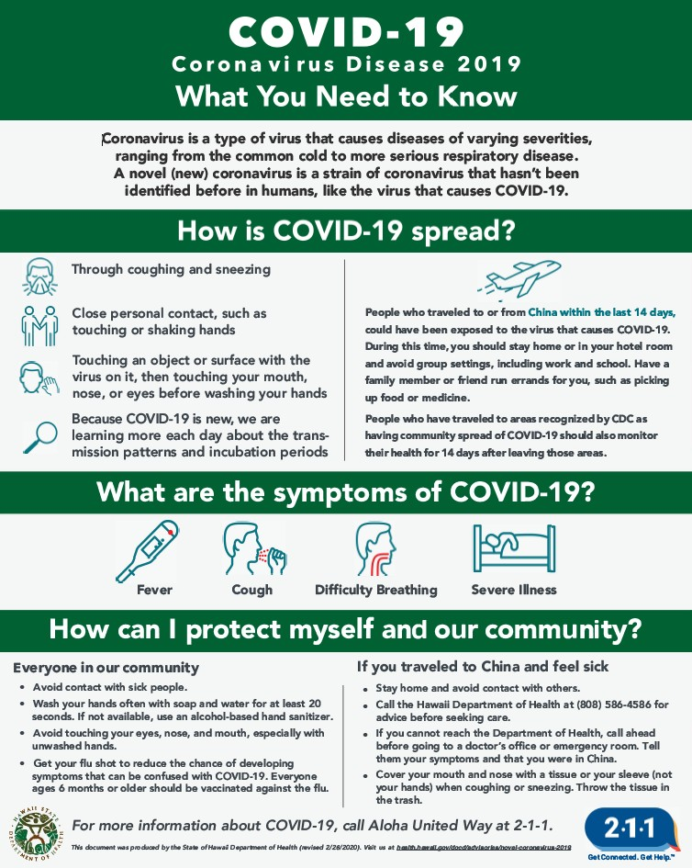
There has been a lot of talk in the news about the new Coronavirus that is making its way around the world and its impacts in Hawaii. Here are some helpful tips to keep you and your family safe from COVID-19 and other respiratory infections like the common cold or flu.
- Wash your hands for at least 20 seconds with soap and water.
- If you don’t have access to water, use a hand sanitizer that has at least 60% alcohol in it.
- Make sure you get your flu shot this year. It will not prevent Covid-19, but it will help you from getting the flu, which shares similar symptoms.
- Keep your kids home (and you too), if they are sick.
- Follow the Hawaii Department of Health (DOH) website and Facebook feeds for the latest information about the virus and how to keep yourself and your family safe. https://health.hawaii. gov/docd/advisories/novel- coronavirus-2019/

2020 SPIN Awards Need Your Nominations!
very year, SPIN publicly celebrates wonderful parents and professionals whose efforts make a positive difference in the lives of our keiki with disabilities and their families. The SPIN Advisory Committee is
E
looking for candidates for our 2020 SPIN Awards and we need your help in nominating someone who models the qualities and actions that families appreciate and rely on. There are three award categories:
- The Parent of the Year Award is given to a parent or parents of a child or young adult with a disability whose actions and advocacy have benefited other families.
- The Professional of the Year Award is given to a professional who has had a significant impact in improving services for children and/or youth with a disability and their families.
- The Family Choice Award is given to a professional who has been particularly helpful to families as they sort out services for their child with a disability. This individual may not have an impact on the larger system, but is recognized in his or her community as an extraordinary professional.
We encourage you to share your aloha and nominate one or more very special people for any or all of the awards. You can go to our website at www.spinhawaii. org, click on the conference tab and download an award nomination form. Or call us at 586-8126 and we’ll accept your nomination over the phone or mail you a form. Deadline to apply is March 18th.

Audio Description is a tool that allows people with a visual disability
to enjoy movies and television with full access to what is happening on screen, even if they can’t see it. It uses narration to provide information around key elements, usually in the natural pauses in the audio. Many museums and exhibitions provide
an audio tour to their guests on request and at no extra charge. The National Library Service for the Blind and Print Disabled has an Audio Description Resource Guide where you can look up information about audio described TV shows, streaming services, movies and more https://www.loc.gov/nls/ about/services/reference-publications/guides/audio- description-resource-guide/ To view the Frozen movie trailer with audio descriptions, click on
this link or search for Audio Description+Frozen Trailer and enjoy!

Spotlight
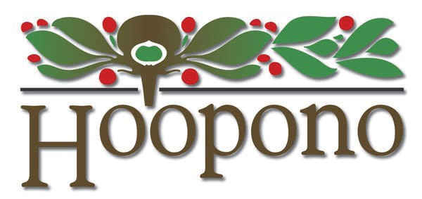on Support

Ho‘opono Services for the Blind is part of the Division of Vocational Rehabilitation (DVR), State of Hawaii. They provide a range of services to individuals of all ages who are blind, visually impaired or deaf-blind.
They offer many programs including:
- DVR Counseling for employment or training
- Transition Services for middle and high school students
- Business Enterprise Services (Blind Vendors)
- New Visions Program (Skills Training)
- Low Vision Clinic
- Job Club/Career Assessment/Job Placement Transition services can begin as early as 14 for your keiki, so ask your IEP team to invite DVR to your next meeting to see if your child qualifies for DVR services. Find out more about Ho‘opono and what they do:
- Website: www.humanservices.hawaii.gov/vr/ hoopono/about/
- Email: gabe@dhs.hawaii.gov
- Call: 808-586-5269

A Day at the Capitol
Thursday March 5, 2020, State Capitol Auditorium, Chamber Level 9:00 - 3:00 pm

March is Developmental Disabilities Month and one of the many activities happening in March is A Day at the Capitol. It is an annual event that celebrates and encourages individuals with intellectual and developmental disabilities and their family members to take the opportunity to discuss disability-related issues and concerns with legislators and network with other concerned citizens.
Activites for the Day:
- Continental breakfast
- Welcome & orientation
- Meet with Legislators
- House & Senate floor sessions
- Lunch
- Legislative hearings
- Tour of State Capitol

For more information call the State Council on Developmental
Disabilities office at 808-586-8100.

34th Annual SPIN Conference
April 18, 2020 • 8:30 am - 3:30 pm
UH Manoa Campus Center
8:30 - 9:00 a.m. - Registration/Resource Room Visitation 9:00 - 9:45 a.m. - Welcome/Keynote
9:45 - 10:15 a.m. - Resource Room Visitation Workshop Session 1 10:20 - 11:20 a.m.
“Raise Your  Sights” | “Can’t Take My  Eyes Off of You” | “Set Your Sights  on Serenity” | “Let’s Have a Look-see” | “Now You See  Me” | “Looking  Ahead”
Positive Behavior Supports | Relationships and Dating | Reducing Your Stress | Alternatives to  Health Care | Inclusive Classrooms | Financial Planning
11:20 a.m. - 1:15 p.m. Resource Room Visitation / Buffet Lunch / Awards Presentation

Workshp Session 2 1:20 - 2:20 p.m.

“Focus on the  Future” | “A B See” | "Hocus Focus" | “Through a  Sibling’s Eyes” | “Shared  Vision” | “Look Both  Ways”
Transition to Adult Life | Early Intervention to Preschool | Assistive Tech:  Vision Supports | Sibling Panel | Parent Engagement | Kids Safety: Online and Off
Workshop Session 3 2:30 - 3:30 p.m.
“See Through  My Eyes” | “Vision Quest” | “Finding Your  Child’s Happy” | “Looking Good”
Autism Supports | Vision Supports | Emotional Well-Being | Health Through Exercise

REGISTRATON FORM

Name:

Address: City Zip

Phone: H / C / W (circle one) Email:

Child’s Disability: Child’s Age:

Program or School:

Please register me for the SPIN Conference. Specify sponsor, if appropriate:

q Parent/Family Member - $25 q Two Family Members - $45 q College Student - $25 q Professional - $50

Amount enclosed (payable to SPIN): $ Check/Purchase Order #:

q Airfare Scholarship Request (for Neighbor Island parents and grandparents of kids with disabilities 0-21)

q Please send me an application by: q email q street address (check one)

q I have a disability and I need an accommodation to participate in the conference. Please specify below:
q Materials in an alternate format (Braille, audiotape, etc.) q Sign language Interpreter
q Other: Accommodations must be submitted by March 15, 2019 to ensure availability.

Send completed form with payment as soon as possible to SPIN via mail, fax or email:
1010 Richards Street, Room 118, Honolulu, HI 96818 • (808) 586-8129 (fax) • spin@doh.hawaii.gov

7

Calendar of Events

Pacific Rim International Conference 3/2 “Connect” 7:00 am - 5:00 pm both days
3/3 Multiple workshops over two days, held at the Hawaii Convention Center in Honolulu.
A special rate of $125 per day is being offered to parents, students and self-advocates. Use the code: A39C43. For more info or to sign up online: www.pacrim.hawaii.edu/ or call
808-956-4437, email: prreg@hawaii.edu

3/5 Day at the Capitol with Hawaii State Council on Developmental Disabilities
9:00 am - 3:00 pm FREE at the Hawaii State Capitol. Meet with legislators and celebrate diversity. To RSVP, call 586-8100, for more info, visit: www.hiddcouncil.org.

3/7 IDEA / IEP Workshop by LDAH
9:00 am - 2:00 pm FREE
245 N. Kukui Street, Honolulu
Learn about special education law, evaluations and how to develop your child’s IEP.
Please RSVP: 536-9684

3/7 Access Surf Day at the Beach
4/4 9:00 am - 1:00 pm, FREE surfing event for all ages and abilities. White Plains, Ewa Beach Sign up online at www.accessurf.org

3/8 TACA Workshop on Student Discipline
1:00 - 2:30 pm FREE Kapolei Heritage Center 91-1250 Kinoiki Street, Kapolei 96707 Speakers from Hawaii ACLU and HDRC. RSVP: tacanow.org/local-chapters/west/hawaii/

3/13 SEAC - Special Education Advisory 4/24 Committee Meeting 9:00 am - 12:00 pm
5/22 Open to the public. Meetings held at Puuhale Elementary Library, 345 Puuhale Rd.
For more info, call 586-8126 or visit their website at www.seac-hawaii.org

Special Needs Planning Workshops
1:00 - 3:00 pm FREE
1163 Beretania St., Honolulu, HI 96814 3/14 Planning for Your Special Needs Dependent 3/27 Planning for Your Special Needs Dependent 3/28 Letter of Intent Clinic
RSVP 527-8818, kirk@specialneedshawaii.com
3/18 Honolulu District Families Embracing 4/15 Autism 6:00 - 7:00 pm FREE
245 N. Kukui Street, Honolulu March topic: Sports Opportunities April topic: Summer Programs
Meets monthly, every 3rd Wednesday Free parking and childcare with RSVP 536-9684.

Ho‘omana Autism Support for Families
6:00 - 7:30 pm FREE Windward Oahu
3/25 Key Project in Kahaluu: Evaluations by LDAH
4/22 Key Project in Kahaluu: Assessments
4/23 Pali View Baptist Church: Financial Planning Free Childcare if you RSVP at least a week before: hoomanagroup@gmail.com or 426-6879

3/26 TACA Coffee Talk
6:30 - 8:00 pm FREE Down to Earth Pearlridge 98-211 Pali Momi St., Aiea, HI 96701
For parents and caregivers of children with autism to talk story and receive support.
RSVP: tacanow.org/local-chapters/west/hawaii/

3/27 EFMP Sensory Movie Night
6:00 - 8:00 pm $2 per person “Toy Story 4” Sgt. Smith Theater, Schofield Barracks
For more info: www.himwr.com/acscalendar

4/8 Talk Story w/ Hawaii Epilepsy Foundation
5:30 - 7:30 pm FREE
200 N. Vineyard Blvd., Honolulu, 5th Floor Family support for those living with epilepsy. For more info: call 528-3058 or email efh@epilepsyhawaii.org

4/11 Hele for Autism & Resource Fair Sponsored by The Autism Society of Hawaii for more info, email autismhi@gmail.com

SAVE THE DATE!
4/18 34th Annual SPIN Conference “SPIN 20/20” 8:30 am - 3:30 pm at UH Campus Center Keynote, 16 workshops, lunch and resources! Registration forms and airfare scholarships available www.spinhawaii.org, call us at
586-8126 or email spin@doh.hawaii.gov.
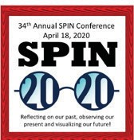

For more events and happenings around the state, be sure to visit our website events calendar at www.spinhawaii.org/events and like us on Facebook!
SPIN - Special Parent Information Network

8

