The Newsletter for Parents of Children with Disabilities
SPIN’s Infographics Guide You Through COVID-19 Changes
October 2020 Volume XXXVII, No. 1 SPIN is co-sponsored by the Disability & Communication Access Board and the Department of Education.
Services include a phone line for information referral and support, a quarterly newsletter, an annual conference and community workshops. SPIN is guided by an Advisory Committee made up of parents, teachers and people with disabilities.

SPIN
1010 Richards Street #118
Honolulu, Hawaii 96813

PHONE
586-8126
Neighbor Islands dial the ex- change below, then 6-8126
Kauai - 274-3141
Hawai’i - 974-4000
Maui - 984-2400
Molokai - 1-800-468-4644
Lanai - 1-800-468-4644

FAX
586-8129

E-MAIL
spin@doh.hawaii.gov

WEB
www.spinhawaii.org

Like us on Facebook

he COVID-19 pandemic has had a huge impact on the delivery of special education services in Hawaii
T
and nationally. School closures necessary to guarantee the health and safety of students and staff have
resulted in many students losing skills.
Now that school has resumed, IEP and 504 teams have been instructed to meet and assess each student’s needs during the 1st Quarter.
The following infographics were designed to help families be informed partners in the IEP process. What
are infographics? They are a way of explaining complex information and bringing more people into a discussion using pictures and charts.
As you look through the infographics on the following pages, we hope you will use them as a starting point for asking for more information from your child’s IEP team members. You are always welcome to talk with SPIN and our partners below, as well.
Mahalo to the Department of Education, the Special
Education Advisory Council, the Community Children’s Council Office, Leadership in Disability & Achievement of Hawaii and the State Council on Developmental
Disabilities for helping to ensure the accuracy and improve the readability of these informational tools.

The SPIN Conference Goes Virtual!

ver since we had to postpone our April 18th SPIN Conference due
E
to COVID-19 concerns, our faithful conference planning advisors have been looking for a way to bring it back to you. Well now it’s alive again as a virtual conference! That means you can join us at no cost on your phone,

Online Learning Options 10
SPIN Conference Agenda 11
Footsteps Transition Fair 12

Saturday, October 17th
tablet or computer. So please put Saturday, October 17th in big red letters on your calendar. And check out page 11 of this newsletter to see what a fun day we have planned. We hope to “see” you all there!

What’s Inside
7 Definitions for Learning | 2
Reopening Requirements | 3
Parent Tips for Virtual IEPs | 4
Telepractice Related Services | 5
Addressing Impact of COVID | 6
COVID-19 Impact Services | 7
Total Distance Learning Plan | 8
Closure Contingency Plan | 9

This is an umbrella term for
learning that does not occur in-
person. Lessons can be provided by way of paper packets, online programs, or during live virtual sessions on Google Meet or
WebEx. Communication may occur through messaging apps,
phone calls, video calls, discussion boards, or live virtual sessions.

The teacher delivers live, real-time instruction to students via Google Meet or WebEx. Students can
participate in real-time and engage with their teachers and classmates.

Students work at their own pace with no real-time instruction.
Learning occurs through teacher assignments (for example, paper packets, self-guided online
programs, turning in English Language Arts (ELA) and Math assignments through Google docs, and other means).

During Distance Learning, schools must implement each student’s
Individualized Education Program (IEP) and provide special education, related services, and specially designed instruction (SDI). This also applies to students whose parents opt-in for Total Distance Learning.
Students receive instruction by way of a self-paced and self-
guided online curriculum like
Acellus, Florida Virtual and ASU Prep Digital. Students work
independently and students in
general education do not typically receive instruction from a HIDOE teacher. Parents opt-in for this option for a semester or year.

This is a platform (for example, Blackboard and Google
Classroom) that helps teachers manage and organize
instructional materials. It provides communication
between teachers, students and parents.
Students rotate between face-to- face instruction and distance
learning. A variety of instructional strategies and resources are used. Models differ slightly across elementary, middle and high school.
Students receive in-person
instruction on the school campus. Priority is given to students with
IEPs, English Learners, and students in grades Pre-
kindergarten to 2nd Grade.

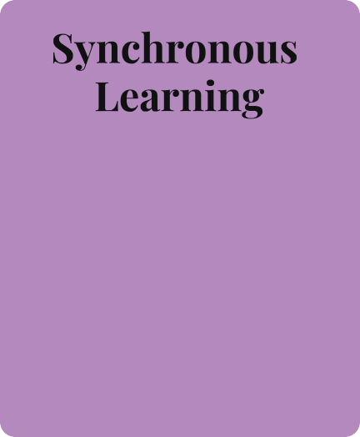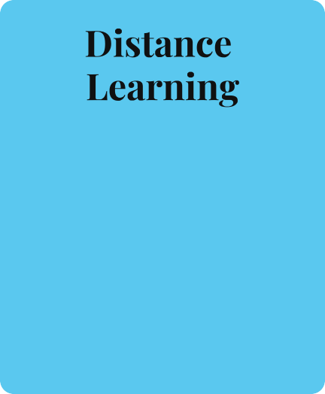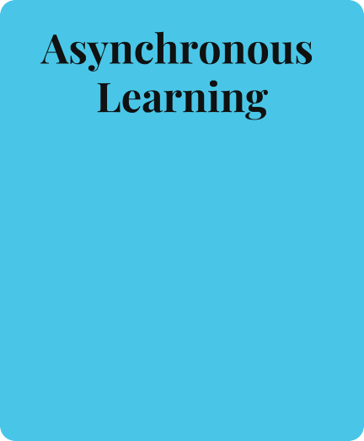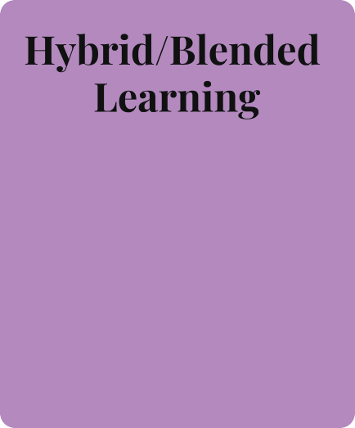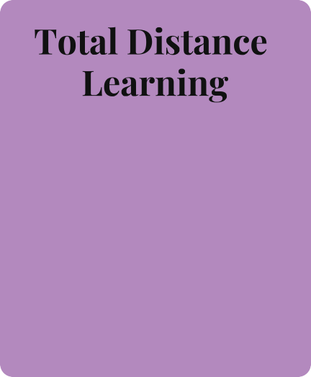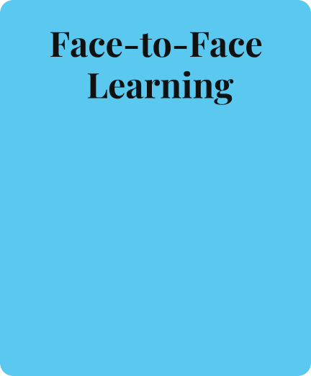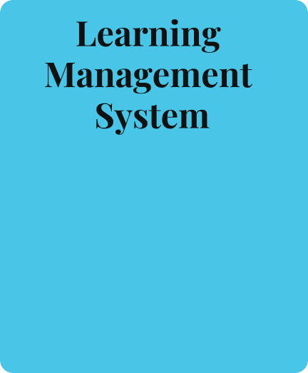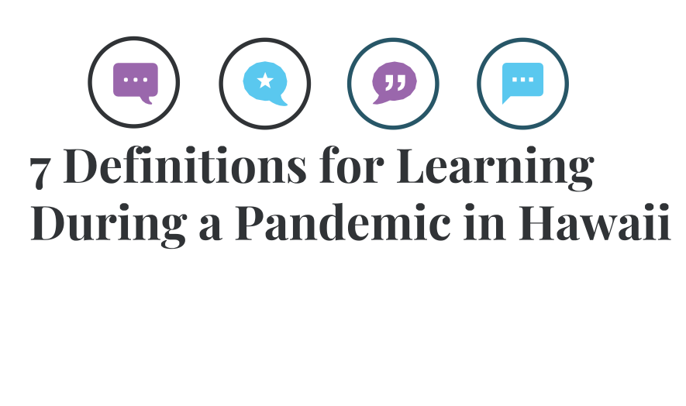

Sources: Digital Transformation for Learning Plan, Hawaii Department of Education, and
Return to Learn Plan, Hawaii Department of Education

2

Reopening Requirements for Students with Disabilities

IEP/Section 504 Review
All students will have an IEP team meeting before the end of the first quarter. Teams must:
Identify accommodations & modifications
needed to access the instructional model, Develop an individualized contingency plan,
Determine additional needs due to the school closure, and,
Create revisions based on student needs, not on the available instructional models.

COVID-19 Impact Services
Within the first quarter, each IEP team must
determine if there is a need for COVID-19 Impact Services for each student including:
Determining if there was a loss in skill(s), and
What supports will be provided to address the skill(s) loss.

Educational Environment
Placement in the least restrictive environment (LRE) has not been waived. IEP teams must remember:
Changes to instructional models will require
schools to determine how they maintain LRE. If a change of placement is suggested, teams must have evidence of a need and supporting data to make their decisions.

COVID-19
Contingency Plan
Schools must prepare for any future disruptions to education. All students with an IEP must have a School Closure Contingency Plan to describe:
What services will be provided,
Which accommodations modifications will be needed to support distance learning, and
If telepractice is appropriate for the student.

Request for Distance Learning
With any school model, parents/guardians may opt for distance learning instead of sending their child to school. The IEP team must:
Develop a Total Distance Learning Plan to
implement the IEP to the greatest extent, and Include services, supports and parent training.

Student Absences

When a student with a disability at high risk of severe medical complications is out of school during an outbreak of COVID-19 and the school remains open:
A student absent less than 10 days will not be
considered for change in placement.
A student absent longer than 10 days in a row must have an IEP meeting to consider a change in placement.

Source: HIDOE Memo "Reopening of the School Year Requirements for Students with Disabilities" (July 31, 2020)

3

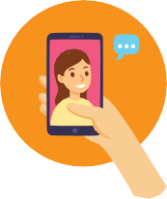

Parent Tips for Virtual IEPs
During this time of closures due to the COVID-19 pandemic, schools must make every effort possible to meet required timelines by scheduling and holding your child's Individualized Education Program (IEP) meeting online or by phone.

BE READY FOR THE CALL
If your child's annual IEP or initial IEP is due, you will be contacted by someone from your child's school to set up the IEP meeting.
If you have recently changed your phone number or email address, be sure to let the school know as soon as possible.
YOUR IEP MEETING WILL NOT BE IN PERSON
The Individuals with Disabilities Education Improvement Act (IDEA 2004) requirements for IEP review, development, evaluations and eligibility are still in place.
IDEA has provisions to use different ways to participate in meetings, including video conferences like Skype, Zoom or WebEx or by phone.
Work with your child's school to decide the best way to hold your meeting.
Ask your school when and how you will receive documents before the meeting.

WHAT YOUR IEP MEETING WILL BE LIKE
Your IEP meeting will not be in person. You and the IEP Team may agree to conduct IEP meetings through alternate means, including videoconferencing or telephone conference calls.
All required IEP members must attend unless you and the school, in writing, consent to excuse a team member.
Team members should review relevant materials ahead of time to prepare for this IEP meeting. Ask the school if you can receive copies in advance of the meeting of important information that will be used to make decisions at the meeting (like draft goals and objectives, recent evaluations, etc.).
ATTENDING YOUR IEP MEETING
Make sure your phone or device is fully charged and you have access to a good cell or WiFi signal. You may want to dress like you would for a regular meeting.
Have all your documents ready: your current IEP, any evaluations, classwork or other evidence, and any concerns and suggestions you have.
Find a quiet, comfortable place with a place to write and good lighting. Be engaged and ask questions.
Request a re-cap of IEP agreements before the meeting ends.
AFTER YOUR IEP MEETING
Contact your child's special education teacher right away, if you forgot to mention something important during the meeting discussion.
Look for the final copy of the IEP within ten days of the meeting.
WHAT IF I NEED HELP
Call your child's special education teacher or the school's Student Services Coordinator for assistance, copies of documents and current assessments.
Call or email Leadership in Disabilities and Achievement of Hawaii @ 808-536-9684 for IEP preparation and support, and questions about IDEA and your rights.
Call or email SPIN @ 808-586-8126 for support, information and questions about special education and community resources.
4 Created by SPIN and adapted from "Parent Tips for Virtual IEP Meetings" by the Oklahoma Parents Center

Using Technology to Deliver Related Services
Telepractice allows a student to benefit from related services when it is unfeasible or unsafe to deliver those services in person. It involves using technology to provide an IEP service, (like speech therapy, ABA services, counseling, etc.) remotely.
Determining the Appropriateness of the Telepractice:
The IEP team members first consider the following questions: Does the student need to access services at home?
Is telepractice appropriate for this particular student and can the service can be delivered via telepractice? One consideration would be does the student have access to a device and internet connection?
Are the parents and therapist in agreement about using technology?

Determining the Need for an E-helper:
While some students are able to interact with the therapist without assistance, others may need help logging in at the scheduled time, having needed materials available, prompting through verbal or physical assists or aiding in communication. If help is needed, is a parent or other family member available and willing to assist?

Training and Support for the E-helper:
Once an E-helper is identified, the related service provider will provide any necessary training and support virtually. That means that the therapist will use videoconferencing and/or teleconferencing to provide instruction to the E-helper to enable him or her to assist the student, including helping the student complete assignments.

Setting up a Service Delivery Plan:
When the necessary technology and in-home E-helper (if required) are in place, the parent and therapist can agree on a plan and a schedule to
provide services. Generally, services fall within the hours of a typical school day.

Obtaining Parent/Legal Guardian Approval:
The last step in setting up telepractice sessions is to get the approval of the student's parent or legal guardian to receive these services.
Information in this infographic was provided by the Hawaii Department of Education, March 2020 5

Addressing the Impact of COVID-19 on Students with Disabilities
During the 1st Quarter of SY 2020-21 IEP and 504 Plan Teams will determine if there was a loss in skill(s) due to school closures.

In order to determine whether a student lost skills during the school closure from mid-March to August, information from a variety of sources should be gathered prior to an IEP or 504 Plan team meeting:

SCHOOL DATA

Right before and during school closure:
3rd & 4th Qtr.
Progress Reports 3rd Qtr. grades Correspondence Recordings
Observations

Since the return to school:
Universal screening Informal assessments
Observations Student work samples
FAMILY INFORMATION
Notes Recordings/videos Correspondence with school Reports from other service providers New information
INFORMATION GATHERING

Meetings will be held to review the IEP or 504 Plan during the 1st Quarter of
the school year to see if the plan is addressing the student's current needs.
Parents may request to have an immediate meeting, if they are concerned about big changes in their child's academic, functional, emotional or behavioral needs.
DETERMINING SKILL(S) LOSS OR NEEDS
The main purpose of the meeting is to determine:
any skill(s) loss
during school closure;
how significant was the loss; and
how skill(s) loss will be addressed.
The method for determining loss is to compare pre- school closure data with current performance. If skill loss is considered minor,
the team may recommend explicit instruction or high impact strategies available to all students (HMTSS). If the skill loss is considered significant, the IEP/504
Plan may need revision.
IEP OR 504 DISCUSSION
An IEP or 504 Plan revision may be required if the student has significant skill(s) loss or needs that require individualized supports and services beyond HMTSS.
Plan revisions may include:
Updating the
Present Levels of Academic and
Functional
Performance (known as the PLEP)
Designing new or revised goals or objectives, and
Increasing the frequency or
duration of related services or specially designed instruction.
When considering the need for a new related service, an assessment in that area must be done.

If the student's skill loss or needs are significant and
cannot be completely addressed through the IEP or 504 Plan, then the team must discuss the need for COVID-19 Impact
Services.
IEP or 504
REVISING THE IEP/504 PLAN
COVID-19 IMPACT SERVICES
COVID-19 Impact Services are services to make up for the student's skill(s) loss which are in addition to the current IEP or 504 Plan services. They are
temporary and high impact specially designed instruction or related services delivered beyond the school day.
The purpose of these services is to quickly improve skill(s) and get the student to a level s/he would have been but for
the school closures.

HOW SERVICES ARE PROVIDED
In person:
small groups of students with similar needs,
before or after school sessions, or tutoring.
Online (with the student and provider in real time):
small groups of students with similar needs,
before or after school sessions, tutoring or
skill-based, before or after school Learning Labs.
STEP 1 STEP 2 STEP 3 STEP 4
Source: Addressing the Impact of COVID-19: Implementation Guidelines for Students with IEPs and Section 504 Plans,
6
Office of StudentSupport Services (updated August 3, 2020).

A Checklist for a
Total Distance Learning Plan
If you choose to have your child receive their education completely through distance learning due to COVID-19, a Free Appropriate Public Education (FAPE) must still be provided to the greatest extent possible, so that students with
disabilities can continue to access learning opportunities. This includes all services, accommodations, and/or modifications listed in your child's Individualized Education Program (IEP) to the greatest extent possible.

STEP 1
STEP 5
IEP Team Identify Barriers
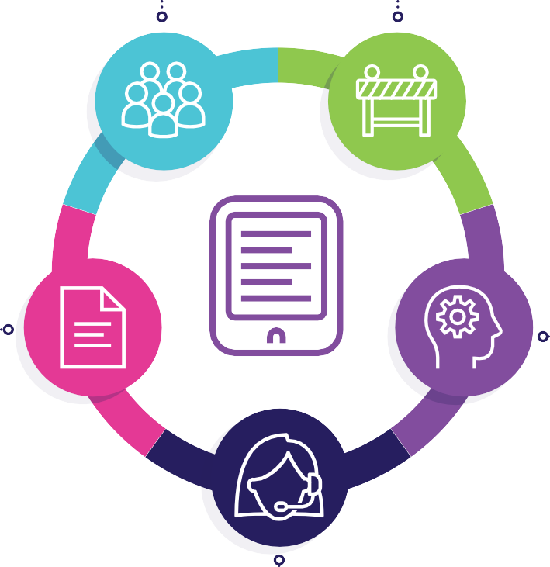Meeting Discuss barriers that may

Ask for an IEP meeting to discuss the plan together. Be sure to include related service staff as well.
prevent your child from accessing their education through distance learning. Identify accommodations that will be provided to address the barriers. Also identify supports your
family may need to help your child learn.

STEP 2
STEP 4

Review IEP goals Review
and objectives accommodations

If the goals/objectives
and

can be implemented modifications
through distance Determine if the supports
learning, ask how it will in your child's IEP can be
STEP 3

be done, who will be
responsible for each goal, how often they are
provided over distance learning. If they can,
discuss how and when

worked on, and how Review all services those supports will be progress will be in the IEP provided.
monitored. Discuss with your team how related services will be provided, who will provide them and how often they will happen. Discuss and fill out the Telepractice Worksheet to see if your child can
use technology to receive these services.

8

Source: Total Distance Learning Plan Checklist, Office of Student Support Services (July 31, 2020)

√ S TEP 1

School Closure Contingency Plan Checklist
In the event that a school closes due to unforeseen safety concerns (like a
natural disaster or disease outbreak), a Free Appropriate Public Education (FAPE) must be provided to the greatest extent possible, so that students with disabilities can participate in distance learning during a school closure.

Have an IEP Meeting
Your child's IEP team includes parent(s)/guardian(s), a special education and general education teacher, school administrator and related service staff (OT, PT, ABA, etc.). If someone from your team needs to be absent, consider rescheduling the meeting; otherwise you will need to excuse them in writing .

Review Each IEP Goal
Discuss each goal and objective and determine how they will be implemented via distance learning. Who will implement each goal/objective? How often will they be implemented? How will progress be monitored? If goals and objectives cannot be implemented, how will your child be supported?

STEP 2√

√ STEP 3

Review All Services in the IEP
Discuss how specially designed instruction and/or related services will be provided to your child. Who will provide the needed service and how often will it happen? Use a separate Telepractice Worksheet to see if your child can or should receive their related services virtually.

Review Accommodations and Modifications in the IEP
Can the accommodations and modifications listed in the IEP be provided to your child? How will that happen? When or in what situations will they be provided? Are there any additional accommodations/modifications needed to support access to distance learning?
STEP 4√

√ STEP 5

Identify Any Barriers
Are there things that will keep your child from accessing their educatior through distance learning? Barriers could include academic, behaviora or environmental factors. What accommodations and modifications be used to address these barriers? Include any supports you will need as the parent or guardian to support your child.

9

Source: School Closure Contingency Plan Checklist, Office of Student Support Services (revised August 17, 2020)

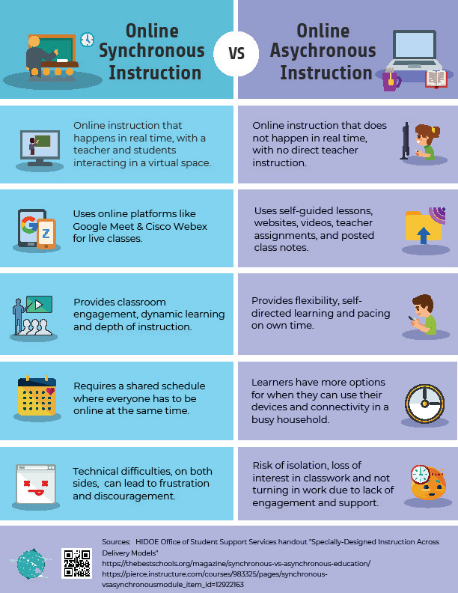

10

9:00
Schedule of events

Welcome & SPIN Dance

9:15 - 10:10
Session 1
Alternatives to Health Care Assistive Technology Family-School Partnerships

10:15 - 11:10
Session 2
Positive Behavior Supports

Saturday

Covid 19 & Virtual IEPs Emotional Well Being
October 17, 2020

9:00 am - 2:00 pm
11:15 - 12:10 Visit
Session 3 www.spinconference.org
Autism Supports
For all your links to
Transition to Preschool Kids Safety Online and Offline
amazing content!

All workshop sessions are
12:00 - 1:00 Live meetings!
Networking Rooms open Watch:
Sibling Panel (pre-recorded) For technical support,
Pandemic & School call 808-791-3467
IEP/504 Plans
Parent Talk Story Q&A for every workshop
12:00 - 2:00 All rooms will be moderated
Exhibitor Rooms open
Visit with organizations Visit the “Virtual Tote Bag” page
Talk with real people on the SPIN Conference
Download brochures & handouts website to find your

favorite resources

11

“GOT PLANS AFTER HIGH SCHOOL?”
IT’S NEVER TOO EARLY TO START PLANNING.

FOOTSTEPS
TO TRANSITION FAIR

OCTOBER 24, 2020
VIRTUAL – VIA ZOOM

8:00 – 8:30 – check in / technology check
8:30 – 12:00 – separate workshops for youth and families/teachers/partners 12:00 – 1:00 – exhibitors
- Pre-conference practice on zoom
- Help desk available by phone and text during the conference
- Presentations on Health, Career Pathways, Citizenship, and Inclusion
- Community based discussion groups
- Need to be registered to participate

- HTTPS://FOOTSTEPSTOTRANSITION.WEEBLY.COM/REGISTRATION- 2020-SIGN-UP.HTML

12

