The Newsletter for Parents of Children with Disabilities

SPIN Conference Video Gems
January 2021 Volume XXXVII, No. 2 SPIN is co-sponsored by the Disability & Communication Access Board and the Department of Education.
Services include a phone line for information referral and support, a quarterly newsletter, an annual conference and community workshops. SPIN is guided by an Advisory Committee made up of parents, teachers and people with disabilities.

SPIN
1010 Richards Street #118
Honolulu, Hawaii 96813

PHONE
586-8126
Neighbor Islands dial the ex- change below, then 6-8126
Kauai - 274-3141
Hawai’i - 974-4000
Maui - 984-2400
Molokai - 1-800-468-4644
Lanai - 1-800-468-4644

FAX
586-8129

E-MAIL
spin@doh.hawaii.gov

WEB
www.spinhawaii.org

Like us on Facebook

re you bored yet with the same ‘ole TV channel listings? Maybe
A
you’re feeling a bit anxious about your child’s second semester of learning?
Well, then, have we got a deal for you! No, it’s not the SPIN Channel.
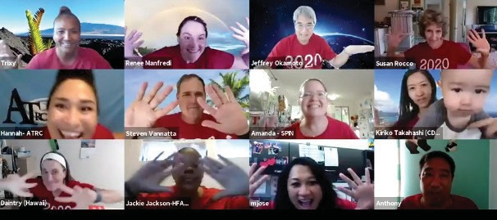
Not yet, but we’re working on that. What we have to offer right now (and for re-watching in the months to come) are some excellent video workshop presentations from our October 2020 virtual SPIN
Conference.
Each workshop received such great feedback from our conference
audience of 350+ parents and helping professionals, that we think you’re going to like them, too. They make you a little bit smarter about topics important to parenting children with disabilities and health needs. Each great presenter will pass on some tip or tool to help improve the quality of life of your household.
To whet your appetite--so that you want to push the ‘Play’ button on your

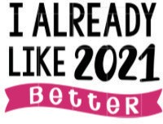
Many of us are looking forward to a new and better year for our families. Are you
one to make New Year’s resolutions? Check out page 9, and then resolve to attend the 2021 Virtual Pac Rim Conference sponsored by our friends at the Center on Disability Studies.
They’ll be offering special discounts for parents and teachers (page 12).
phone, tablet or computer-- we have described seven of the workshops through an infographic, found in the next seven pages of this issue. Each infographic sums up some important information from a particular workshop, with a link at the bottom of the page to the video presentation.
When you visit our SPIN Conference pages, you’ll also find other video gems:
- “Sibling Talk Story” capturing the wise thoughts
of two brothers and a sister of a sibling with a disability.
Even the moderator, an ordained minister and former special education professor, is a sibling herself; and
- “Medicine Eagle” - original music by Guywood Dela Cruz on the Native American flute, along with his insights on his life’s journey as a man who lost his sight as a young boy.

What’s Inside
Evaluating CAM 2
Getting to Know AT 3
Function-based Treatment 4
COVID-19 Impact Services 5 Emotional Well-being 6
Visual Supports for Autism 7
Transition to Preschool 8
Resolutions for 2021 9
COVID Vaccines 10
Upcoming Events 12

5 Domains of CAM
Body-based & Biologically manipulative based therapies approaches
Mind-body interventions
CAM
Energy therapies
Alternative medical
systems
Definition
The National Institutes of Health define
complementary and alternative medicine as a group of diverse medical and health care systems, practices and products that are not presently
considered part of conventional medicine. A therapy or product used instead of a conventional treatment is referred to as alternative. One used to supplement traditional medicine is considered complementary.

diets, herbs, vitamins, probiotics

50+%
of children with chronic
conditions (asthma, ADHD,
cancer, cerebral palsy, juvenile arthritis, etc.) use CAM.

Qi gong, Reiki, magnets, Healing Touch
Chinese medicine, Ayurvedic medicine, homeopathy biofeedback, prayer, meditation, yoga, hypnosis
chiropractic, Reexology, massage

35-95%
of children with autism use some form of CAM.

Pediatricians often use the model below when helping their families decide whether to try Complementary and Alternative Medicine approaches. The two main deciding points are: Is it safe? and Does it work to relieve

Check out the link to our SPIN workshop below for evidence on neurofeedback , technological aids and mindfulness (for ADHD), hippotherapy (for cerebral palsy), Melatonin, Vitamin C, multivitamins,
Gluten and Casein Free Diets (for autism) and CBD oil (for a
variety of conditions).
symptoms (efficacy)? Talking with your child's doctor is the best way to ensure that CAM does no harm and is worth the effort and cost to try it out.

 | EVIDENCE FOR EFFICACY | CONFLICTING OR NO EVIDENCE
SAFE | ENCOURAGE | TOLERATE & ENCOURAGE OBJECTIVE MONITORING
UNSAFE OR SAFETY UNKNOWN | MONITOR CLOSELY OR DISCOURAGE | DISCOURAGE
Kemper 2004, Akins 2010

References: October 17, 2020 Presentation on Alternative Medicine by Dr. Mike Ching and Dr. Jeff Okamoto
The National Center for Complementary & Integrative Health
Created by SPIN from the "Let's Have a Look-See"
SPIN Conference Workshop, October, 2020

What is Assistive Technology?
Any item or equipment that helps people work around challenges so they can learn,
communicate and function better. It may be homemade, specially designed, modified or made commercially.

Low-Tech Ideas
These can be anything jumbo or oversized, a slant board, highlighters, tactile rulers, pencil grips, clothespins or binder clips, Velcro, visual schedules or manipulatives like cars, blocks or cups.

There Are 3 Kinds of A.T.
Low-Tech: is easy to make or adapt yourself.

Mid-Tech: may be provided by the school or available to borrow from a technology resource center.

High-Tech: can be purchased for use, or turn on accessibility options in technology you already have.

High-Tech Ideas
These could be a tablet or iPad, smart pen, smart board, AAC (augmentative & alternative communication), text-to-speech, speech-to-text, screen readers, eye gaze tech,

Mid-Tech Ideas
These include screen magnifiers, FM systems, voice amplifiers, mouse alternatives or adaptive keyboard for the computer, digital recorders or switches
that can be pushed or tapped.

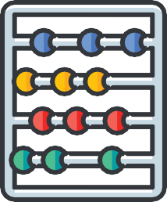zoom or magnify, software programs or wearable OCR (optical character recognition).
References: October 17, 2020 presentation on Assistive
Technology "Hocus Focus"
Created by SPIN from the SPIN Conference Workshop
October 2020

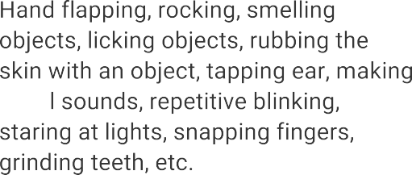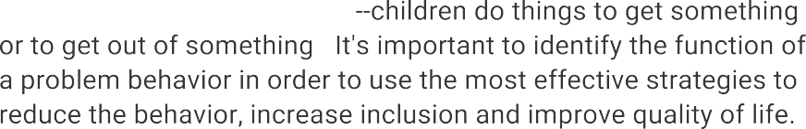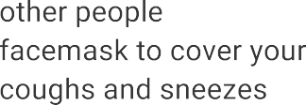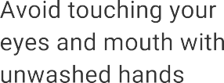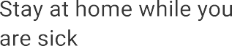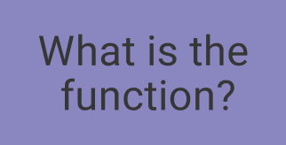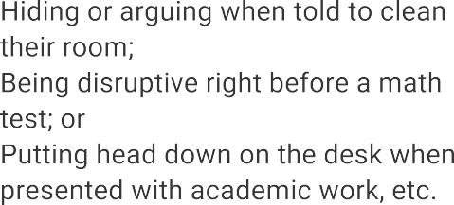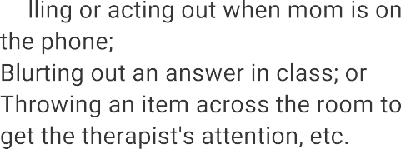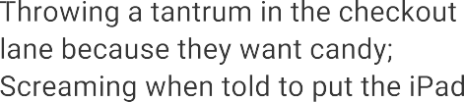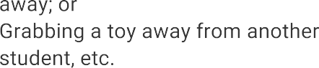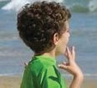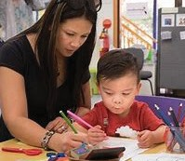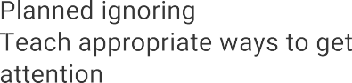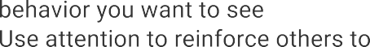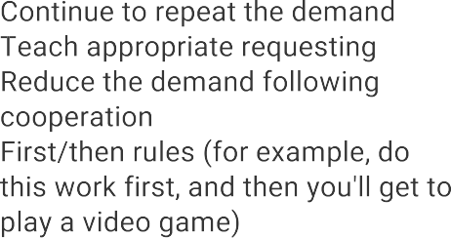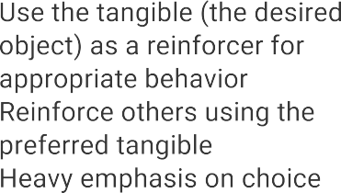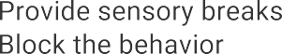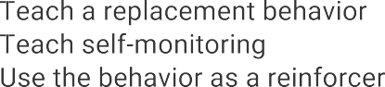

Reference: Presentation on ABA & PBS: Everything Under the Sun by Joshua Fouts, PhD, BCBA-D
Created by SPIN from the SPIN Conference workshop by Dr. Fouts, October 2020

COVID-19 Impact Services

What are they?
COVID-19 Impact Services are services in addition to the IEP or 504 Plan services that are needed to make up for significant skill loss(s) resulting from delayed, interrupted or inaccessible IEP services caused by school closures.

Temporary, high impact specially designed instruction and related services,

Beyond the regular school day, and

Based on the student's current needs which may result in different services than were received in the past.

Who makes the decisions about COVID-19 Impact Services?

The IEP team or 504 Plan team determines:

What services are needed
How often and how long the services are needed
Where and how the services will be delivered

How will the services be provided?

On-line with a Provider in Real Time OR In-Person

Small groups of students with similar needs Small groups of students with similar needs

Before or after school sessions Before or after school sessions

Learning lab
Tutoring

Skill-based Learning Labs
Tutoring

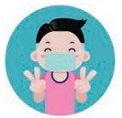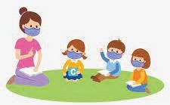References: 10/17/20 presentation on COVID 19 & Virtual IEPs by Lisa Craig and Nanea Lo, Addressing the Impact of COVID-19: Implementation Guidelines for Students with IEPs and Section 504 Plans, Office of Student Support Services (updated August 3, 2020).
Created by the Special Parent Information Network (SPIN)

Finding Your Child's Happy
Emotional Well-Being Tips for Youth

Children's social and emotional health affects their overall development and learning. A child who is emotionally healthy tends to be more motivated to learn, has a positive attitude towards school and family and is generally happier. By contrast, a child with social and emotional challenges can find it difficult to follow directions, have low self esteem and do poorly in school. Here are some tips to encourage social and emotional growth and well-being in your child.
1
PROVIDE A SAFE PLACE
Everyone needs a safe place where they can let down their guard and let someone else in.
A safe place could be your home, a teacher's classroom at school, a community program or an outdoor space. Don't be discouraged if your child's safe place is outside the home.
2
CONSIDER PROTECTIVE FACTORS
Children and youth need to connect with their "MAMA": a Meaningful Adult and a Meaningful Activity. Does your child have someone they can check in with or things they can do? Even virtual check-in's are safe and effective and online programs offer learning and connections.
3
TEACH RESILIENCY
The ability to bounce back from stress, trauma and challenges is called being resilient. Kids who show resiliency have warm, supportive adults in their lives and don't sweat the small stuff. Teach them coping skills like problem solving, making realistic plans and encourage independence.
4
MANAGE ANXIETY
If your child is having trouble sleeping, complaining of head or tummy aches, or sticking to you like glue, they may be showing signs of anxiety. To help them, actively listen to your child and check in with them, focus on small, easy tasks, create routines and encourage positive thinking & exercise.
5
MODEL SELF CARE
When you take time to care for yourself, you model how to manage stress, be resilient and promote positive thinking. Try adding a short walk to your day, get plenty of rest, ask for help (and accept it) and try some mindful meditation. Self care is something we all need more of.
6
SEEK PROFESSIONAL HELP
If you are concerned about your child's emotional well-being, contact their pediatrician or one of the numbers below:
Crisis Line of Hawaii: 832-3100 or 800-753-6879
Crisis Text Line: text ALOHA to 741-741
Health Hotline for DOE students: 844-436-3888

References: October 17, 2020 Presentation on Emotional Well-Being by C.J. Rice and Sarah Man www.naeyc.org/resources/pubs/yc/mar2018/promoting-social-and-emotional-health
Created by SPIN from the "Finding Your Child's Happy" SPIN Conference Workshop, October 2020

Visual Supports, like the schedules and reminders below, help make the world feel more safe and predictable to children with autism. They can go a long way in easing stress and anxiety in this time of uncertainty caused by the COVID-19 pandemic.

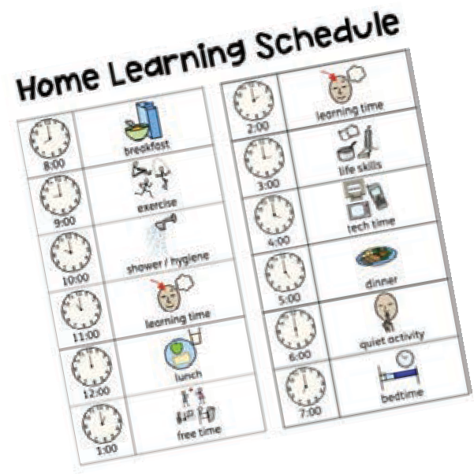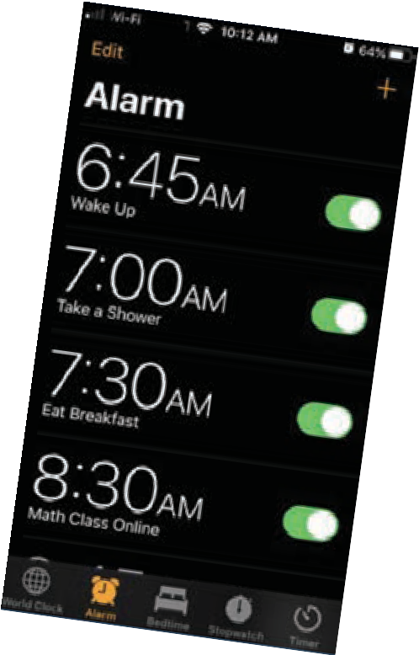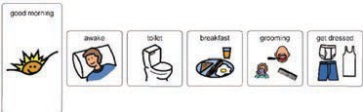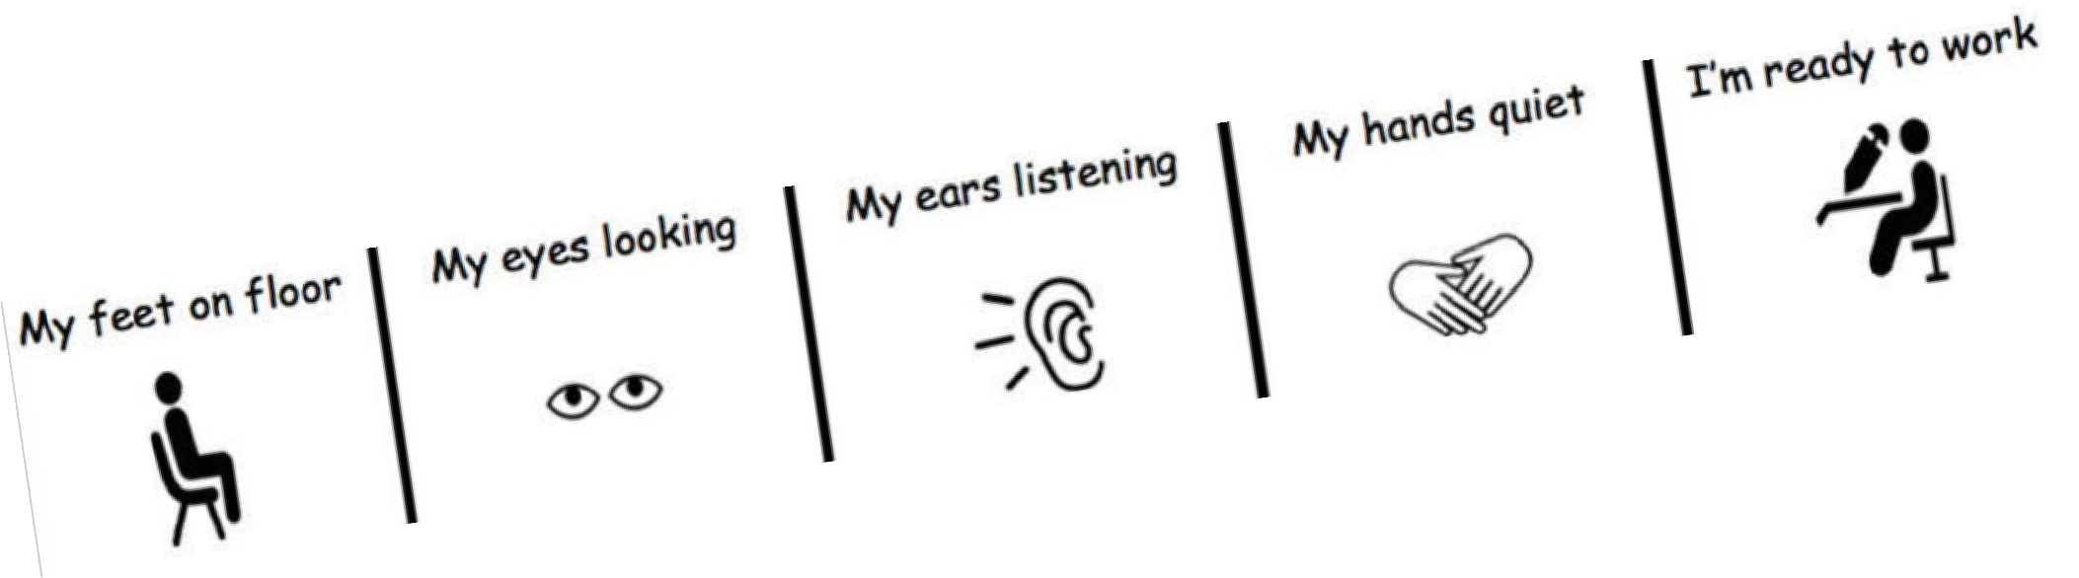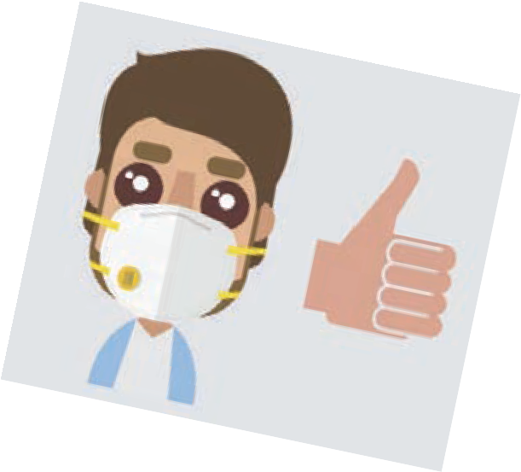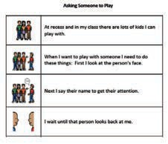Visual schedules break down a routine or activity into smaller tasks. They use words and images to show kids what they need to do to complete a routine or finish an activity. Pairing a picture with a time or an alarm indicates when one activity is done and it's time for the next activity.
To be successful, a visual schedule should be personalized to the child and based on his or her level of comprehension. It's also important to provide a reward or reinforcement when the schedule is completed.

Visual reminders are simple rules and reminders framed in a positive way, for example, "walking feet" instead of "no running."
Like picture schedules, they should be personalized to the skill level of the individual. Keeping the reminder in sight--even posting it in several locations--helps the child understand what behavior is expected of him or her.
Parents or teachers can point to the visual reminder when the rule is being repeated.

Reference: Presentation on Autism Supports: See Through My Eyes by Alysha Kim and Benjamin Chu
Created by SPIN from the October 17, 2020 SPIN
Conference Workshop

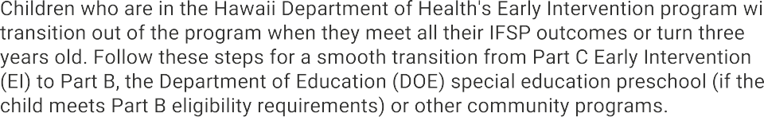Early Intervention Transition

Step 1
Planning for Transition Starts Early

Step 2 Think About Your Transition Options

Step 3

Part C EI Transition Conference

Step 4

Special Education Transition

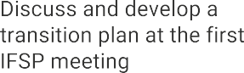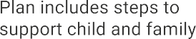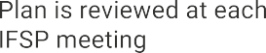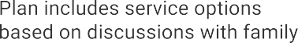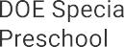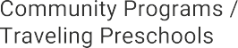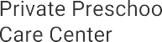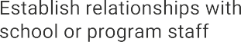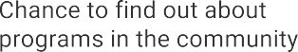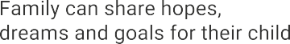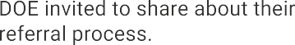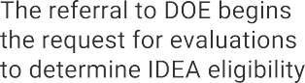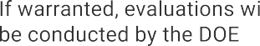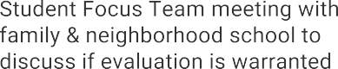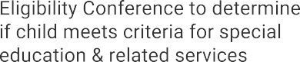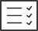IFSP: Individualized Family Support Plan
IDEA: Individuals with Disabilities Education Act Part C: Early Intervention is Part C of IDEA
Part B: Department of Education is Part B of IDEA
To watch the SPIN Workshop about EI transitions, visit:
https://spinconference.org/workshops/

Created by SPIN from the
"AB See Transition" workshop for the 2020 SPIN Conference

Smaller, specific goals are easier to manage and can provide you with a boost of confidence when complete.

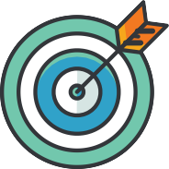

Instead of cutting out your favorite foods, add more fruits and vegetables and leave room for dessert.

Find a quiet place and set aside time every day to relax your mind and body for 20 minutes. You deserve it.

Take a few deep breaths and think about your goals for a few minutes each day, to provide focus and clarity.

Decide on 2 days a week to start and stick with it. Do things you enjoy, like family walks, yoga and bike riding.

Whether you pack a home lunch once a week or save your change, make a plan to save a bit each day.
Having enough daily water will increase your energy, help with digestion, mood and help you lose weight.

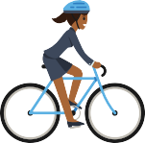
Lack of sleep affects your energy and weight. Plan a bedtime routine and stick with it for improved health.

When you complete a micro goal or milestone, celebrate and treat yourself. Self-love yields positive results.

Sources: www.yourtownhealth.com/5-realistic-new-year-resolutions/
www.uabmedicine.org/-/10-secrets-of-people-who-keep-their-new-year-s-resolutions
Created by SPIN 12/2020

Now that the United States has a vaccine shot that works for people, here are some things you need to know about the new COVID-19 Vaccination process.
The safety of COVID-19 vaccines is a top priority.

COVID-19 vaccines were carefully tested in clinical trials before being approved to use.
Trials have been done all around the world.

COVID-19 vaccines will NOT give you COVID-19 because they do not use a live virus.
COVID-19 vaccines will NOT cause you to test positive if you have a COVID-19 test.

There is no vaccine for children under 16 at this time. Adults who receive the vaccine will, in turn, help to protect our keiki, until a safe and effective vaccine is available for children.
Teachers, childcare providers and

Essential health care workers.

Nursing home residents and staff.

Police officers, fire fighters, emergency responders, and corrections officers.
support staff, food and agriculture workers, utility employees.

Adults and teens over 16, who have high risk medical conditions.

Anyone who is over the age of 65.

A vaccine is important to help stop the
spread of COVID-19.

It is a safe way to protect yourself from getting COVID-19.

It will help protect others around you.

It will help us get back to regular activities faster.

You will need 2 doses of the vaccine to have the best protection.

15
After your shot, you must wait 15 minutes to be sure you don't have a reaction to the vaccine.

You will need a second shot 3 or 4 weeks after you get your first one.

You can go to a medical clinic, pharmacy or a drive through vaccine station to get your
vaccine.

Yes. Your body may feel different after the shot. This is called having side effects. If the area around your shot looks different, tell a trusted adult right away or call your doctor.

You may have a headache or cough.
You might be really tired for a few days.

You may get a slight fever or chills.
Your arm might be sore in the area where you got your shot

You might feel nausea or sick to your stomach.
These side effects should go away in a few days.

It may take a year before most people are vaccinated and it is safe to gather in large groups and not wear a mask all the time. Until that time, be sure to stay safe when you are around others.

Wear a mask when you leave your home

Wash your hands often

Keep social distancing

Do not gather in large groups

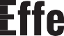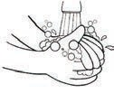Source: https://www.cdc.gov/vaccines/covid-19/health-systems-communication-toolkit.html
https://www.yahoo.com/lifestyle/everything-you-need-to-know-about-the-covid-19-vaccine-and-children-192153268.html
Created by SPIN December 2020

Upcoming Events

Every Friday

New topics every week!

Join LDAH every Friday on Facebook for the next installment. For more information, call 536-9684 or email tking@ldahawaii.org.

For more info, email: kiele.pennington@tacanow.org

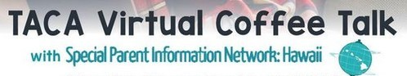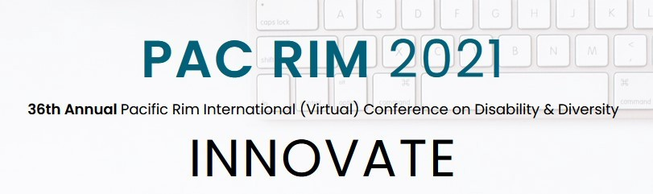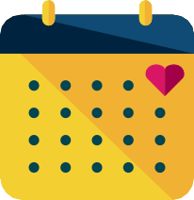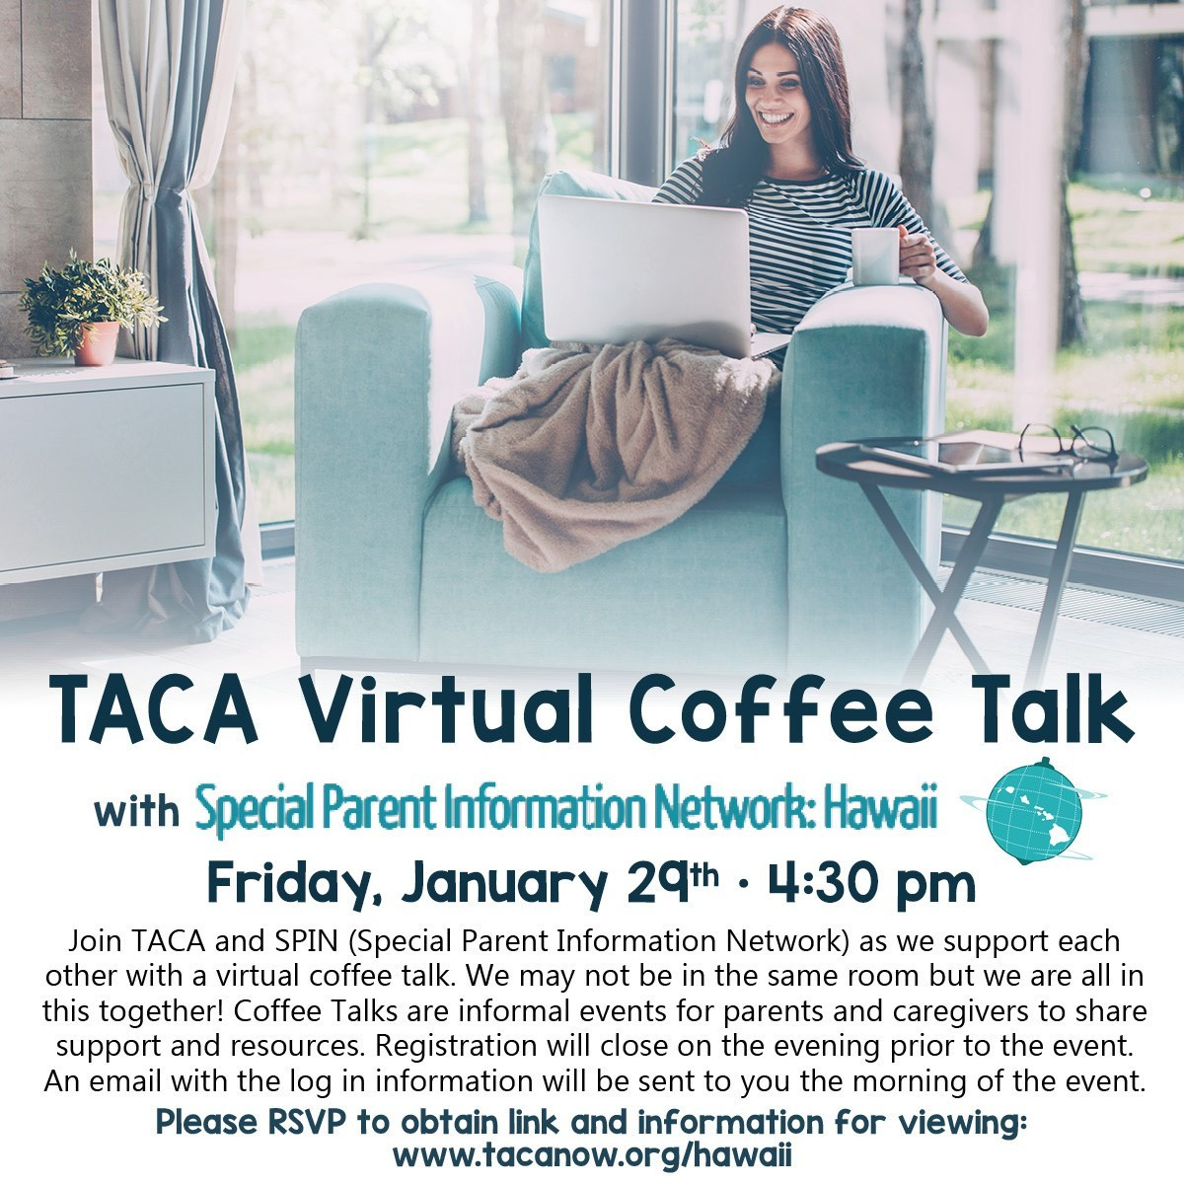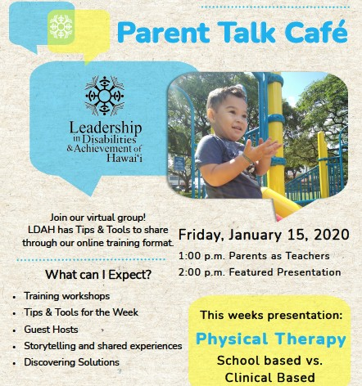

The University of Hawaii PAC RIM Conference will be virtual in 2021. They are offering a Pre- Conference event on Saturday February 27th, as well as two full days of workshops, posters sessions, films and talk story. In addition to the discount codes shown on the right, there is also a kama'aina rate for 20% off (kamaaina20). For more information about the schedule and to register, visit their website: https://pacrim.coe.hawaii.edu/. If you have questions about the conference or need a discount code, call SPIN at 808-586-8126. We'll be happy to help you out.

March 1-2,
2021

Online

Discount codes for PAC RIM 2021:
Self-Advocates/Persons with Disabilities: PRSA: $100 for all 3 days
PRSA-aloha: FREE Pre-Conference only
Family Members of Persons with Disabilities: PRfamily: $100 for all 3 days
PRfamily-aloha: Free Pre-Conference only
Students:
PRstudent: $100 for all 3 days
PRstudent-aloha: FREE Pre-Conference only
PreK-12 Educators:
PReducator: $100 for all 3 days
PReducator-aloha: FREE Pre-Conference only

