The Newsletter for Parents of Children with Disabilities

Smoothing the Path Forward
June 2021
Volume XXXVII, No. 3 SPIN is co-sponsored by the Disability & Communication Access Board and the Department of Education.
Services include a phone line for information referral and support, a quarterly newsletter, an annual conference and community workshops. SPIN is guided by an Advisory Committee made up of parents, teachers and people with disabilities.

SPIN
1010 Richards Street #118
Honolulu, Hawaii 96813

PHONE
586-8126
Neighbor Islands dial the ex- change below, then 6-8126
Kauai - 274-3141
Hawai’i - 974-4000
Maui - 984-2400
Molokai - 1-800-468-4644
Lanai - 1-800-468-4644

FAX
586-8129

E-MAIL
spin@doh.hawaii.gov

WEB
www.spinhawaii.org

Like us on Facebook
“Life is a story of transition. You are always leaving one chapter behind while moving on to the next.” --Anonymous

s parents of children with disabilities, we don’t always feel
A
ready or adequately prepared to help our children move smoothly through transitions, whether they be big or small. Sometimes we’re fearful of the unknown, or we want to hang onto routines and relationships that we are familiar with. But let’s face it: change happens!
SPIN was founded on the belief that giving parents access to information will support their ability to make decisions
that are the best fit for their family. By taking action, parents boost their courage and build confidence.
In the next few pages, we put together some
informational tools that offer guidance through some common transitions:
√ Planning for Transitions gives a big picture view of what elements are common to all transitions. It offers the reassurrance that while stressful, transitions can lead to a brighter tomorrow with the right planning.
√ 3 Ways to Transition Your Keiki Back to School In-Person offers tips to ease the anxiety and health- related issues that go along with returning to school fulltime.
√ Tips for Timely Transitions talks about strategies most teachers of young children have learned--how to move a child with a disability
from one activity to another with the least amount of disruption.
√ Transitioning Students to More Inclusive Placements offers an informal planning tool that helps families of children who have been receiving their education in self- contained classrooms think about the supports needed to move to an inclusive classroom or community activity.
√ The two infographics that talk about Transfer of Parental Rights at Age 18 discuss options for parents whose children will still be receiving services through their IEP after their 18th birthday.
√ Finally, SPIN’s Recipes for Success points you to our latest series of virtual workshops on transition that are meant for families of all ages and offer local expertise and resources. The last in the
series--Arriving at the Future-- can be viewed live on June 19th.

What’s Inside
Planning for Transitions 2
Transition Back to School 3
Tips for Timely Transitions 4
The MAPS Tool 5
Transfer of Rights Discussion 6
Transfer of Rights Options 7
SPIN Recipes for Success 8

PLANNING FOR TRANSITIONS

Transition is movement from one stage or place to another. Examples of transition are when your child moves from one grade to another, or one kind of educational placement to another. Job changes and family moves are also examples of transition. All transitions appear to have several things in common:

Increased feeling of stress or anxiety triggered by the change or adjustment.

A change in our support system. Family, friends & co- workers are often affected.

A period of uncertainty & questioning. Growth often occurs at this time.

Transitions require some advance planning to make the move less hectic, more efficient and successful. They also require the efforts of a team. By recruiting friends, family, teachers and other supportive folks to join the transition planning process, we make our load lighter and the journey easier. Think of transition planning as building bridges to your future.

Steps to take for a smoother transition for you or your child.
1. Write down what your next transition will be.
4. Think about your support network.
Which family members, friends, service providers and advisors might help you in this transition?

For instance, if your child is graduating from high school, would a successful transition include a job? More education? Continuing friendships?
2. Ask yourself & your family members what a successful transition would look like.

Delegate some of these tasks to your support network.
4. Think about your support network.
5. Describe some steps to take to move you forward.

3. Write down worries you may have.
6. Keep a positive attitude and celebrate successes!

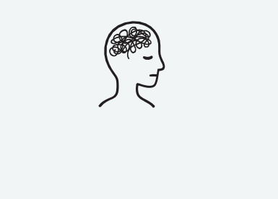This step will help you to develop any needed contingency plans.

SPIN May, 2021

3 Ways to Transition Your Keiki Back to School In-Person
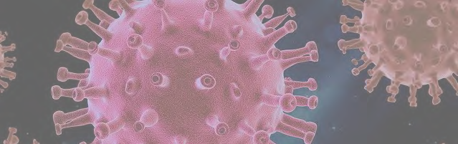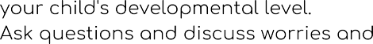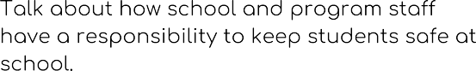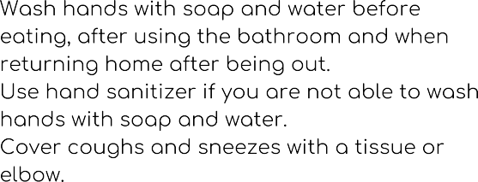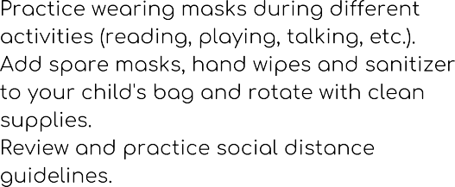

Moving from one activity to another can be challenging for young children.
Here are some helpful tips to keep your day frustration-free.

Give Warnings

Make it Fun

Be Consistent & Calm
Use a Timer

Natural Breaks

Offer Choices
More Time Between Activities

Sensory Breaks

Give Praise, Avoid Threats

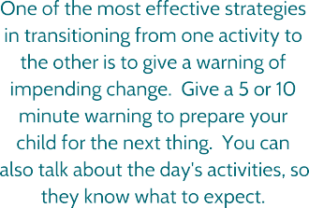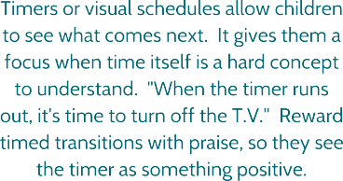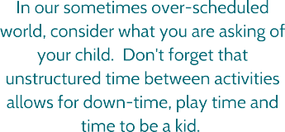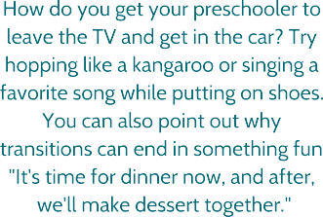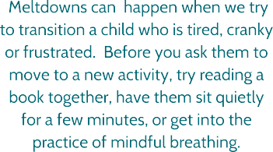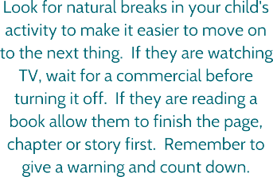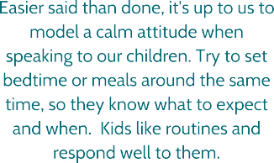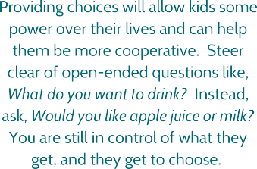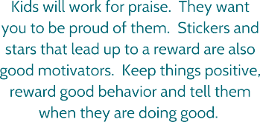Source:
https://www.mindfulmazing.com/transition-strategies-for-kids-9-tips-to-ease-transition-troubles/ https://theinspiredtreehouse.com/transition-strategies-preventing-tantrums-during-daily-routine/ https://www.friendshipcircle.org/blog/2017/05/10/coping-with-transitions/

Adapted by SPIN
May 2021

Transitioning Students to More Inclusive Placements

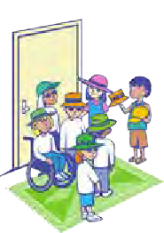
MAPS is still used by individual schools and teacher training programs like the UH College of Education.
The McGill Action Planning System (MAPS) was developed by Marsha Forest, Jack Pearpoint & Judith Snow at the Center for Integrated Education in Canada in the late 1980s as a planning process to help children with significant disabilities experience more inclusion within their schools and communities.

It is not intended to take the place of the IEP. It helps to make the IEP more personal by exploring the student's dreams and wishes and inviting the student's circle of support--friends, family members and helping professionals--to identify needed supports, including natural supports.

MAPS offers creative solutions for students who do not succeed in typical ways.

The success of mapping depends on gathering the key people in a student's life, including his or her non disabled peers to visualize goals and dreams.
The MAPS process can help make sure the student and his or her peers will have positive learning experiences in the classroom.
MAPS is similar to other person-centered planning strategies that put the person with the disability in the center of the plan and work toward allowing him or her the ability to choose from the same range of options and experiences as persons without disabilities.

What is the student's history?
Family members share important information about the students health, social and educational history.

What is your dream for the student?
Team members share what they want for the student's future and what they think the child wants. It's helpful to dream BIG.

What is your nightmare?
Once team members, including the family, share their fears of
what may happen to the student, they can commit to making sure the nightmare never happens.
7 Questions

McGill Action Planning System

MAPS

Team planning for school & community inclusion

7. What would an ideal day be like at school (or in the community)?
Start with a typical day for children the student's age who do not have disabilities. What supports are needed to achieve this vision?

6. What are the student's needs?
These include social- emotional, behavioral, physical, health and academic needs.

5. What are the student's gifts?
The focus of discussion is on what members believe the child CAN do--the child's contributions-- rather than what they cannot do.

Infographic by SPIN May 8, 2021
More information about MAPS can be found at: https://education.rowan.edu/_docs/maps-doc.pdf

4. Who is the student?
Everyone talks about what comes to mind when they think about the student. When the list is complete, the team picks the top three descriptions to highlight.

Transfer of Parental Rights at Age 18:
An Informal Process for Determining if Representation May Be Needed for the Adult Student with a Disability

Parental rights under the Individuals with Disabilities Education Act (IDEA) transfer from the parent(s) to the adult student on the day the student turns 18 years of age. Parents are notified one year in advance of their child's 18th birthday that this transfer of rights means the student will have access to his or her education records, make his or her own education decisions, and have the authority to give or withhold consent for evaluations, services and placements. The discussion tool developed by SPIN below helps the student and family identify options for ensuring that the adult student is adequately represented and protected under IDEA until exiting special education.

A Process for Discussing Transfer of Rights Options

Is the adult student able to understand, reason and act on his/her own behalf?

YES NO

Does the student want to make decisions for him/herself?
Has the family considered guardianship of the student?

YES
NO NO
YES

POWER OF ATTORNEY FOR SPED
SELF REPRESENTATION
The adult student makes educational decisions for himself or herself. The parent can act as an advisor/supporter in meetings with the school, if the student gives permission. The adult student is presumed competent to make informed choices unless the school receives documentation that this is not the case.

The adult student appoints an agent--a family member, a spouse, a friend or other trusted individual--to make educational decisions on his or her behalf. The student can decide to revoke (take back) the appointment of an agent at any time before leaving school.

See the infographic on the next page for details.
EDUCATIONAL REPRESENTATIVE

A parent, spouse or relative can make decisions after obtaining a written statement from a physician, psychiatrist, psychologist,or the Developmental Disabilities Division that the adult student lacks the capacity to make informed decisions for himself/herself.

See the infographic on the next page for details.

GUARDIANSHIP

The guardian makes all decisions in the best interest of the student while the student is receiving special education. Decisions by a guardian outrank those of an educational representative or agent unless the Court says otherwise.

See the infographic on the next page for details.

Documentation is provided to the school, and the school acknowledges the rights of the agent/guardian/educational representative to legally make decisions.

SPIN, May 2021 Sources: Chapter 60 Guidelines, Appendix F,
Act 182, Relating to Special Education and Transfer of Rights, 2008
6

Transfer of Parental Rights at Age 18:

Options for Parents to Continue to Represent Their Adult Child Under IDEA

Power of Attorney Agent for SPED
The Power of Attorney for Special Education (POA SPED) is an option for students who:
are considered to be capable of
making informed decisions; and feel more comfortable having a parent or a trusted adult advocate on his/her behalf.
The POA SPED consists of a document written by the adult student with a disability that appoints an agent to make special education decisions only. The student can choose for his or her agent:
a family member,
a friend,
any responsible adult,
but not an owner or employee of the school the student attends.
There is no special form that must be used--just a written document containing required information than can be found in the sources at the bottom of this page. The student can also revoke or take back the POA SPED at any time.
Once the POA SPED is witnessed by two individuals or notarized by a notary public, the school is given a copy for the student's file.

Educational Representative
When an adult student lacks the ability to understand, reason and act on his/her own behalf, Hawaii law allows for the parent(s) or the adult spouse of the student to act as the educational representative on behalf of the student.
Three kinds of information are needed: a statement by a qualified professional (primary physician, psychologist, psychiatrist) that the adult student lacks the capacity to make decisions,
the name and contact information for the adult student, and
the name, contact information and relationship to the adult student of the educational representative.
Once the school receives this information it will appoint the educational representative to participate in meetings about:
the identification, evaluation and
placement of the student;
the provision of a free appropriate public education (FAPE), and providing input that takes into account the student's instructions, wishes, personal values and best interest.

Guardianship

Guardianship is a legal means of protecting children and adults who cannot:
take care of themselves,
make decisions in their own best interest,
communicate their understanding of issues, and/or
handle their assets (like money).

Parents are the natural guardians of their minor children and are often surprised that they must petition the Court, if they want to become the legal guardian of an adult child with a disability.
A judge makes the decisions about: whether guardianship is needed to protect the adult student, who is appointed guardian, and
whether the guardian's powers are limited to some decisions or all aspects of the adult child's needs.
Some parents choose to avoid this option because of:
the time involved;
the out-of-pocket expense,
the requirement to provide annual updates to the Court; and
the availability of alternatives to guardianship that maintain their child's freedom of choice and self-determination.

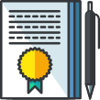
SPIN
May, 2021

Sources: Chapter 60 Guidelines, Appendix F
Act 182, Relating to Special Education and Transfer of Rights, 2008

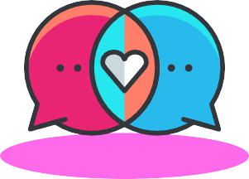
SPIN's Recipes for Success: Transition Workshops

SPIN has two workshops that are ready for viewing with our final event on June 19th. Be sure to visit our SPINConference.org website to access the videos and handouts and to register for our "Arriving at the Future" event.

Financing the Future - April 17
Understanding the basics of benefits planning Learn about Hawaii's ABLE Act and Kal's Law Speakers from UH and DD Council
Handouts and slides from the presentation

Pathways to the Future - May 8
Add marathon skills to your parent tool box
Discover how to use person-centered planning tools Speakers from UH, DDD & a parent/youth team Download planning tools and presentation slides

Arriving at the Future - June 19

Hear transition stories from 3 parent/youth teams Opportunities to ask questions
Live Zoom event will be recorded for viewing later Register for FREE at www.spinconference.org

SPIN - The Special Parent Information Network May 2021

