The Newsletter for Parents of Children with Disabilities

SPIN’s Journey Through the Wilderness
September 2021
Volume XXXVIII, No. 1
SPIN is co-sponsored by the Disability & Communication Access Board and the Department of Education.
Services include a phone line for information referral and support, a quarterly newsletter, an annual conference and community workshops. SPIN is guided by an Advisory Committee made up of parents, teachers and people with disabilities.

SPIN
1010 Richards Street #118
Honolulu, Hawaii 96813

PHONE
586-8126
Neighbor Islands dial the ex- change below, then 6-8126
Kauai - 274-3141
Hawai’i - 974-4000
Maui - 984-2400
Molokai - 1-800-468-4644
Lanai - 1-800-468-4644

FAX
586-8129

E-MAIL
spin@doh.hawaii.gov

WEB
www.spinhawaii.org

Like us on Facebook

re you feeling a bit lost in this never-ending pandemic? Do
A
you wish for trusted folks to guide you through the uncertain future to a place of safety and well-being for you and your children? Would you like a guide like Russell, the brave Wilderness Explorer from “UP!”?
Well, look no further than the 35th Annual SPIN Conference, “SPIN’s Journey Through the Wilderness,” coming to your phone, computer screen or tablet on Saturday, October 23rd. We have put together an A-list of ‘wilderness guides’ who believe our shared struggles and experiences
Nurturing the relationship between parents and teachers to benefit students;

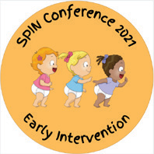
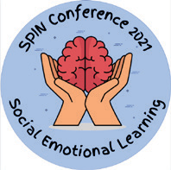
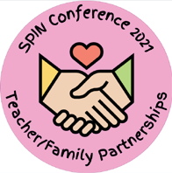
Making the most of your child’s early intervention services;

Social and emotional learning supports in the pandemic; and

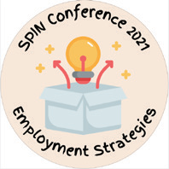
Out-of-the-box thinking on preparing for future employment.

provide an opportunity to In addition to the nine live
reshape our world for the workshops, SPIN is offering
better. three networking sessions:
Like Russell, you • Autism parent-to- will be able to earn merit parent supports, badges (knowledge and • Benefits planning &
confidence) in a variety of Social Security, and
topics like: • Extended School Year.
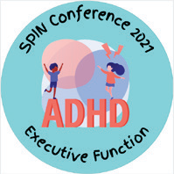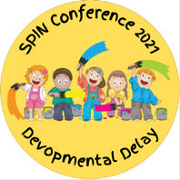Strategies to improve

executive functioning in kids with ADHD;
Understanding the eligibility category of Developmental Delay and what comes next;
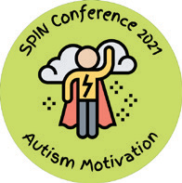
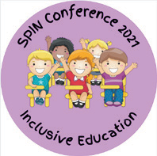
Finding the right motivations for students with autism and building on their strengths;
The benefits of inclusive education for students with IEPs and their peers;
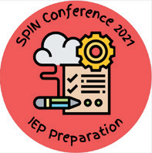
Strategies to prepare for your child’s next IEP meeting in light of the pandemic;
Are you ready to start the
journey to better relationships, deeper understanding and improved outcomes for your
keiki? Go to page 7 to register, and let’s all meet up on October 23rd!
WHAT’S INSIDE
Famiiy Input on Learning Loss 2 Approaches to Learning Loss 3 Parent Involvement Survey 4
Parents for Public Schools 5
The APP Corner - SMART 5
COVID-19 Staff Shortages 6
Conference Registration 7
Hawai‘i ABLE Savings Program 8 Kal’s Law 9
Fall Calendar of Events 10

How Families Can Help Address Learning
Loss for Students with Disabilities

Given the continued educational impact of the COVID-19 pandemic, COVID-19 Impact Services* will continue to be an option available through school year 2021-2022 when the student's multi-tiered system of supports or revised IEP/504 Plan is not sufficient to address the loss.

* COVID-19 Impact Services are temporary, individualized services provided beyond the school day to make up a significant learning loss resulting from the pandemic.

Learning Loss includes:
Educational loss Skill loss
Lack of expected progress New need/s

Parent(s)/legal guardian(s) are vital partners to the IEP team. Make sure you engage with your team and participate in the IEP decision-making process.

If You Suspect Your Child Has Had Learning Loss
- Contact your school immediately to schedule an IEP/504 Plan meeting.
- Review data, discuss and determine if there has been learning loss.
- If there has been learning loss, work with the team to determine how learning loss will be addressed: HMTSS and/or revise IEP or Section 504 plan, and/or COVID-19 Impact Services.
- Discuss with your team whether additional assessments are needed to shed light on the cause of learning or skill loss.

To Determine Learning Loss, Consider the Following:
Student Participation
Has your child participated in their educational program and responded to activities and assignments by their teachers? Look at work samples and other evidence of learning.

Parent Report/Information Do you have additional information (from other service providers, observations, etc.) to share about your child's learning and the services they are receiving.

How Progress is Measured Were a variety of sources and methods used to determine your child's progress toward goals and objectives?

Progress Report/Grades Has there been a drop in how your child is progressing towards IEP goals or in his or her grades?

Current IEP/504 Plan
Review your child's IEP/504 Plan. Was your child able to access and engage in all outlined services & supports?

Source: HIDOE Memo from Assistant Superintendent Heidi Armstrong 4/30/2021

Created by SPIN May 2021

Learning Loss & Accelerated Learning Approaches
Once the IEP team agrees that a student has experienced a learning loss, what kinds of supports are available to help the student make up that lost skill or learning opportunity in the shortest amount of time? Put another way, how can learning be accelerated, or speeded up, in order to help the student learn at or near grade level?
related services and creating new objectives or revising old ones.
HMTSS
In-School Acceleration
Acceleration builds on what students already know as a way to access new learning. Often the focus is on the most
important knowledge and skills. If a student with an IEP or 504 plan has a minor skill loss, it can often be supported through Hawaii's Multi-tiered System of Supports (HMTSS). For more significant losses, the IEP may decide to revise the IEP or 504 plan, increasing the frequency or duration of
1
Tutoring
Tutoring that occurs in small groups of 5 or fewer students and is delivered by well-trained tutors during the school day tends to have a very positive impact on student learning. It is often offered in Tiers 2 and 3 of HMTSS to any student who is in need of extra support. One way to avoid taking the student away from other instruction is to provide the tutoring during study hall or flexible periods.
2
Out-of-School Programs
These services are provided before and after the regular school day, on weekends, and during school breaks. They range from high-quality after school programs for all students to specially designed instruction and/or related services provided as part of Extended School Year (ESY) services or a COVID-19 Impact Services Plan (compensatory
services due to a significant skill loss related to the pandemic).
3
Summer Learning & Enrichment
During the summer months in 2021, students with disabilities participated in a variety of summer learning opportunities including official summer school, school learning hubs, ESY and non-ESY special education programs, and a variety of enrichment programs.
4

Sources: USDOE ED COVID-19 Handbook, Volume 2, 2021 SPIN
Addressing the Impact of COVID-19 on Students with Disabilities, August 2020 Sept. 2021

Special Education
Parent Involvement

The Hawaii State Department of Education needs your feedback in order to improve our system and create better partnerships with parents. The survey results will help the Department to strengthen:

Parent Survey

The Annual Survey is Easy to Do

School communication

Parent engagement Information sharing Family partnerships
Fast
It takes about 10 minutes to complete the survey, which has 25 questions,
available in 15 different languages.
Convenient
You can use your cell phone, computer or tablet to complete the survey online, or ask for a paper copy to mail in.
Confidential Your responses are anonymous and the information you provide can not be traced back to you or your child.

For more information, see the Parent Involvement Survey Handout:
bit.ly/3m9os3B

SY 2019-20
3.26%
Annual surveys returned
Fill out the survey every year

One survey per IEP student

Use this QR code to access the survey from your phone.

In 2019-20, about 20,000 surveys were shared with parents, but only 3.26% of the surveys were returned. Your responses will help to improve special education in Hawaii.

www.hiparent survey.com

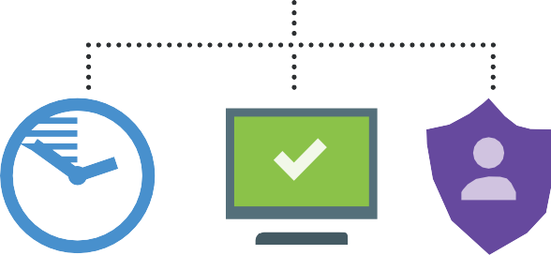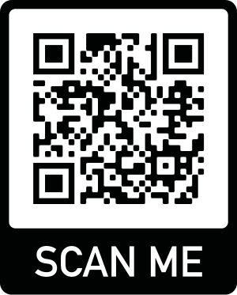
Source: Hawaii DOE, Monitoring and Compliance Branch
Note: The Parent Involvement Survey is required by IDEA and is recorded as "Indicator 8". Read the report here:
https://www.hawaiipublicschools.org/VisionForSuccess/SchoolDataAndReports/StateReports/Pages/Special- Education-Performance-Report.aspx

Created by SPIN Special Parent Information Network
August 2021

Spotlight
on Support: Starting September 10th, Hawaii will be offering a

Parents for Public
new app to show your vaccine status called the Hawaii SMART Health Card. The program is

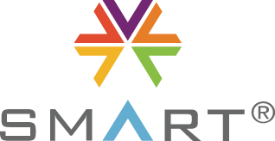Schools Hawaii voluntary and will allow users to upload their
vaccination card into the app and receive a QR
Parents for Public Schools is non-profit code to show they have been vaccinated. The community organization dedicated to supporting program only works for vaccines received in and improving public education for all students, Hawaii, and you will still be able to show your through family engagement. They are part of a vaccine card or negative COVID-19 test if you larger organization, Parents for Public Schools need to.
Inc, with 17 chapters in 12 states. One of the
unique services they provide are middle school Here’s how the Hawaii SMART Health Card
tours and transtion nights for famillies of 5th works:
and 6th grade students to learn about the public 1. Go to the Hawaii Safe Travels website: middle or intermediate school in their community. https://travel.hawaii.gov.
They work with the school to provide tours of the 2. Create an account or use your existing campus, opportunites account.
to meet current 3. Click on the SMART Health Card logo. students at the school 4. Take a picture of yoru vaccination card and and ask questions of upload it.
the school staff and 5. Enter your vaccination information. leadership. These tours 6. If you are a parent or guardian and have are not special COVID-19 vaccination records for minors, education specific, upload each digital vaccine record request although it is a fun way separately.
to meet school staff and learn what the school has 7. Once validated by the system, you will receive to offer. The transition nights also cover school a QR code that you may present to business- culture, adolescent development and allow dis- es and establishments that require proof of cussion for parent concers. Recently, Parents vaccination status.
for Public Schools have been hosting parent 8. Your QR code will be available for display in feedback meetings on Zoom, to understand how the Hawaii SMART Health Card section of the students and families are doing this school year. Safe Travels website.
They have created a “Hopes” document and a petition to sign if you agree with their 5 Hopes, including the need for the HIDOE to provide safe conditions for all staff and students, options to deliver instructional models based on family and student needs and creating plans to reflect current needs. You can find more information about Parents for Public Schools Hawaii and sign up to become a member for free at ppshi.org.

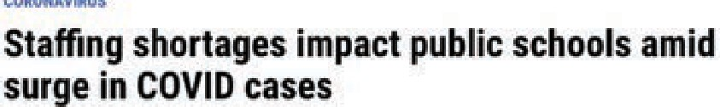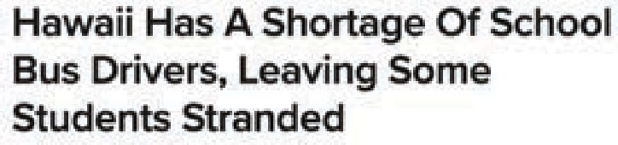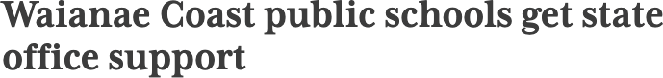

Staff Shortages Add to the Negative Impacts of COVID-19

he headlines above represent some of the many recent examples of schools in Hawaii and across
T
the nation being challenged to provide basic services this school year due to absences and vacant positions related to COVID-19. Not only is there a shortage of teachers, including substitute teachers, but also a variety of other critical staff--educational assistants, bus drivers, cafeteria workers, after school providers, contracted agency personnel for related services like behavioral support, and more. These shortages are adding to the anxiety, stress and frustration already experienced by school staff and families after a year and a half of dealing with the health and educational challenges posed by COVID-19.
There are also many reasons for the shortages, making solutions to the problem of an adequate work force harder to come by. Some of these factors include:

many more cases of COVID-19 infection due to the super contagious Delta variant and/or low rates of vaccination,

quarantines required after close contacts with someone who has contracted COVID-19,

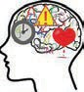
a changing economy that has resulted in some staff changing their careers, contributing to a national labor shortage,
stress and burnout leading some educators and support staff to leave the profession, and

a testing mandate from the Governor that may be hard to satisfy due to costs or lack of access to a testing facility.
Schools, districts and state offices are doing their best to prevent students from experiencing delays
in services or lost instructional opportunities. They are prioritizing the needs of vulnerable students, like students with IEPs, and reaching out to community partners to assist in finding solutions to the gaps
in coverage. In some cases, parents have been part of the solution, as when they have offered to provide transportation to school in areas where bus transportation is unavailable in exchange for being reimbursed for their gas and mileage.
No one knows how long schools and after school programs like A+ will be struggling to find enough staff to meet the needs of the students they serve. In the meantime, if your child is experiencing any gaps in service, here are some suggestions on what you can do:
Communicate with your child’s teacher or after school program. Ask if your child’s IEP services have been impacted by shortages in educators or related service personnel, including contracted therapists and bus drivers. Request frequent updates, if you think your child’s program may be impacted.
Offer to help problem solve whenever possible. See yourself as a true partner with your child’s school or after school program and try to avoid blaming others. COVID-19 is continuing to disrupt all of our lives, and everyone is affected by the stress and uncertainty.
Notice any areas of learning loss your child may be experiencing due to how services may be altered or disrupted by staff shortages. Also, if your child has been quarantined due to close contact with someone at school, try to monitor their progress at home. If you sense that your child has been negatively impacted, ask for an IEP meeting to discuss strategies to get him or her back on track.
Feel free to contact SPIN for support and ideas during this difficult time.

Saturday, October 23, 2021
9:00 a.m. to 1:30 p.m.
SPIN's Journey Through the Wilderness

Go here to register at spinconference.org

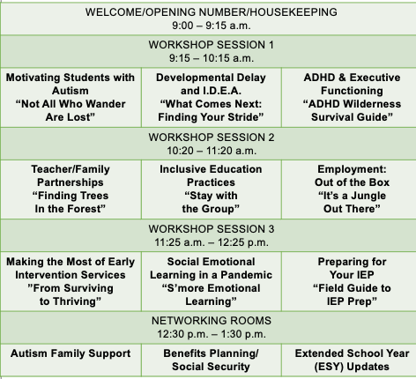It's FREE,
and you can join us from your couch!
PRIZES

Receiving SSI

For more information about the Hawai‘i ABLE Savings Program contact Daintry Bartoldus at the Hawaii State Council on Developmental Disabilities (daintry.bartoldus@doh.hawaii.gov, (808) 586-8100) or go to the website on November 1, 2021: https://hawaiiablesavings.com.
ABLE Plan Update

GREAT NEWS! The Hawai‘i ABLE Savings Program is due to launch on November 1, 2021. After years of careful planning, Hawaii has chosen to partner with the State of Oregon and their ABLE for
is partnering with Oregon’s ALL Savings Plan.
For as little as $25 dollars, eligible Hawaii residents can open an account and begin to save for a variety of purchases without risking government benefits.
What does ABLE stand for?

The Achieving a Better Life Experience (ABLE) Act of 2014 gave people with disabilities receiving government benefits and their families a financial tool to put money aside for purchases to enhance quality of life without risking the loss of those benefits (like SSI and Medicaid). The Act was modeled on the popular ‘529’ College Savings Plan that allows tax-deferred savings for higher education.

$15K Yearly Individuals, their families and friends can $100,000 Cap Accounts that deposit up to $15,000 a year in an ABLE grow larger than
account. Account holders choose from a $100,000 over the
variety of investments, and can withdraw years will cause
money throughout the year for qualified SSI benefits to be
expenses. suspended.
What are ‘qualified expenses’ under the ABLE Act?

Health/Wellness | Housing | Financial | Education | Transportation | Job Training Assistive Funeral and
/Prevention |  | Management |  |  | and Support Technology Burial Expenses
Who is eligible to open an ABLE Plan account?

Current eligibility is limited to persons whose disability occured before age 26. Legislation has been introduced in Congress to expand eligibility to individuals whose disability occured before age 46.

Proof of Eligibility includes:

OR Receiving SSDI OR Meeting SSA’s definition of eligiblity

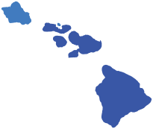Kal's Law

Hawaii's Medicaid Income Disregard Program

1

This law eliminates barriers to employment.
Many people with disabilities in Hawaii have been afraid to find a job for fear of losing their Medicaid coverage. Medicaid may be the only medical insurance available to the individual, and it may also be needed to receive Medicaid Waiver services.

2

It was named after Kal Warrington Silvert.
Kal was a bright college student with a disability who dreamed of one day becoming a professor and a writer. Sadly, he learned he could never have the dignity of earning a comfortable living, because he needed nursing services from Medicaid to live.

3

Workers are now able to have higher earnings. Income up to 138% of the federal poverty level ($1705 for a household of one) is disregarded when determining eligibility for
Medicaid. With all deductions, a worker could earn up to
$5,000/month and keep his or her Medicaid coverage.

4

The law covers most workers with disabilities and raises their asset limit.
To be eligible for the income disregard, workers with disabilities must be between the ages of sixteen and sixty-four. A worker can now can hold assets of up to $7970 for a household of one.

5

The law applies to all wages earned this year.
Now that Kal's Law has gone into effect, it applies to wages earned from January 1, 2021 to the present. Individuals who may have been turned down for Medicaid earlier this year because their income was too high may want to reapply under the new rule.

For more information, contact the State Developmental Council on Developmental Disabilities @
808-586-8100 or email Daintry.Bartoldus@doh.hawaii.gov.
Information is current as of September 25, 2021.

Fall Calendar of Events

LDAH Parent Talk Cafe - FREE Every Friday, 1:00 - 3:00 pm
New topics each week. On Zoom and Facebook Live. Join their Facebook page or call 536-9684 for more information.

9/27 TACA Coffee Talk - FREE
4:30 - 5:30 pm, for families who have a child with autism. Meeting held virtually on Zoom. You must register by September 26. tacanow.org/local-chapters/west/hawaii/

10/3 Children & Youth Day - FREE
Will showcase a 1-hour TV special this year. For more information and the visit www.hawaiicyd.org

10/4 Hawaii Fetal Alcohol Spectrum Disorder 11/1 (FASD) Action Group - FREE
12/6 1st Monday every month, 7:00 - 8:00 pm Virtual meetings held on Zoom, email to get link: pili.sina.p@gmail.com

10/5 DDD Training Series - FREE
11/2 1st Tuesday every month, 11:00 am- 12:00 pm
12/7 Various topics each month. Virtual meetings held on Zoom. To register, visit their website: health.hawaii.gov/ddd and for more info, mail: doh.dddtraining@doh.hawaii.gov.

10/8 SEAC - Special Education Advisory 11/12 Committee Meeting 9:00 am - 12:00 pm
12/10 2nd Friday each month, August through June.
Meetings held virtually on Zoom. Find the link on the monthly agenda at:
SEAC-Hawaii.org

Providing a world of support to parents of children with special needs

Special Parent Information Network
1010 Richards Street, Room 118
Honolulu, Hawaii 96813
(808) 586-8126

10/14 Children & Youth Summit - FREE
10/15 This annual event is an opportunity for youth 22 years and younger to discuss topics that are important to them. The 2-day event will be held virtually on Zoom. For more information, visit hawaiicys.org or email: info@hawaiicys.org

10/20 Afterschool Alliance Community Conference 10/21 $20 per person, 9:00 am - 3:00 pm daily
10/22 Geared towards afterschool programs and staff, families are welcome to attend. Register online: hawaiiafterschoolalliance.org

Ho‘omana Parent Support Meetings - FREE Meetings are held virtually on Zoom, and are open to all families across the state.
10/21 Informal/Talk Story, 10:30 am - noon
10/27 Talk Story, 6:00 - 7:30 pm
10/28 Benefits Planning Presentation, 6:00 - 7:00 pm
12/08 To be announced
12/09 To be announced
Email for a link: hoomanagroup@gmail.com

Registration is now open!
10/23 SPIN Conference - FREE 9:00 am - 1:30 pm. The 35th annual conference
is for families, teachers and helping professionals, with 9 live workshops and
3 live networking rooms. Register today at SPINConference.org

2021 Virtual Legislative Forums Sponsored by the Hawaii State Council on Developmental Disabilities and the
Self-Advocacy Advisory Council (SAAC)
10/25 Kauai Legislative Forum & Resource Fair
3:30 - 6:30 pm.
10/27 Hilo Legislative Forum, 1:00 - 3:00 pm
10/28 Kona Legislative Forum, 1:00 - 3:00 pm Call (808) 586-8100 or email Daintry (Daintry.Bartoldus@doh.hawaii.gov) for more information on the forums.

