The Newsletter for Parents of Children with Disabilities
Dipping your Toe into Systems Advocacy
December 2021
Volume XXXVIII, No. 2
SPIN is co-sponsored by the Disability & Communication Access Board and the Department of Education.
Services include a phone line for information referral and support, a quarterly newsletter, an annual conference and community workshops. SPIN is guided by an Advisory Committee made up of parents, teachers and people with disabilities.

SPIN
1010 Richards Street #118
Honolulu, Hawaii 96813

PHONE
586-8126
Neighbor Islands dial the ex- change below, then 6-8126
Kauai - 274-3141
Hawai’i - 974-4000
Maui - 984-2400
Molokai - 1-800-468-4644
Lanai - 1-800-468-4644

FAX
586-8129

E-MAIL
spin@doh.hawaii.gov

WEB
www.spinhawaii.org

Like us on Facebook

“Change will not come if we wait for some other person or some other time. We are the ones we’ve been waiting for. We are the change that we seek.”
-- Barack Obama

ll of our readers who have children with disabilities or who
A
have advocated for a child with a disability have experienced individual advocacy. That means standing up for the rights and the needs of your child, or your student, or your client. On the other hand, very few of us make the additional choice of advocating on a systems level. Why is that?
Systems advocacy is about working together with others to benefit
a group of individuals, for example, all children receiving special education services. It often involves working
to change policies, laws or rules that impact a community of people.
There are a lot of reasons that families of kids with disabilities don’t engage in systems advocacy. Here are some of them:
Parents are busy folks. They may feel they don’t have the time.
They may also lack
Many parents are uncomfortable with the conflict of
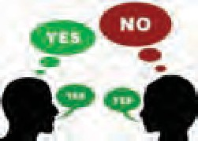
opposing views on an issue.
Others lack the confidence that they can make a difference in the lives of others.
Whatever it is that has kept you from engaging in systems advocacy, SPIN respects your choice. But if you have an issue that you feel passionate about, don’t be afraid to take a few baby
steps towards becoming a systems advocate. Many parents have a desire to honor parents who came before them and opened doors for their children by clearing the way for future families.
‘ In this issue, we’re going to spend some time sharing information about the State Performance Plan
and Annual Performance Report and suggesting baby steps you can take to get involved in this process. In our February issue, we’ll be focusing on legislative advocacy.

WHAT’S INSIDE

knowledge about an issue. What are the barriers to success? What’s been tried before?
Systems advocacy often
What is the SPP/APR? SPP/APR Indicators Indicators 3, 6, 7, 8, 13,
14 and 17
Ideas for Getting Involved Self-Care Treat
1
2

4-10
11
12

results in progress that
moves at a snail’s pace. Some lack patience.
Winter Calendar of Events 13

What is the SPP/APR?

e’ve all heard the expression: “if you don’t know where you’re going, how will you
W
know when you get there?” That is why Congress mandated the State Performance Plan (SPP) and the Annual Performance Report (APR) as part of the overall monitoring system under the Individuals with Disabilities Education Act (IDEA) to ensure every state is held accountable for how it educates its students with disabilities.

SPP Components
The State Performance Plan is basically a plan for continuous improvement organized into six-year cycles. The current SPP runs from SY 2020-21 to SY 2025-26, and is made up of 17 measures or indicators based on key requirements of IDEA. For each indicator, there must be a baseline and annual targets.
Baseline data is the state’s performance for the indicator on year one of the six-year cycle. Baselines can also be reset, if the way data is measured or calculated changes
after the initial baseline is set.
Measureable targets must be set for each year of the plan (expanding each year to get closer to the goal). They should be both precise and achieveable.

What is NOT in the SPP?
While the SPP/APR is currently the best tool that OSEP and Congress have to measure a state’s special education performance, the SPP does not include all the information stakeholders might need to understand the bigger picture:
- Some of the indicators are limited to one aspect of a special education requirement.
For example, OSEP only asks for data on student suspensions that total more than ten days in a school year. It does not ask for data on suspensions of 10 days or less or whether they are disproportionately higher for special education students compared to all students. Research shows that suspensions of any length jeopardize academic success for students with disabilities.
- States are not required to meet their targets for mediation in any year in which less than 10 mediations are held.
This is at odds with the strong urging of Congress to promote mediation as a means of resolving conflicts between parents and schools.
- OSEP requires ethnicity reporting to fit into seven broad categories only.
In Hawaii, where the population is so diverse, reporting using these broad categories of Asian or Native Hawaiian/Pacific Islander may mask poor performance for students from a specific ethnic group.

Annual Performance Report
States are required to report annually to OSEP, using data collected during the previous school year to
measure progress toward each of the indicators. If a target is not met, the APR must include an explanation of why the slippage occurred. The APR also must report any noncompliance, for example, failure to
provide timely initial evaluations to students with
disabilities (Indicator 11), and whether compliance reported in a previous year has been corrected.
Finally, the APR must include evidence that special education stakeholders were involved in target setting, annual review and providing input on improvement activities.
Stakeholders can belong to any group
that has a “stake” or strong interest in the successful implementation of special education supports and services. These groups include family members (including students
with disabilities), community members, educators and school administrators, other agency personnel, advocates and legislators. The Special Education Advisory Council, the Community Children’s Councils and the Parent Training & Information Center have traditionally been included in SPP/APR review and planning.

Why YOU may want to participate
Few parents are aware of these federally set goals or the process to monitor them. SPIN thinks it’s important for parents and other stakeholders to know about them for two reasons:
- they provide important information on how Hawaii has set about to improve services to students with disabilities, and
- they offer an opportunity for you to give your opinion about what is working for your child (and what is not) and hopefully influence the process!
In the following pages, we’ll describe some of the key indicators and share ideas on how you can be involved in setting targets.

SPP/APR Indicators & What They Measure

Of the 17 indicators, six are called compliance indicators (in red) and these targets are set by OSEP at either 100% or 0%. They reflect regulations in IDEA which must be met. Here are some examples:
1. Indicator 11, the %
Indicator # | What Improvement the Indicator Measures
1 | Improving graduation rates for students with disabilities
2 | Decreasing dropout rates for students with disabilities
- 3A  - 3B-D | Ensuring all students with disabilities (SWD) participate in statewide assessments  Improving proficiency on statewide assessments Reducing the gap in proficiency rates between SWD and all students taking the statewide assessment
4A  4B | Reducing suspension and expulsion rates for SWD Reducing suspensions of SWD by race and ethnicity
5A-C | Providing services in the least restrictive environment (LRE) for school-aged SWD
- 6A-D | Providing services in the least restrictive environment (LRE) for preschool-aged SWD
- 7A-C | Improving the social emotional, knowledge & skills, and use of appropriate behavior of preschool SWD (preschool outcomes)
8 | Improving parent involvement in their child’s education
9 | Reducing the disproportionality of racial/ethnic groups  due to inappropriate identification (ID)
10 | Reducing the disproportionality of racial/ethnic groups in specific disability categories due to inappropriate ID
11 | Improving efforts to find and evaluate SWD and provide special education in a timely manner (child find)
12 | Ensuring a smooth and timely transition from preschool programs to school-based programs (pre-K transition)
- 13 | Improving transition services for SWD at the secondary level (secondary transition)
- 14 | Improving outcomes for students moving from secondary to post-school activities (post-school outcomes)
15 | Increasing the use of resolution sessions to resolve due process hearing requests prior to a hearing
16 | Increasing the use of mediation to resolve differences between parent and school
- 17 | Improving results for SWD through the implementation of an ambitious and multi-year plan (SSIP)

of children whose initial
evals were completed within 60 days is set at 100%.
- Indicator 9, the % of students who are over- represented in special education, is set at 0%.
In order to meet this
target, a state has to be in
at 95%, or less than 5% of
“substantial compliance” -- the target.
The items that are
★
starred are described in the infographics on the following pages. These seven indicators were the focus of discussion at the December 10th SPP/APR Stakeholder Engagement Meeting to recommend targets and improvement activities for the APR that will be submitted on February 1,
2022.

Under each indicator you will see a link for the data that has been collected, and a link to a brief and anonymous survey that asks for your input on the proposed targets and improvement activities. The surveys are
due by January 7th.

3 Statewide Assessments

What it measures:
  - The participation rate on statewide assessments for students with IEPs;
  - The proficiency rate for students with IEPs against grade level academic achievement standards for ELA & math;
  - New The proficiency rate for students with IEPs against alternate academic achievement standards for ELA & math;
  - New The gap in proficiency rates for students with IEPs and for all students against grade level academic standards.

Overall Hawaii Achievement Gap SY 2018-19
% procient
100

All means all
Every student in grades 4, 8 and 11 with an IEP is expected to participate in the annual statewide assessment in one of three ways:

- With no accommodations,

- With accommodations, or

- Through an alternate assessment (AA). The AA is for students with the most
significant cognitive disabilities.

While OSEP is just now collecting data on achievement gaps, Hawaii's Strive HI system

50 43
0

11

Math

All Students SPED
13

ELA
54
has been tracking the achievement gaps for student subgroups since 2015. Special education students have always experienced the biggest gaps in achievement.

National Comparison for Participation Rates
One-third of other states and territories had participation rates above
Hawaii's for the statewide assessment in FFY 2018.

Potential Improvement Activity for Participation
Communication with families about the benefits of the statewide assessment

Potential Improvement Activities for Proficiency Rates

Highly effective teaching using
High quality Early literacy evidence-based
Inclusive classrooms initiatives strategies

Reducing chronic Accelerated learning strategies like absenteeism tutoring, summer programming, etc.

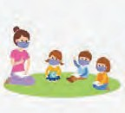
Source: 2020 Part B FFY 2018 SPP/APR Indicator Analysis Booklet and Hawaii Strategic Plan Dynamic Report
Here is the link for data and proposed targets on Statewide Assessments. Here is the link to the stakeholder survey on Statewide Assessments.

Preschool Environments
6

FAPE in the LRE for Preschool Children

What it measures:
The percent of children with IEPs aged 3, 4, and 5 who are enrolled in a preschool program attending a:
  - Regular early childhood program and receiving the majority of special education and

Hawaii is behind most states in including preschoolers.

Comparison with Nat'l Data FFY 2018*
50
50

28.5

related services in the regular early childhood program;
  - Separate special education class, separate 0
school, or residential facility; and
  - NEW Receiving special education and related services in the home.

OSEP recently changed the measurement for Preschool LRE
23.8 20

% in reg. ed % in separate
*FFY refers to Federal Fiscal Year, in this case SY 18-19.
Hawaii National Avg.

New baselines (green bars)showing
% of preschoolers for 6A & 6B.
31.2

The old measurement included all 3-5 yr. olds. The new measurement for FFY 2020 and beyond removes 5 yr. olds who are
attending Kindergarten.
Indicator 6A
Indicator 6B

0 20
21.3

28.9
32.3

3-5 w/ kindergarten 3-5 w/o kindergarten

Indicator 6C

1.26%
of preschoolers received special education at home in FFY 2020

The targets for Indicator 6B & 6C should remain low.
OSEP expects that most children would attend a regular early childhood program and receive the majority of special education and related services in the regular early childhood program.

Potential Improvement Activities

Universal Preschool
More training in Inclusive practices
Expanding partnerships

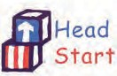

Source: 2020 Part B FFY 2018 SPP/APR Indicator Analysis Booklet and Hawaii Annual Performance Report Data

Here is the link for data and proposed targets on Preschool Environments.

Here is the link to the stakeholder survey on. Preschool Environments.

7 Preschool Outcomes

What it measures: For each outcome, states are

The percent of preschool children with IEPs who demonstrate improved:
- Positive social-emotional skills (including social relationships);
- Acquisition and use of knowledge and skills (including early language/
communication and early literacy); and
- Use of appropriate behaviors to meet their needs.

asked to report two measures:
The % of children who were behind their peers that substantially increase their rate of growth by the time they exit, &
the % of children who are functioning within age expectations by the time they exit the program.

100
Hawaii v. National Mean FFY 2018* Hawaii outcomes compared
reasonably well against the national
average through FFY 2017. A 2018

62 55 66
79
80
% of childen
50 44

0
64
50 49
59 change in the measurement system
40 Hawaii uses (TS Gold) caused rates for growth and age-appropriate functioning of Hawaii preschoolers to
78

7A-1 7A-2 7B-1 7B-2 7C-1 7C-2 drop about 10 percentage points or
more below the national mean on most
Hawaii Nat'l Mean measurements.
*FFY refers to Federal Fiscal Year, in this case SY 18-19--the most recent year data is available for a national comparison.

90+%
of special education preschoolers have oral language difficulties.
A balance of both academic language and conversational language is needed for improved preschool outcomes.

Potential Improvement Activities
Universal Improving
Preschool/ functional and Maintaining
Inclusive academic quality data on
Preschool language language literacy

Source: 2020 Part B FFY 2018 SPP/APR Indicator Analysis Booklet & Hawaii Annual Performance Report
Here is the link for data and proposed targets on Preschool Outcomes. Here is the link to the stakeholder survey on. Preschool Outcomes.

8 Parent Involvement

What it measures: 3 main considerations:
The percent of parents with a child receiving The level of parent satisfaction with the special education services who report that school's efforts
schools facilitated parent involvement as a The rate of return means of improving services and results for
children with disabilities. The representativeness of the returns

Hawaii parents reporting school's support of involvement vs. the national average*
% of parent repor

57
76
0 25 50 75
* Data is from FFY 2018 -- the most recent year comparable data is available.

FFY* 2020 response rate
# of parent respondents ≠
all parents receiving survey x 100
= the response rate
1178 ≠19,966 x 100 =

5.9%

Hawaii Nat'l avg,
* Federal Fiscal Year. In this case it refers to SY 20-21.

Representativeness of the FFY 2020 respondents
Age Ethnicity
Parents of preschool children Parents whose children identified responded disproportionally more, as 2 or more races responded
while parents of high schoolers disproportionally more, while parents responded disproportionally least of Hispanic children responded least

Potential Improvement Activities

Translate the | Borrow parent | Offer training to | Consider having
online survey | involvement ideas from | under-represented | parent groups help
in other languages | states with high | parent groups | redesign the survey
 | satisfaction rates

Source: 2020 Part B FFY 2018 SPP/APR Indicator Analysis Booklet Hawaii Annual Performance Report Data

Here is the link for data and proposed targets on Parent Involvement. Here is the link to the stakeholder survey on. Parent Involvement.

Secondary Transition
13

of youth with disabilities aged 16 and older

What it measures:
The percent of youth with IEPs aged 16 and Hawaii and 27 other states use the above with an IEP that includes appropriate NSTTAC Checklist to measure this measurable postsecondary goals that are indicator.
annually updated and based upon an age The check list is comprised appropriate transition assessment, transition of eight components. If a student's services, including courses of study, that will IEP review shows any of the
reasonably enable the student to meet those components do not meet the
postsecondary goals, and annual IEP goals standard for compliance, that IEP is
related to the student’s transition service marked noncompliant. needs. There also must be evidence that the
student was invited to the IEP Team meeting Components targeted for
where transition services are to be discussed improvement include:
and evidence that, if appropriate, a

representative of any participating agency
was invited to the IEP Team meeting with the prior consent of the parent or student who has reached the age of majority.
Transition services enable the student to meet post-secondary goals, and
Courses of study enable the student to meet post-secondary goals.

Hawaii lags behind the national average of
SY 19-20 and SY IEP compliance on secondary transition
89
92
% compliant IEPs

20-21 showed a very low % of IEP compliance with
required transition elements
100

64.6
74.1
91

69.1

due to factors related to the COVID-19 pandemic.
0
2016 2017 2018

Hawaii Nat'l Mean

Potential Improvement Activities
Transition Offer collaborative Prepare students to
Professional training in transition lead their IEP/
Learning components needed transition planning
Communities for success

Source: 2020 Part B FFY 2018 SPP/APR Indicator Analysis Booklet and Hawaii Annual Performance Report Data

Here is the link for data and proposed targets on Secondary Transition. Here is the link to the stakeholder survey on Secondary Transition.

14 Post-School Outcomes

What it measures:
The percent of youth who are no longer in secondary school, had IEPs in effect at the time they left school, and were:

- Enrolled in higher education within one year of leaving high school;

- Enrolled in higher education or competitively employed within one year of leaving high school;

- Enrolled in higher education or in some other postsecondary education program; or competitively employed or in some other employment within one year of leaving high school.

Response Rate
Hawaii teachers collect

Hawaii has outperformed the national mean on this indicator.
Results for Class of 2018*
100
88.4
% of students
61
78
80
50 34.2 28
0
14 A 14 B 14 C

Hawaii Nat'l Mean
* The most recent year comparable data is available

College-going rates for Hawaii students with disabilities in the Class of 2020 fell by one-third over the previous year due to factors related to the pandemic.

Trends in the Class of 2020 Response
Race/ethnicity Eligibility category

the data on post school outcomes by contacting former students one year after leaving high school.
Native Hawaiians/ Pacific Islanders had the highest response rate at 63%.
Students with intellectual disabilities had the highest response rate at 63%.

Class of 2020
Response Rate
58.3%
White and Black students had the lowest response rate at 47% and 29%.
Students with autism had the lowest response rate at 48.8%.

Potential Improvement Activities
Increase the Increase
rate of participation in

graduation with a regular
ls
Teach self- advocacy skil
a CTE Program of Study

Develop more

diploma for needed sources of
supports financial aid

Source: 2020 Part B FFY 2018 SPP/APR Indicator Analysis Booklet, Hawaii Annual Performance Report Data

Here is the link for data and proposed targets on Post-School Outcomes. Here is the link to the stakeholder survey on Post-School Outcomes.

17 State Systemic Improvement Plan (SSIP)

What it measures:
The outcomes of a comprehensive, ambitious, yet achievable multi-year plan for improving results for children with disabilities. The SSIP is intended to help states strengthen their infrastructure to support local practice and to use data to make decisions to achieve better outcomes for students with IEPs. In Phase 1 of the SSIP, stakeholders picked a focus for improvement, called the State-identified Measurable Result or SiMR, which centered on improving literacy for 3rd and 4th graders receiving special education supports. Phase II marked implementation of the plan using evidence-based practices. Phase III began the evaluation of efforts to achieve the SiMR. February 2022 will mark the 8th year of the current SSIP.

Hawaii is one of 35 states and territories to choose reading as its SiMR. Key measures include:
Proficiency on the Smarter Balanced Assessment in English Language Arts (ELA) for 3rd & 4th graders, and

The Mean Growth Percentile (MGP) of 4th graders.

Hawaii's SiMR targets 3 subgroups of 3rd & 4th grade students from these eligibility categories:
Specific Learning Disabilities (SLD) Other Health Disabilities (OHD) Speech or Language Disabilities (SoL)

High Expectations Grades 3 & 4 Combined Literacy Rates

The stakeholders (parents, 50
% ELA prociency
administrators, teachers,
community providers) who
helped set the SiMR in Phase I 25
35 50
20

of the SSIP set ambitious SiMR targets which have not yet been attained.
11 9.6
0
2015-16
9.1

2016-17
10.2

2017-18
11

2018-19

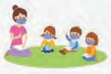
Target Prociency

Potential Improvement Activities

Early literacy | Professional | High quality | Partnering with
initiatives like oral | Learning | Inclusive classrooms | parents and
language | Communities |  | students

Source: 2020 Part B FFY 2018 SPP/APR Indicator Analysis Booklet and Hawaii Strategic Plan Dynamic Report

Here is the link for data and proposed targets on the SSIP. Here is the link to the stakeholder survey on the SSIP.

Ideas for Getting Involved
Now that you know a bit more about the SPP/APR, here are some suggestions-- some baby steps to systems advocacy--for you to consider:

Participate in the HIDOE Survey on SPP/APR Indicator Targets
The Department of Education is inviting stakeholder feedback on setting targets for the current State Performance Plan, as well as suggestions to improve services. You will notice SPIN has put a link to the SPP/APR data and proposed targets for each of the seven indicators featured in this newsletter issue. There is also a link to the anonymous survey for these indicators. Data and surveys on the remaining ten SPP/APR indicators is available at: https:// www.hawaiipublicschools.org/TeachingAndLearning/SpecializedPrograms/SpecialEducation/ Pages/home.aspx. Be sure to complete the survey by January 7th to have your voice heard.

Attend one or more SEAC meetings
SEAC is a state advisory body mandated by the Individuals with Disabilities Education Act and made up of a broad group of special education stakeholders, the majority of whom are parents of students with disabilities and persons with disabilities. One of SEAC’s
responsibilities is to participate in the SPP/APR process. SEAC holds open virtual meetings each month and welcomes your input on Zoom, by email, by phone or by letter. To learn more about SEAC and get a schedule of meetings, go to https://seac-hawaii.org. You can also apply to be appointed as a member.

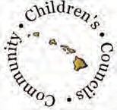
Join or visit the Community Children’s Council in your area
The 17 CCCs are made up of a partnership of parents, school personnel, private providers and other community members who are concerned with the delivery of services and support to children with disabilities and families in the local community. They are located on every island and in every district and meet monthly via Zoom or WebEx. You can visit their website at https://www.hawaiipublicschools.org/ParentsAndStudents/SupportForParents/ Pages/CCC.aspx or call (808) 305-0695 for more information.

Attend trainings by Leadership in Disabilities and Achievement of Hawaii
LDAH is the OSEP designated Parent and Training Information Center in Hawaii, offering regular workshops on topics related to the indicators, such as conflict resolution, family/ school partnerships, and least restrictive environment. For the past several years, they have offered a Traveling Mini Conference, a weekly Parent Talk Cafe, as well as a Facebook group. Visit their website--https://ldahawaii.org--or call (808) 536-9684 to discover what might be available to growth your knowledge and confidence.

Ask to join the DD Council Legislative Notifications by Email
The State Council on Developmental Disabilities is a great resource for staying alerted to upcoming legislative hearings. We’re going to be talking more about legislative advocacy in our February issue, but you may want to get a head start on what’s ahead by asking Che Silvert, the DD Council’s Legislative Specialist, to put you on his listserve. Contact him at Che.Silvert@doh.hawaii.gov or call (808) 586-8100.

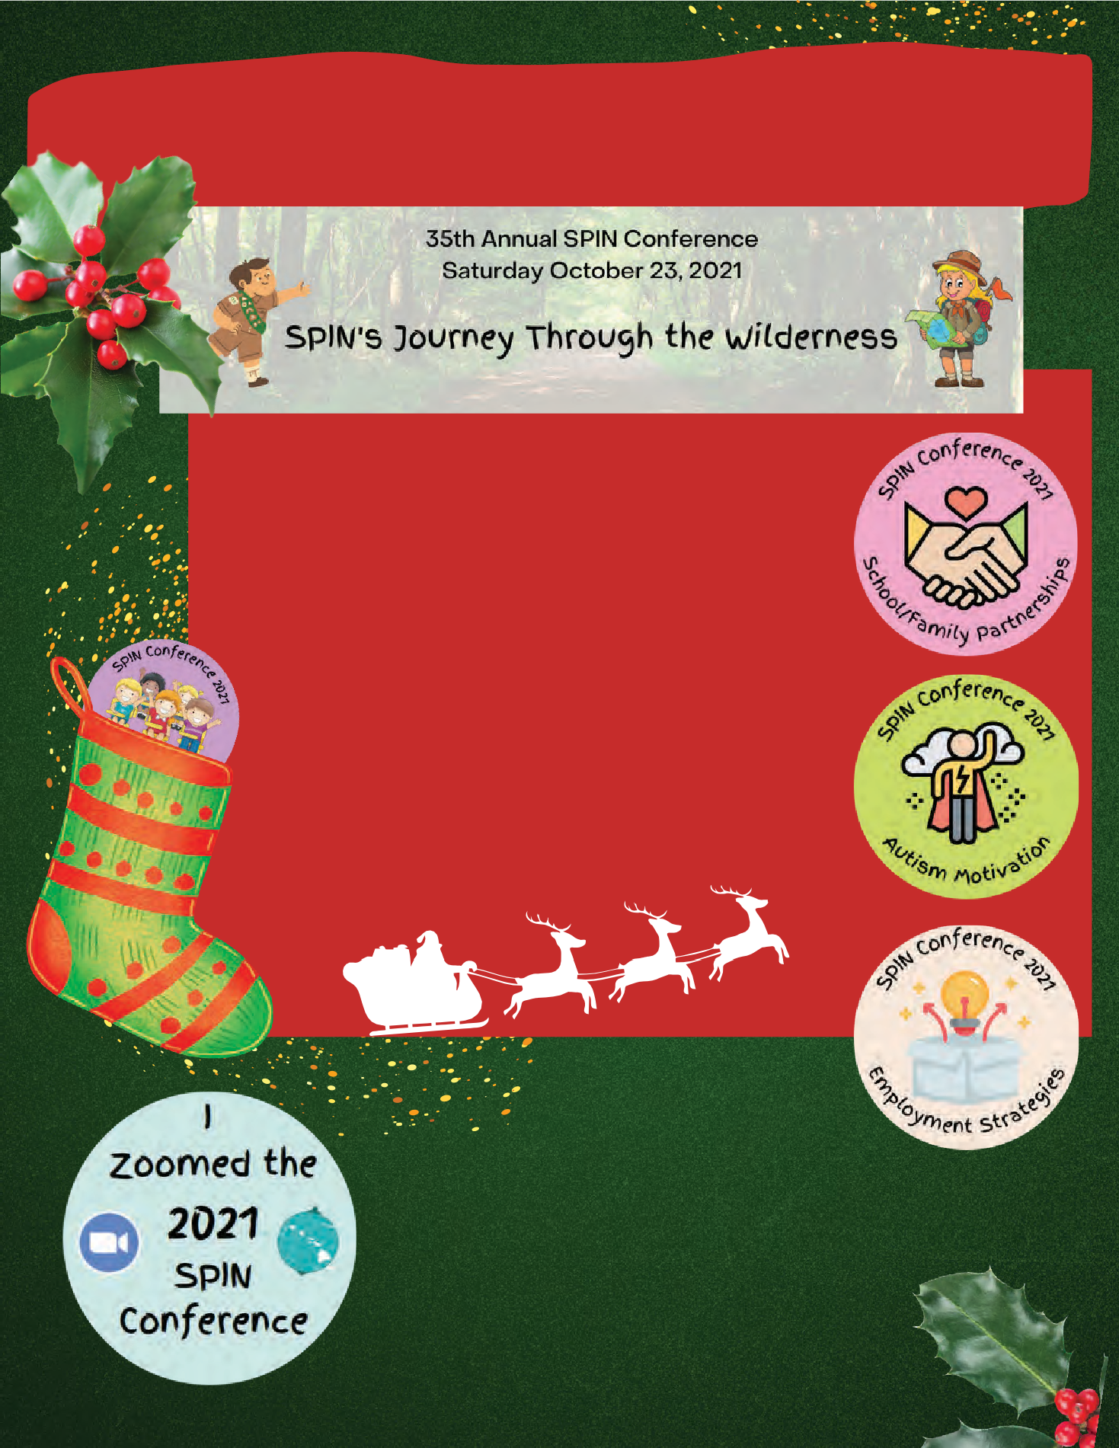
Looking for a Self-Care Treat?
Visit our SPIN Conference website!

www.spinconferenc.org

SPIN Conference.org is your one-stop shop for learning new things! Head over to the SPIN Conference website to watch newly posted workshop recordings on your favorite topics, download handy resources and find a community resource, all in one place!

Year-Round Stocking Suffers:
SPIN offers FREE electronic newsletters, 4 times a year and weekly E-blasts of helpful events and local happenings
right to your inbox. Sign up by emailing us at spin@doh.hawaii.gov!

Upcoming Events for Winter 2022

Special Education Advisory Council (SEAC)
Meets virtually on the 2nd Friday each month. Visit the SEAC website to download the agenda, which contains the zoom link. SEAC meetings are a great way to learn more about systems advocacy and how to have a greater impact for all students with disabilities in Hawaii.
Find out more here: https://seac-hawaii.org/

Hoomana Parent to Parent Support
Meetings are held virtually on Zoom and are open to all families across the state.
Email for a link: hoomanagroup@gmail.com

January 2022
1/26 Wed 6:00 7:30 pm
1/27 Thur 10:30 am 12:00 pm
1/27 Thur 6:00 7:30 pm
Topic: It's our 4th Birthday! We're having a jam session with Sounding Joy for both evening meetings.

February 2022
2/23 Wed 6:00 7:30 pm
2/24 Thur 10:30 am 12:00 pm
2/24 Thur 6:00 7:30 pm

Footsteps to Transition Fair
Saturday February 5, 2022
9:00 am - 12:00 pm
FREE on Zoom Register:
footstepstotransition.weebly.com
Come learn about transition from high school to adult life and how to prepare your child for their best life.
Open to families of all ages and stages!

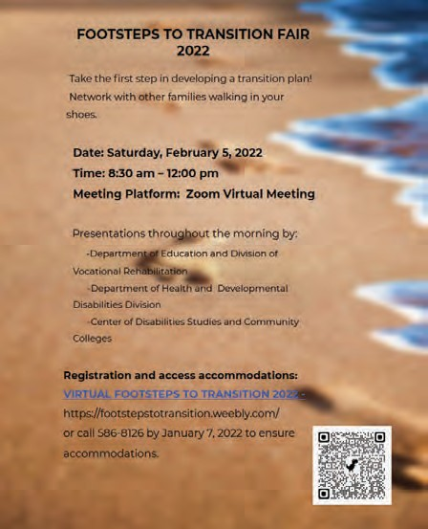

Pac Rim Conference on Disabilities

A special parent rate of $99 for all 2 days of workshops, networking, poster sessions, film festival and keynote speakers.
To register: https://pacrim.coe.hawaii.edu/ Questions? Email: prinfo@hawaii.edu

Looking for more events? Visit https://spinhawaii.org/events/ and check out our calendar page. Are you planning a family-friendly event, training or workshop? Email us so we can share the love with others: spin@doh.hawaii.gov.

