Think Mental Wellness
May 2022
Volume XXXVIII, No. 4
SPIN is co-sponsored by the Disability & Communication Access Board and the Department of Education.
Services include a phone line for information referral and support, a quarterly newsletter, an annual conference and community workshops. SPIN is guided by an Advisory Committee made up of parents, teachers and people with disabilities.

SPIN
1010 Richards Street #118
Honolulu, Hawaii 96813

PHONE
586-8126
Neighbor Islands dial the ex- change below, then 6-8126
Kauai - 274-3141
Hawai’i - 974-4000
Maui - 984-2400
Molokai - 1-800-468-4644
Lanai - 1-800-468-4644

FAX
586-8129

E-MAIL
spin@doh.hawaii.gov

WEB
www.spinhawaii.org

Like us on Facebook

“Your child’s mental health is more important than their grades ANYTHING.” -- The Minds Journal
ay is National Mental Health Month. It’s a time when we
M
call attention to the mental health needs of children and teens and focus on prevention. Sadly, despite the efforts of family members, educators and health professionals, children’s mental health has been negatively affected by the stresses associated with the COVID-19 pandemic
including:
- increased social isolation,
- health & safety concerns,
- family economic hardships,
- loss of normal social activities (sports, school events, hobbies, etc.),
- family illness and loss,
- increased screen time and lack of exercise, and
- decreased access to medical and mental health care.
The infographics on page 2 and 3 are a reminder of both the challenges
New Guidelines on ESY
The Special Education Advisory Council (SEAC) has recently shared a new infographic on Extended School Year (ESY) Services for use by IEP team members in determining whether a student with a disability needs services beyond the school day to benefit from special education. It is based on ESY guidelines released in October 2021.
we face, as well as the positive steps we as parents can take to ensure our child’s mental wellness.
The staff at SPIN and the parents and helping professionals in our network want to remind you first of all that you are not alone. There are lots of us ready to extend an ear and a helping hand. Some of those resources are listed on page 3.
Secondly, don’t be afraid to talk about mental health. For too long parents have been ashamed to admit
to a mental health issue affecting the family. It’s time we treat mental health like any other health need. And most importantly, recognize that your own
mental health challenges may be affecting your children. The Center for Disease Control and prevention has put together a wonderful on-line tool called How Right Now that asks you how you are feeling and then connects you to useful resources (https://www. cdc.gov/howrightnow/). By nurturing your own mental wellness, you will help your child be healthier, too.

WHAT’S INSIDE
Understanding Mental Health 2 Supporting Mental Health 3
Extended School Year/ESY 4-5
Virtual Summer Learning 6
SPIN Awards Quest 6
App Corner 7
Spotlight on Parent Guide 7
Year End IEP Tips 7
Family Surveys 8
Calendar of Events 9

Understanding Children's Mental Health
The Mental Health Continuum*

Mental Illness Factors
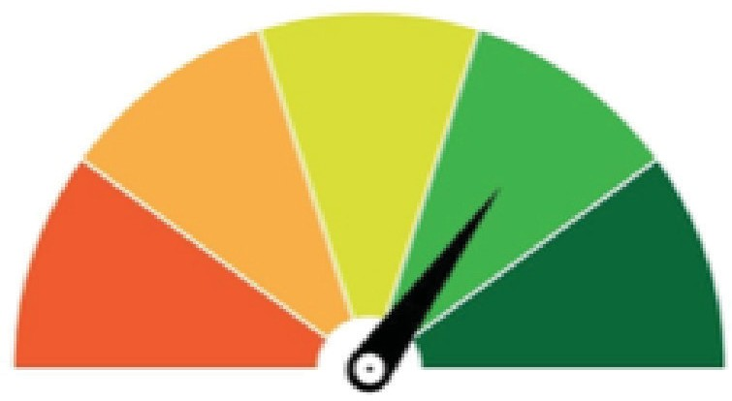Brain chemistry Family history Family stressors Traumatic life events Unhealthy lifestyle Physical illness Substance Abuse
Illness
Wellness
Social/cultural expectations Unsafe environment

Mental Wellness Factors
Mindfulness Medication Supportive family life
Evidence-based therapy Healthy lifestyle Physical wellness
Safe environment

For each Essential Life Function below, look for any areas of concern, and gauge whether it is mild, moderate or severe. Even a mild problem with any function might be an early warning sign worth looking into.

Social Functions
(for example, participation, ability to form and maintain healthy relationships, appropriate interactions, adapt to new environments. etc.)

Academic/Work
(for example, engagement, appropriate achievement, ability to manage projects & assignments, problem solving, cooperate with others, etc.)

Daily Activities
(for example, seeing, eating, personal hygiene, self-care, manage personal affairs, etc.)

* Adapted from the Youth Mental Health Project, ymhproject.org
12.4%
COVID- Related Statistics on Youth Mental Health**

37.1%
of high school students experienced poor mental
health during the pandemic
64%

of LGBTQ teens had poor mental health during the pandemic

of teen girls attempted suicide from January - June 2021

56.5% of females
31.4% of males in grades 9-12 had persistent feelings of sadness or hopelessness

Pediatric mental health ER admissions
increased 31%

SPIN News May 2022
** Sources: Adolescent Behaviors and Experiences Survey, United States, January - June 2021 "Mental Health Effects of the COVID-19 Pandemic on Children and Adolescents", May 2021

Supporting Children's Mental Health
What Parents Can Do

OBSERVE
Is your child acting differently? Has the new behavior lasted more than a few weeks?

TALK
Encourage communication. Talk to your child often about how they feel.

TRUST
Trust your gut. If you believe your child is struggling or needs help, trust that feeling.

ROLE MODEL
Show your child it is okay to care for their mental health by taking care of yourself.

ENCOURAGE
Teach your child coping strategies for when they feel overwhelmed.

ASK FOR HELP
Don't be afraid to seek help from counselors, therapists, doctors, and friends.

Source: Adapted from an Infographic by the Federation of Families for Children Mental Health, https://ffcmh.org
Sources of Youth Mental Health Support

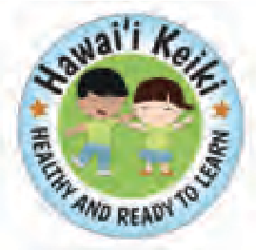Hazel HEART
(Hazel's Early Assessment, Response and Treatment)
Short term teletherapy sessions by licensed mental health therapists
Available in-school or in-home Contact your child's school for more information.

On-line resources for youth and families by MHA of Hawaii www.noshamegethelp.org (808) 521-1846

Hawai‘i Keiki Health Hotline
School nurses answer questions re: mental or physical health concerns FREE and confidential Available M-F, 8 a.m. to 3 p.m. (844) 436-3888

Local crisis line open 24/7 Oahu: (808) 832-3100
N.I.: 1-800-753-6879

Child & Adolescent Mental Health Division (CAMHD)
Provides FREE mental health services for eligible youth who have severe emotional and/or behavioral challenges Available on every island
Main Admin: (808) 733-9333

The National Crisis Text Line
Trained Crisis Counselors available 24/7, 7 days/week Text "ALOHA" to 741741

SPIN News May 2022

Extended School Year: Is it right for your child?
What is ESY?
Special education and related services that considers 6 factors Services provided during school breaks for students with disabilities aged 3-22
Services determined by the IEP team to address prioritized IEP goals in the student's current IEP Specially Designed Instruction (SDI) provided in any location, consistent with the student's IEP and least restrictive environment

What ESY is NOT:
Summer Fun, summer school or credit recovery
ESY does not require regression and/or recoupment
Provided because the student got it last year
Based on a disability category or medical diagnosis
Provided as childcare or respite Compensatory services to make up for services not received during the school year
There are 6 Factors IEP teams must consider annually for ESY eligibility:
Not all factors have to be met, only considered.

Nature of Disabling Condition
Does the nature of the student's disability impact the emergence of a critical skill or keeping a learned critical skill?

Severity of the Disabling Condition
Does the student require
consistent education with no big breaks, to make progress on IEP goals?

Areas of Learning Crucial to Self-Sufficiency Goals
Is the student at a crucial stage to master a critical skill to gain self-sufficiency or independence?

The Extent of Regression Caused by Interruptions
If the regression is more than a
student without a disability would have, ESY may be warranted.

Rate of Recoupment after a Break in School
Does the student need extensive review to show what they already learned?

Special Circumstances or Other Factors

Extended School Year:
Examples shown are not all-Inclusive

Lets Talk About Factors & Special Circumstances

Nature of Disabling Condition
Is the disabling condition impacting the learning of critical skills? (self-help, safety, emerging communication, emerging reading, social-emotional, etc.) Have there been multiple illnesses or a mental health condition that prevent access to learning?

Severity of the Disabling Condition
Does the student need a consistent & highly structured program without big breaks to learn? (for reading, behavior, self-care, communication, etc.)
Do the IEP goals/objectives focus on critical skills and/or maintaining those skills?

Areas of Learning Crucial to Self-Sufficiency Goals
Are there emerging skills or breakthrough opportunities that might be missed with a break in service such as learning to read, social skills, etc.?
Is the student at a critical stage of mastering a new level of independence?

Source: HIDOE ESY Guidelines

The Extent of Regression Caused by Interruptions
Is there data to show the student has significant regression, or impacts to their rate of progress, with breaks in school?
If no data is available, the IEP team can predict a potential regression based on the students disability and/or needs (team input, parent report, teacher report).

Rate of Recoupment after a Break in School
Does it take a lot longer for the student to catch up or re-learn skills or do they need a more extensive review or supports after a break in school?
Consider social-emotional, behavior and other parts of their program, not only academics.

Special Circumstances or Other Factors
The IEP team may determine whether, without ESY, other factors will prevent the student from receiving benefits from their program during the regular school year.
The team should include needed accommodations and programming around prioritized IEP goals.

Updated 4/2022

Summer Virtual Learning Still Going Strong

When it comes to summer learning and activities, opportunities for children and youth with disabilities can be few and far between, and with COVID-19 cases surging again, many families are looking for virtual options to keep their keiki safe while still offering learning and enrichment opportunities. We’ve compiled a list of fun classes and camps online that kids might enjoy during the summer months.

Varsity Tutors offers large, celebrity-led classes for free and fee-based week-long camps, classes and clubs, as well as tutoring for kids with learning differences. www.varsitytutors.com

Outschool is another variety camp option for different ages and interests and has some great “adulting” classes for older students. www.outschool.com

Virtual Summer Camps has a big list of current virtual classes taking place this summer. Some are fee-based and some are free. www.virtualsummercamps.org
PBS for Kids is geared towards young children and is loaded with games, activities and educational videos to teach and entertain kids all summer. www.pbskids.org

Camp Wonderopolis is a free camp with 5 different camps: music, construction, health, animals and a general Mission to Wonder. www.camp.wonderopolis.org

Khan Academy is free and offers lots of classes in academics as well as life skills like growth mindset and social emotional learning. www.khanacademy.org

The Smithsonian Museums have a full schedule of games, activities and pre- recorded programs for kids of all ages to enjoy. www.si.edu/kids

If you are looking for some in-person offerings or are looking for some fun family outings this summer, check out the list of museums in Hawaii, www. en.wikipedia.org/wiki/List_of_museums_in_Hawaii.

2022 SPIN Awards Need Your Nominations!
e are delighted to announce the SPIN Awards are back after a 2-year break for our virtual conferences! SPIN publicly
W
celebrates wonderful parents and professionals whose efforts make a positive difference in the lives of our keiki with disabilities and their families. The SPIN Advisory Committee is looking for candidates for our 2022 SPIN Awards, and we need your help in nominating someone who models the qualities and actions that families appreciate and rely on. There are three award categories:
- The Parent of the Year Award is given to a parent or parents of a child or young adult with a disability whose actions and advocacy have benefited other families.
- The Professional of the Year Award is given to a professional who has had a significant impact in improving services for children and/or youth with a disability and their families.
- The Family Choice Award is given to a professional who has been particularly helpful to families as they sort out services for their child with a disability. This individual may not have an impact on the larger system, but is recognized in his or her community as an extraordinary professional.
We encourage you to share your aloha and nominate one or more very special people for any or all of the awards. You can go to our website at www.spinhawaii.org, click on the conference tab and download an award nomination form. Or call us at 586-8126, and we’ll accept your nomination over the phone or mail you a form. Deadline to apply is Sept. 23rd.

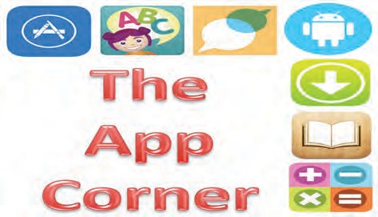
Are you planning to travel this summer? The Dr. Panda Airport app might make
traveling with your child a little more fun and prepare them
for what is to come. With 10 different activities, your child
can become more familiar with the different places in the airport and what they may have to do when they get there.
The app begins with check-in and takes them on a journey of taking a trip on an airplane. Activities include the security check and x-ray, lost and found, finding your gate, washing the plane and more. There are no in-app purchases
or third party ads for your kids to click on and no text to read, so it’s easy to pick up and play. You can download this app to both apple and android devices for a small fee of $2.99 and it is rated for kids ages 3 years and up.

Spotlight
on Support

Every state has their own set of special education laws, based on the federal law of IDEA -- the Individuals with Disabilities Education Act. In Hawaii, our special education law is called Chapter 60. You can find the official Chapter 60 Administrative Rules on the State of Hawaii Board of Education page by clicking on this
link: https://boe.hawaii.gov/policies/AdminRules/Pages/ AdminRule60.aspx. These rules are written in formal language and not always easy for families to understand, so SPIN and SEAC (Special Education Advisory Council) created the Parent’s Guide to Special Education as an easy-to-read document to help families and professionals understand Hawaii’s laws and processes. In the guide, you will find chapters on:
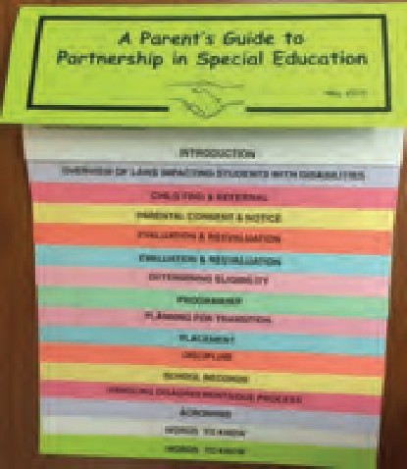
- Referrals to special education
- Evaluations
- Eligibility
- Programs & Placement
- Handling disagreements
- and more!
Download your copy today at https://spinhawaii.org/education- parent-guide/

8 Tips for Wrapping up the IEP Year
As the school year comes to a close, it’s time to start Say “Mahalo” to those who helped - Send a getting all your ducks in a row and papers sorted note to those who made a difference in your so when August rolls around - and you know it child’s day and helped them through the year. will come quickly - you’ll be organized and ready Ask for a copy of needed information - Do to go. Here are a few tips from Wrightslaw.com/ you have a copy of teacher reports, evaluation howey/10tips.end.sch.yr.htm: reports or other items? If not, ask your team.
Review your child’s IEP - Did your child Ask the IEP team to address Extended make progress this year? Does the IEP School Year - ESY guidelines have been address your child’s needs? updated; talk with your team about eligibility. Ask for an IEP Team meeting - If you Plan for other summer learning programs feel the IEP needs some adjusting, ask to - Summer school, virtual learning or summer
schedule a meeting in August. fun are not individualized, so plan for supports. Prepare for the IEP meeting - Write Make a Year-End binder - gather the IEP, down your concerns and suggestions, so evals, tests, notes and communications and put you remember them when August comes. them in a binder, so you can find them easily.

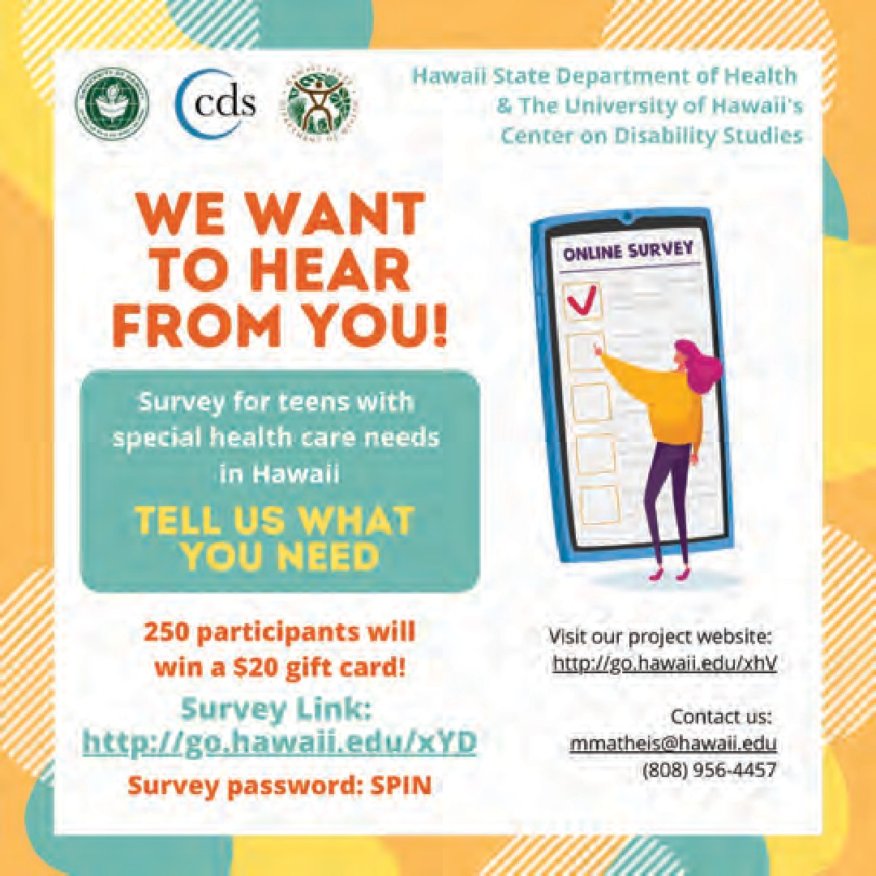
Survey for Parents & Teens
Calling all teens with special health care needs, we want to hear from you! The University of Hawaii’s Center on Disability Studies (CDS) is conducting a needs assessment in partnership with the Hawaii State Department of Health. We want to hear from teens (ages 12-22) with special health care needs about
their experiences with the health care system (like doctor and dentist visits), especially during the COVID-19 pandemic.
The survey is anonymous (no names collected) and is online. It will take about 15 minutes to complete. If your teen is unable to complete the survey on their own, a parent/legal guardian can fill out the survey on their behalf, or you can contact CDS and we can assist your teen in completing the survey.
At the end of the survey, click on a link to enter into a drawing for a $20 gift card.

Survey on Health, Education & Employment
The Hawaii State Council on Developmental Disabilities (DD Council) is asking for input from individuals with intellectual and developmental disabilities (I/DD) and their families and caregivers on how well the state is responding to the needs of persons with I/DD.
It is our hope that we are able to reach all individuals with intellectual and developmental disabilities in Hawaii, so we can hear from them, their families and their caregivers about their health, education and work/ employment needs that are so vital to their quality of life and well-being.
The survey will take about 20 minutes to complete online and responses are confidential. The information gathered will be compiled into a final report with recommendations for statewide improvements and change.
Survey link: www.surveymonkey.com/r/HSCDDsurvey
The survey will be open from May 18 to August 3, 2022. If you need assistance answering any or all of the questions in the survey, or if you have questions about the survey itself, please email us at HSCDDsurvey@ gmail.com.
Survey on Afterschool Programs

The University of Hawaii’s Center on Disability Studies (CDS) is also interested in developing an afterschool enrichment program in the future,
specifically for students with disabilities at Hawaii Department of Education schools.
We are asking for your feedback to help us develop a program and apply for grant funding. Our goals for the afterschool enrichment program are to combine Native Hawaiian cultural activities, adapted physical activities, and popular Paralympic activities. This will allow students to learn and appreciate Native Hawaiian culture and learn recreational activities that they can engage in outside of school with family members.
The survey should take about 10 minutes to complete online and will be open until the end of June. We
are collecting confidential information from parents/ guardians, teachers, health care workers and those who work with students with disabilities.
Survey link: https://forms.gle/iM1MrNyCSRx8uaGY7
For more information, email Kelle Murphy at kellem@hawaii.edu.

Calendar of Events

Ho’omana Parent to Parent Support
 | TACA Coffee Talk & Learn  6:00 pm FREE  The Autism Community in Action (TACA) hosts monthly virtual coffee talks for newly diagnosed families or those new to TACA. RSVP by visiting their website: www.tacanow.org/local-chapters/west/hawaii | 6/23  7/28  7/9
 | LDAH Parent Talk Cafe
Meets Thursday evenings from 6:00-7:00 pm
FREE Virtual meetings held each week. Monthly themes with different topics weekly. Held on both Facebook and Zoom. For more
 | information, call 808-536-9684. | 10/22
5/28 | LDAH Health & Wellness Fair Drive Thru 8:30 am - 12:00 pm, 245 N. Kukui St., Honolulu, HI 96817. Free hearing and vision screening, grab-n-go resources, vaccinations and more. Pre-register for free at https://.forms.gle/ZJLOQS5ESDJRDT879

6:00 - 7:30 pm FREE
Virtual meetings for families on all island, who have a child with a disability attending public school. Email for a link: hoomanagroup@gmail. com or call 808-426-6879 for more information.

Access Surf Day at the Beach
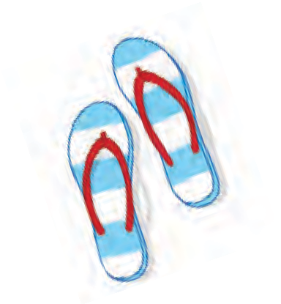
9:00 am - 1:00 pm, FREE surfing event for all ages and abilities. White Plains, Ewa Beach Sign up online at www.accessurf.org

SAVE THE DATE!
36th Annual SPIN Conference “It’s a Marathon, Not a Sprint”
8:30 am - 3:30 pm at UH Campus Center
In-person and virtual options. Registration form and airfare scholarships available www.spinconference.org, call us at
586-8126 or email spin@doh.hawaii.gov.

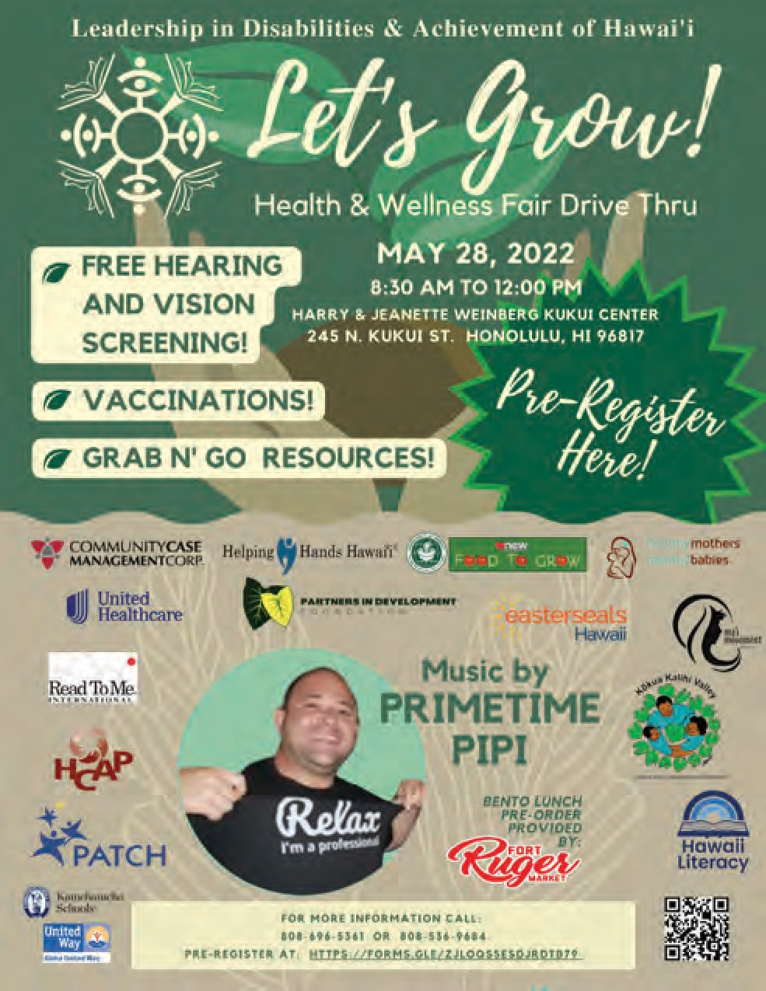
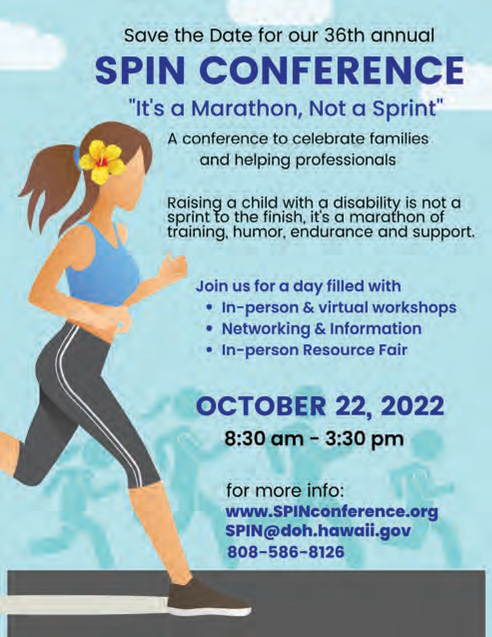
For more events and happenings around the state, be sure to visit our website events calendar at https://spinhawaii.org/events/ and like us on Facebook!
SPIN - Special Parent Information Network

