Parenting for a Marathon
October 2022
Volume XXXIX, No. 1
SPIN is co-sponsored by the Disability & Communication Access Board and the Department of Education.
Services include a phone line for information referral and support, a quarterly newsletter, an annual conference and community workshops. SPIN is guided by an Advisory Committee made up of parents, teachers and people with disabilities.

SPIN
1010 Richards Street #118
Honolulu, Hawaii 96813

PHONE
586-8126
Neighbor Islands dial the ex- change below, then 6-8126
Kauai - 274-3141
Hawai’i - 974-4000
Maui - 984-2400
Molokai - 1-800-468-4644
Lanai - 1-800-468-4644

FAX
586-8129

E-MAIL
spin@doh.hawaii.gov

WEB
www.spinhawaii.org

Like us on Facebook

f you’re a longtime reader of the SPIN News, you’ve heard us talk
I
about “marathon skills” in past issues. Marathon skills have to do with becoming more resilient, so that we can parent our child with a disability with more grace, hope, and ability.
We first learned about marathon skills from Ann Turnbull, a co-founder of the Beach Center on Disability and the Family. She helped us realize
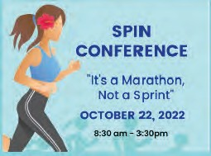
that choosing to make some shifts in our attitudes or
in the way that we respond to stresses and challenges can be amazingly helpful as we guide our children’s journey
to adulthood. On page 3 and 4 you’ll be reminded of some
of these marathon skills that you can acquire (or that you may already possess) for the long run.
And now, our SPIN Advisory Committee has taken these ideas and RUN WITH THEM. For real! SPIN
and our partners have put together a two-part conference with the theme “It’s a Marathon, Not a Sprint” where we’ll share lots of great tips on preparing for the future, whether it’s next week or five years from now.
The first “leg” of the marathon is scheduled for Saturday, October 22nd from 9:00 a.m. to 12:30 p.m. on Zoom. Think of this conference on October 22nd as a warm-up to an all- day conference in April 2023. In Part One we are going to focus on three key marathon skills:
- Learning how self-care can be
an effective way to reduce stress;
- Practicing the basics of mindful meditation, and
- Beginning to build a network of support.
Dr. Matthew Wappett will begin by reminding us how the stress of parenting a child with a disability can be harmful not only to our own heath--our minds and bodies--but also to our relationships with family,
friends and helping professionals. Dr.
Wappett and our next set of presenters
--Dr. Thao Le and Benjamin Chu--will guide us through some very effective methods to handle stress and enjoy our present moment.
Then our SPIN Advisors will lead you through an exercise in Care Mapping to take stock of the resources you and your child have presently, and explore other possible sources of support. Check out page 2 for a more complete description and a link to register
for this FREE conference on our spinconference.org website!
WHAT’S INSIDE
Oct. 22nd Conf. Flyer 2
Marathon Skills 3-4
Teens & Quality Sleep 5
Sleep Workshops 6
Election Reminders 6
Support for Families 7
Safety from Monkeypox 8
Keiki Mindfulness 9
Calendar of Events 10

*
on Zoom
*For parents of children & youth with disabilities and helping professionals.
Resilience for the Long Run: Understanding & Managing Stress
Addressing your child's educational, financial, health and social needs can be very stressful. Learn simple self-care strategies to manage stress and promote mental health. Become aware of how to use the body to calm the brain and use your brain to calm your body. Start your journey with a better understanding of the mind/body connection.

Dr. Matthew Wappett
Find Your Peace, Find Your Pace
Mindful meditation is simple, but it's not always easy. This mental exercise allows you to enjoy the present moment without worrying about the past or what is coming in the future. Research has also shown that children who practice mindful breathing have better sleep, higher self-esteem and a sharper focus. Come learn from the master teacher and a devoted student of this practice.

Dr. Thao Le Benjamin Chu
Mapping the Course

Children with disabilities or at risk of disability often need additional or more specialized services than their peers without disabilities in order to be healthy and successful. Learn the process of Care Mapping: identifying and organizing the services that a child is receiving, and identifying additional services that may help to support that child and family.
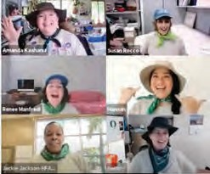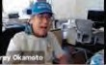
SPIN Advisors
Register for free at www.spinconference.org
2

Building Your Resiliency
A Family Guide to Marathon Skills
Step 1: Love your Child Unconditionally | Unconditional love means to appreciate and value your child in the moment and not get hung up waiting for improvements. Meet them where they are and let them know you love them, regardless of their behavior, talent, success or abilities.
Step 2: Take Time for Yourself | As a primary caregiver, it's important to find ways to de- stress and regroup in order to keep giving to your child and family. You are important and have interests and abilities that are outside your role as a parent. If you can enjoy yourself more, you can enjoy your family more.
Step 3: Develop Your Sense of Humor | Laughing feels a lot better than crying. It changes our thoughts, emotions and behaviors and allows us to handle stress better. Laughter really is the best medicine, so give yourself permission to laugh and joke around.
Step 4: Build a Network of Supports | It's easy to feel isolated and alone, raising a child that is unique among your friends and family. Discover the value of a Facebook group or monthly parent-to-parent meeting to find others out there walking in shoes like yours. Much of the info that you find helpful is in the hearts and minds of other parents like yourself.

3

Step 5: Know Yourself &
Your Family

Step 6: Allow Your Child to Take (Small)
Risks

Step 7: Balance Family Needs
Finding out what your family needs, values and enjoys is important for getting through stressful situations. Family members deal with stress in different ways. Allow them to deal with it in their own way while offering support and encouragement in ways they will each find helpful.

We want to protect our kids from hurt, but we must allow them to take some small risks to learn from their mistakes. Often resilient behavior requires us to take action in the face of fear. Overcoming fear and taking small risks safely helps build confidence and competence and allows for growth.

Often the temptation, when you have a child with a disability, is to focus all your time, energy and resources on that child.
Instead, consider how to balance your special child's needs with your other children, your spouse and your work life (and don't forget Step #2 and add some me-time in there too).

Step 8: Learn to be Flexible

Step 9: Be An Involved Parent
One of the first lessons a parent learns (sometimes the hard way), is that life is about compromise. We need to be realistic and flexible and accept that not all solutions will be perfect. Remember, in a storm, the palm tree bends in the wind and is still standing, strong and tall, after the storm passes.
Get involved in your child's school, attend a PTA meeting, take a class to help you grow your confidence and knowledge. Practice re-framing a problem situation into a positive solution to gain a sense of control over your life. Be an example of resiliency to your children and family and reap the rewards of a calmer, happier life at home.

4

How to Help Your Teen Get More (Quality) Sleep

is the optimal amount of sleep needed for teens aged 13-18
yet only 23%
of Hawaii teens get 8 hours or more of sleep per night*
9-10 hours
*2019 Hawaii Youth Risk Behavior Survey
This is due to the fact that most teens are
night owls--they prefer to go to bed later and wake up later.

Why is sleep important?
It improves focus and memory and makes you a better learner.

It regulates your mood and reduces the risk of depression and suicidal
thinking.
It reduces your risk of injury, unsafe sex, and drug and alcohol abuse.

It strengthens your immune system and reduces your risk of obesity, heart disease and diabetes.

Common teen sleep disorders:

Sleep deprivation
Getting too few hours of sleep results in feeling sleepy during the day, being less able to control emotions and having physical symptoms, like a headache.

Circadian dysregulation
This involves either difficulty falling asleep, waking up during the sleep cycle, or waking up too early and being unable to fall back to sleep.

Social jet lag
Irregular bed and wake times and sleeping in on the weekends can result in a general feeling of discomfort or uneasiness and mood swings.

Tips for quality sleep

Have regular bedtimes and wake up times.
Wake up no more than two hours later on
weekends.

Turn off all electronic devices about an hour prior to sleeping. Put smart phone on night mode.

Dim light conditions the hour before bedtime.
The body needs dark to release melatonin. Use bright light when waking.

Avoid caffeine, late night snacking and
exercise an hour or two before bedtime.

SPIN Sources: https://www.teenlinkhawaii.org/sleep
October, 2022 https://www.psychologytoday.com/us/blog/teen-angst/201806/how-teen-sleep-deprivation-leads-risk-taking-behaviors

Speaking of Sleep

The Evidence-Based Services (EBS) Committee in Hawaii has been shining a light on how to treat sleep disorders in children and teens. They have shared two great workshop presentations on their Help Your Keiki website (https://www.helpyourkeiki.com/where-can-i- find-the-ebs-committees-archived-roundtable-presenta- tions):
- A Transdiagnostic Approach to Sleep and Circadian Challenges Faced by Youth with Dr. Alison Harvey, a clinical psychologist and professor at the University of California, Berkeley talks about the nature of sleep and ways to promote healthy sleep
practices for children and teens. Don’t let the long title fool you. Dr. Harvey is easy to follow and very interesting.

Cognitive Behavioral Therapy Approaches for Treating Nightmares by Dr. Kristi Pruiksma,
a professor in the Department of Psychiatry and Behavioral Sciences at the University of Texas Health Center San Antonio, helps folks understand when nightmares may rise to the level of impacting a child’s or teen’s mental health. Parents will learn of
evidence-based interventions provided by mental health professionals. These can be helpful for adults, too!

7 Reminders for the General Election
Ahead of the 2022 General Election on November 8th, we have a few key reminders for Hawaii Voters. You have the right to ask for assistance in completing the registration and voting process. If you need help, you can ask a trusted individual, family member or caregiver for assistance. Hawaii law does not permit your employer, an agent of your union or a candidate to provide assistance. For more information, call 808-453-8683.
#1
#2
#3
#4
#5
#6
#7
Check that your
voter registration is current
Visit elections.hawaii.gov or call 808-453-8386 to verify that your information is accurate.
If you have moved, you must update your voter registration info.
Sign your ballot
envelope
The return envelope must be signed for the ballot to be counted. Your signature will be compared to your voter registration record.
Sign up for ballot
alerts
Alerts can be text, email or voice mail. Visit www.elections.hawaii.gov or call 808-453-8683 to enroll in alerts for when your ballot is on its way and reminders to return your ballot.
Hawaii is a vote by
mail state
As a registered voter, your General Election ballot will conveniently arrive in your mailbox. Gone are the days of carving out time to vote at your assigned polling place. Hawaii Voters are automatically mailed a ballot for every election.
Vote your Ballot
You can expect to receive your ballot by October 21 for the General Election. Read the instructions, mark your ballot with a blue or black pen, seal it in the envelope and sign the envelope.
Ballot must be
received by 7 pm on November 8
You can return it by mail or drop off at a Voter Service Center or Ballot Drop Box within your county.
Assistance is available
If you need help casting your ballot, visit a voter service center to use accessible voting machines. Alternate format ballots are also available for at-home voting by request.
Developed in partnership with the
Office of Elections SPIN News October 2022

Support for Families
Families who have a child with a disability have unique educational needs. There are several organizations in
Hawaii that can help, providing information, support and advocacy for a better school experience.

State Advisory Panel meets monthly to discuss current challenges in special ed Public input is welcome to share personal or systemic concerns
808-586-8126
www.seac-hawaii.org
SEAC
Special Education Advisory Council

Supports families and individuals with disabilities through legislative and community advocacy Statewide meetings provide a safe space to discuss concerns 808-586-8100
www.hiddcouncil.org
DDC
Hawaii Statewide Council on Developmental Disabilities

Helps families navigate and understand the health care systems in Hawaii Download transition
workbooks for youth moving from high school to adult life 808-791-3467
www.hilopaa.org
Hilopa'a
Family to Family Health Information Center

Facilitates 17 statewide monthly community meetings Offers a safe place to talk about challenges & solutions 808-305-0695
https://www.hawaiipublicscho ols.org/ParentsAndStudents/S upportForParents/Pages/CCC.
aspx
CCC
Community Children's Council

Parent Training & Information Center Workshops, parent training, advocacy & supports Developmental, social emotional, vision & hearing screening
808-536-9684
www.LDAHawaii.org
LDAH
Leadership in Disabilities & Achievement of Hawaii

Information, referrals and help finding and connecting to community resources Annual conference, newsletters & e-blasts
808-586-8126
www.spinhawaii.org www.spinconference.org
SPIN
Special Parent Information Network

National Resources for Special Education https://www2.ed.gov/about/offices/list/osers/osep/index.html https://ldaamerica.org/
https://www.wrightslaw.com/
National Parent-Serving Organizations https://www.pta.org/ https://parents4publicschools.org/ https://www.pacer.org/transition/

Keeping Safe from Monkeypox
Monkeypox is a virus that can make you sick and spreads from person to person.
It can affect everyone in the community, no matter what your sexual orientation or gender is. You can take steps to keep yourself and other safe.
01
How Can I Get Monkeypox?
Close, intimate contact with bodily fluids. Touching the rash of someone with Monkeypox.
Touching surfaces or items that have been in contact with the rash of someone with Monkeypox.

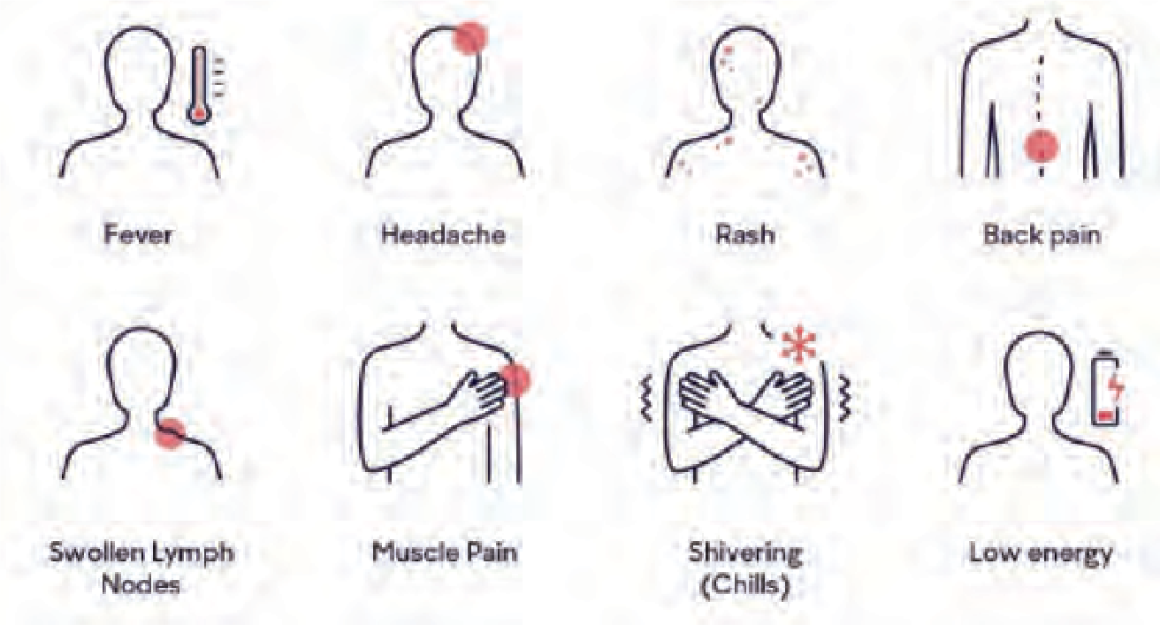What Are the Symptoms?
graphic from CSCDD*
Fever Headache
02
Rash on chest, hands,

feet, face or genitals Back pain
Swollen lymph nodes Muscle pain Shivering & chills Low energy
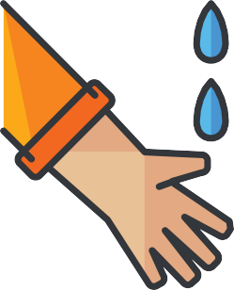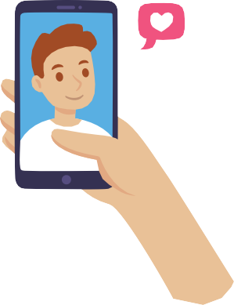
03
Ways to Keep Yourself Safe
Avoid skin-to-skin contact with someone who has or might have Monkeypox. This includes sex, kissing, cuddling & hugging.
Avoid contact with surfaces and fabrics like clothes or bedding that have been in contact with someone who has or might have Monkeypox.
Always wash your hands with soap and water or use hand sanitizer & wear a mask around others.
For more information: https://health.hawaii.gov/docd/disease_listing/monkeypox/
*Adapted from the California State Council on Developmental Disabilities Aug 2022
Special Parent Information Network
What to Do if You Think You Have Monkeypox
Stay by yourself and away from others (isolate). Call your doctor and make an appointment.
Follow the advice from your doctor.
04
Remember: many symptoms can look like a cold, flu or even Covid and can last for 2 to 4 weeks. If you have flu-like symptoms plus a rash, bumps or blisters that are new, contact your doctor right away.

Mindfulness for Keiki
Tools for Self-Calming
Mindfulness is the ability to focus on the moment, the here and now and let go of thoughts that come along. It provides children a tool to self-calm and focus on what's happening at the moment so they can pause and use strategies they know work for them to tackle a stressful situation. Try a few of these activities, about 5 minutes each, to help your child find their inner calm.
This classic mindfulness exercise helps you to pause and focus your thoughts on the present. Turn on your "Spidey senses" to pay attention to sights, smells, hearing, taste and touch. Take a moment to focus on each sense, one at a time, while breathing deeply.
Use Your Spidey Senses
This activity lets you visualize your swirling emotions that will settle once you are calm. Fill a clear jar with water, some glitter and baby oil. Shake the jar and watch as the glitter settles down after swirling chaos. Focus on your breathing.
Glitter or Calming Jar
Coloring can help you feel more present, calm your mind and chase worries away. Find a peaceful place. Focus on your breathing and how different colors make your feel. Notice the textures and how colors blend. Don't let your mind wander, stay focused on the present.
Focused Coloring
A simple, yet powerful exercise that shifts attention to the present moment and surrounds. Ring a bell (a physical bell or from an app). Close your eyes and listen to the vibration of the bell. Raise your hand when it stops, then
listen for other sounds for 1 minute.
Bell Listening Exercise
Watching bubbles can calm the mind, reduce frustration and promote peaceful thinking. Blow a single bubble. Pay attention to the swirling colors. Watch how each bubble floats magically in the air. Intentionally pop one and notice how it feels on your skin.
Mindful Bubbles
When we are stressed, our breaths come fast and shallow. Belly breathing reduces our heart rate and triggers a calm response.
Place your hands on your belly. Breathe in and expand your belly for 4 seconds, hold in the air for 4 seconds, slowly blow out the air until it's all gone. Repeat 5 times.
Belly Breathing
Sources:
https://www.pbs.org/parents/crafts-and-experiments/practice-mindfulness-with-belly-breathing https://www.mentalup.co/blog/mindfulness-activities-for-teens https://blog.stageslearning.com/blog/six-simple-mindfulness-practices-for-kids-with-autism https://positivepsychology.com/mindfulness-for-children-kids-activities/
SPIN News Sept. 2022

Calendar of Events

10/14 White Cane Walk
9:30 - 11:00 am FREE In-person The White Cane walk helps to increase
awareness of the white cane and it’s importance to persons who are blind or visually impaired. Meet at the State Capitol Rotunda for more info, call Gaven Abe 808-586-5271
or email gabe@dhs.hawaii.gov

10/14 SEAC - Special Education Advisory 11/18 Committee Meeting
12/9 9:00 am - 12:00 pm In-person/Virtual Open to the public. In-person meetings held at
Office of Student Support Annex 475 22nd Ave., Honolulu. Zoom meeting ID 964 3914 1539.
For more info, call 586-8126 or visit their website at www.seac-hawaii.org/meetings

10/19 TACA Parent Support Meeting
1:30 - 2:30 pm FREE Virtual
This month the focus is on parents who have teens or adult children with autism. Come talk story, share resources and meet new people.
Please RSVP to receive a Zoom link www.tacanow.org/local-chapters/west/hawaii

10/22 36th Annual SPIN Conference
9:00 am - 12:30 pm FREE Virtual “It’s a Marathon, Not a Sprint” Part 1
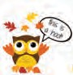
Please join us for a 3 workshop event featuring dynamic speakers and information to support families who have a child with a disability and the professionals who work with them. See the flyer and workshop details in this newsletter.
For more info call 808-586-8126
or visit www.spinconference.org to register.

10/22 Halloween Dance Party for Teens
6:30 - 8:30 pm FREE In-person Hawaii Autism Foundation is sponsoring a Halloween dance party for differently abled
teens and youth. There will be a DJ, face and arm painting with light snacks and drinks. Wear your costumes! Register online https://lp.constantcontactpages.com/su/WyobaHi
10/26 Hoomana Parent Support Group 10/27 Call or email for times FREE Virtual
12/7 Speakers, talk story and resources for families
12/8 with a child with any disability. Open statewide.
Email or call for speaker topics and times hoomanagroup@gmail.com 808-426-6879

10/29 Abled Hawaii Artists Art Festival
10:00 am - 3:00 pm FREE In-person Hawaii Island. Puna Kai Shopping Center, 15-2714 Pahoa Village Rd. Pahoa.
For more information, call 808-935-7699

11/5 Hawaii Epilepsy Education Conference
8:30 am - 12:30 pm FREE In-person
For people living with epilepsy, their families and professionals. There will be speakers, free parking and refreshments. Aloha Tower,
Multi-purpose room 2. For more info, visit www.epilepsyhawaii.org or call 808-528-3058

Access Surf Day at the Beach
11/5 8:00 am - 2:00 pm FREE In-person
12/3 Surfing event for all ages and abilities. Meet at White Plains, Ewa Beach
Sign up online at www.accessurf.org

11/19 LDAH 2nd Annual Youth Conference 5:00 - 7:30 pm FREE In-person “Beyond the Moment” For teens and their parents to learn about transition beyond high school. There will be guest speakers, dinner,
activities, entertainment and prizes. Blaisedell Center, Pikake Room, Honolulu.
Call to register 808-536-9684

SAVE THE DATE!
4/22 37th Annual SPIN Conference
“It’s Not a Marathon, It’s a Sprint” Part 2 8:30 am - 3:30 pm at UH Campus Center We are planning an in-person event with a
resource fair in the spring. There will be Zoom options too. Registration forms and airfare scholarships will be available www.spinconference.org, or call
us at 586-8126 or email spin@doh.hawaii.gov.

For more events and happenings around the state, be sure to visit our website events calendar at www.spinhawaii.org/events and like us on Facebook!
SPIN - Special Parent Information Network
8

