Putting the Happy in 2023
December 2022
Volume XXXIX, No. 3
SPIN is co-sponsored by the Disability & Communication Access Board and the Department of Education.
Services include a phone line for information referral and support, a quarterly newsletter, an annual conference and community workshops. SPIN is guided by an Advisory Committee made up of parents, teachers and people with disabilities.

SPIN
1010 Richards Street #118
Honolulu, Hawaii 96813

PHONE
586-8126
Neighbor Islands dial the ex- change below, then 6-8126
Kauai - 274-3141
Hawai’i - 974-4000
Maui - 984-2400
Molokai - 1-800-468-4644
Lanai - 1-800-468-4644

FAX
586-8129

E-MAIL
spin@doh.hawaii.gov

WEB
www.spinhawaii.org

Like us on Facebook

s we look forward to a new year and the possibilities it holds for better times ahead, SPIN encourages
A
our readers to give themselves these precious gifts:

The Gift of Peace
While it is easier to talk about peace than to actually experience it, SPIN learned some important lessons from Dr. Matthew Wappett, Dr. Thao Le and Benjamin Chu at our October SPIN Conference. Our society is one that encourages extra busy lives, long work hours and competition.
Sadly, the chronic stress that results is actually slowly
destroying our quality of life. The good news
is that there is an antidote to that stress, and it is called the relaxation response. Learn all about it on pages 4 and 5 of this newsletter.

The Gift of Organization
One of the common complaints SPIN hears from families across the state
is that they are feeling overwhelmed by the many extra supports their child with disabilities requires that are over and above the demands of normal parenting. The first step in
getting a handle on actually organizing these supports is to map them out.
We suggest a process called “care mapping.” First developed by medical professionals in a pediatric intensive care unit, it uses a simple chart to organize different needs into categories--health, education, social, etc. Then families can list all the services their child is receiving
under those categories. That simple exercise helps families get a greater understanding of the full extent of needed supports, and it also serves as a way of describing those supports
to others--like folks on the IEP team. Check out the process on page 3.

The Gift of Knowledge
Most families of children with disabilities are amazed and dismayed by the amount of extra facts and terms they need to learn to be an active member on their child’s care
team at school, in the doctor’s office, and in the community.
SPIN tries to take complex information and break it down into
smaller bites--like the infographic on the Hawaii Multi-Tiered System of Supports on page 2. In fact this quarterly newsletter is meant to keep you, the most important person on your child’s team, informed and confident in your role. Let SPIN be on YOUR support team in 2023!
WHAT’S INSIDE
Parents and HMTSS 2
Care Mapping 3
Chronic Stress Antidote 4-5
The APP Corner 6
Spotlight on DVR 6
Award Nominations 6
Legisative Process & You 7 Footsteps to Transition 8
Calendar of Events 9

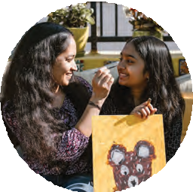
Hawai‘i Multi-Tiered System of Support (HMTSS) The Role of Parents and Family
HMTSS is a framework that Hawai‘i schools use to provide instruction and support to ALL students and address obstacles to learning before they affect student outcomes. Parents are equal partners in every step of the support system.
Key Components of HMTSS

Tier 3
Individualized & intensive intervention
Multiple tiers of instruction that are progressively more intense based on the student's response to instruction

2
1
Tier 2

Small group
targeted intervention

Tier 1
Universal screening is provided to find students who may need more than Tier 1 supports

Progress monitoring - short but regular assessments to see that a student meets his or her goals
3

The use of evidence-based practices that have been proven
4

Core instruction to all students along with a positive school culture and climate
to meet the student's particular need for academic, behavioral, emotional or physical support

Academic • Behavioral • Social-Emotional • Physical
How Families Partner in HMTSS
Talk regularly with your child's teacher(s) and ask for the results of screening and progress monitoring.
Ask what interventions are being used to address your child's academic, behavioral, social-emotional and/or physical needs. Use the same strategies or interventions at home whenever possible.
Request that the school provide a comprehensive evaluation for special education, if you suspect an underlying disability that is affecting your child's learning and/or behavior.

SPIN News
December 2022
For more information on HMTSS, click on the links below:
HMTSS Flyer, Office of Student Support Services, 2021 Hawai‘i Multi-Tiered System of Supports (HMTSS), SEAC, 2020

THE ESSENTIALS OF
Care Mapping

For Your Child

What is Care Mapping? A family-driven, person- centered process that provides a big picture snapshot of your child's
needs, the supports they are receiving and the connections between resources. Making a care map at different ages and stages helps you visualize the changes in your child's needs and services as they grow.

How Do I Use a Care Map? You can share the map with your child's IEP team, medical specialists and therapists to help them understand your child's needs. You can also look for gaps or duplication in services to see where your child may need more or less supports and it's a useful tool to help you fill in their circle of supports with family, friends and community.

How Do I Create a Care Map? Start with a blank paper and draw a circle with your child's name in it. Draw a second circle around that and add your family. Draw spokes around the circle and add categories like school, medical, advocacy, community, etc., at the end of each spoke. For each category, add names, services and supports your child has. Use multiple colors for each grouping to see them better.

Designing Your Care Map

Use multiple colors for different categories
You can start on paper, then make it digital for easy reading & printing

Start simple, add more as needed
Include your child in the creation process

Break down large
categories into smaller groups
Think outside the box of typical supports your
child uses.
Creating a care map can help you see the big picture around the care and supports needed for your child to grow and thrive.

SOURCE: https://www.childrenshospital.org/integrated-care/care-mapping https://cristinlind.com/newcaremap/
Adapted from October 2022 SPIN Conference Workshop "Mapping the Course"

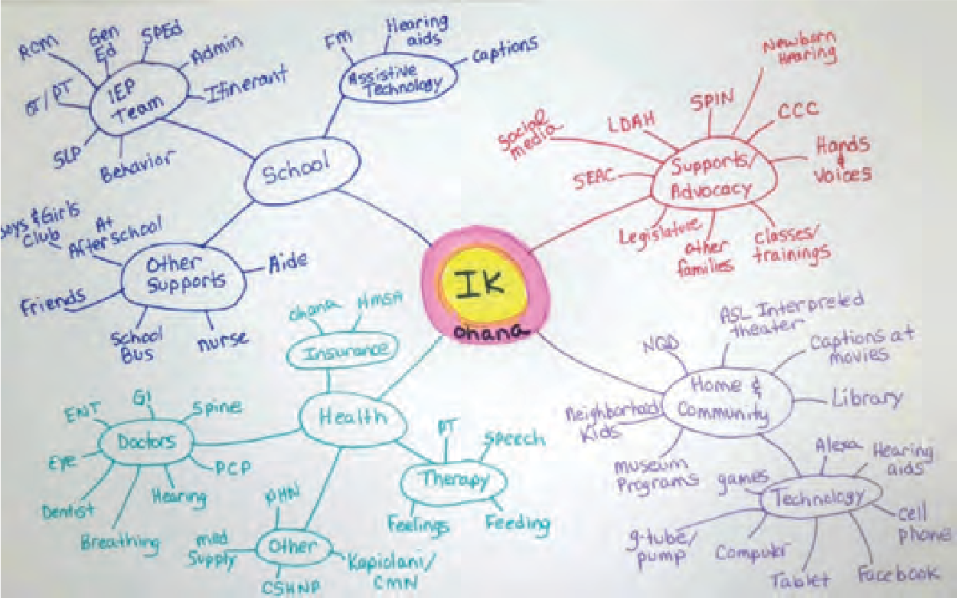For ideas and guidance on how to create your own Care Map, check out the recorded workshop, presented by the SPIN Advisory Commitee, on the SPIN Conference website: https://www.youtube.com/watch?v=HO2MJLMOzfw

Preventing the harmful effects of chronic stress
For parents and kids with disabilities

What is chronic stress?

90% 90%
60-90% of all health care 80-90% of behavioral problems visits are related to stress in school are related to stress
Stress is a part of everyone's life. It is a physical and emotional reaction to routine challenges in our lives, such as the demands of work and school, money problems, relationships issues, etc. as well as to sudden threats or adverse events. When you are stressed, your body releases hormones that produce a "fight-or-flight" response, nature's way to help you survive a threatening situation. Think of a zebra who is fleeing a lion and needs extra adrenaline to outrun his attacker.
Unlike animals in the wild, however, the "fight-or- flight" response in humans may not get turned off, if we encounter numerous stressors throughout the week or in the months to come. This heightened sense of alert creates chronic stress, with many negative effects on the physical body and our mental health, as you can see by the graphic below.

What are the effects of chronic stress on the body?
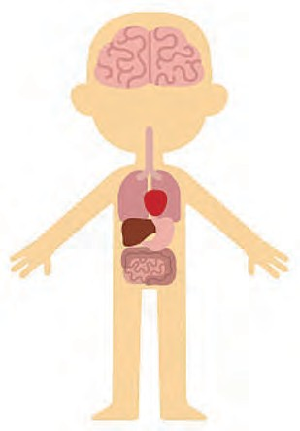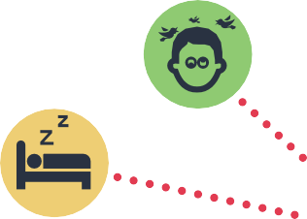Trouble concentrating and/or Irritability

Difficulty sleeping
Headaches ?

Anxiety and/or Depression

Skin rashes

Weight loss or gain

Diarrhea or Constipation
Teeth Grinding

Faster heart beat
Rise in blood pressure

Tiredness Muscle aches

Learning how to relieve stress by turning on the relaxation response
What makes up the relaxation response?
The relaxation response consists of two main steps:
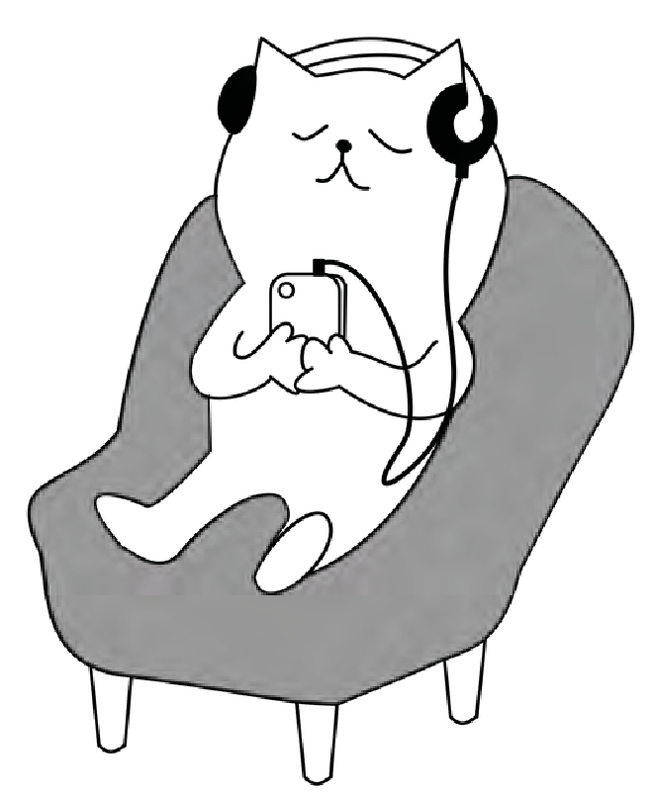
Repeating a word, sound, thought, phrase or muscular activity, and Returning to the repetition, if you get distracted by other thoughts.
1

2
The response can be achieved by using the mind to calm the body--slow breathing, prayer, mindfulness--or using the body to calm the mind--yoga, petting an animal, gardening, running, rowing, surfing, dancing, paddling, and other repetitive sports.
How does the relaxation response shut down the fight-or-flight response?
Relaxation Response decreases:

heart rate blood pressure breathing rate muscle tension
your perception of stress
Turning on the relaxation response brings your brain into the present moment and lets you realize you are safe. When you are in the present moment and feeling safe, your mind and body turn off the stress response.
What are some easy exercises to bring on the relaxation response?
Box Breathing
Breathe in for a count of 4
Hold for a count
of 4
4
4
Hold for a count of 4
Release breath for a count of 4
Physiologic Sigh
- Take a deep breath in.
- Take another small sip of air to fill your lungs.
- Release the air to a count of 7-10.
- Repeat.
Body Scan
- Check your body for tension.
- Start at your head and go to your toes contracting & relaxing each muscle.

These exercises are free, accessible at any time of the day or night, and require no equipment. Doing these exercises or a similar activity for just a few minutes several times a day can prevent stress from building up.

Adapted from a 2022 SPIN Conference workshop, "Stress Management Basics for Stressed-out People", SPIN News by Dr. Matthew Wappett from Utah State University. You can access the video of his presentation at December https://www.youtube.com/watch?v=d5RF6syOxBE. Also check out the National Institutes of Health 2022 infographic "Press Reset on Stress" at https://files.nccih.nih.gov/press-reset-on-stress-flyer.pdf.

Looking for a good app for your toddler to explore their ABC’s? How about an app for your teen to help them with their mental health? Our go-to website for finding great apps is Common Sense Media. They have “Best App” lists, as well as reviews for over 4000 apps on the market. You can filter by device, age, pricing, subject, skills and more, with links to download the app from your preferred app store. Common Sense Media does more than app recommendations, they also have suggestions for movies, TV, books, games and podcasts. So next time your keiki asks if they can download an app that you’ve never heard of, or if you’re looking for something to keep your little darling occupied while you finish dinner, check out their website for parent-reviewed, kid-tested, honest information to help us make good app choices. www.commonsensemedia.org

Spotlight on Supports
DVR
Division of Vocational Rehabilitation

The State of Hawaii’s DVR program is part of the Department of Human Services and serves
eligible youth and adults with disabilities, helping them train for and find competitive employment. In the Department of Education, students can be connected to DVR as young as 14 years of age
as part of Pre-ETS (Pre-Employment, Training & Services). Pre-ETS includes 5 modules:
- Job Exploration & Counseling
- Instruction in Self-Advocacy
- Work-Based Learning Experiences
- Post-Secondary Exploration
- Workplace Readiness Training
Talk to your child’s care coordinator or IEP team about inviting a DVR counselor to your next IEP meeting. To find out more about DVR services and see if they are right for your child, visit: www.
humanservices.hawaii.gov/vr or call 808-586-9729.

SPIN Awards Coming Back to the SPIN Conference
After a 3 year break due to the pandemic, the SPIN Awards will make their comeback at the 2023 SPIN
Conference being held at the UH Campus Center on April 22, 2023. The SPIN Awards publicly celebrate wonderful parents and professionals whose efforts make a positive difference in the lives of our keiki with disabilities and their families. Our SPIN Advisors are looking for candidates who model the qualities and actions that families appreciate and rely on. Nominations are now being accepted for three award categories:
- The Parent of the Year Award is given to a parent or parents of a child or young adult with a disability whose actions and advocacy have been helpful to other families. Impacts can be island specific or statewide.
- The Professional of the Year Award is given to a professional who has made meaningful improvements to the systems of services and supports for children and/or youth with a disability and their families.
- The Family Choice Award is given to a professional who has been very helpful to families as they sort out services for their child with a disability. This individual may not have an impact on the larger systems, but is recognized in his or her community as an extraordinary professional.
We encourage you to share your aloha and nominate one or more very special persons for any or all of the SPIN Awards. Visit our SPINconference.org website to download a copy of the nomination form.

How to Get Involved in the

Hawaii State Legislative Process

1: Communicate with your Legislators
If you have an idea or if there is an issue that is important to you, let your Senator and Representative know about it by sending them an email, a letter or call their office. When sending a letter or email, remember to keep it brief and get to the point, be kind, tell the truth and don't exaggerate. Explain your idea or position and why it matters to you. Be sure to share your contact information. Not sure who your representative is? Search for them on https://www.capitol.hawaii.gov/fyl/

2: Share an idea for a new law
Legislators introduce new bills during the first week of the new session, which begins
in mid-January. Find a legislator who represents you or who has supported similar bills in the past and share your idea with them. Include what you think the law should do and use bullet points to highlight main objectives. Let them know if you have research, sources or examples to back up your idea.

3: Ask for a public hearing
Once a bill is introduced, it goes into committee. It must be "heard" in a public hearing
to be voted on and to move forward. You have to follow your bill carefully and be quick to ask the chair of the committee, by phone or letter, for a hearing. If a bill does not get a hearing, it will miss its deadlines and "die in committee." If your bill does not make it out of committee, try following similar bills; otherwise you must wait till next year to reintroduce your bill. Visit the capitol website to view the committee chair assignments.

4: Testify & repeat as necessary
If a bill gets scheduled for a hearing, you may get the opportunity to testify for or against the bill in writing and/or in person. If the bill moves from one committee to the next, be ready to send in your testimony again. Try to find others to help you testify and gather legislative support for your bill. Having a bill become law is not an easy process and can take a few years. Be patient, be persistent and be passionate.

5: Want to learn more?
The Public Access Room (PAR) can assist you in learning more about the process, timelines and contact information for your legislators. They can also help you navigate the legislature's website to keep track of bills, sign up for hearing notices and more.
Contact them by phone at 808-587-0478 or by email: par@capitol.hawaii.gov. For a list of your representatives and to follow this year's bills, visit www.capitol.hawaii.gov.

SOURCE: Public Access Room. www.lrbhawaii.org/par/ December 2022 SPIN News

lease join us at the “Footsteps to Transition Fair,” hosted by the Department of Education, Central District! This FREE event is geared towards middle and high school students with disabilities, their
P
families, case managers, therapists, teachers, and anyone else in their circle of support. It’s not too early to start planning and preparing for life after high school. As your child transitions to post- graduation and adulthood, it can be a challenge to make the many decisions about life after high school. Will they go to
college, get a job, and/or move into their own place? Who do you turn to for questions about school, health and self-advocacy for your child? These and questions and more can be answered at the 10th Annual Footsteps to Transition Fair in February. This FREE event will be hosted on Zoom and will be accessible to families across the state. Registration is now open on their website: www.footstepstotransition.weebly.com or call SPIN at 808-586-8126 to register over the phone.
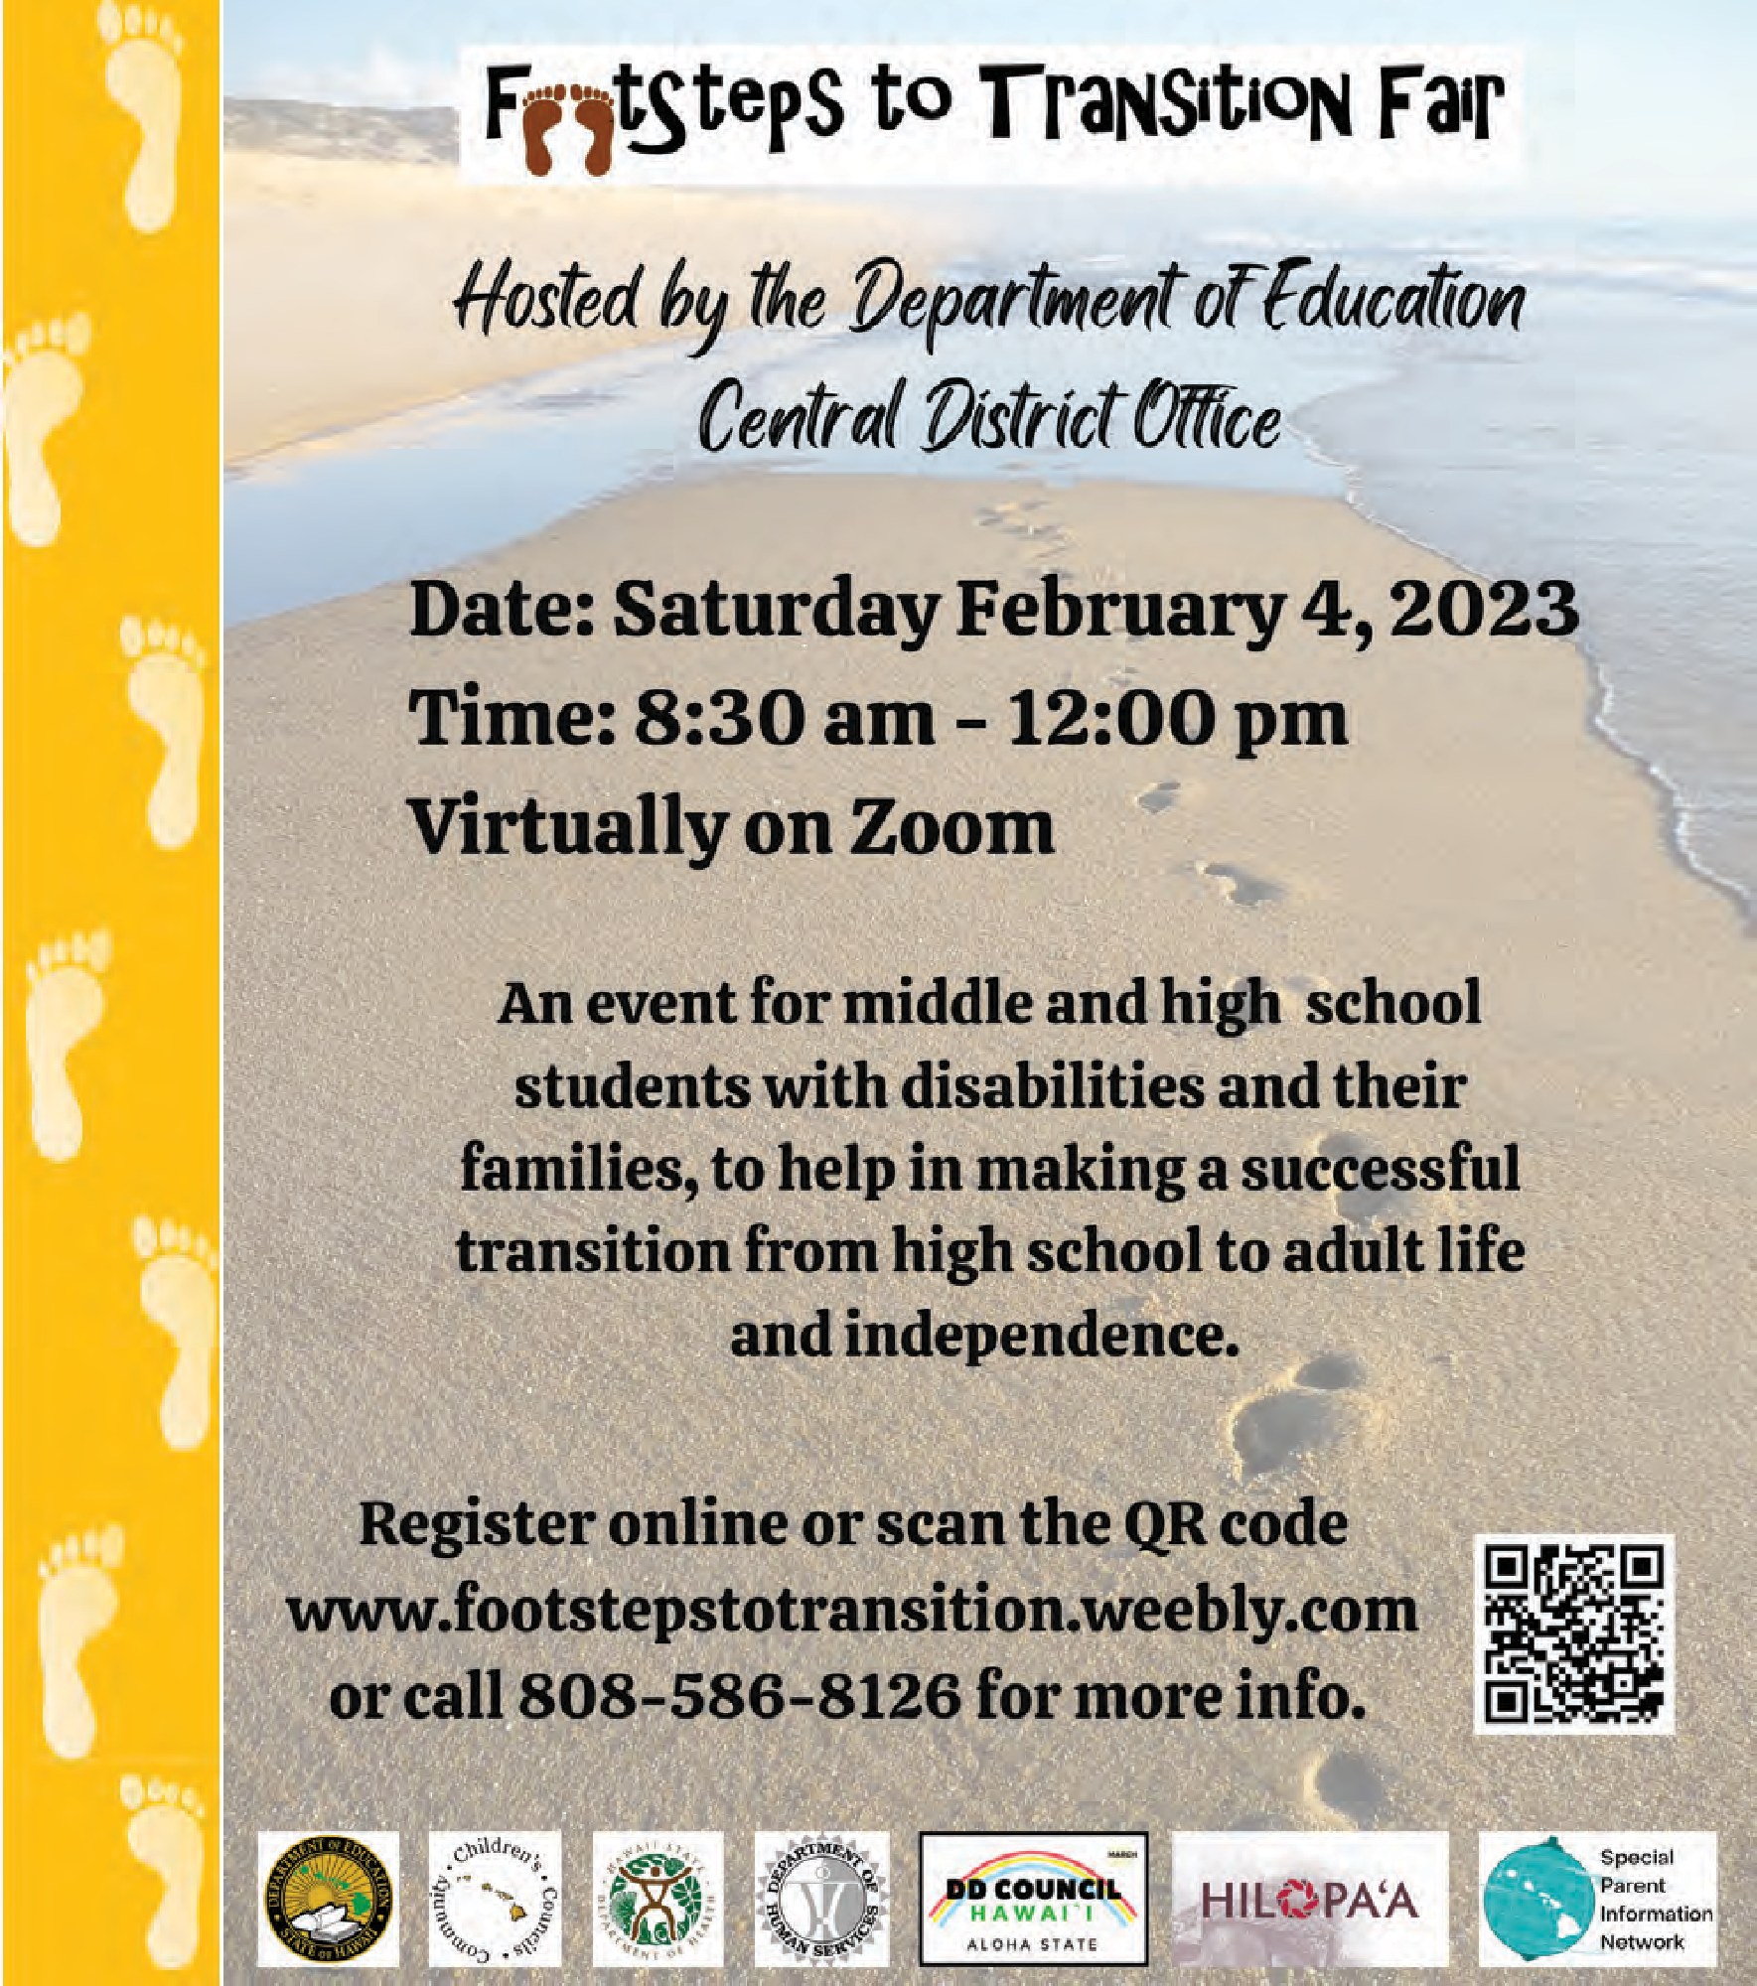

Winter Calendar of Events

Monthly TACA Parent Support Meeting 6:00 - 7:00 pm FREE In-person Connect with other parents to talk about plans
for next year, your biggest concerns and
topics
or your daily struggles you need help with. Childcare is not available. Visit their website for dates and to RSVP (required to attend): www.tacanow.org/local-chapters/west/hawaii

Access Surf Day at the Beach
1/7 8:00 am - 2:00 pm FREE In-person
2/4 Surfing event for all ages and abilities. Meet at White Plains, Ewa Beach
Sign up online at www.accessurf.org

1/13 SEAC - Special Education Advisory 2/10 Committee Meeting
3/10 9:00 am - 12:00 pm In-person/Virtual* Open to the public. In-person meetings held at Office of Student Support Annex 475 22nd Ave., Honolulu. Zoom meeting link found on the monthly agenda on the SEAC website: www.seac-hawaii.org/meetings.
*Check agenda to see if meeting is in-person. For more info, call SPIN at 808-586-8126.

LDAH Upcoming Events
Jan/ Weekly Small group sessions in person or Feb virtual sessions. AM & PM times available. 1/18 Parent Talk Cafe on Facebook, 6:00 - 7:00 pm
Marathon IDEA Training 9:00 am-2:30 pm
1/28 In person on Oahu
2/4 In person on Maui
2/15 Parent Talk Cafe on Facebook, 6:00 - 7:00 pm All programs and trainings are FREE.
Call for info or to register 808-536-9684.

2/4 Footsteps to Transition Fair
9:00 am - 12:00 pm FREE Virtual
An event for middle and high school students with disabilities and their families, to help in making a successful transition from high school to adult life and independence. Register online: www.footstepstotransition.weebly.org or call SPIN for more info: 808-586-8126.

3/6-7 Save the Date: Pac Rim Conference
All day Fee involved In-person
The theme is “Coming Together and Moving Forward”. It will be held at the Hawaii Convention Center. For more information, visit their website: www.pacrim.coe.hawaii.edu

Ho‘omana Parent Support Group
Call or email for dates/time. FREE Virtual Speakers, talk story and resources for families with a child with any disability. Open statewide. Email or call for speaker topics and times hoomanagroup@gmail.com 808-426-6879

SAVE THE DATE!
4/22 37th Annual SPIN Conference
“It’s Not a Marathon, It’s a Sprint” Part 8:30 am - 3:30 pm at UH Campus Center We are planning an in-person event with a resource fair. There will be Zoom access to all live workshops. Registration forms and airfare scholarships will be available.
2
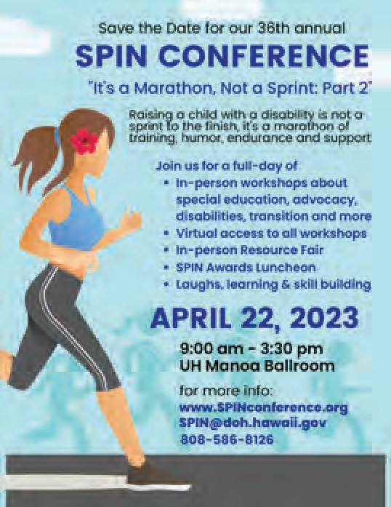
www.spinconference.org/ spin@doh.hawaii.gov or call us at 808-586-8126.

For more events and happenings around the state, be sure to visit our website events calendar at www.spinhawaii.org/events and like us on Facebook!
SPIN - Special Parent Information Network
9

