THE NEWSLETTER FOR PARENTS OF CHILDREN WITH DISABILITIES

Running the Marathon Together!
March 2023
Volume XXXIX, No. 3
SPIN is co-sponsored by the Disability & Communication Access Board and the Department of Education.
Services include a phone line for information referral and support, a quarterly newsletter, an annual conference and community workshops. SPIN is guided by an Advisory Committee made up of parents, teachers and people with disabilities.

SPIN
1010 Richards Street #118
Honolulu, Hawaii 96813

PHONE
586-8126
Neighbor Islands dial the ex- change below, then 6-8126
Kauai - 274-3141
Hawai’i - 974-4000
Maui - 984-2400
Molokai - 1-800-468-4644
Lanai - 1-800-468-4644

FAX
586-8129

E-MAIL
spin@doh.hawaii.gov

WEB
www.spinhawaii.org

Like us on Facebook

After four years of working to create a sense of community through a Zoom window, the 27th Annual SPIN Conference is back at the University of Hawaii Campus Center! Hooray!

The Saturday, April 22nd
conference is titled “It’s a Marathon,
Not a Sprint - Part 2.” It carries on the message that we shared with folks in October 2022: parenting a
child with a disability to the finish line requires building up a variety of skills and knowledge that we
can use again and again to help our keiki (and our family) succeed.
And a great place to gain some of that
knowledge? At the SPIN Conference, of course!
Imagine this . . .
12 different workshops on a wide range of timely topics and inspiring stories--each one lead by experts in that area.
Great advice from our keynote speaker--Dr. Matt Wappett, the Laugh Yoga guru.
Information tables filling the whole 2nd floor of the Campus Center cafeteria and featuring over 50 agencies serving children and families.
An opening number by the SPIN Advisors that will get you pumped up and ready to run through the day.
An Award Ceremony at lunch that celebrates our “marathon mentors.”
Carbo-Loading -- an ono-licious Italian buffet lunch. YUM!
Imagine also that you can come dressed in your favorite exercise clothes--whatever makes you comfortable.
Now that you can see the
conference in your mind’s eye, you’ll want to register using the form on page 7 or by calling SPIN at (808) 586-8126.
Conference forms are also available on our website at www.spinhawaii.org.
Once again, the Conference will be held in our favorite spot--the University of Hawaii at Manoa Campus Center on Saturday, April 22nd from 8:30 am - 3:30 pm.
SPIN still has some airfare scholarships available for neighbor island parents, and we will have a shuttle from the Honolulu Airport on Saturday to bring folks to and from the conference. Please call ASAP as those scholarships won’t last long!
WHAT’S INSIDE
Universal Design for Learning 2 UD for Partnerships 3
Words to Know: SDI 4
Archived SPIN Workshops 5
Annual SPIN Awards 5
SPIN Conference Flyer 6
Conference Registration 7
Calendar of Events 8

Universal Design for Learning

Everyone benefits when designs take into account the need of every user.
Universal Design for Learning (UDL) is an approach to teaching and learning that can help teachers customize the Common Core curriculum to benefit all learners, regardless of ability, disability, age, gender, culture or language background and teach a classroom full of students with diverse needs. It was patterned after a movement in architecture called Universal Design (UD) which has a goal of making places and things accessible and adaptable to a variety of users, including individual with disabilities. For example, ramps and curb cuts, which provide access for wheelchair users, also make it easier for parents with baby strollers, elderly people and delivery people to negotiate walkways and streets.
UDL is a set of principles for designing a course of study that provides all individuals with equal opportunities to learn. The goal is to create learning
that challenges the most gifted learner while providing a variety of options and supports for the most struggling student,
UDL principles are based on research into students’ learning differences and effective supports in the classroom and allow for varied and flexible ways to:
- Present or access information, concept and ideas (representation),
- Plan and execute learning tasks (expression)
- Get engaged and stay engaged, in learning (engagement/motivation)
UDL addresses the primary barrier to learning: inflexible, one-size-fits-all teaching. It gives teachers the tools to meet the needs of a variety of students.
When schools commit to UDL, the diversity of student learning styles is build into the course of study from day one, so that every student can achieve success. For more information on UDL, go to the Parents’s Guide to UDL: https://www.
advocacyinstitute.org/resources/ParentUDLGuide.pdf

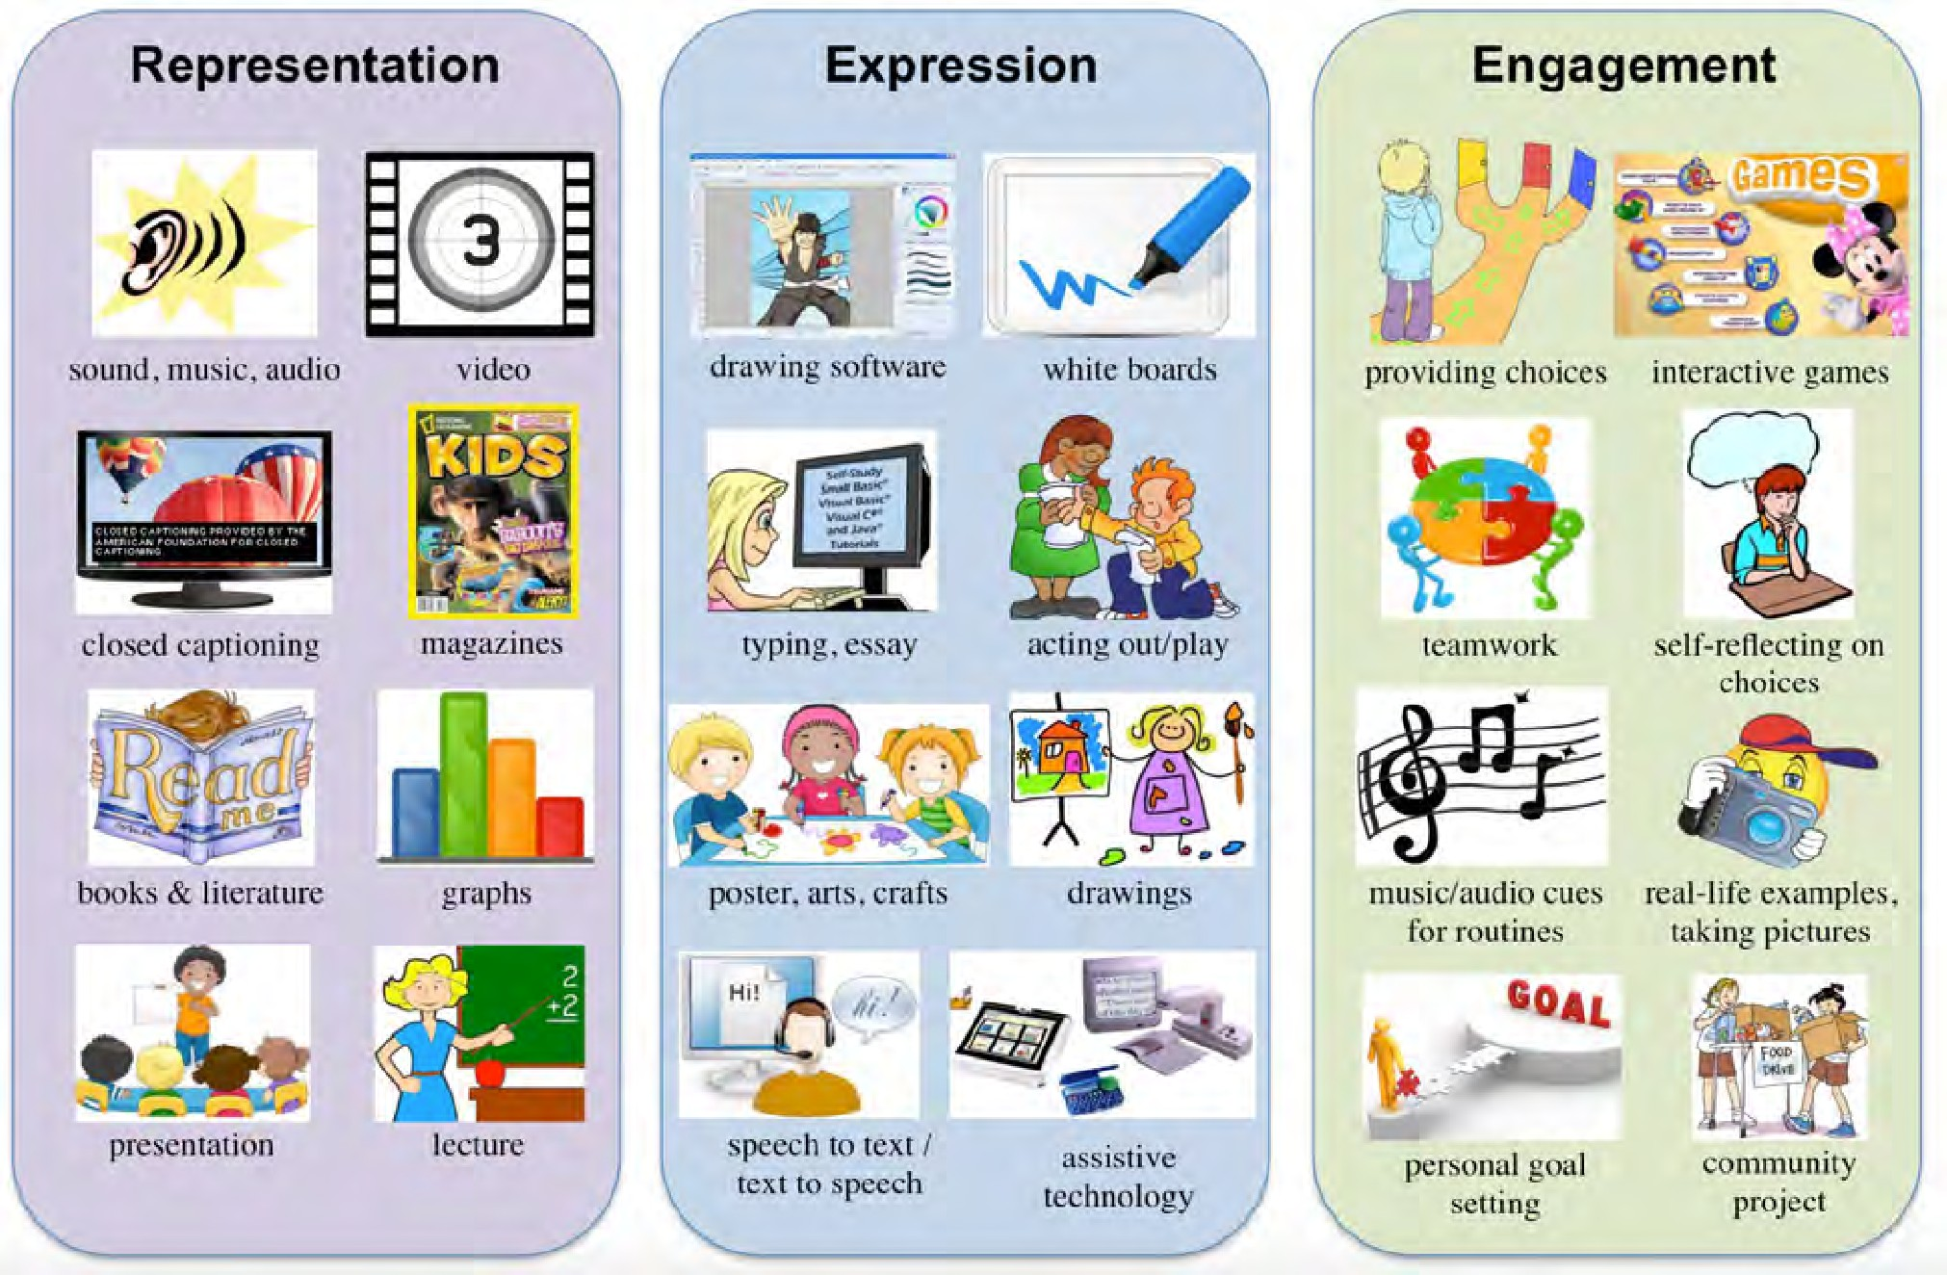
EXAMPLES OF UNIVERSAL DESIGN FOR LEARNING

2 Graphic credit: Montgomery County Public Schools

Universal Design for Family-
School Partnerships
(Patterned after Universal Design for Learning)

The Big Idea
Families and educators may differ from each other in the ways they think and communicate. They also have different interests and demands on their time, energy and attention. Applying the principles of Universal Design to family-school partnerships provides flexibility and multiple opportunities for families and educators to engage with each other to create positive outcomes for students.

Present information
and content to families in a variety of ways.
Provide multiple ways for families to express choice and participate.
Stimulate interest and motivation for
partnering with school.

Have information available in multiple languages and formats (print, audio, video, online and offline).

Present content in multiple levels of complexity (from a simple flyer to advanced training).

Present information through multiple messengers (parent or family group, parent-to- parent, teacher to family, school team to family, community partners, etc.)

Define terminology. Avoid jargon.
Highlight big ideas.
Offer family choice for communication method: notes between school and home, email, parent checklists for monitoring progress at home, phone calls, text messages, etc.

Offer family choice of participation: school- sponsored events, workshops or other training, volunteer activities, phone conversations, surveys, input through family advocates, etc.

Include family as a team member in decision making and planning meetings (in person, by phone or teleconference).

Utilize family members as trainers.
Ensure information and activities are relevant and have value to the family. Personalize information to the family s experience and culture.

Make the purpose of the communication or activity clear.

Invite the family s response and evaluation.

Create an accepting and supportive climate.

Offer links to parent-to- parent support.

Offer other supports such as childcare and transportation.

Incorporate family ideas in planning.

Source: Hawaii Comprehensive Student Services System Family Advisory Committee, 2011

3

Special Education ords to Know:
Specially Designed Instruction (SDI)

A key requirement for eligibility for special education and related services is that the student with a disability needs specially designed instruction (SDI) to address educational needs resulting from his or her disability. SDI means adapting the content of what is taught, the methods used to help the student acquire knowledge and skills, and the delivery of instruction.

CONTENT
SDI is not ...
a location

accommodations

lowering expectations for student performance
dictated by the bell schedule (for determining minutes in the IEP).
SDI is ...
what the teacher does

individualized to the student's unique needs

a service

directly tied to IEP goals

instruction that helps the student make progress toward grade-level standards

METHOD(S)
Content refers to what is taught. It addresses the student's academic and functional needs, including behavior. Instruction is tied to grade-level standards.

Methodology is how students are taught. It includes specific evidence-based strategies and techniques and in what order educational or behavioral goals are taught.

DELIVERY OF INSTRUCTION
The delivery of instruction refers to who provides SDI, as well as when and where it is delivered.
- SDI is developed by a special education teacher and related service providers.
SDI can also be delivered by a general education teacher or EA in partnership with and trained by a special education teacher.
Some students need their SDI daily and for a
large part of the school day, while others may need SDI for a single class or activity.
SDI may occur one-to-one or in a small group.
It can happen in general education, a resource room, a fully self-contained classroom, as well as elsewhere on campus and in the community.

SPIN News
March 2023

4
SOURCES:
SDI Guidance Document - https://www.mdek12.org/sites/default/files/sdi_document.pdf Parent Center Hub - https://www.parentcenterhub.org/iep-specialeducation/
Exceptional Children - https://exceptionalchildren.org/topics/specially-designed-instruction

Archived Workshops on the SPIN Conference Website
Did you know that the SPIN Conference website - www.spinconference.org - has more than the current conference offerings, family resources and community organization listings? We have also archived our past 3 years of virtual conference workshops there too! Click on the “Archived Workshops” tab to access our captioned videos from 2020, 2021 and 2022. Recorded workshops are a great way to listen and learn. Each captioned workshop is available on YouTube and you can watch anytime of day or night. Below are a few of our favorite workshops.

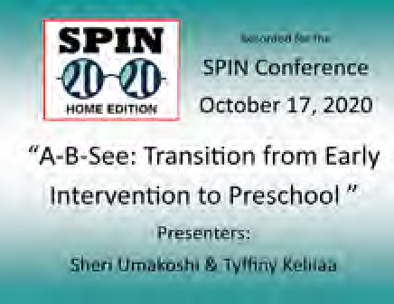
2020 Conference
Theme: SPIN 2020
Workshop: Transition from Early Intervention to Pre- school.
Why we like it:
Moving from EI to DOE is a daunting experience for many families. This workshop takes some of the guesswork out of the move so fami- lies know the right questions to ask and who can help them find answers for a successful transition to DOE.

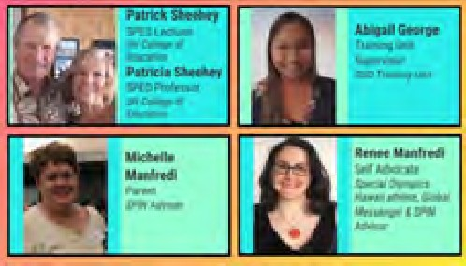
2021 Spring Conference Theme: Transition Workshop: Pathways to the Future
Why we like it: When our children leave high school
as young adults, the process can be overwhelming and scary. These presenters will help with tools and insights to make transition easier for everyone.
2021 Conference Theme: SPIN’s Journey Through the Wilderness Workshop: ADHD Wilderness Survival Guide
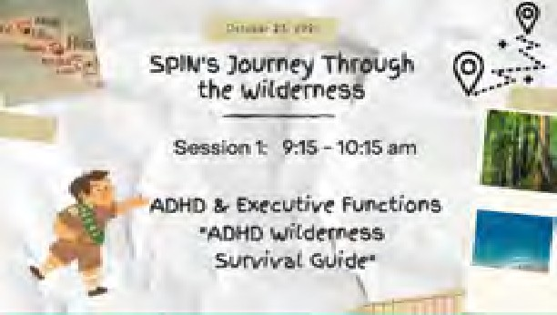
Why we like it: Our present- er, Rockey Knox speaks from
personal and professional experiences to shares tools and tips on how executive functions affect children and adults with ADHD and how to support your child in school and at home.

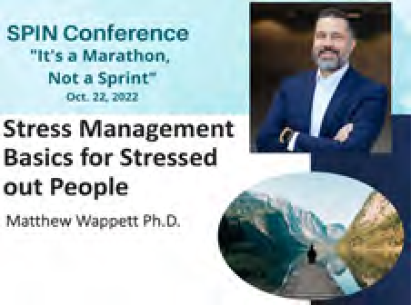
2022 Conference
Theme: It’s a Marathon, Not a Sprint: Part 1
Workshop: Resilience for the Long Run
Why we like it: Dr. Matthew Wappett talks about the effects of stress on our minds and bodies and gives us some tools on how to reduce it. Dr. Wappett will be our Keynote Speaker this year, and will introduce us to Laugh Yoga!

2023 SPIN Awards Need Your Nominations!
E
very year, SPIN publicly celebrates wonderful parents and professionals whose efforts make a positive difference in the lives of our keiki with disabilities and their families. The SPIN Advisory Committee is
looking for candidates for our 2023 SPIN Awards and we need your help in nominating someone who models the qualities and actions that families appreciate and rely on. There are three award categories:
- The Parent of the Year Award is given to a parent or parents of a child or young adult with a disability whose actions and advocacy have benefited other families.
- The Professional of the Year Award is given to a professional who has had a significant impact in improving services for children and/or youth with a disability and their families.
- The Family Choice Award is given to a professional who has been particularly helpful to families as they sort out services for their child with a disability. This individual may not have an impact on the larger system, but is recognized in his or her community as an extraordinary
professional.
We encourage you to share your aloha and nominate one or more very special people for any or all of the awards. You can go to our website at www.
spinhawaii.org, click on the conference tab and download an award nomination form. Or call us at 586-8126 and we’ll accept your nomination over the phone or mail you a form. Deadline to apply is April 7th.

5

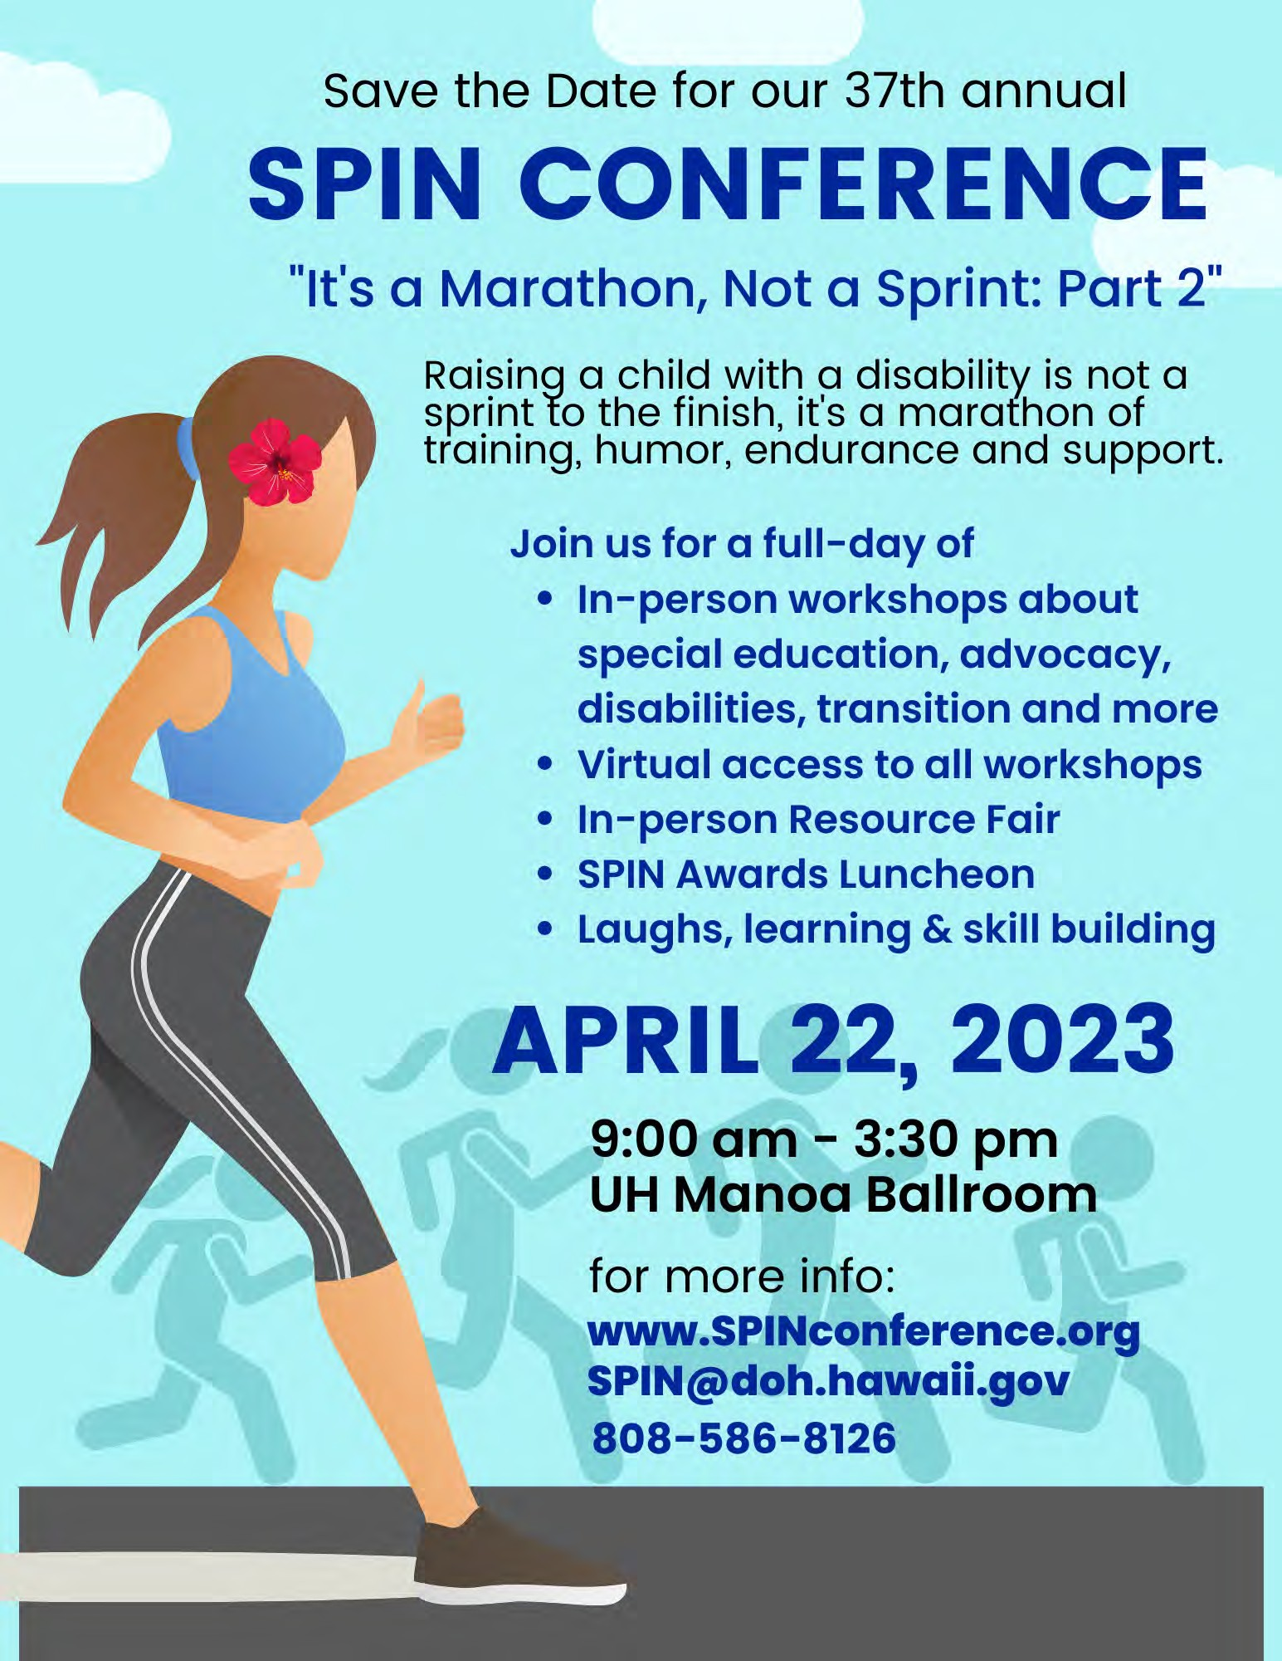

6

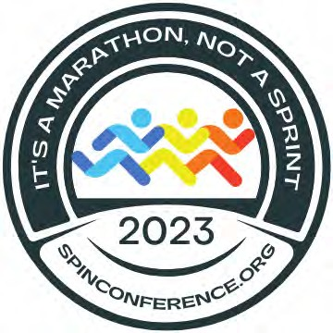
37th Annual SPIN Conference April 22, 2023 8:00 am – 3:30 pm UH Manoa Campus Center
In-person with virtual access to live workshops

8:00 – 9:00 am Registration / Resource Room Visitation
9:00 – 10:15 am Welcome / Keynote
10:15 – 10:45 am Resource Room Visitation Workshop Session #1 10:45 – 11:45 am
“Who’s Cheering You On” | “Every Run Starts with a First Step” | “Listening to My Body” | “In It for the Long Run” | SPIN Resource Fair
Positive Behavior Supports | Early Literacy | Puberty and the Brain | Alternatives to Guardianship | The Resource Fair is Open for Visiting

12:00 – 1:15 pm Lunch & SPIN Awards Workshop Session #2 1:20 – 2:20 pm
“Run Like a Pro” | “Stretching to Go the Distance” | “The Finish Line is Not the End” | “In My Shoes | SPIN Resource Fair
3 Skills for Parent & Student Advocacy | Financial Literacy | Transitioning from High school | Trauma Informed Care | Resource Fair is Open until 2:00 pm

Workshop Session #3 2:30 – 3:30 pm
“Find Your Happy Pace” | “Mapping the Course” | “You Don’t Have to Run Alone” | “Your Pace or Mine?”
Autism & Sensory Issues | Care Mapping | Special Ed 101 | Dyslexia & SLD

*Workshops & times are subject to change*
SPIN 2023 Registration Form

Name(s):
Address:
Phone: Email:
Child’s Disability: Child’s Age:
Program or School:
$25 Parent/Family Member $45 2 Family Members $25 Student $50 Professional

Amount Enclosed (payable to SPIN): $
Check # / PO#:
$15 Virtual

I am being Sponsored by: Airfare Scholarship request (for Neighbor Island parents & caregivers of kids with disabilities 0-21) Please send me application by email or street address
I need an accommodation due to a disability, please specify below

Send completed form with payment to SPIN via mail or email: 1010 Richards St, Room 118, Honolulu, HI 96813 • spin@doh.hawaii.gov

Calendar of Events

4/1 Access Surf Day at the Beach
6/3 9:00 am - 1:00 pm, FREE surfing event for all ages and abilities. White Plains, Ewa Beach Sign up online at www.accessurf.org

TACA - The Autism Community in Action 4/2 Family Day 10:00 am - 1:00 pm FREE
Palama Settlement with games & activities.
4/27 Coffee Talk 10:00 - 11:00 am FREE Kapolei Golf Club Restaurant
RSVP: tacanow.org/what-we-do/chapters/

4/2 Honolulu Theater for Youth
4/8 “Peter Pop Pan” $10 kids / $25 adult
4/16 Showtimes vary by date. Visit their website for 4/23 more info: www.membership.htyweb.org

SEAC - Special Education Advisory Committee Meeting 9:00 am - 12:00 pm
4/14 Virtual on Zoom, see online agenda for link. 5/12 In-Person, 475 22nd Ave, 2nd floor conference
room. All meetings are open to the public. For more info, call 586-8126 or visit the SEAC website at www.seac-hawaii.org

4/15 ASL Day at Sea Life Park with the Comprehensive Services Center (CSC)
FREE admission to anyone who is deaf or hard of hearing. If you pre-register with CSC, you can
receive reduced entrance rates for others in your group and reduced parking fees.
Register online: https://bit.ly/ASLatSLP
for more info, text Ginger at 808-699-3934.
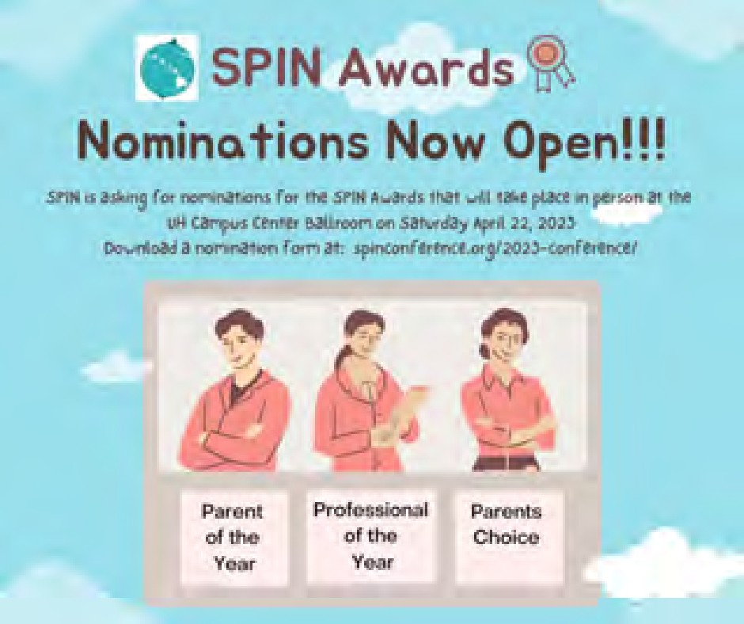
For more events and happenings around the state, be sure to visit our website events calendar at www.spinhawaii.org/events and like us on Facebook!
8 SPIN - Special Parent Information Network
LDAH Workshops & Parent Cafe FREE
Parent Talk Cafe: Parent support and training 6:00 - 7:00 pm Zoom and Facebook
4/19 Functional Behavior Assessments 5/17 Developing the IEP
6/21 Transitioning from DOH to DOE 9:00 am -2:00 pm In-person
6/10 Marathon Series: Chapter 60/IDEA, understanding the evaluation process developing the IEP.
,
245 N. Kukui Street, Honolulu Please RSVP: 536-9684

4/30 Kauai Train Ride for Autism Acceptance Month Sponsored by Be the Voice 10:00 am $8 kids / $10 adults
Kilohana Plantation, 3-2087 Kaumualii Hwy, Lihue. RSVP by April 27 at: www.eventbrite.com/e/kilohana-train-ride- tickets-584153608167. For more info, email: bethevoiceautismkauai@outlook.com

6/4 2nd Annual King Kamehameha’s Awesome Athletes Inclusive Canoe Race
9:00 am - 3:00 pm Hilo Bay Front FREE
Youth division: 10-17 years, Adult division: 18+ Register online: hilocanoerace.com

SAVE THE DATE!
4/22 37th Annual SPIN Conference
“It’s a Marathon, Not a Sprint: Part 2” 8:30 am - 3:30 pm at UH Campus Center
Keynote, 12 workshops, lunch and resources! Registration forms and airfare scholarships available www.spinhawaii.org, call us at
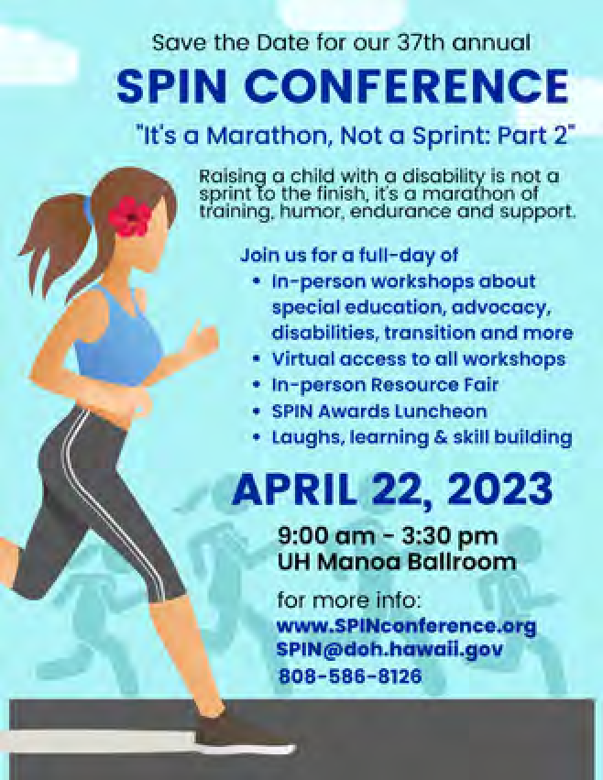
586-8126 or email spin@doh.hawaii.gov.

