STAND
2 BULLYING

espite renewed efforts over the last five years to better address
June 2023
Volume XXXIX, No. 4
SPIN is co-sponsored by the Disability & Communication Access Board and the Department of Education. Services include a phone line for information referral and support, a quarterly newsletter, an annual conference and community workshops. SPIN is guided by an Advisory Committee made up of parents, teachers and people with disabilities.

SPIN
1010 Richards Street #118
Honolulu, Hawaii 96813

PHONE
586-8126
Neighbor Islands dial the ex- change below, then 6-8126
Kauai - 274-3141
Hawai’i - 974-4000
Maui - 984-2400
Molokai - 1-800-468-4644
Lanai - 1-800-468-4644

FAX
586-8129

E-MAIL
spin@doh.hawaii.gov

WEB
www.spinhawaii.org

Like us on Facebook
D
bullying in our public schools and to enable more students with IEPs to experience belonging in inclusive classrooms, a large number of students continue to be harmed each year by unchecked bullying.
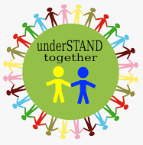
Just look at recent results from the Hawaii Youth Risk Behavior Survey (YRBS) which show more than half of middle school students expressing concern than bullying is a problem at their school. Or that one
in three young teen girls is being cyberbullied (bullied by phone, by email or through social media). Or that students who identify as gay, lesbian, bisexual, or transgender are bullied at
twice the rate of straight students.
The Hawaii YRBS does not ask the student taking the survey if he or she has a disability, so we have no local data on bullying rates among these students. Yet nationally, research studies have shown that students with disabilities are bullied 2-3 times more than students without disabililities.
Many of our children with IEPs fit the profile of a high risk student, because they are perceived as being different from their peers, less able to defend themselves or less popular.
Research has also shown a connection between certain emotional disabilities and bullying behavior. For example, one symptom of having a conduct disorder is showing aggression toward others.
Students with Attention Deficit Hyperactivity Disorder (ADHD) may
also become bullies due to poor impulse control, often after having been bullied by others.
There is also plenty of evidence
that all who are involved in bullying
--the bully, the bully’s victim, or the bystander who witnesses bullying--are harmed by it in both the short and the long run.
Stopbullying.gov, a leading website managed by the U. S. Department of Health and Human Services urges all of us to take action against bullying:
“When adults respond quickly and consistently to bullying behavior they
send the message that it is not acceptable. Research shows this can stop bullying behavior over time.”
It’s time for us to underSTAND together, whether we are parents, educators, other helping professionals, legislators or advocates.
The next three pages offer some facts and strategies for addressing bullying here in Hawaii. There are
also two invitations by the Community
Children’s Councils and Leadership
in Disabilities and Achievement of Hawaii to get informed and get involved.
WHAT’S INSIDE
How to Prevent Bullying 2
Learn the Signs of Bullying 3
5 Steps Parents Can Take 4
Virtual Summer Camps 5
SPIN Award Winners 6-7
Calendar of Events 8

HOW PREVALENT IS BULLYING IN HAWAII'S PUBLIC SCHOOLS?
Bullying within the last year
% of Students Bullied
50
25
17
0
Middle School High School
Source: 2019 Hawaii YRBS
Twice
as many Middle Schoolers report being BULLIED
than High Schoolers
37.8
About 11% of Middle
Schoolers admitted to
cyberbullying someone else
Source: 2019 Hawaii YRBS
Hawaii's Youth Risk Behavior Survey data for 2021 showed a decline in the incidence of bullying reported for the past 12 months. This was probably due the fact that fewer students were on campus due to the pandemic. The exception was Middle School students who were cyberbullied. That percentage increased to 28% for all students and 43% for Middle School students who
reported as gay, lesbian, bisexual or other.
Source: 2021 Hawaii YRBS

More than
one-half
of Middle Schoolers said bullying was a problem at school

Source: 2019 Hawaii YRBS
Girls are
2x more likely
to be cyberbullied than boys
The rate for
M.S. Girls is
30%
compared to
16%
for M.S. Boys
Source: 2019 Hawaii YRBS

11.4% of High Schoolers skipped school because it felt unsafe at
school or on the way to and from school in the last 30 days.
10.3% of Middle Schoolers skipped school because it felt unsafe at school or on the way to and from school in the last year.

Source: 2019 Hawaii YRBS Source: 2019 Hawaii YRBS

SPIN News
June 2023

2
Note: Much of Hawaii's data on bullying in schools comes from the Center for Disease Control and Prevention's Youth Risk Behavior Survey which is given to students 12-18 in Hawaii every two years. You can access data at https://hhdw.org/data-sources/youth-risk-behavior-survey/.

Learn the Signs of Bullying
Research has shown that students with disabilities are 2-3 times more likely than their peers to experience bullying while in school. Learn the signs, so that you can help prevent or stop the harm caused by bullying.
Signs of a Child Who Is Being
Bullied
lost or destroyed items (books, electronics, jewelry, clothing, etc.); changes in eating or sleeping habits; declining grades not wanting to go to school unexplained injuries frequent stomach aches or headaches attempts to run away or harm
himself/herself
Elements
of Bullying Aggression Imbalance of power
Repetition
Signs of a Child Who Bullies Others
3
Types of
Bullying
Physical
gets into physical or verbal fights gets in trouble at school
has unexplained money or new belongings
has friends who are bullies blames others for his/her problems worries about popularity
Verbal
Social

SPIN News
June 2023
Resources: CDC Bullying Fact Sheet, Stop Bullying.gov website,
Cyberbullying Research Center parent pages

3

5 Steps Parents Can Take to Address Bullying of Their Child
Parents are their child's best advocate and can play an important role in both preventing and responding to the bullying of their child with a disability.

KEEP ALERT TO THE SIGNS OF BULLYING

Watch for changes in your child's behavior and check out these signs that might indicate that your child is either being bullied or bullying others. Monitor your child's use of electronic devices such as a phone, tablet or laptop. Ask if you might "friend" or "follow" your child's social media activities.

TEACH WHAT TO DO IF BULLYING OCCURS
STOP, WALK & TALK
Encourage your child to be an "upstander"--someone who speaks out when they see or hear about bullying. If your child is bullied, teach her or him this simple response: have them tell the bully to STOP, then WALK away from the bully and TALK to you or a trusted adult or use the app below.

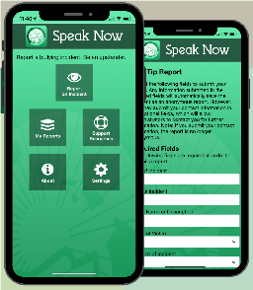DOWNLOAD THE SPEAK NOW HIDOE APP
This reporting app available from the Apple App Store or Google Play instantly informs the Department of Education about bullying that occurs on school campuses, on the school bus or at school-sponsored activities.
Students can choose to make an anonymous report, if they prefer.

USE THE IEP TO PUT PROTECTIONS IN PLACE
IEP

If your child is a potential victim for bullies, you can ask that IEP goals include self-advocacy skills and opportunities to build friendships with other students as a means of deterring bullying. When your child is being actively bullied, you may want to enlist the IEP team to ensure hallway or playground monitoring by school staff and other protections are provided.

JOIN OTHERS IN RAISING AWARENESS

Just this month, a number of organizations, including the Community Children's Councils and Leadership in Disabilities and Achievement of Hawaii have planned events around the prevention of bullying. Consider adding your own voice and advocacy to their efforts.
SPIN News
June 2023
Sources: Guidance from the HIDOE on what parents should know and can do about bullying
Speak Now reporting app flyer

4

Virtual Camps, Classes and Learning for Summer

When it comes to summer learning and activities, opportunities for children and youth with disabilities can be a challenge to find. We’ve compiled a list
of fun virtual classes, camps and websites that kids might enjoy during the summer months. Whether your looking for an online social group, academic prep or just want to learn fun new things, we’ve got you covered.

Varsity Tutors offers large, celebrity-led classes for free and fee-based week-long camps, classes and clubs, as well as tutoring for kids with learning differences. www.varsitytutors.com

Outschool is another variety camp option for different ages and interests and has some great “adulting” classes for older students www.outschool.com

Virtual Summer Camps has a big list of current virtual classes taking place this summer. Some are fee-based and some are free. www.virtualsummercamps.org
PBS for Kids is geared towards young children and is loaded with games, activities and educational videos to teach and entertain kids all summer. www.pbskids.org

Camp Wonderopolis is a free camp with 5 different camps: music, construction, health, animals and a general Mission to Wonder. www.wonderopolis.org

Khan Academy is free and offers lots of classes in academics as well as life skills like growth mindset and social emotional learning. www.khanacademy.org

The Smithsonian Museums have a full schedule of games, activities and pre- recorded programs for kids of all ages to enjoy. www.si.edu/kids

If you are looking for some in-person offerings or are looking for some fun family outings this summer, check out the list of museums in Hawaii, www.en.wikipedia. org/wiki/List_of_museums_in_Hawaii

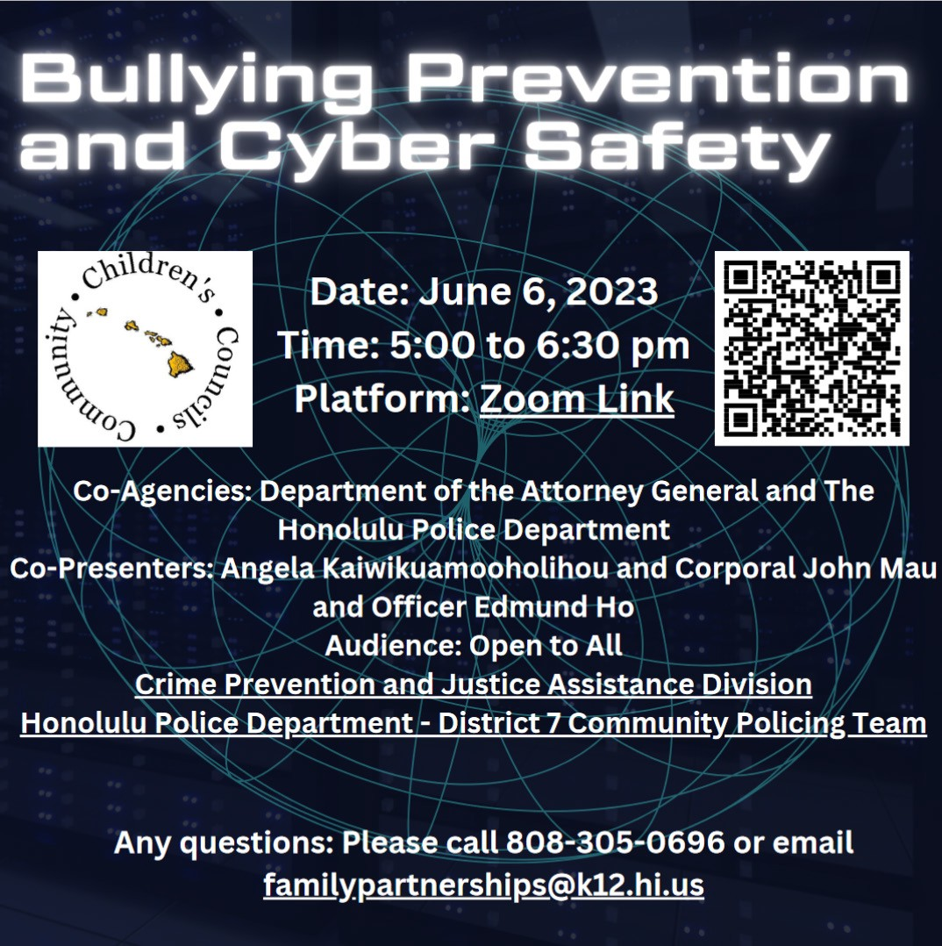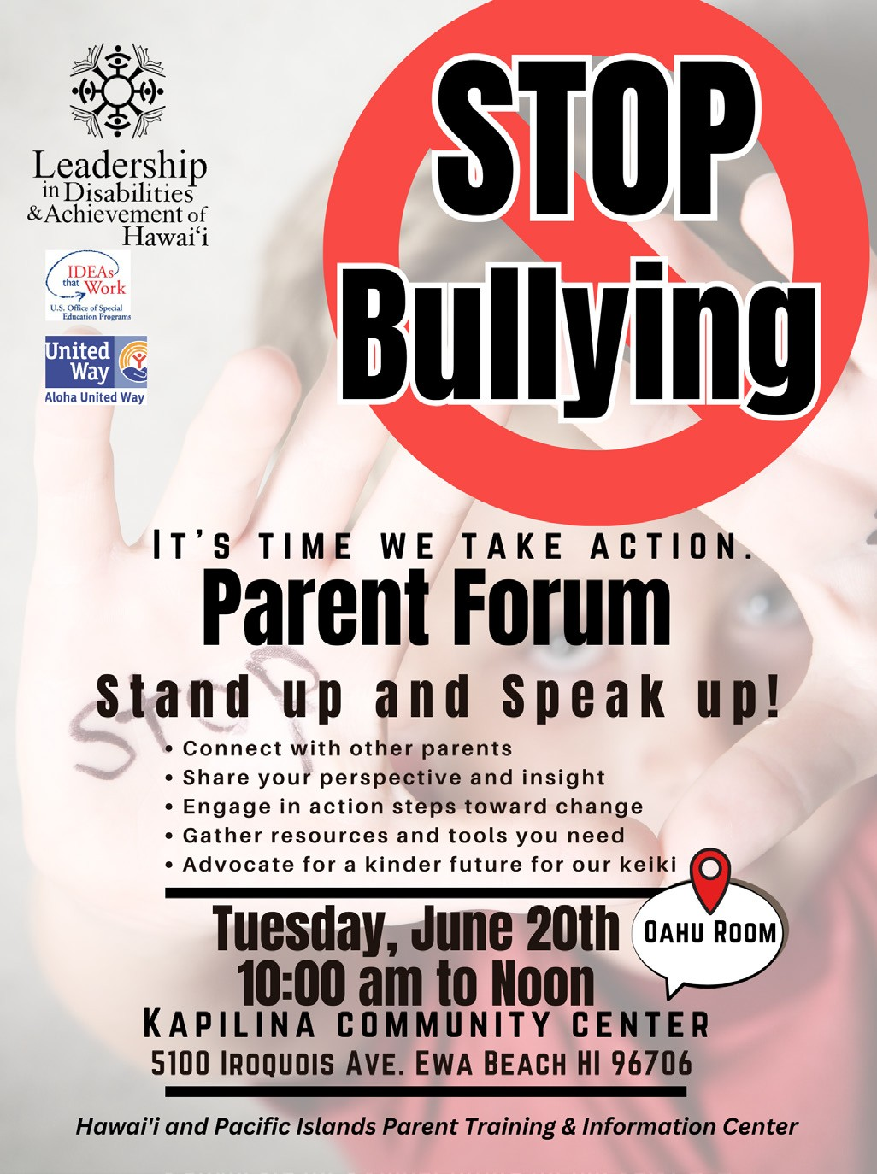

5

SPIN Conference Award Winners
Throughout the Covid-19 pandemic, the SPIN Conference continued to bring families and our professional
partners timely information using the Zoom platform. We had virtual workshops on inclusion, behavior supports, self-care, transition and more and you can watch all of them on our SPINconference.org website! But one thing was missing: the SPIN Awards. This lunchtime activity is always a highlight, showcasing parents and professionals who are doing good work in our communities. One of the things that make it a extra special is the award winners usually do not know they have been chosen for an award and watching them hear their names called in the ballroom is part of the fun. We are so pleased to not only get back in person for the SPIN Conference this past April 22nd, we are also delighted to welcome back the SPIN Awards, showcasing six amazing parents and professionals in 3 categories: Parent of the Year, Professional of the Year and Parent’s Choice Awards. Please join us in congratulating all of our winners.
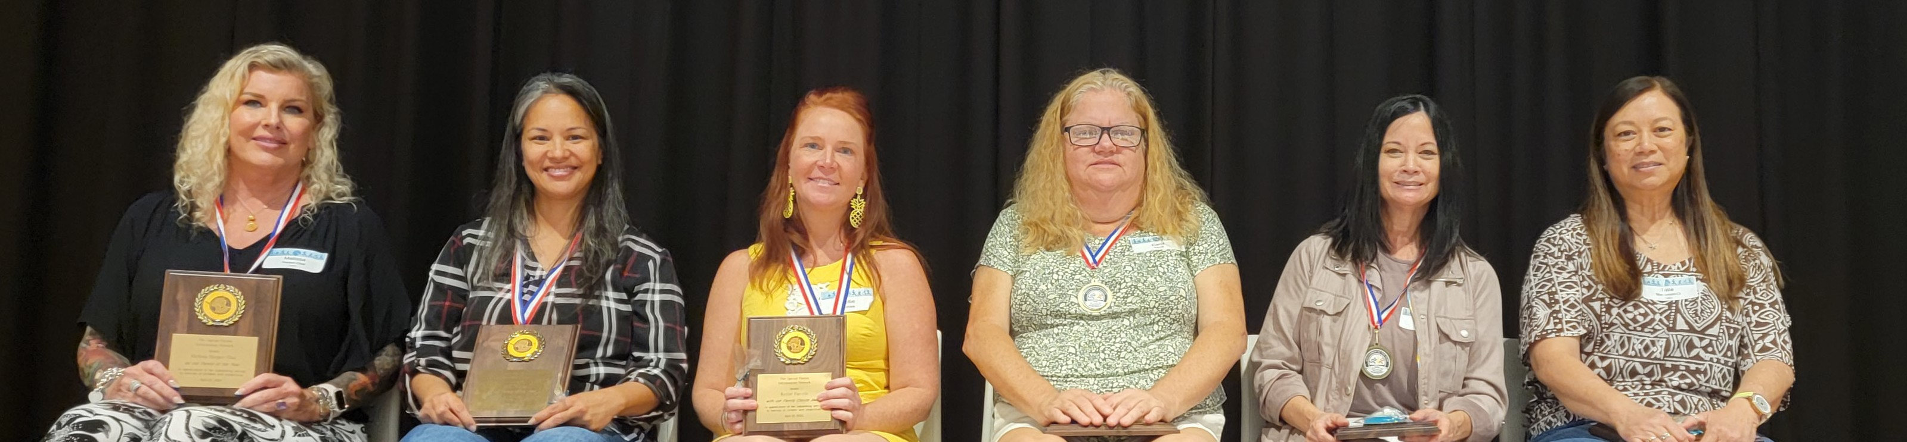

2023 SPIN Award Winners! Dale Matsumoto-Oi, far right, filled in for Keiko Nitta, who was unable to join us.

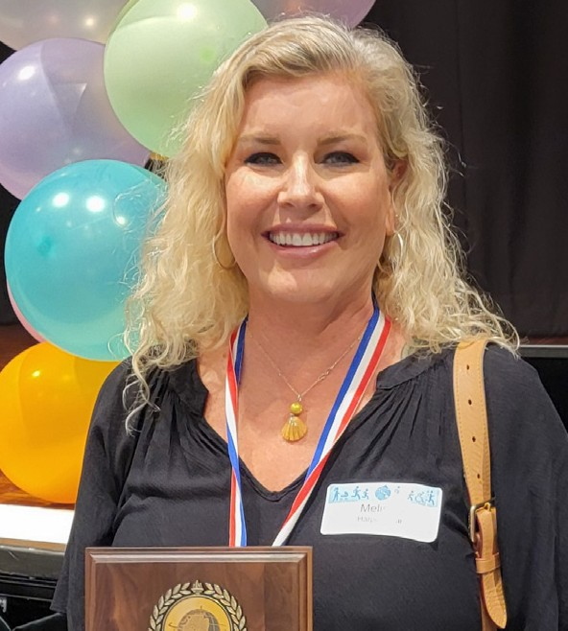
Parent of the Year: Melissa Harper-Osai
Melissa is the proud mama of a middle-schooler who was the Kapiolani Children’s Miracle Network Champion, 5 years ago. Her son Kayle was born with autism and Carney Complex, a very rare genetic disorder that results in complex medical needs. Melissa has helped give back to her community by creating a Facebook group called C.A.L.M. - Chromosomal Abnormality Learning Moms - to help other parents understand the special education process and how to navigate the medical systems. She helps to support and fundraise for Make a Wish Hawaii and Special Olympics, where Kayle has been a recipient and a participant, and serves as the Parent Co-Chair of the Central District South Community Children’s Council. Melissa also carves out time each month as a parent representative on the Special Education Advisory Council.

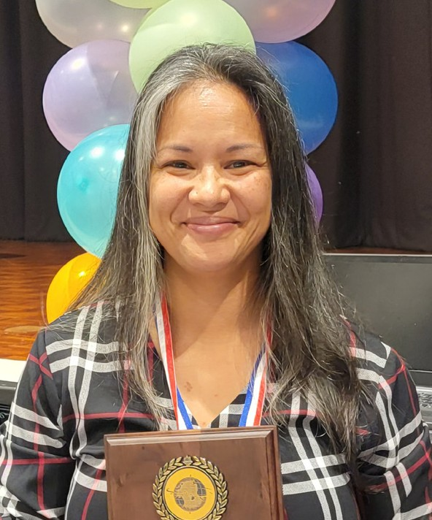
Parent of the Year: Nikki Kepo’o
Nikki is an Oahu mom of two children, Caleb, who is deaf, and Rebekah, who attends a Hawaiian immersion school. She works tirelessly to promote the Deaf and Hard of Hearing community and parents to build a better Hawaii for all children and families. Nikki serves as the Vice Chair of the Disability and Communication Access Board and has played a large role in ensuring communication access to the people of Hawaii. She is a parent advisor to the Newborn Hearing Screening Program and connects with families who have children who are deaf or hard of hearing by sharing her story through the Comprehensive Services Center. Nikki has also been a powerful member the Hawaii LEAD-K - Language Equity and Acquisition for Deaf Kids Initiative, a national effort to promote state legislation to improve language and learning of deaf/hard of hearing kids across the state.
6

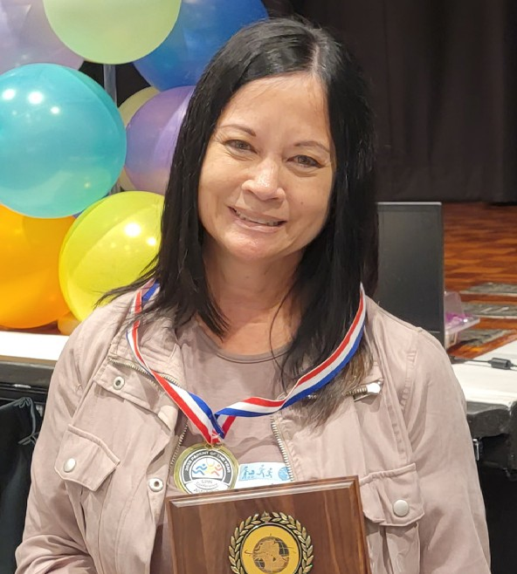
Professional of the Year: Annie Kalama
Annie has been advocating for children with disabilities and their families for over 35 years. She’s worked as an autism specialist and led an initiative to develop more inclusive placements with appropriate supports, and was the Director of the Exceptional Support Branch. Most recently, Annie has been appointed by Superintendent Hayshi to become the Assistant Superintendent of the Office of Support Services. Throughout her career, which she refers to as a “calling”, Annie has led with grace, compassion and patience and always reminds her team to focus on how their work supports children and families.
The parents and advocates who have come to know and work with Annie have immense respect and gratitude for her calm, pleasant demeanor and her ability to move the system in the right direction.
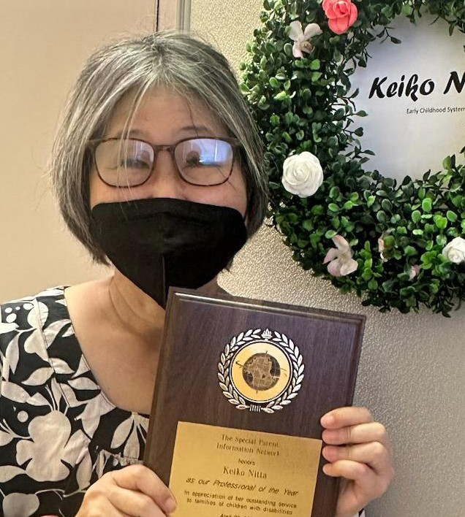
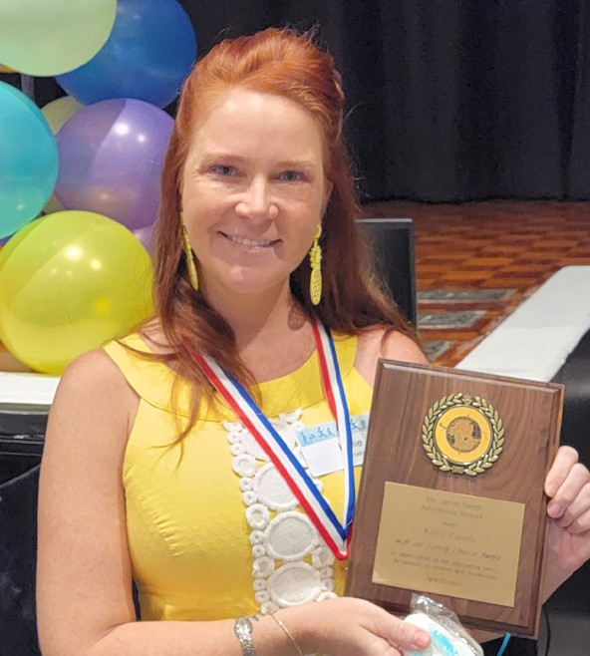
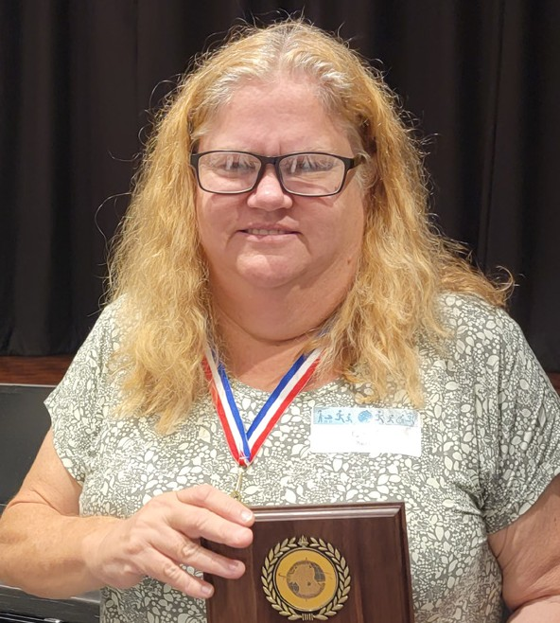
Professional of the Year: Keiko Nitta
Keiko blesses us continually with her talents, presence and grace. An early advocate for families, she served as a Chaplain for Kapiolani Hospital as an ordained Zen priest. Her path within the Department of Health has been a journey of systems change, family-professional partnerships and life-long friendships. As a Children and Youth Specialist IV for the Children with Special Needs Branch, Keiko has blazed a trail to ensure every keiki has access to quality health care. Her ability to partner is limitless, whether it’s through her co- leadership role for the “Learn the Signs. Act Early” initiative, or her tireless work over the last 10 years with the Early Childhood Action Strategy. In any meeting or workgroup, you’ll find Keiko leading by example, always advocating for families and the community with kindness, follow-through and determination.
Parent Choice Award: Kellie Parcels
Kellie is a special education teacher at Mokapu Elementary School in Kailua. She calls her room the “Pineapple Room” and it’s a place where kids are happy to learn because Kellie makes learning fun. Kellie supports her students to participate in extra curricular activities at school, including to be Jr. Police
Officers, where she is available to step in if needed, but stays in the background to encourage independence and social skills. She was nominated by 2 moms, Amanda & Michelle, who credit Kellie with not only teaching their children and growing their successes, they also appreciate the mentoring and supports she provides to them so they can be contributing partners in their child’s education. Both moms believe Miss Kellie is the most caring, most talented and most generous teacher they have ever met.
Parent Choice Award: Carol Pierce
Carol is a 5th and 6th grade teacher at Aikahi Elementary School. She is a general education teacher, and holds a certification in special education, which makes her skillful in modifying the curriculum and applying accommodations to meet the unique needs of her students. Carol was nominated by mom Amanda, who credits Mrs. Pierce for changing the educational trajectory for her son Ikaika. When Ikaika was in 6th grade, he was in a resource math class doing 3rd grade work. Mrs. Pierce advocated with Amanda to have him moved to her 6th grade math class, where he scored the highest on his next test. His
success in her class led to inclusive placements in middle and high school where he graduated. What makes Carol so beloved by parents like Amanda is that when she takes a student under her wing, her belief in their ability and her insistence on holding them to high standards changes the arc of their future.

7

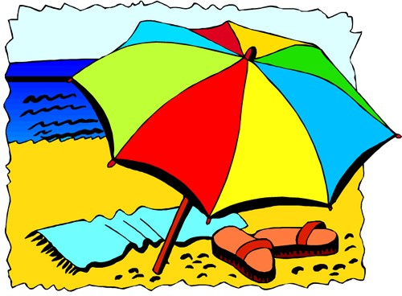
Calendar of Events

Beginning ASL Classes - In Person
Various days/time, see below for pricing. All classes held at the Comprehensive Services Center, 1953 S. Beretania St. #5A, Honolulu Parents of deaf/hard of hearing/deaf-blind children ages 0-5 attend for free.
5/31 Beginning ASL 1A: Wednesdays May 31 to Aug 2 6:00 - 7:30 pm $125
6/10 Beginning ASL 1B: Saturdays June 10 to Aug 12 9:00 - 10:30 am $125
6/12 ASL for Children: Mondays June 12 to July 24 10:00 - 11:00 am $25
Register: bit.ly/aslwitherincsc
For more info, email: roz@csc-hawaii.org

7/8 AccesSurf Hawaii Day at the Beach - In Person
8:00 am - 2:00 pm FREE
Open to anyone with a physical or cognitive disability. Featuring assisted swimming and floating as well as surfing, trained volunteers and specialized equipment will help everyone enjoy an inclusive day at White Plains Beach. Sign up: www.accessurf.org

6/6 Bullying Prevention & Cyber Safety - Virtual
5:00 - 6:30 pm FREE
The Community Children’s Council office is hosting this Zoom event with speakers from the Department of the Attorney General and the Honolulu Police Department.
Zoom meeting ID: 839 5211 8628
Passcode: 720641 or visit www.spinhawaii.org/ events for the Zoom link. For more info, email family.partnerships@k12.hi.us

6/8 Read to Me Conference - Virtual
8:00 am - 1:30 pm FREE
Read to Me International is hosting it’s annual reading conference. Join in for this free virtual event with national children’s authors. Visit www.spinhawaii.org/events for a link to join.

6/17 Healthy Relationships & Sexuality - Virtual
9:00 - 11:30 am FREE
The DD Council is sponsoring this informative workshop for parents, caregivers and individuals who are aged 14+ to help you become more comfortable talking about this sensitive subject. Register: https://forms.gle/rfZfDP66uyq8EHsy5 For more info: zosimo.arista@doh.hawaii.gov

6/17 “Celebrating Fatherhood” - In Person
10:00 - am - 2:00 pm FREE
Family Support Hawaii, in Kailua-Kona on the Big Island is hosting an event at Kahalu’u Beach Park, south of Kona. There will be books, games, raffle prizes and food. For more info, call
808-326-7778.

6/18 Sensory Friendly Film: “Elemental” In Person The Autism Society of Hawaii is hosting a sensory friendly film at Kahala Mall Theaters. Keiki with autism are free, all others $16.75 For more info and tickets, visit: https://www.autismsocietyhi.org/meet-ups

6/20 Parent Forum to Stop Bullying - In Person
10:00 am - 12:00 pm FREE
Connect to other parents, gather resources and tools and engage in action steps towards change. 5100 Iroquois Ave, Ewa Beach
For more info: call LDAH 808-536-9684

16th Annual Traveling Mini Conference
In Person - FREE
Leadership in Disabilities & Achievement of Hawaii will be bringing their 1 day conference to each island this fall, celebrating parent leadership and youth advocacy.
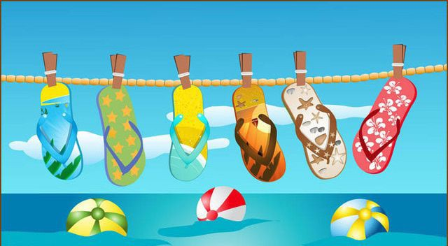
8/17 Molokai 8/30 Lana’i
9/8 Kona
9/9 Hilo
9/23 Maui
10/7 Kaua’i 10/21 O’ahu
For more information or to submit a proposal for a workshop, contact LDAH 808-536-9684.

For more events and happenings around the state, be sure to visit our website events
calendar at https://spinhawaii.org/events/ and like us on Facebook!
SPIN - Special Parent Information Network 8

